Keep keyboard focus inside the discipline cancellation dialog
  - QA-082 | P2 | Bug | TODO
Environment: Staging https://vantai.tingting.vip
Reviewed: 14 September 2026
Role: ADMIN; Chrome desktop 1440 × 900
Page: /penalties → Hủy kỷ luật → Xác nhận hủy kỷ luật?

Existing behaviour
The centered confirmation and backdrop appear, but focus remains on the background Hủy kỷ luật button. Pressing Tab moves focus to the background Sửa bảng phạt → link while the confirmation remains open. Its accessibility content is generic rather than a named dialog; the saved DOM check reports dialogCount 0.

Target behaviour
Use a shared accessible confirmation dialog with a name and modal semantics. Move focus inside on opening, contain keyboard navigation, make the background inactive, and restore focus when closing.

Impact
Keyboard users can reach unrelated navigation while deciding whether to cancel a discipline record, and the confirmation lacks a programmatic dialog context. No screen-reader session was performed.

Cause and investigation
Hypothesis: the visual overlay lacks the shared dialog’s semantics and focus management. Inspect its mounting and focus lifecycle; no implementation cause is confirmed.

Steps to reproduce
1. As Admin, open /penalties and activate Hủy kỷ luật on an existing record.
2. Observe that focus remains on the background trigger, then press Tab once.
3. The Sửa bảng phạt → link receives focus behind the still-open confirmation. Inspect the paired accessibility and DOM captures.

Acceptance criteria
1. The confirmation exposes an appropriate named dialog role and modal state; initial focus moves to a suitable control inside it.
2. Tab and Shift+Tab stay inside the open dialog, and background controls cannot receive focus or interaction.
3. Escape and Đóng dismiss without cancellation and restore focus to the trigger. Only explicit confirmation performs the existing authorized cancellation.
4. Check keyboard, accessibility-tree and screen-reader behavior on desktop, tablet and phone without enlarging the compact layout.

Requirement reference
Staging keyboard interaction, accessibility snapshots and DOM focus capture on 14 September 2026.

Evidence 1
  - Keep keyboard focus inside the discipline cancellation dialog
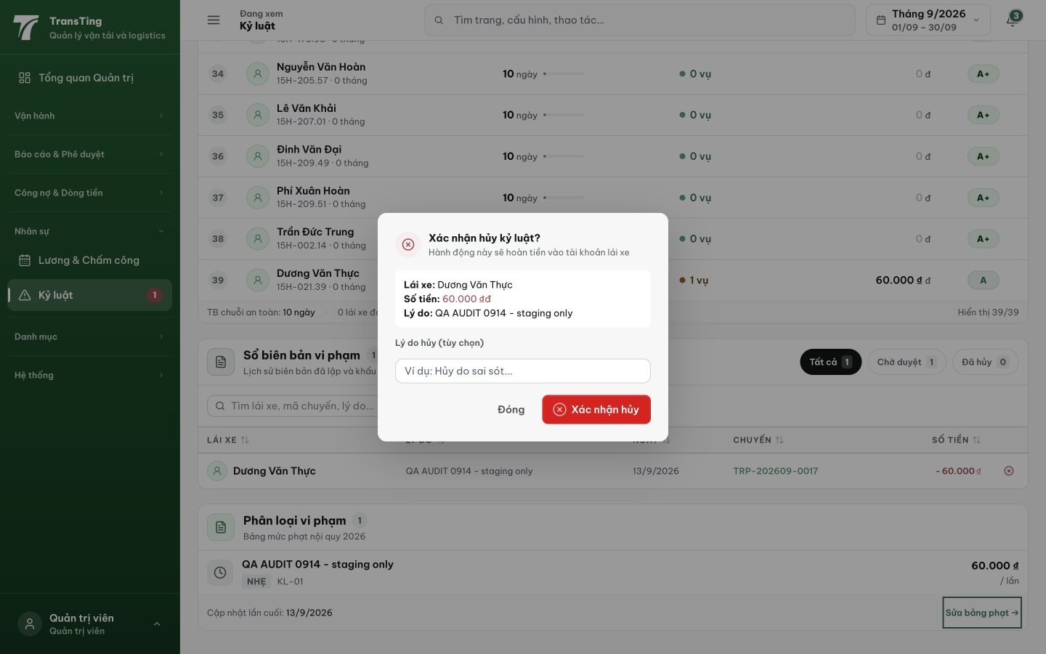
Figure 1. After Tab, the visible focus outline is on Sửa bảng phạt → at the bottom right behind the open confirmation. Paired DOM evidence identifies that background link as active and reports no dialog element.
[2026-09-14 note — mã + test xong (1c16ebcc, 61/61): migrate shared Modal (role/aria-modal/focus trap/Escape/focus return). Browser rung chờ fixture penalty hủy được (local chưa seed) — staging round hoàn tất theo tiền lệ.]
[2026-09-14] QA PASSED — staging (build e72f10c5): Đóng path — dialog đóng VÀ focus trả về đúng trigger Hủy kỷ luật (03-staging6-focus-restored-via-dong.png); role/aria-modal/name/focus-inside giữ nguyên. CAVEAT ghi nhận: Escape-dismiss không hoạt động dưới automation trên cut 6 (cut 5 có) — d8 xác nhận là intentional/automation-artifact hay regression (nếu regression → fix 1 dòng kèm round sau). Chuỗi code 1c16ebcc + 15011b5e.

