Render uploaded expense receipts after saving and reloading
  - QA-087 | P2 | Bug | TODO
Environment: Staging https://vantai.tingting.vip
Reviewed: 14 September 2026
Role: ADMIN; Chrome desktop 1440 × 900, tablet 834 × 1112 and phone 390 × 844
Page: /expenses/1/edit → Ảnh hóa đơn

Existing behaviour
A valid PNG upload creates an Ảnh 1 entry that remains after reload, but the thumbnail is broken and clicking it yields no readable image. DOM intrinsic dimensions are zero despite complete=true. Deletion works; a second valid PNG reproduces the failure after reload.

Target behaviour
Show a readable, persisted thumbnail and accessible preview. Resolve the media URL for the authorized user, with distinct loading feedback and a clear retryable error if retrieval fails.

Impact
Users cannot inspect the evidence attached to an expense or tell whether uploading it succeeded. Retrying with another valid file repeats the failure.

Cause and investigation
Hypothesis: media URL mapping or retrieval differs from the upload result. Inspect the captured /api/photos/expense-photos%2F1%2F…png URL and authorized response. HTTP status, storage loss and implementation cause are unverified.

Steps to reproduce
1. As Admin, open /expenses/1/edit and activate Nhấn để tải lên ảnh hóa đơn. Select DELIVERY-REPORT.png, a readable 1000 × 600 PNG below 5 MB.
2. Reload, inspect Ảnh 1 at desktop, tablet and phone widths, and click it. The entry is present but the image is unreadable.
3. Delete the entry, upload FUEL-QA-0914.png, a readable 900 × 700 PNG, then reload. The replacement is also broken; it remains attached in the audit fixture.

Acceptance criteria
1. Both valid fixtures display correctly immediately and after reload, with nonzero intrinsic dimensions and a readable keyboard-accessible preview.
2. Loading and failed retrieval have distinct feedback; retry works without creating duplicate entries. Preserve authorized access to expense evidence.
3. Delete and replacement still work. Verify the saved image at 1440 × 900, 834 × 1112 and 390 × 844 using compact controls.

Requirement reference
Staging Admin upload/reload checks, 14 September 2026; both local PNGs validated. Approval posting is QA-086; Driver viewer enhancement is QA-018.

Evidence 1
  - Render uploaded expense receipts after saving and reloading
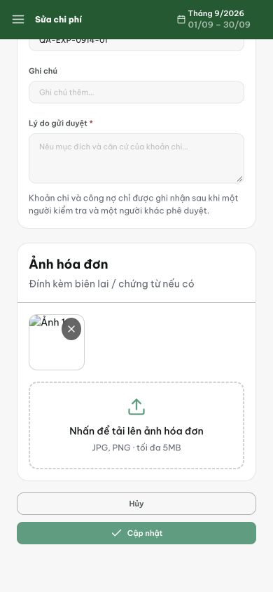
Figure 1. Phone 390 × 844: the invoice slot shows a broken-image icon and Ảnh 1 instead of the uploaded report; the delete control remains visible.

Evidence 2
  - Render uploaded expense receipts after saving and reloading
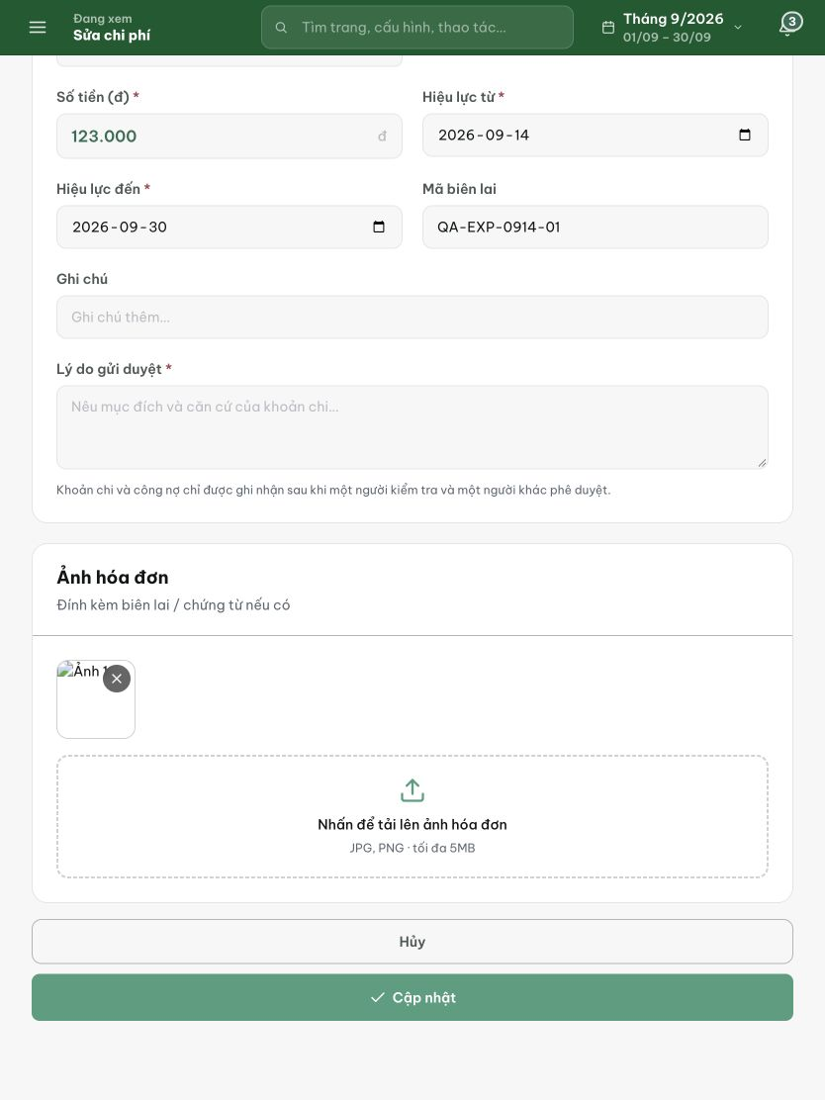
Figure 2. Tablet 834 × 1112: the same broken thumbnail appears above the upload area. The image entry exists, but the receipt cannot be read.

Evidence 3
  - Render uploaded expense receipts after saving and reloading
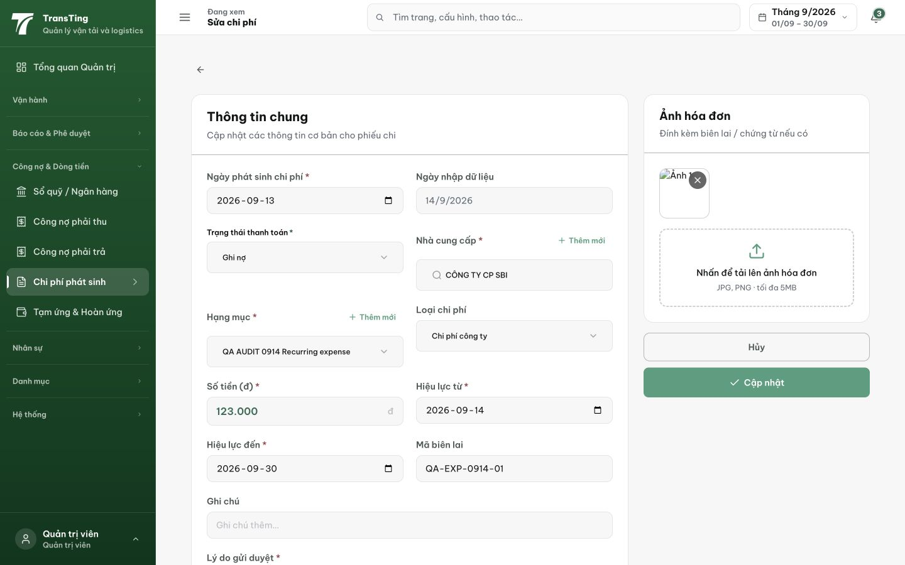
Figure 3. Desktop 1440 × 900 after replacement: the second valid PNG also displays a broken thumbnail. The live test confirmed that this state remains after reload.
[2026-09-14] DEV COMPLETED — Thumbnail qua getAuthenticatedPhotoUrl (token param, pattern one-file; blob: pass-through); load fail → tile VN retryable ('Không tải được ảnh / Thử lại') — retry key-bump reload token mới, không re-upload; thumb = button mở shared PhotoViewer (QA-018) — zoom/pan/Escape + focus, keyboard-accessible; delete/replacement giữ nguyên. Tests 3/3. Live-repro server-side (upload → 2 URL forms 200 image/png) trong evidence trail. Commit 0783bc26. Browser rung staging.
[2026-09-14] QA PASSED — staging: upload → 900×700 thumb + preview real dims, persists reload, PhotoViewer full image.

