Keep financial summary labels and amounts separate at narrow widths
  - QA-093 | P2 | Bug | DEV COMPLETED — chờ deploy staging + QA
Environment: Staging https://vantai.tingting.vip
Reviewed: 14 September 2026
Role: MANAGER and ACCOUNTANT · 390 × 844, 834 × 1112, 1440 × 900
Page: /expenses; /salary; /finance; /debt; /accounting?view=overview

Existing behaviour
At 390 px, Manager summaries overlap labels with expense, payroll, profit and receivable amounts. At 834 px, Accountant overview forces six metrics into one row: Phải thu and Phải trả collide with their values, and Lợi nhuận kỳ extends past the right edge. The other captured role and width combinations keep these summaries separated.

Target behaviour
Use a compact responsive summary layout that reserves space for both the complete label and its value. Reflow each label above its amount, or use fewer columns when needed, without enlarging the summaries unnecessarily.

Impact
Managers and accountants cannot scan totals reliably when labels and amounts merge or extend off screen.

Cause and investigation
Inspect minimum widths, wrapping and label/value alignment. A shared rendering pattern is visible; its implementation cause is unverified.

Steps to reproduce
1. As Manager, open the four listed financial pages at 390 × 844 with the current September figures.
2. As Accountant, open /accounting?view=overview at 834 × 1112. Inspect all six metrics; compare each route at the other tested widths.

Acceptance criteria
1. No label, value or currency unit overlaps or clips on all five routes at 390, 834 and 1440 px, including the six-metric Accountant overview.
2. Keep amounts, minus signs, decimal precision and currency units intact; allow labels to wrap naturally in a reserved area.
3. Verify zero, negative and longer formatted amounts, long labels and text zoom. Preserve logical reading order and readable type.
4. Keep summaries compact with consistent alignment and modest padding; preserve calculations. Filters, payroll selection and record cards are outside this task.

Requirement reference
Fresh Manager and Accountant captures; requested compact responsive interface.

Evidence 1
  - Keep financial summary labels and amounts separate at narrow widths

Figure 1. Expense total at 390 px: 3.257.000 đ intrudes into the Tổng chi phí label; the unpaid label is squeezed into a tall narrow stack.

Evidence 2
  - Keep financial summary labels and amounts separate at narrow widths
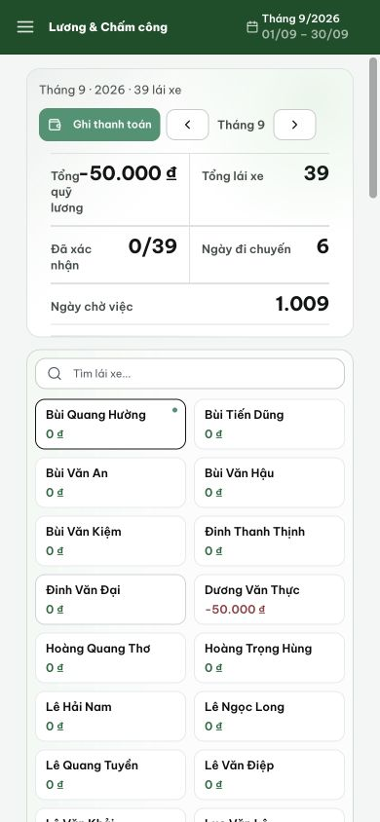
Figure 2. Payroll at 390 px: −50.000 đ and Tổng quỹ lương compete for the same horizontal space.

Evidence 3
  - Keep financial summary labels and amounts separate at narrow widths
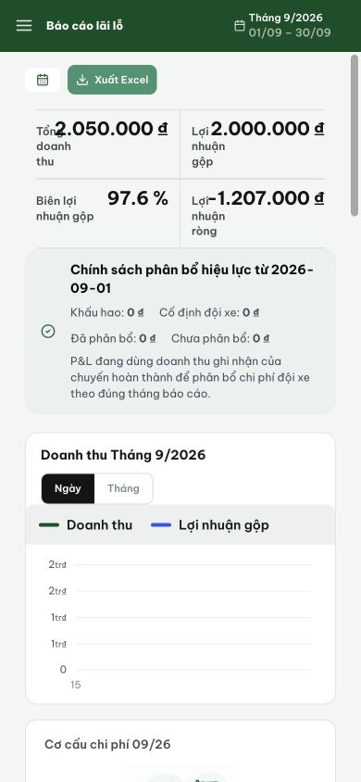
Figure 3. Profit report at 390 px: revenue and profit amounts overlap their labels in the two-column summary.

Evidence 4
  - Keep financial summary labels and amounts separate at narrow widths
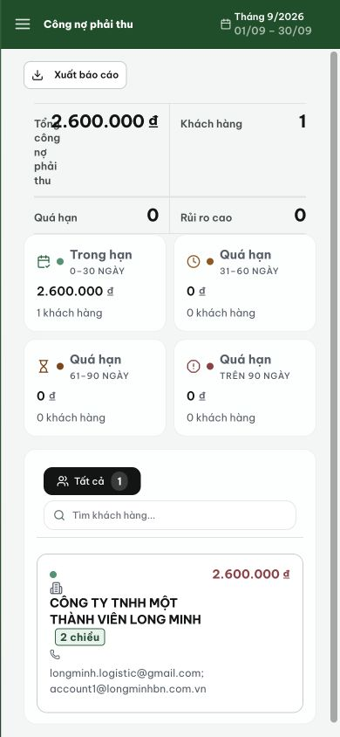
Figure 4. Receivables at 390 px: 2.600.000 đ overlaps the narrow Tổng công nợ phải thu label.

Evidence 5
  - Keep financial summary labels and amounts separate at narrow widths
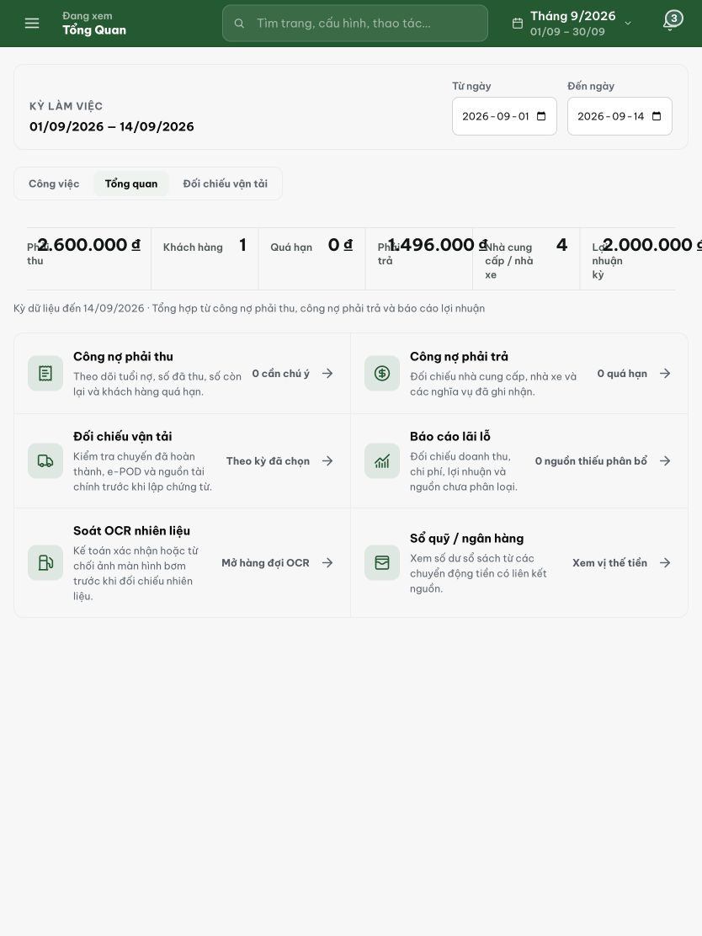
Figure 5. Accountant overview at 834 px: receivable and payable values overlap their labels; the last profit value extends beyond the right edge.

Fix evidence
Commit: e49031b9 fix(finance): separate summary labels and amounts at narrow widths
Branch: prod
Files changed: SummaryRail.css (+11/−4), KpiCard.css (+6)
Validation: tsc --noEmit clean; vitest 288 passed (5 pre-existing failures unrelated to CSS); SummaryRail + workboard style tests all green.
Root cause
The shared SummaryRail component uses a flex row (label left, value right) at all widths. At 700 px it collapses to two columns (flex-basis: 50%), but the next breakpoint was at 380 px for full-width stacking. At 390 px (common phone width), each item was only ≈183 px wide — too narrow for Vietnamese labels like “Tổng cổng nỡ phải thu” next to formatted amounts like “1.234.567.890 ₫”.
Fix
1. SummaryRail.css: raised the full-stack breakpoint from 380 px to 480 px. Below 480 px, items now use flex-direction: column with label stacked above value (gap: 4px), value font reduced to 16 px, and flush gutters.
2. KpiCard.css: added a global @media (max-width: 480px) override so .kpi-grid and .kpi-grid.cols-3 collapse from 4/3 columns to 2 columns with 8 px gap.
Both changes are CSS-only; no TypeScript, no component markup, no API changes. All existing SummaryRail and workboard golden-standard tests pass unchanged.
Coverage
All five routes use the shared SummaryRail component: /expenses (ExpenseListPage), /salary (SalaryAttendancePage), /finance (FinancePage), /debt (DebtListPage), /accounting?view=overview (AccountingOverview). The fix applies uniformly. The ExecutiveFinancialStrip on the dashboard already had its own 639 px mobile override.

