Prevent statement toolbar actions from overlapping on tablets
  - QA-104 | P2 | Bug | DEV COMPLETED — chờ deploy staging + QA
Environment: Staging https://vantai.tingting.vip
Reviewed: 14 September 2026
Role: Accountant — tablet 834 × 1112; desktop 1440 × 900 and phone 390 × 844 compared
Page: https://vantai.tingting.vip/debt/1 — Bảng kê → Tạo bảng kê

Existing behaviour
In the statement creation dialog at 834 pixels, Lọc lại and Thêm dòng trình bày occupy overlapping space on the same toolbar row. Their labels visibly collide. A fresh settled capture reproduces this; measured control bounds overlap by about 76 pixels. The desktop and phone comparison captures place these controls separately. No incorrect filtering or row-creation outcome is asserted.

Target behaviour
Keep both toolbar actions fully readable and independently reachable. Reflow the date range, export template and actions before they collide, using the available width efficiently.

Impact
Overlapping labels make the two statement actions difficult to distinguish and aim at accurately.

Cause and investigation
Hypothesis: the toolbar retains an insufficient-width single-row layout at this breakpoint. Source implementation is unverified.

Steps to reproduce
1. Open a customer account in Công nợ phải thu as Accountant, select Bảng kê and click Tạo bảng kê.
2. Set the viewport to 834 × 1112 and inspect the toolbar containing dates, Mẫu xuất, Lọc lại and Thêm dòng trình bày. Compare the last two controls.

Acceptance criteria
1. The two actions have non-overlapping bounds and fully readable labels throughout tablet widths and near layout breakpoints.
2. Wrap related controls onto a compact additional row when necessary. Keep date and template labels associated with their fields and retain the action order.
3. Preserve approximately 44-pixel touch targets, keyboard access and visible focus. Each control must activate only its own action.
4. Verify the current fixture, longer labels and text zoom at phone, tablet and desktop sizes. Preserve the line-item editor, export options, notes and dialog footer without adding oversized fields or unnecessary vertical gaps.
5. Regression-check filtering and adding a presentation row after the layout fix. Preserve existing values, calculations and permissions.

Requirement reference
Current staging screenshot and browser-owner control-bound measurements.

Evidence 1
  - Prevent statement toolbar actions from overlapping on tablets
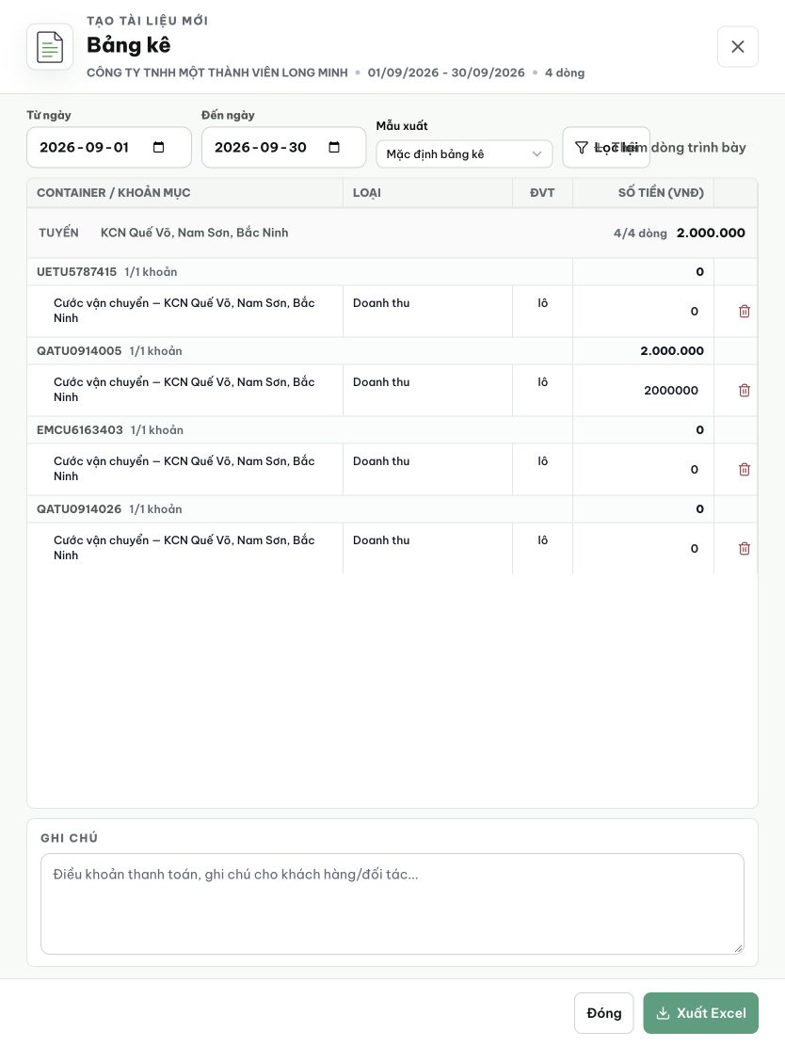
Figure 1. Settled tablet view at 834 × 1112: Lọc lại overlaps Thêm dòng trình bày to the right of Mẫu xuất. Other statement content is shown for context.

# Evidence 2 — Fix applied

File changed: frontend/src/components/billing/BillingDocumentBuilder.css

Change: Added @media (max-width: 880px) breakpoint that switches .billing-builder__controls from a rigid 5-column CSS grid to flex-wrap. Labels and the template select get flex: 1 1 168px so they reflow naturally, while the action buttons (Lọc lại, Thêm dòng trình bày) get flex: 0 0 auto to stay inline when space allows and wrap to a new row when the viewport tightens around 834px. Touch targets remain ≥44px as specified by the existing min-height rule.

Verification:
• tsc --noEmit: clean (0 errors)
• vitest run: all billing tests pass (288/293 files pass; 5 pre-existing failures unrelated to this change)
• Commit: 1c13390b fix(accounting): wrap statement toolbar actions at tablet widths
• Pushed to prod branch

Trạng thái: DEV COMPLETED — chờ deploy staging + QA

