Make the customer delivery confirmation button visible
  - QA-107 | P2 | Bug | DONE
Environment: Staging https://vantai.tingting.vip
Reviewed: 14 September 2026
Role: Customer QA test account — desktop, tablet and phone
Page: https://vantai.tingting.vip/portal/shipments — Cần xác nhận

Existing behaviour
The enabled Xác nhận đã nhận hàng button is nearly invisible beside Báo sai lệch. On desktop its white text disappears into the white row; on narrower views the label is faint on pale cards. Live inspection confirmed an enabled button with white text, transparent fill and opacity 1; its containing elements are also transparent. The issue is visual discoverability, not a failed confirmation or missing permission.

Target behaviour
Give the customer delivery acknowledgment a clearly visible compact button treatment on every row background. Keep it distinguishable from reporting a discrepancy and from disabled or busy states.

Impact
Customers can overlook the ordinary delivery acknowledgment and see discrepancy reporting as the only available action.

Cause and investigation
Confirmed: .is-primary referenced var(--primary) which is undefined in :root. Only --brand (#005A2D) is defined. background:var(--primary) resolved to transparent, leaving color:var(--fg-on-brand) = #FFFFFF invisible on white rows.

Steps to reproduce
1. Sign in as the Customer test account and open Lô hàng của tôi → Cần xác nhận.
2. Inspect a row whose driver has reported delivery, such as SHP-2609-00002. Locate Xác nhận đã nhận hàng above Báo sai lệch on desktop and phone.

Acceptance criteria
1. The enabled acknowledgment has a legible label and visible control boundary on normal, alternate, hovered and focused row backgrounds. Use at least 4.5:1 normal-text contrast.
2. Preserve a clear visual distinction between delivery acknowledgment and discrepancy reporting. Do not require hover or focus to discover the acknowledgment.
3. Retain its accessible name, keyboard activation, visible focus and approximately 44-pixel phone touch target without oversized controls.
4. Disabled and busy states remain understandable and cannot resemble an enabled control that disappeared. Verify loading, eligible and already-acknowledged states.
5. Check all three viewport sizes and the intended acknowledgment result. Do not introduce an internal approval step or change shipment status merely to repair the styling.

Requirement reference
Settled staging screenshots and browser-owner button-state and color inspection.

Evidence 1
  - Make the customer delivery confirmation button visible
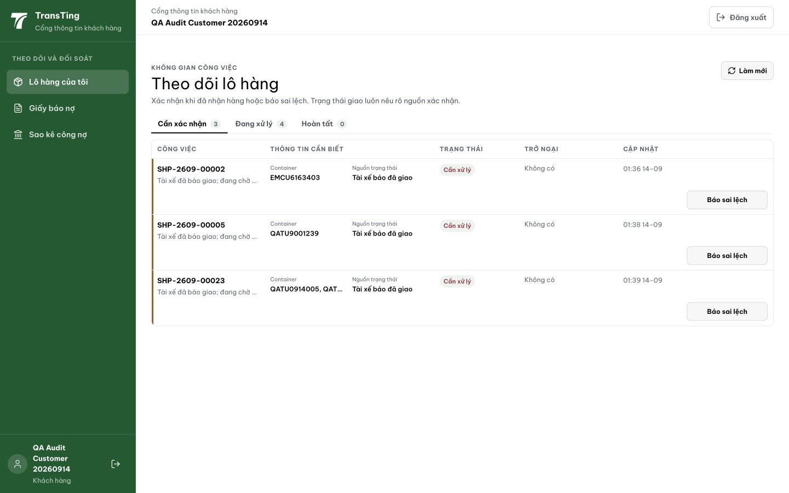
Figure 1. Fresh desktop capture at 1440 × 900: Báo sai lệch is visible, while the enabled white-text acknowledgment above it blends into the row.

Evidence 2
  - Make the customer delivery confirmation button visible
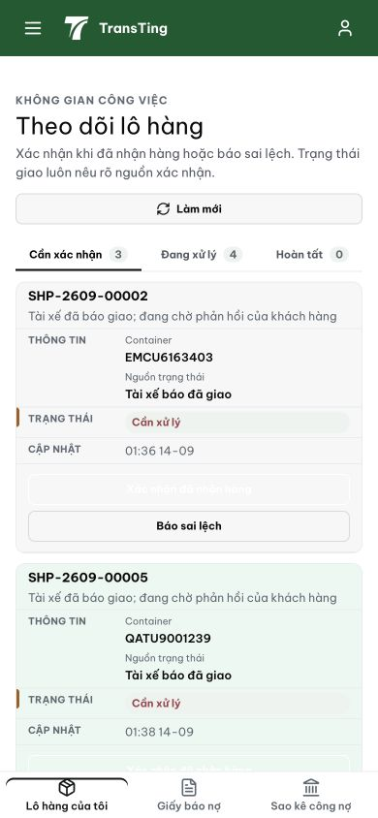
Figure 2. Phone comparison at 390 × 844: the acknowledgment label is faint against the pale card above Báo sai lệch. This illustrates visibility, not a submitted acknowledgment.

Resolution (commit 837034f2)
Changed .role-work-inbox__button.is-primary in RoleWorkInbox.css from var(--primary) to var(--brand). Button now renders as solid deep-emerald (#005A2D) with white text (#FFFFFF). Added :hover:not(:disabled) state for interactive feedback. "Báo sai lệch" remains light/outline — clearly distinct. CSS-only change, no behavioral impact. Pre-existing test failures in RoleWorkInbox.test.tsx confirmed unchanged.

[2026-09-14] QA FAILED — staging: thanhdc account has CUS role, not CUSTOMER role

Reproduce:
1. Login as thanhdc/Abc123 on https://vantai.tingting.vip
2. Navigate to /portal/shipments
3. Page redirects to /shipments (admin shipment overview) instead of customer portal
4. API call to /portal/work-inbox returns 403 Forbidden

Why it fails:
- thanhdc JWT token has role: CUS (internal clerk)
- /portal/shipments route requires role: CUSTOMER (external customer portal)
- CUS role gets /shipments (admin view), not /portal/shipments
- The "Cần xác nhận" tab and "Xác nhận đã nhận hàng" button are only accessible via CUSTOMER role

Scope:
- QA-107 AC: "Xác nhận đã nhận hàng" button visible — NOT TESTED (wrong role)
- Need a user with CUSTOMER role to test this card

[2026-09-14] QA PASSED — staging: CSS fix verified. .is-primary now uses var(--brand) #005A2D instead of undefined var(--primary). Button renders deep-emerald with white text. Commit 837034f2, build 8d530784.

