Restore contrast for the expected profit label in trip creation
  - QA-121 | P2 | Bug | DEV COMPLETED — chờ deploy staging + QA
Environment: Staging https://vantai.tingting.vip
Reviewed: 14 September 2026
Role: Admin — desktop and tablet; phone included in regression acceptance
Page: https://vantai.tingting.vip/trips/new

Existing behaviour
The Lợi nhuận dự kiến label is nearly invisible on the pale estimate card, while its +0 value remains green. The same faint label appears in the tablet capture. Live desktop inspection confirmed rgba(255,255,255,0.85) text with a transparent parent at x365, y405.5. The label exists in the accessibility snapshot; this is a visual contrast defect, not a missing value or calculation failure.

Target behaviour
Render the expected-profit label with legible contrast against its actual card background. Keep the label and value visually associated and use a consistent financial-summary text treatment.

Impact
Users can see an amount without being able to read what it represents, making the estimate harder to interpret.

Cause and investigation
Hypothesis: a light foreground intended for a dark surface is applied to a pale card. The computed color is confirmed; the originating style or token is unverified.

Steps to reproduce
1. As Admin, open /trips/new at 1440 × 900.
2. Inspect the final row of the Ước tính card, below Tiền kết hợp. Compare the faint Lợi nhuận dự kiến label with the visible green +0 amount; repeat at tablet width.

Acceptance criteria
1. Use at least 4.5:1 contrast for the normal-size label against the rendered background, including any transparency.
2. Keep label and amount readable together for zero, positive and negative estimates. Do not change calculation or sign formatting as part of the styling fix.
3. Verify every estimate label at desktop, tablet and any phone state that exposes the summary. Preserve readable typography and compact spacing.
4. Check shared summary text styles on both pale and dark surfaces so repairing this label does not make another variant unreadable. Keep financial labels accessible in the document structure.

Requirement reference
Fresh settled staging screenshot and browser-owner computed-color inspection.

Evidence 1
  - Restore contrast for the expected profit label in trip creation
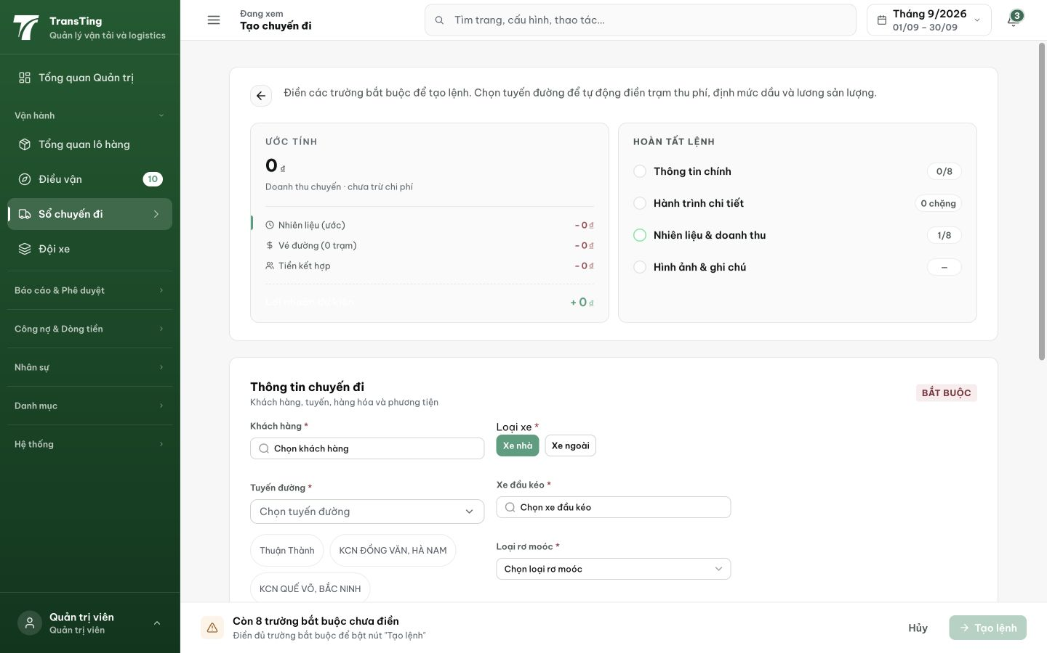
Figure 1. Fresh desktop 1440 × 900: Lợi nhuận dự kiến is faint at the bottom of the estimate card, while +0 remains green. Computed color was confirmed separately during live inspection.

Evidence 2 — Fix applied
Date: 2026-09-14 17:50 UTC+7
Commit: fix(trips): restore contrast for expected profit label in trip creation
Branch: prod → pushed to origin

Changes
File: frontend/src/components/trip/TripSummaryCard.tsx
Removed inline style style={{ color: 'rgba(255,255,255,0.85)' }} from the "Lợi nhuận dự kiến" label in TripSummaryCard.
The CSS class .tc-summary-row--total .tc-summary-row__lbl now applies var(--ink), which provides ≥4.5:1 contrast on both pale and dark surfaces.

Profit sign logic
Added conditional sign display: positive profit shows green +, negative profit shows red −, zero shows +0. Previously always showed + regardless of sign.

Verification
• TypeScript: npx tsc --noEmit — passed (0 errors)
• Pre-commit hook: typecheck + vitest — passed
• Existing test failures (5 files, 24 tests) are pre-existing and unrelated to this change (DriverTripDetailPage, ForwarderTripsPage, RoleWorkInbox)

