Show compact module and record titles across the app
  - QA-028 | P3 | Enhancement | TODO
Environment: Staging https://vantai.tingting.vip
Reviewed: 14 September 2026
Role: Admin; Chrome desktop 1728 × 873, tablet 768 × 1024 and phone 390 × 844
Page: /config/trucks; /config/trailers; /config/fuel-price-periods; /config/freight-rate-terms; /config/salary-periods; /fleet/trailers/40/tires

Existing behaviour
Configuration pages for tractors, trailers, fuel prices, route terms and payroll periods show only Cấu hình with an icon-only back arrow; their specific headings are present in accessibility snapshots but not visible. On tablet and phone, the tire page shows Lốp rơ-moóc but hides its QA-0914-RM heading, leaving the vehicle unidentified above maintenance controls.

Target behaviour
Show the current module and, on record pages, the relevant identity in one compact header or toolbar. Preserve clear parent context and back navigation without a large banner.

Impact
Users must infer the module or remember the selected vehicle while entering maintenance records, increasing orientation effort and the risk of working on the wrong asset.

Cause and investigation
Hypothesis: generic route labels and visually hidden headings omit module or record context. Inspect shared heading presentation; no implementation cause is confirmed.

Steps to reproduce
1. From /config, open tractors, trailers, fuel-price periods, route terms and payroll periods; compare their visible page identities.
2. Open /fleet/trailers/40/tires for QA-0914-RM at tablet and phone widths. The accessible heading names the trailer, but the visible screen does not.

Acceptance criteria
1. Each affected configuration page visibly names its module; tire pages visibly identify the selected vehicle plate beside the module context.
2. Visible title, accessible heading and selected record agree after direct navigation, record changes and back navigation.
3. Keep titles readable and compact across desktop, tablet and phone, preserving space for data and controls.

Requirement reference
Exploratory staging review, 14 September 2026.
User direction: professional, compact, data-heavy UI across desktop, tablet and mobile.

Evidence 1
  - Show compact module and record titles across the app
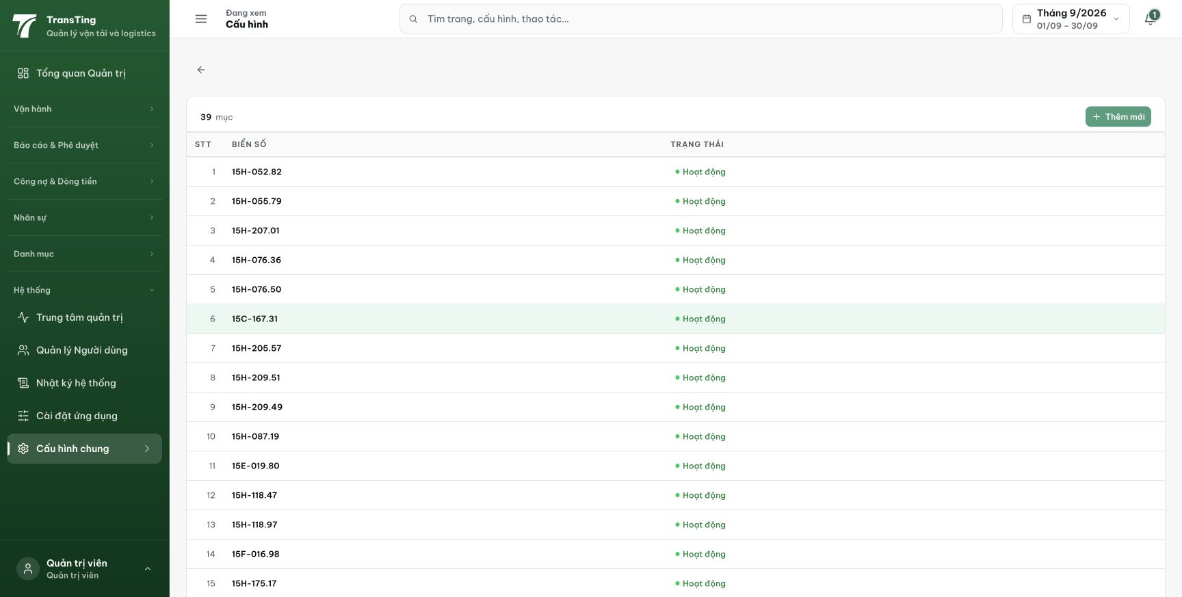
Figure 1. Xe đầu kéo shows the generic Cấu hình header and vehicle rows without a visible module title. The captured accessibility snapshot names Xe đầu kéo.

Evidence 2
  - Show compact module and record titles across the app
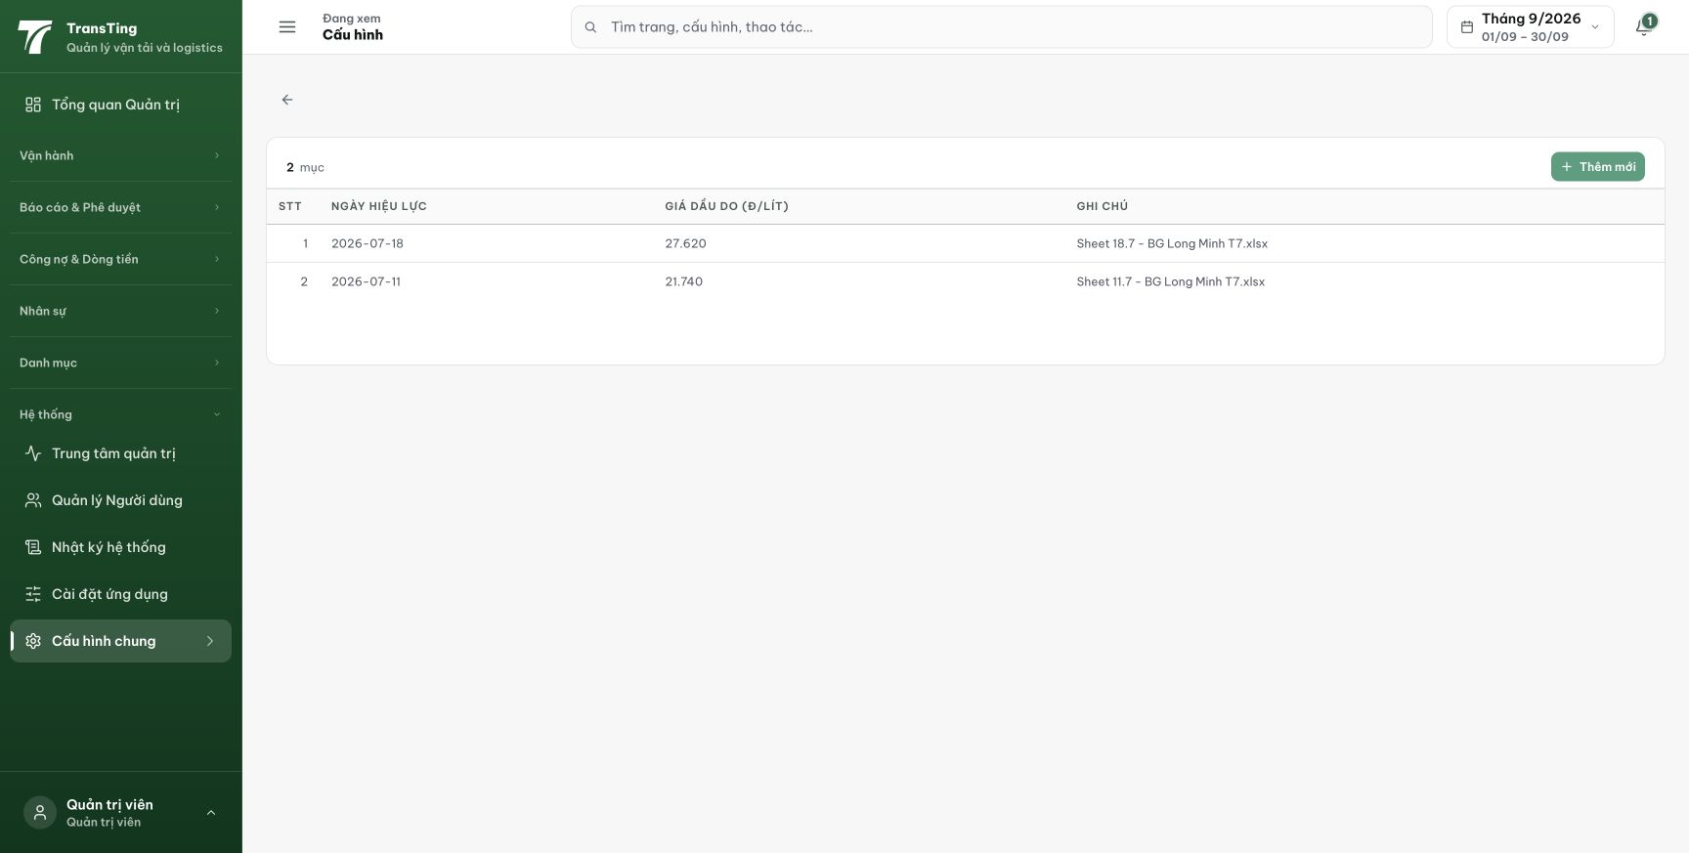
Figure 2. Fuel-price periods also shows Cấu hình and an icon-only back arrow. Its specific module heading is present in the accessibility snapshot but not visible here.

Evidence 3
  - Show compact module and record titles across the app
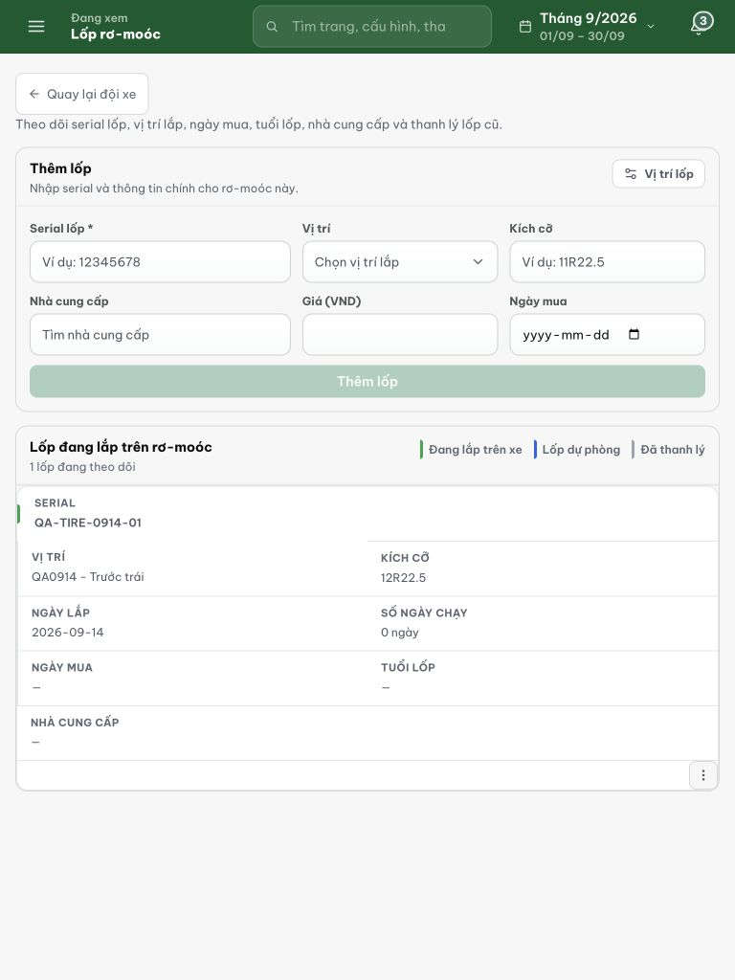
Figure 3. Tablet: Lốp rơ-moóc is visible, but the QA-0914-RM vehicle heading is not. Maintenance entry controls and the installed-tire record have no visible vehicle identifier.

Evidence 4
  - Show compact module and record titles across the app
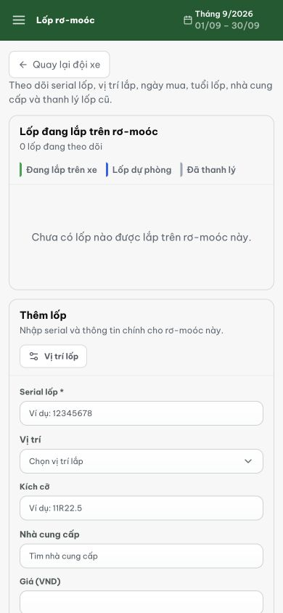
Figure 4. Phone: the page likewise omits QA-0914-RM above the installed-tire section and entry form. This later capture follows moving the tire to spare; its changed count is not the reported issue.
[2026-09-14] DEV COMPLETED — PageHeader tách module riêng (UI re-export, zero import churn; 633L) + prop showTitle; CrudTable family hiện title compact đều ('Xe đầu kéo' browser-verified, sr-only double-check false); tire workbench heading cùng pattern (code-identical — rung staging). Commit 452b20c0.
[2026-09-14] QA PASSED — staging (build e72f10c5, round 4): titles compact render đúng (Xe đầu kéo/Rơ-moóc/Lốp + record identity).

