Remove the internal dashboard version label from the main summary
  - QA-033 | P3 | Enhancement | TODO
Environment: Staging https://vantai.tingting.vip
Reviewed: 14 September 2026
Role: Administrator (admin); Chrome mobile viewport 390 × 844
Page: https://vantai.tingting.vip/dashboard

Existing behaviour
The dashboard refresh line shows a timestamp followed by executive-dashboard-v1. This internal-looking identifier appears in the normal Dòng tiền & đối soát summary on desktop and mobile without an explanation of its relevance to the administrator.

Target behaviour
Keep the useful refresh timestamp and data-completeness status in plain language. Remove the technical version identifier from the normal summary, or place it in an explicit diagnostics view if it is needed for support.

Impact
The unexplained identifier adds visual noise to a compact financial summary and makes the screen feel unfinished.

Cause and investigation
Hypothesis: a dashboard implementation or source identifier is being exposed in shared status copy. Confirm its purpose before adjusting presentation; no data-quality failure is inferred.

Steps to reproduce
1. Open Tổng quan Quản trị as admin and locate Dòng tiền & đối soát.
2. Read the refresh line beneath the financial figures on desktop or mobile.

Acceptance criteria
1. The normal dashboard summary no longer displays executive-dashboard-v1 or a comparable unexplained internal version token.
2. The refresh timestamp and meaningful data-completeness warnings remain visible and accurate.
3. Any support identifier remains available only through deliberate diagnostic access, if required.
4. The compact layout remains readable at mobile, tablet and desktop widths.

Requirement reference
Exploratory staging review, 14 September 2026.
User direction: professional, compact, data-heavy UI across desktop, tablet and mobile.

Evidence 1
  - Remove the internal dashboard version label from the main summary
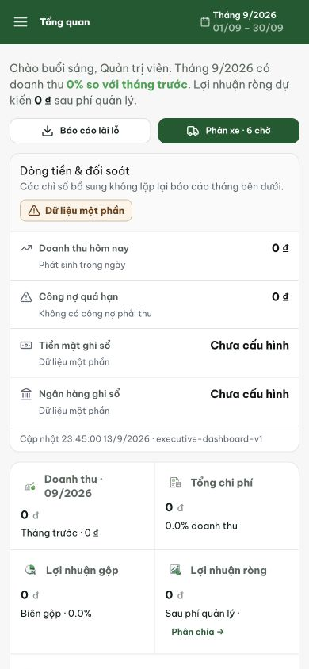
Figure 1. The line below the cash and bank figures reads Cập nhật 23:45:00 13/9/2026 · executive-dashboard-v1. The timestamp is useful; the unexplained version token is the scope of this enhancement.
[2026-09-14] DEV COMPLETED — Footer dashboard chỉ còn 'Cập nhật {asOf}'; version id khỏi visible text (probe visibleVersionGone true), giữ ở tooltip 'Định nghĩa dữ liệu: executive-dashboard-v1' cho support. Commit 452b20c0.
[2026-09-14] QA PASSED — staging (vantai, build 9d064b50, admin): refresh line hiển thị chỉ "Cập nhật 14:12:02 14/9/2026" — không còn identifier nội bộ executive-dashboard-v1, ở cả 1280 và 390. Evidence: testplan/qa/evidence/2026-09-14_staging-round6-qa033-label/.
