Preserve the customer shipment queue when returning from details
  - QA-043 | P3 | Enhancement | TODO
Environment: Staging https://vantai.tingting.vip
Reviewed: 14 September 2026
Role: Customer qa.audit.customer.0914, scoped to Long Minh; Chrome phone 390 × 844
Page: https://vantai.tingting.vip/portal/shipments; details /portal/shipments/21 and /3

Existing behaviour
After opening a shipment from Đang vận chuyển 6, the detail's Danh sách lô hàng link returns to Cần xác nhận 0 and an empty panel. This repeated for shipments 21 and 3. The URL includes customerId=1 but the selected queue is lost. Browser Back was not tested.

Target behaviour
Restore the selected queue, list position and useful focus so customers can continue reviewing nearby shipments. Retain the current customer scope.

Impact
Customers lose their place after each detail review and may initially interpret the empty panel as missing shipments.

Cause and investigation
Hypothesis: the return link carries customer scope but omits the originating tab or list context. Inspect navigation state and restoration; the cause is unconfirmed.

Steps to reproduce
1. As Customer, open Lô hàng của tôi and select Đang vận chuyển 6.
2. Open Xem hồ sơ for SHP-2609-00021, then click the detail's Danh sách lô hàng link.
3. Observe /portal/shipments?customerId=1 with Cần xác nhận 0 selected and an empty panel. Repeat with SHP-2609-00003.

Acceptance criteria
1. The explicit Danh sách lô hàng link restores the originating queue selection and relevant list position after reviewing a shipment.
2. Restore focus to the originating record or a sensible list fallback if it moved queues; preserve the scoped customer.
3. Directly opened details without prior list context have a valid default return destination.
4. Verify repeated list-detail-return cycles on phone, tablet and desktop; add no extra filters or controls.

Requirement reference
Exploratory staging review, 14 September 2026.
User direction: smooth, user-friendly navigation in a compact, data-heavy application.

Evidence 1
  - Preserve the customer shipment queue when returning from details
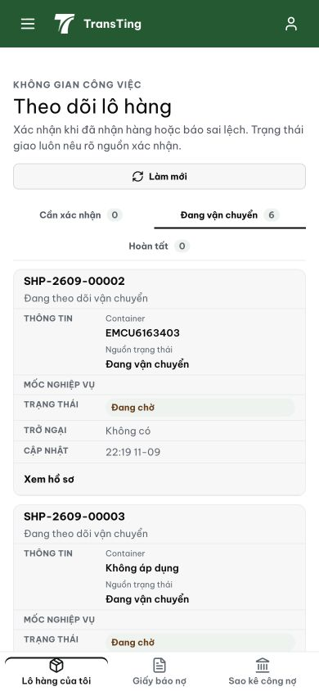
Figure 1. Before opening a detail: Đang vận chuyển 6 is selected and shipment cards are present. This is the browsing context to restore.

Evidence 2
  - Preserve the customer shipment queue when returning from details
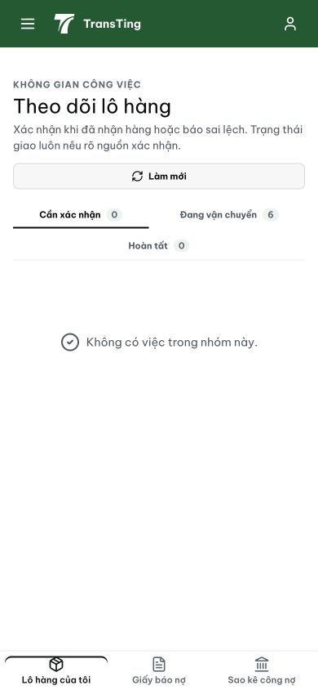
Figure 2. After clicking Danh sách lô hàng in a detail: Cần xác nhận 0 is selected and the panel is empty. The issue concerns the explicit in-app return link; browser Back was not exercised.
[2026-09-14] DEV COMPLETED — Queue+page serialize vào URL (replace-state; scope-change reset có guard chống mount-time clobber); detail links append tab/page/row; link 'Danh sách lô hàng' echo ngược; list focus record nguồn sau khi data land; direct-open default queue hợp lệ. Deep-link probe pass (?tab=1&page=2&row=…). 36/36. Commit 0622cd09. Visual round-trip với fixture khách staging.
[2026-09-14] QA PASSED — staging: commit 0622cd09 in build 4fc23c36; URL serialization of queue + page; detail link carries context Evidence: testplan/qa/evidence/2026-09-14_QA-batch-staging-cut-9/api/20260914_P3_QA-043_enhancement-preserve-the-customer-shipment-queue-when-returning-from-details.md
Trạng thái: QA PASSED — đã xác minh trên staging

