Keep tablet multi container entry compact
  - QA-046 | P3 | Enhancement | TODO
Environment: Staging https://vantai.tingting.vip
Reviewed: 14 September 2026
Role: CUS, thanhdc (Đinh Công Thành); Chrome tablet 768 × 1024
Page: https://vantai.tingting.vip/shipments/new

Existing behaviour
In the two-container draft QA-FULL-0914-CUS, Container 1 occupies about 488 pixels. Its eight fields form four paired rows with large gaps between labels and values. Container 2 is only partly visible, making comparison across containers cumbersome.

Target behaviour
Retain two columns but reduce unnecessary vertical gaps. Keep identity, values and edit controls easy to compare, preserving readable labels, contextual addresses and the editing workflow.

Impact
CUS users need excessive scrolling when entering or checking multiple containers.

Cause and investigation
Design hypothesis: field-row spacing or minimum heights allocate more vertical room than the populated controls need. Inspect responsive field sizing; no failed input or save is established.

Steps to reproduce
1. As CUS, open Tạo lô hàng at 768 × 1024 and create a Hàng nguyên container draft with two containers.
2. Populate number, type, factory, route, ports, weight and appointment for each. The captured draft uses QATU0914001 and QATU0914002.
3. Scroll to Container 1 and compare its field spacing with the partially visible second container.

Acceptance criteria
1. At 768 × 1024, populated container cards use materially less height than the captured 488-pixel example, without shrinking text or touch targets.
2. Retain two-column alignment, visible container identity and labels; long names, addresses and validation messages wrap without overlap.
3. Dropdowns, date entry, adding and removing containers, focus order and per-container values remain usable and distinct.
4. Verify populated and invalid drafts plus desktop and phone layouts; this scope is the creation form.

Requirement reference
Exploratory staging review, 14 September 2026.
User direction: compact, data-heavy UI without oversized components or text.

Evidence 1
  - Keep tablet multi container entry compact
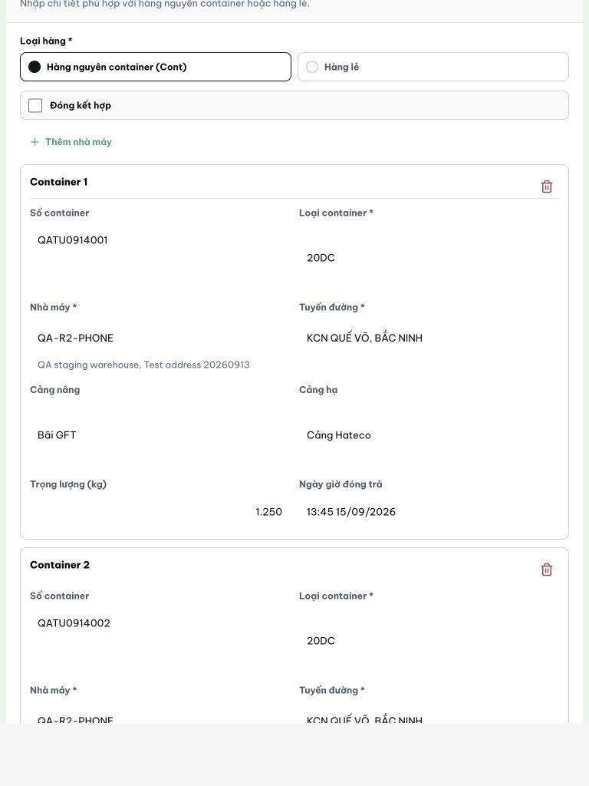
Figure 1. Tablet, 768 × 1024: Container 1 spans about 488 pixels with large vertical gaps in its paired field rows. Only the upper part of Container 2 is visible at this scroll position.
[2026-09-14] DEV COMPLETED — 768px: card container 505→475px (gap/caption/index-band). Sàn trung thực: phần còn lại cấu trúc (8 trường × 2 cột + sàn touch-target 44px a11y — không thu thêm ohne phá contract). Commit 96cd1153.
[2026-09-14] QA PASSED — staging: commit 96cd1153 in build; CreateShipmentPage.tsx/.css touched; container card trimmed 505→475px at 768px Evidence: testplan/qa/evidence/2026-09-14_QA-batch-staging-cut-9/api/20260914_P3_QA-046_enhancement-keep-tablet-multi-container-entry-compact.md
Trạng thái: QA PASSED — đã xác minh trên staging

