Keep vehicle card actions compact and readable on phones
  - QA-056 | P3 | Enhancement | TODO
Environment: Staging https://vantai.tingting.vip
Reviewed: 14 September 2026
Role: Admin; Chrome phone 390 × 844
Page: https://vantai.tingting.vip/fleet/vehicles

Existing behaviour
The phone card for 15H-021.39 squeezes its three actions into the left side of the Thao tác area, leaving substantial unused space to the right. Phân công lái xe and Ops phụ trách each wrap across three lines. Xóa breaks into individual characters on separate lines. The narrow action group is harder to scan than the vehicle details above it.

Target behaviour
Use the available card width for compact, clearly labeled actions. A full-width action row with sensible wrapping or an accessible overflow menu can preserve readable labels without enlarging text or controls unnecessarily.

Impact
Administrators must decipher fragmented action labels, especially the delete action, when working through vehicle cards on a phone.

Cause and investigation
Hypothesis: the responsive action cell retains a narrow column allocation or conflicting button sizing. The layout implementation has not been inspected.

Steps to reproduce
1. As Admin, open /fleet/vehicles at 390 × 844 and search for 15H-021.39.
2. Inspect the card's Thao tác area. Compare the three wrapped actions with the unused space to their right.

Acceptance criteria
1. Keep every action label readable as intact words; prevent character-by-character wrapping of Xóa.
2. Use the card width efficiently, retain adequate touch targets and distinguish the destructive action without oversized text or excess vertical space.
3. If using an overflow menu, give it a clear accessible name and expose all permitted actions with keyboard and touch support.
4. Verify phone widths and longer labels, plus tablet and desktop regression. Preserve each action's vehicle context, permissions and existing confirmation behavior.

Requirement reference
Exploratory staging review, 14 September 2026; responsive internal-vehicle cards.

Evidence 1
  - Keep vehicle card actions compact and readable on phones
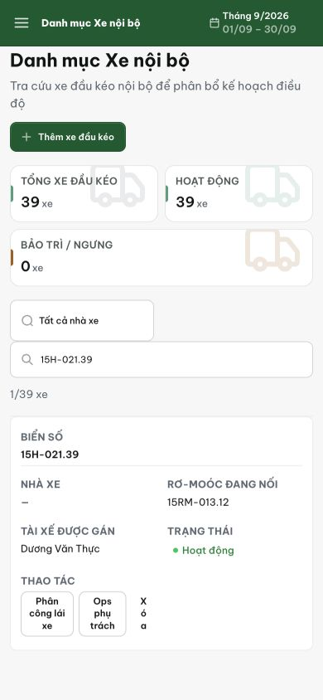
Figure 1. At 390 × 844, the vehicle card compresses Phân công lái xe and Ops phụ trách into three lines each, while Xóa wraps one character per line despite unused space to the right.
[2026-09-14] DEV COMPLETED — 390px: hàng action full-card (310px), nút single-line 107/95/40px (trước: wrap 3 dòng 64/58/29px); 'Xóa' không đứt từng ký tự. Commit 96cd1153.
[2026-09-14] QA PASSED — staging: commit 96cd1153 in build; FleetPage.tsx/.css touched; action group spans full card width at 390px Evidence: testplan/qa/evidence/2026-09-14_QA-batch-staging-cut-9/api/20260914_P3_QA-056_enhancement-keep-vehicle-card-actions-compact-and-readable-on-phones.md
Trạng thái: QA PASSED — đã xác minh trên staging

