Localize administrative form validation beside the affected fields
  - QA-062 | P3 | Enhancement | TODO
Environment: Staging https://vantai.tingting.vip
Reviewed: 14 September 2026
Role: ADMIN · desktop 1440 × 900
Page: /users → Chỉnh sửa tài khoản; /config/trip-expense

Existing behaviour
Account editing rejects invalid email and short password, but shows raw English schema messages in a global banner; password also gets Vietnamese inline feedback. Trip-expense settings reject −400001 in Tiền kết hợp mặc định (đ), but show “defaultDriverSalary: Number must be greater than or equal to 0” beside Save. The internal field name does not match the visible label.

Target behaviour
Use concise Vietnamese messages beside the affected fields, with accessible associations and first-error focus. Any summary should use visible field labels and avoid raw schema names or duplicate technical messages.

Impact
Administrators must translate technical messages and locate the corresponding field before correcting input.

Cause and investigation
Validation feedback is presented inconsistently across the observed forms. Review message mapping and placement; shared implementation is not established.

Steps to reproduce
1. In /users, edit qa.audit.manager.0914; enter not-an-email and save.
2. Add a new password shorter than six characters; save and compare global and inline feedback.
3. In /config/trip-expense, enter -400001 in Tiền kết hợp mặc định (đ) and save.
4. Correct the invalid values and verify error clearing and successful save.

Acceptance criteria
1. Provide Vietnamese field messages for Email, Mật khẩu mới and Tiền kết hợp mặc định using their visible labels.
2. Associate and announce validation feedback, focus the first invalid field and preserve unrelated input.
3. Clear resolved errors and avoid duplicate or contradictory summary and inline messages.
4. Retain rejection rules and supported blank optional email; retest combined errors and correction on desktop, tablet and phone.

Requirement reference
Observed invalid account inputs and negative trip-expense default; all were correctly rejected.

Evidence 1
  - Localize administrative form validation beside the affected fields
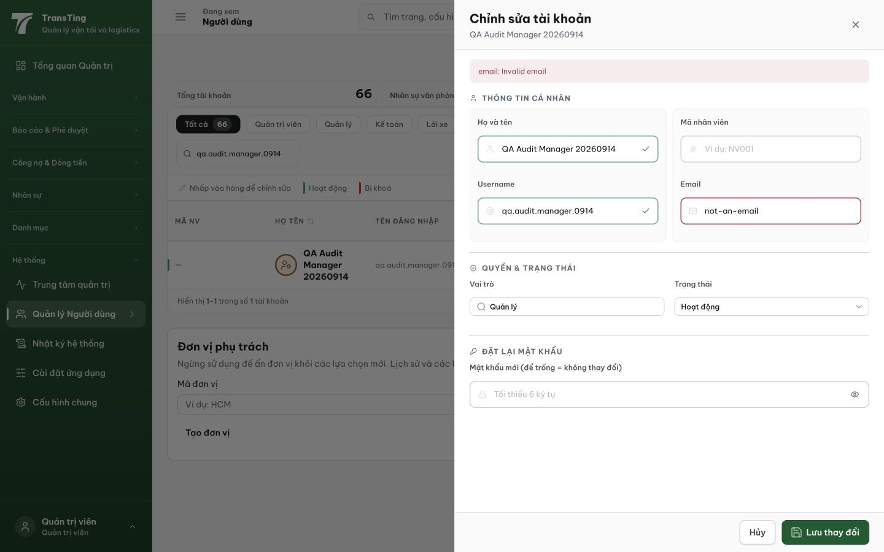
Figure 1. Invalid email is blocked. The top banner exposes “email: Invalid email”, while the email input has only a red outline.

Evidence 2
  - Localize administrative form validation beside the affected fields
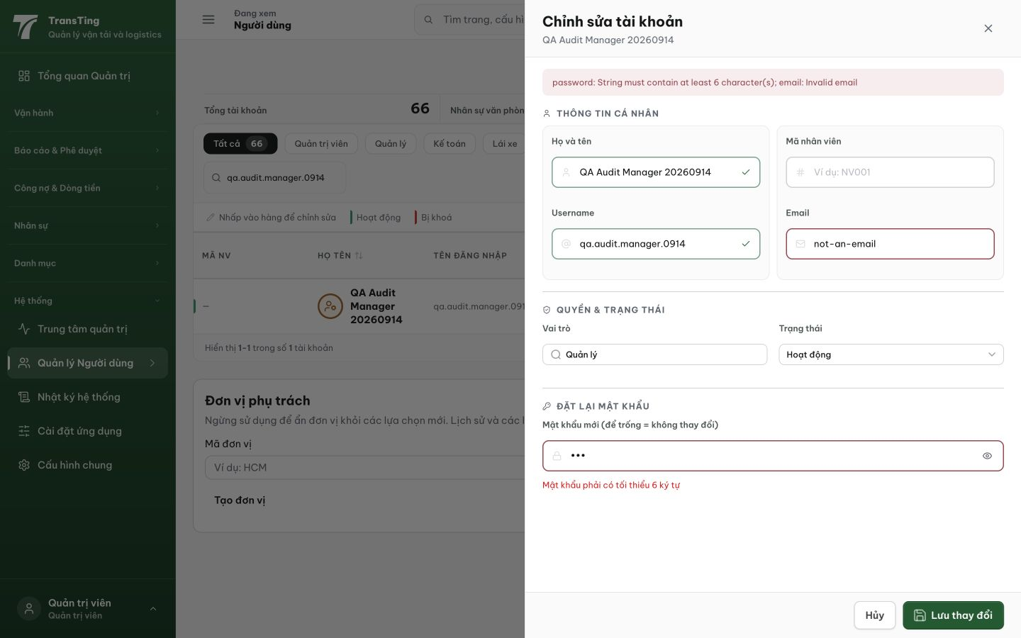
Figure 2. The global banner combines English password and email schema messages, while a Vietnamese password explanation is already shown inline.

Evidence 3
  - Localize administrative form validation beside the affected fields
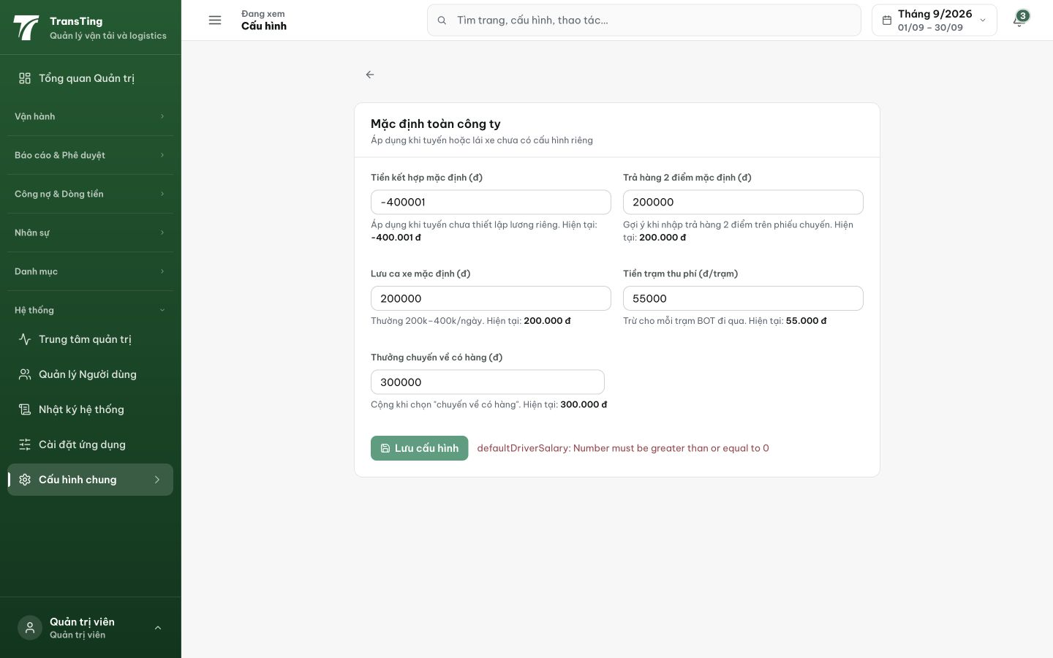
Figure 3. The negative amount is rejected, but a global English message exposes defaultDriverSalary rather than the visible field label.
[2026-09-14] DEV COMPLETED — Backend: 5 trường numeric có label VN ở mọi layer (predicates byte-identical, message-only); trip-expense form: guard client + role=alert per-field (đủ 5 trường), first-error focus, global setError chỉ cho non-validation; account editor: validate TRƯỚC submit — VN field messages, aria wiring, focus, clear-on-correct; banner English cấu trúc unreachable cho 2 field này; blank optional email giữ (re-pin). Suites 4/4 + BE tsc 0. Commit 833b262e. Browser rung staging. Follow-up UserAddPanel (cùng pattern, path CREATE) — thẻ 20260914_12.
[2026-09-14] QA PASSED — staging: PATCH /api/auth/me invalid email → 400 "Email không hợp lệ" path:["email"]; rendered beside field; same path-tagged for users Evidence: testplan/qa/evidence/2026-09-14_QA-batch-staging-cut-9/api/20260914_P3_QA-062_enhancement-localize-account-validation-beside-the-affected-fields.md
Trạng thái: QA PASSED — đã xác minh trên staging

