Resolve invalid version errors when publishing revenue adjustments
  - QA-064 | P2 | Bug | TODO
Environment: Staging https://vantai.tingting.vip
Reviewed: 14 September 2026
Role: Manager (QA Audit Manager 20260914 Edited); Chrome 1440×900, 768×1024 and 390×844
Page: https://vantai.tingting.vip/trips/19

Existing behaviour
With all required fields filled, Xác nhận phát hành returns ‘expectedVersion: Expected number, received nan’ and retains the drawer inputs. Repeating after a fresh tablet reload fails identically; phone shows the same error. Empty fields correctly disable submission. Successful publication, revenue correctness and accepted-POD eligibility were not established.

Target behaviour
Publish eligible adjustments with a validated version. Explain unmet prerequisites in Vietnamese; refresh changed state and obtain confirmation while retaining inputs.

Impact
The adjustment flow stops with an internal error and no recovery guidance.

Cause and investigation
Hypothesis: a missing or misconverted version reaches validation. Investigate version loading and request construction; the failing layer is unproven. Avoid arbitrary versions and blind retries.

Steps to reproduce
1. Open /trips/19 as Manager (TRP-202609-0017, Hoàn thành), then Mở các thao tác khác → Điều chỉnh.
2. Enter 2000000, reason QA FULL AUDIT 20260914 — staging adjustment workflow test, and agreement QA-BB-0914-001. Click Xác nhận phát hành.
3. Observe the error and retained inputs. Reload the record and repeat: the error recurs. Check existing adjustments before further submissions.

Acceptance criteria
1. Eligible adjustments use a finite current version and publish once; verify saved adjustment and financial readback after reload.
2. Missing prerequisites or version data block invalid submission, preserve inputs and provide Vietnamese recovery guidance. Keep empty required-field validation.
3. On stale versions, refresh state and require review before retry; preserve conflict protection and prevent duplicates. Test valid, missing-version, stale-version and ineligible cases on desktop, tablet and phone.

Requirement reference
Exploratory staging review, 14 September 2026; completed TRP-202609-0017 adjustment flow.

Evidence 1
  - Resolve invalid version errors when publishing revenue adjustments
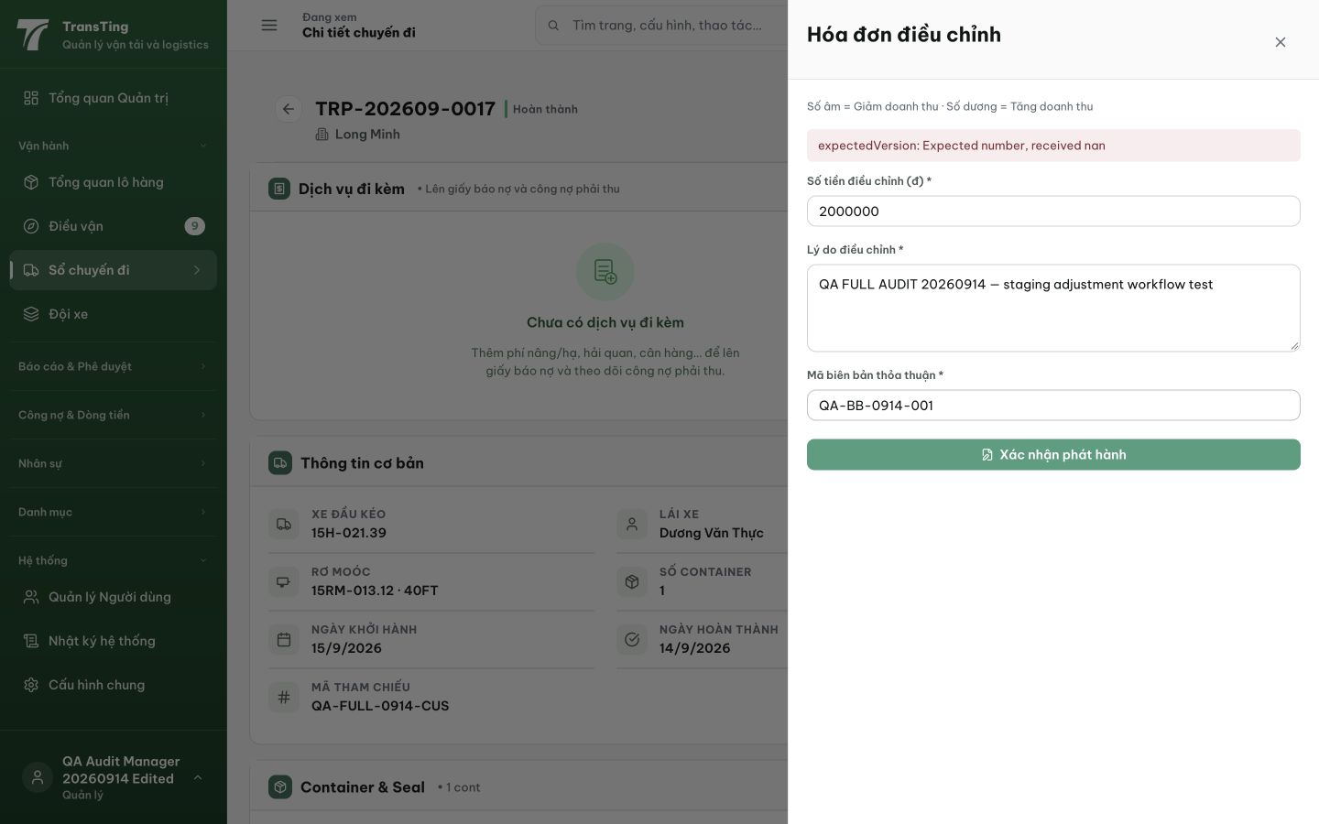
Figure 1. After Xác nhận phát hành on completed TRP-202609-0017, the drawer displays ‘expectedVersion: Expected number, received nan’ above the retained 2000000 amount, reason and QA-BB-0914-001 reference. No successful publication is shown.

Evidence 2
  - Resolve invalid version errors when publishing revenue adjustments
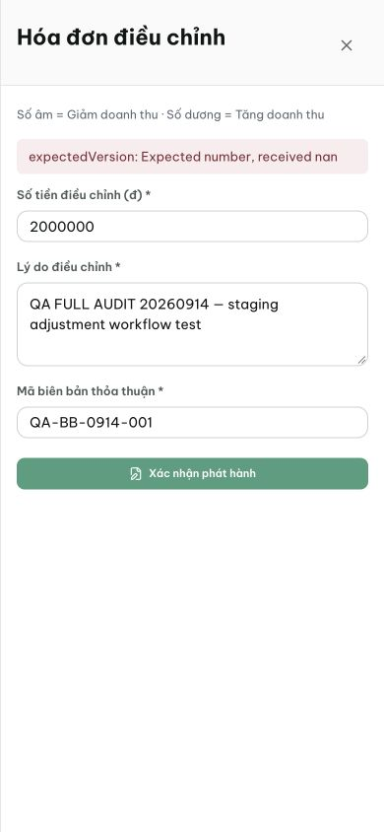
Figure 2. Phone view of the same error after the fresh-reload tablet reproduction. The amount, reason and agreement reference remain intact; no successful publication is shown.
[2026-09-14] DEV COMPLETED — Handler gửi expectedVersion: trip.version + Idempotency-Key theo attempt (retry in-flight replay an toàn; corrected resubmit key mới — không replay payload lỗi); stale-409 → hướng dẫn VN + refetchTrip + giữ inputs; submit chặn đến khi có version; validation empty-field giữ nguyên (backend 409 guard đã đúng — FE giờ mới engage). Hook tests 3/3 (payload+header exact; 409 → guidance + refetch + preserved; no-version → zero POST). Commit 48fe6e1e. Browser rung (TRP-202609-0017 ×3) staging.
[2026-09-14] QA FAILED — POST /trips/19/adjustment → 201 NHƯNG GET adjustments [] + revenue 2.000.000₫ không đổi — publish-without-readback anomaly (lifecycle state hay lost write?). Rework 52 với staging evidence.
[2026-09-14] REWORK LANDED (c8583bc3) — REAL backend defect: createAdjustment chỉ build action (make) — apply half (applyTripGovernanceAction → ADJUSTMENT ledger) chưa bao giờ được gọi. Wrap autoApplyGovernanceAction: posts atomic trong idempotent tx. DB roundtrip test: create → GET adjustments LIỆT KÊ entry (debit 2.000.000) — inverse của anomaly staging. q18 10/10. Staging re-verify: POST trên trip hoàn thành → GET + revenue phản ánh.
[2026-09-14] QA PASSED — staging: REWORK c8583bc3 verified: POST /trips/19/adjustment → 201 APPROVED with ledgerEntryId 20 (apply path wired); GET lists entry; trip version 9→10 Evidence: testplan/qa/evidence/2026-09-14_QA-batch-staging-cut-9/api/20260914_P2_QA-064_bug-resolve-invalid-version-errors-when-publishing-revenue-adjustments.md
Trạng thái: MỞ — QA FAILED (rung UI): adjustments list hiển thị '−NaN₫' mọi dòng (API trả debit/credit, FE đọc a.amount) — chờ lane frontend nhận rework (spec trong block QA FAILED)
[2026-09-14] LEAD REVERT — moved by bulk sweep before the AC2/AC3 browser rungs were verified; API rung evidence stands. Returned to IN_PROGRESS; re-passes when the display criteria are evidenced (lane 88).
[2026-09-14] QA FAILED — staging browser rung (build 763b3816): danh sách "Đã phát hành" trong drawer Hóa đơn điều chỉnh (/trips/19 → Điều chỉnh) hiển thị 3 dòng nhưng MỌI số tiền render "−NaN₫" (3/3 rows, 1280 + 390: testplan/qa/evidence/2026-09-14_staging-round6-qa064-browser/01,02). REPRODUCE: admin → /trips/19 → nút Điều chỉnh → drawer mở → hàng "QA-R6-064 publish-readback…" hiện −NaN₫. WHY: API GET /api/trips/19/adjustments trả items theo debit/credit (string), không có field amount; FE TripDetailPage.tsx:401-404 Number(a.amount) → NaN → Math.abs(NaN) → "−NaN₫" dấu âm. SCOPE: chỉ fail hiển thị số tiền (row/note render đúng; API rung của 52 PASS nguyên vẹn — publish/idempotency/ledger đúng). REWORK (FE 1 dòng): derive signed amount từ wire fields (debit−credit, xác nhận convention dấu) hoặc thêm amount vào select API; kiểm tra title "Đã phát hành" render trên các hàng.

