Keep selected payroll details close to the driver picker
  - QA-094 | P2 | Enhancement | TODO
Environment: Staging https://vantai.tingting.vip
Reviewed: 14 September 2026
Role: MANAGER · 390 × 844; comparisons at 834 × 1112 and 1440 × 900
Page: /salary

Existing behaviour
All 39 driver selectors appear as bordered cards before the calendar and selected-person detail. At 390 px, clicking Dương Văn Thực updates the selected tile but leaves the viewport among the roster; calendar and details remain below it. The tablet first viewport is also consumed by the roster, while desktop only begins the calendar near its bottom. The selected detail reports a loading error in the captured page text; this task does not assess payroll data correctness.

Target behaviour
Use a compact searchable picker that keeps the selected driver visible and places their calendar/detail state close to the selection. The full roster should remain available on demand, without permanently preceding all selected-person work.

Impact
Reviewing one employee requires navigating past dozens of unrelated selector cards, especially on phones and tablets.

Cause and investigation
The unbounded roster appears before the selected content in responsive layouts. Review selection presentation and navigation; no payroll service cause is asserted.

Steps to reproduce
1. Open September 2026 payroll as Manager with the 39-driver roster.
2. At 390 × 844, select Dương Văn Thực from the unfiltered roster. Observe the selected tile and offscreen calendar/detail area.
3. Compare the expanded roster and selected-content position at 834 × 1112 and 1440 × 900.

Acceptance criteria
1. Selecting a driver exposes their calendar/detail or its loading/error state without manually traversing the whole roster. Keep the selected identity visible.
2. Provide compact search and a clear way to reopen or browse the full roster; preserve every driver and existing selection semantics.
3. Use responsive columns or a bounded selector instead of 39 permanent cards above the work area; avoid extra nested surfaces or oversized controls.
4. Verify all three widths, long names, keyboard selection and 39 or more drivers. Preserve period/payment actions; metric overlap is QA-093 and calendar behavior remains separate.

Requirement reference
Fresh Manager selection and the requested compact data-heavy interface.

Evidence 1
  - Keep selected payroll details close to the driver picker
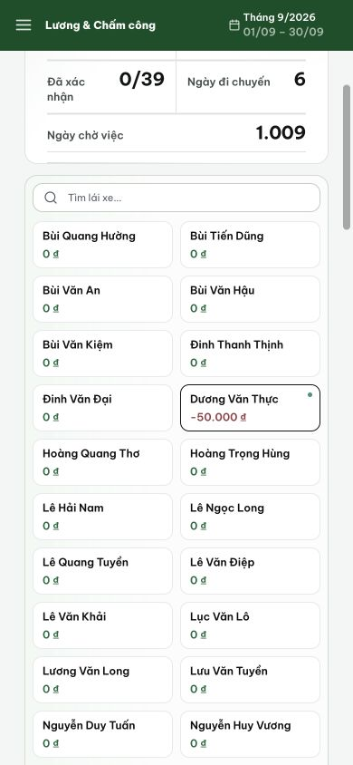
Figure 1. After selecting Dương Văn Thực at 390 px, the selected tile is outlined but the view remains inside the long roster; calendar and details are not visible.

Evidence 2
  - Keep selected payroll details close to the driver picker
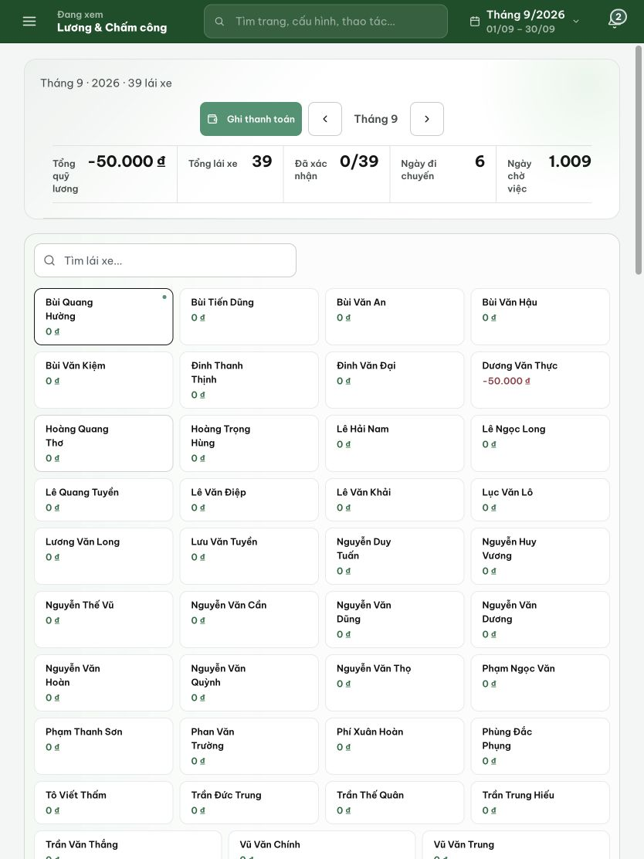
Figure 2. At 834 px, the first viewport is occupied by summary and driver cards; the selected employee work area is below the roster.

Evidence 3
  - Keep selected payroll details close to the driver picker
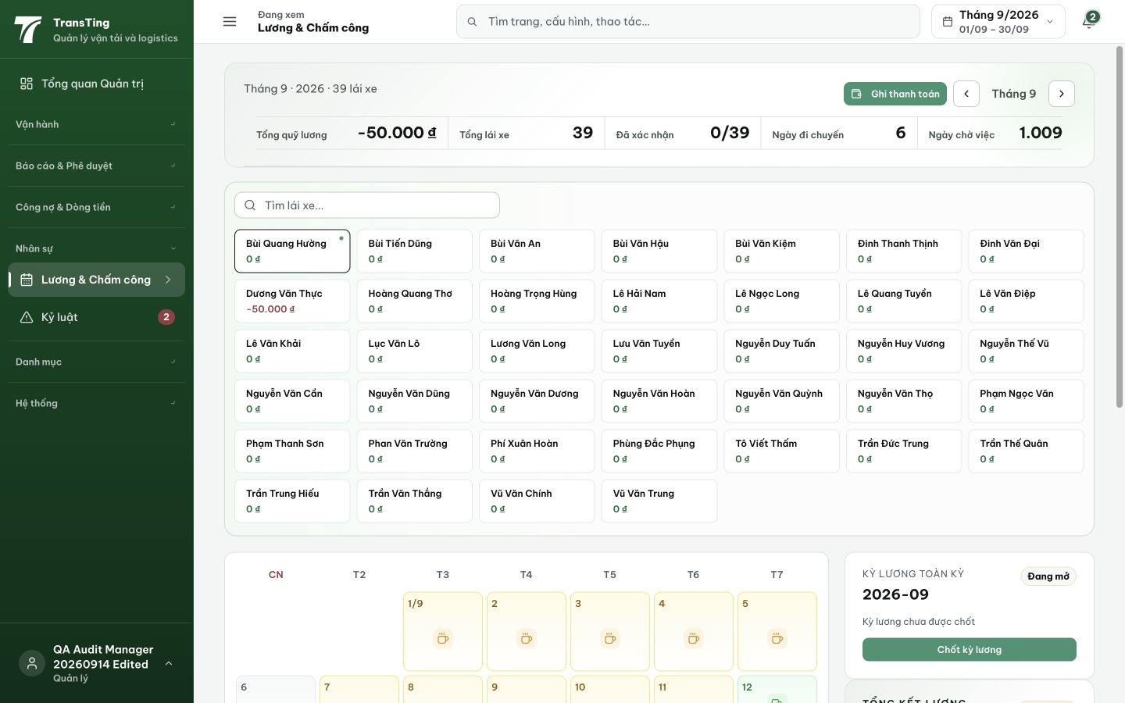
Figure 3. Desktop comparison: the 39-card picker consumes several rows, and the calendar begins near the bottom of the initial viewport.

