Remove approval handoffs from advances and settlements
  - QA-113 | P2 | Requirement | TODO
Environment: Staging https://vantai.tingting.vip
Reviewed: 14 September 2026
Role: OPS, ADMIN, ACCOUNTANT and MANAGER within ordinary role access.
Page: /my-advances; /advances; /settlements/1; /my-settlements/new; /ops/wallet

Existing behaviour
Advance requests remain in Chờ duyệt / Đã duyệt / Từ chối buckets, with reason fields and approval/rejection proposals. Settlement creation requires approved advances. PT-2609-0001 says reversal needs a preparer, checker and approver, and offers Gửi yêu cầu hoàn tác.

Target behaviour
Save authorized advance and settlement operations directly. Replace approval handoffs with clear recorded, outstanding, settled and reversed states; retain data validation, reconciliation and audit history.

Impact
Routine reconciliation waits on approval stages that the product owner has removed from scope.

Cause and investigation
The displayed lifecycle still models internal approval. Update corresponding server transitions as well as controls; hiding buttons alone could leave records blocked.

Steps to reproduce
1. As Ops, open advance and settlement creation; inspect request wording and the approved-advance prerequisite.
2. As Admin or Accountant, inspect Tạm ứng & Hoàn ứng, then Phiếu hoàn ứng → Xem phiếu for PT-2609-0001.

Acceptance criteria
1. Authorized creation, correction, settlement and reversal save directly, with clear success/error feedback and no reviewer or approver.
2. Remove approval buckets, proposal reasons and reviewer handoffs. Keep useful business notes and ordinary role access.
3. Eligibility uses recorded advances/expenses, remaining balances and completeness. Preserve arithmetic, required fields and duplicate-posting protection.
4. Migrate pending requests through a logged transition so none remain stranded. Retain historical audit evidence without active approval requirements.
5. Saving a record must not falsely report an unperformed cash transfer. Verify refresh, failures and the complete direct lifecycle.
6. Use compact controls on phone, tablet and desktop. Coordinate Ops expense removal with QA-114.

Requirement reference
User decision, 14 September 2026: remove approval workflows until customers define future requirements.

Evidence 1
  - Remove approval handoffs from advances and settlements
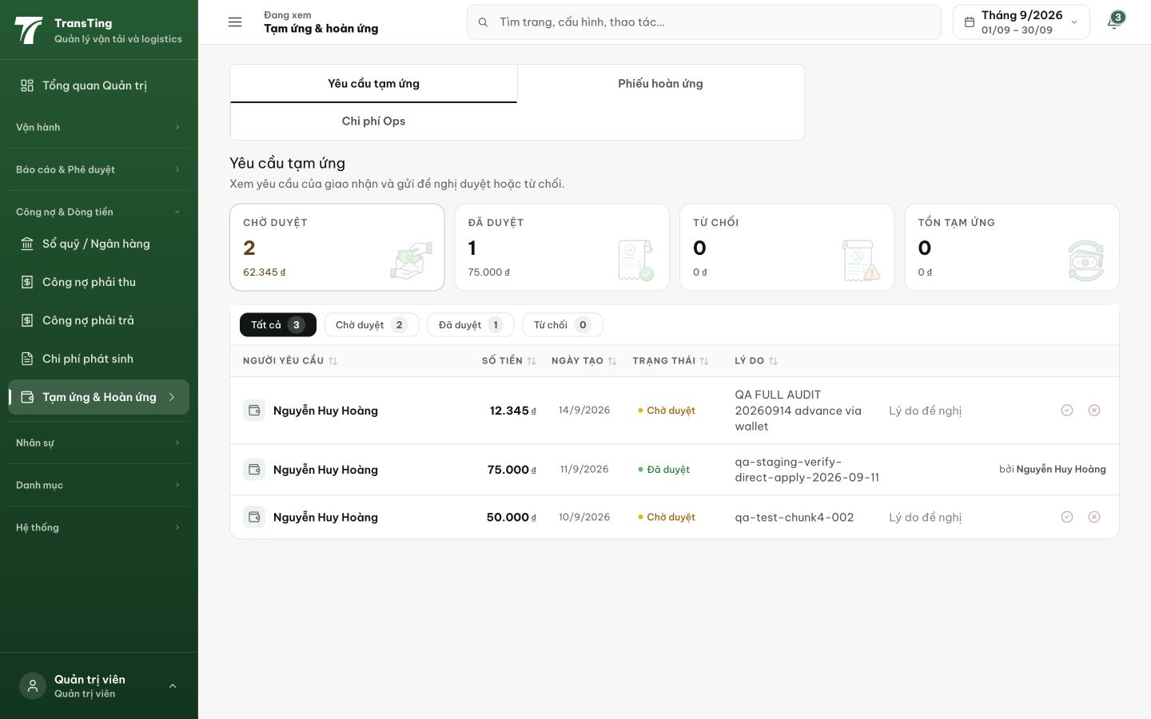
Figure 1. Fresh Admin request workspace: approval buckets and proposal controls remain active.

Evidence 2
  - Remove approval handoffs from advances and settlements
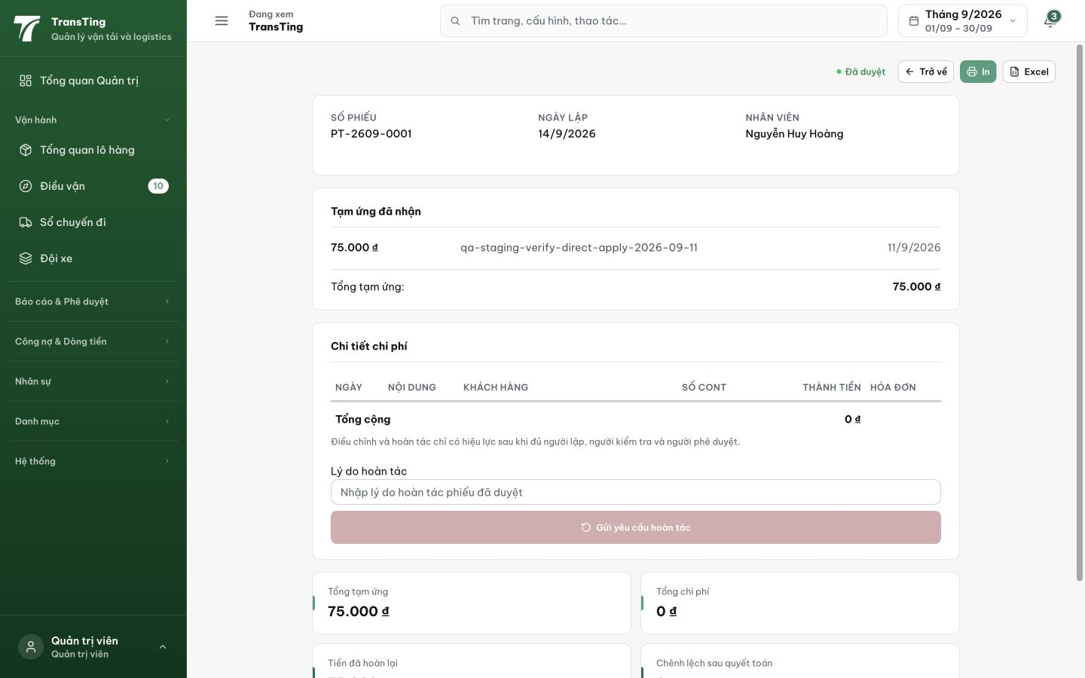
Figure 2. Settlement detail still requires preparer, checker and approver before reversal can take effect.

Evidence 3
  - Remove approval handoffs from advances and settlements
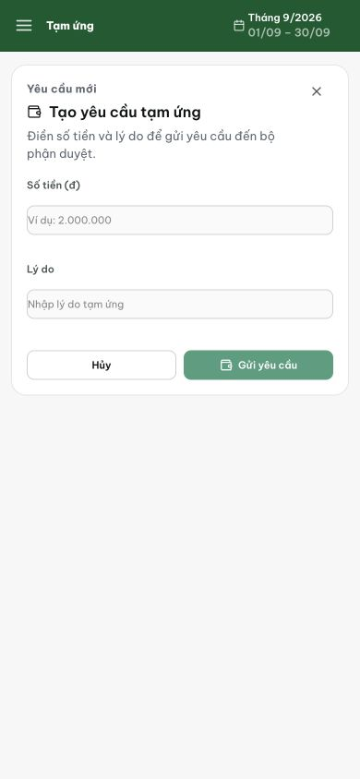
Figure 3. Ops phone advance form still sends the request into the approval lifecycle.

