Remove approval routing from Ops field expenses
  - QA-114 | P2 | Enhancement | TODO
Environment: Staging https://vantai.tingting.vip
Reviewed: 14 September 2026
Role: ACCOUNTANT, ADMIN and OPS · desktop, tablet and phone captures
Page: /advances?view=ops-expenses; /config/forwarder-expense-types; /config/app-settings; /ops/wallet

Existing behaviour
Chi phí Ops still instructs staff to approve or reject field expenses and provides Chờ duyệt, Đã duyệt and Bị từ chối filters. Expense category QA0914 configures approval routing to Finance at 5,000,000 VND and Director at 10,000,000 VND per day. App settings retains Ngưỡng tiền duyệt cấp 1 at 500,000 VND. The Ops wallet also distinguishes pending and approved expense amounts.

Target behaviour
Save valid Ops field expenses directly through authorized actions. Remove internal approval routing, queues, status filters and escalation thresholds. Show recorded expenses, evidence and settlement state consistently in the Ops wallet and accounting workspace.

Impact
Ops expenses still direct users through internal approval steps that are no longer required.

Cause and investigation
Remove the workflow dependency rather than relabeling or automatically approving records. This review inspected controls without submitting a new expense.

Steps to reproduce
1. Open /advances?view=ops-expenses as Accountant and inspect its approval instructions and status filters.
2. As Admin, inspect QA0914 approval routing and the app-settings level1 cap. As Ops, inspect approval summaries in /ops/wallet.

Acceptance criteria
1. An authorized valid expense save or edit persists directly and updates related views without a reviewer, approver or pending-approval queue.
2. Remove category approval-routing fields and the level1 approval cap. Keep ordinary amount, category, receipt and role validation; remove only thresholds used for approval escalation.
3. Keep evidence upload, expense correction, ownership and genuine payment or settlement state available. Reconcile wallet totals without approval-based reservations or duplicate postings.
4. Migrate existing pending items deliberately, preserving attachments, history and balances. Do not implement removal by silently marking all items approved.
5. At 390, 834 and 1440 px, show compact recorded-state lists and clear save/error feedback with keyboard and touch access.

Requirement reference
User requirement to remove internal approval flows; current Ops expense queue and configuration.

Evidence 1
  - Remove approval routing from Ops field expenses
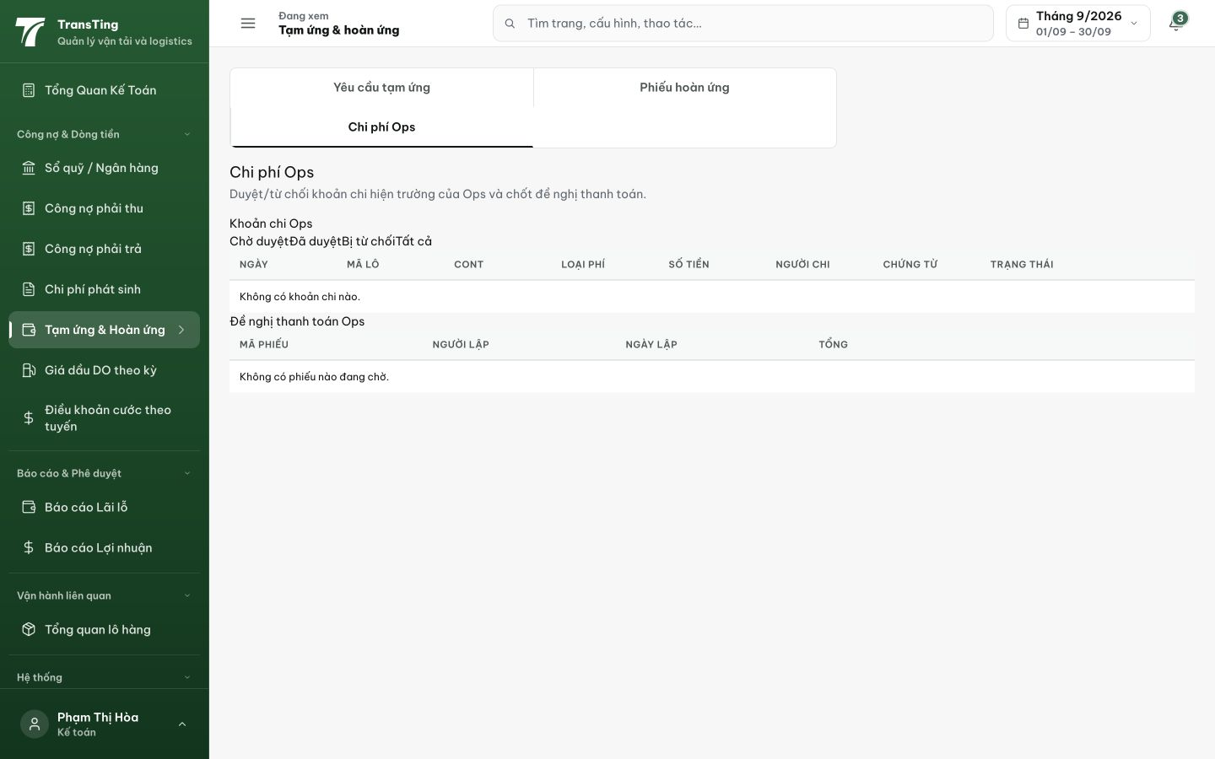
Figure 1. Accountant desktop: Chi phí Ops instructs approval or rejection and exposes approval-state filters above the expense list.

Evidence 2
  - Remove approval routing from Ops field expenses
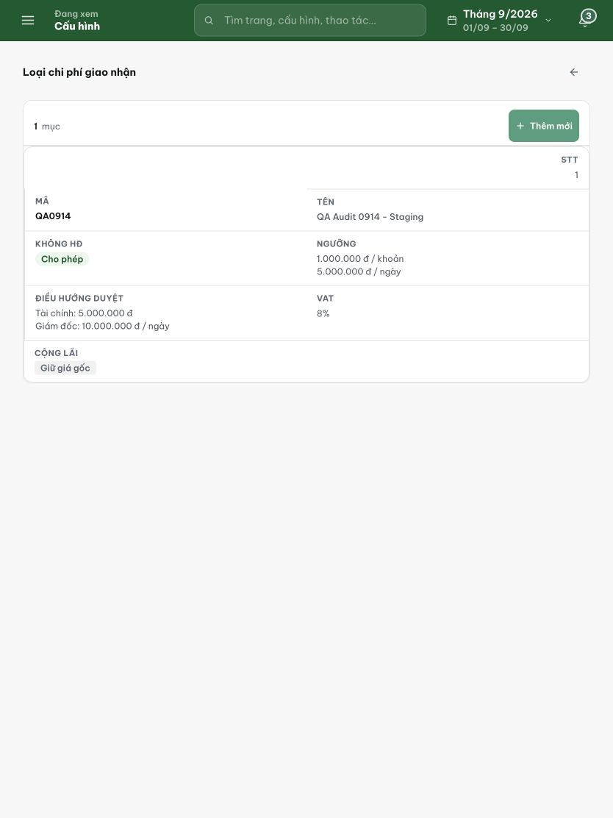
Figure 2. Admin tablet: category QA0914 still defines Finance and Director approval routing thresholds.

Evidence 3
  - Remove approval routing from Ops field expenses
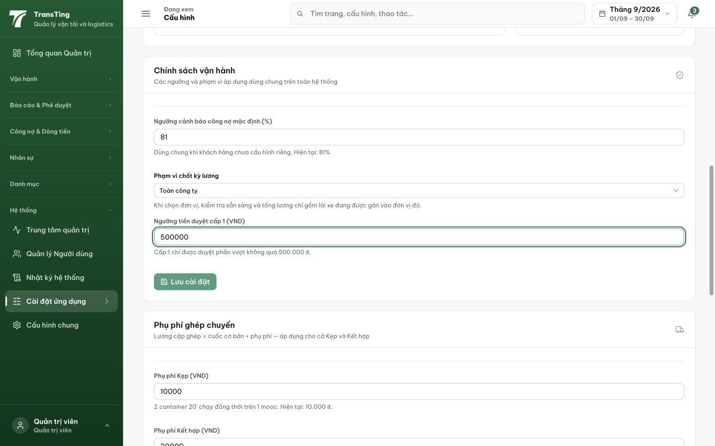
Figure 3. Admin settings: the level1 approval cap remains configured at 500,000 VND with approval-specific helper text.

