Record operating expenses without internal approval
  - QA-115 | P2 | Enhancement | TODO
Environment: Staging https://vantai.tingting.vip
Reviewed: 14 September 2026
Role: ADMIN; Accountant list comparison · 1440 × 900, 834 × 1112 and 390 × 844
Page: /expenses/new and /expenses

Existing behaviour
The create form requires Lý do gửi duyệt and offers Gửi duyệt chi phí. It says expense and debt are recorded only after one checker and a different approver. Invoice images are unavailable until approval. The expense list still contains Chờ kiểm tra and Chờ duyệt records with Kiểm tra, Duyệt and Từ chối actions.

Target behaviour
Let authorized users save and edit valid expenses directly, with invoice evidence available during entry. Record the expense and applicable payable state on save. Remove checker/approver stages and pending queues; distinguish recorded expenses from actual payments.

Impact
Expense entry and attachments remain tied to an obsolete two-person approval process.

Cause and investigation
Remove the workflow dependency rather than renaming or automatically approving requests. Current controls were inspected without submitting a new expense.

Steps to reproduce
1. As Admin, open /expenses/new. Inspect Lý do gửi duyệt, the two-person requirement, locked invoice area and Gửi duyệt chi phí.
2. In /expenses, inspect the 123,000 VND QA86 records with pending-review or pending-approval actions.

Acceptance criteria
1. A valid authorized create or edit saves directly and remains correct after reload, without another user or an internal approval queue.
2. Allow invoice evidence during creation and editing. Keep ordinary required fields, receipt rules, file checks and role access; an approval reason must not be required.
3. Update expense totals and applicable supplier debt exactly once. Keep recorded, unpaid and paid states consistent; saving must not imply a bank transfer or settlement that did not occur.
4. Remove checker/approver actions and pending-approval UI. Migrate existing pending records while retaining evidence and history without duplicate expense or debt entries.
5. Verify clear save, validation and error states at 390, 834 and 1440 px, including keyboard and touch use.

Requirement reference
User requirement to remove internal approval flows; current operating expense create form and queue.

Evidence 1
  - Record operating expenses without internal approval
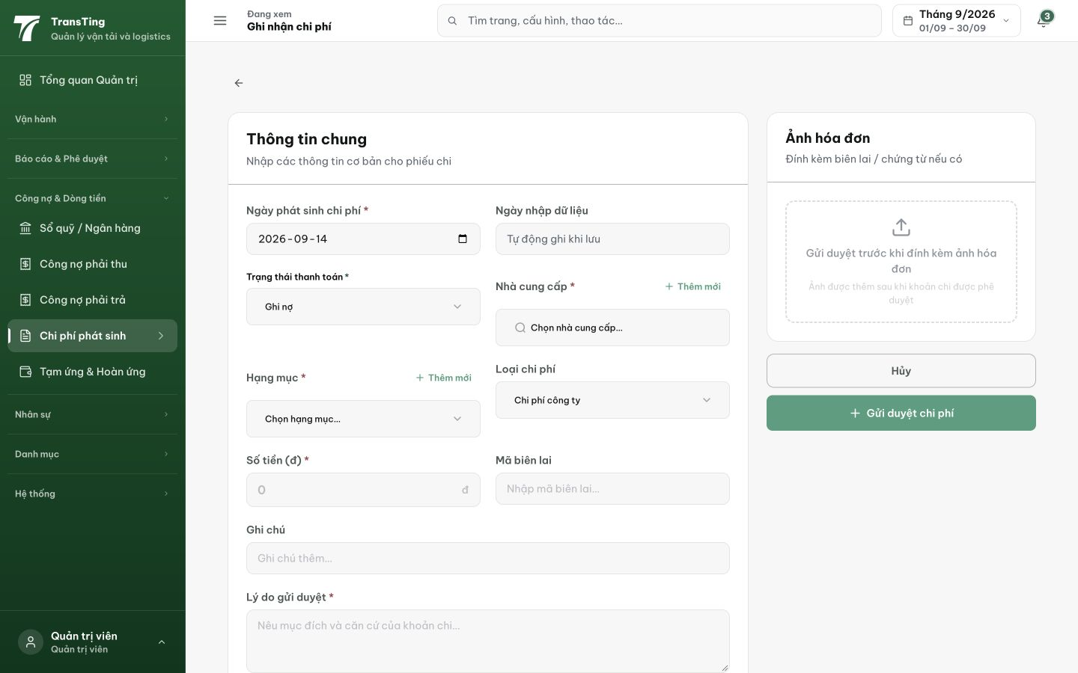
Figure 1. Desktop create form: invoice images are withheld until approval, and the primary action is Gửi duyệt chi phí.

Evidence 2
  - Record operating expenses without internal approval
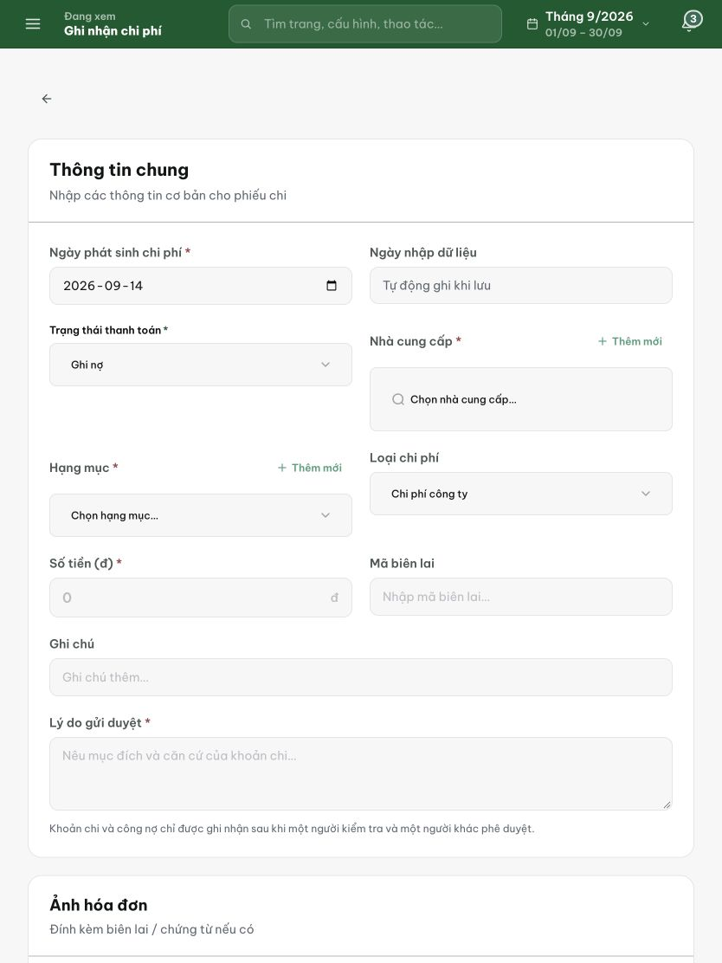
Figure 2. Tablet create form: Lý do gửi duyệt is required, followed by the stated checker and different approver requirement.

Evidence 3
  - Record operating expenses without internal approval
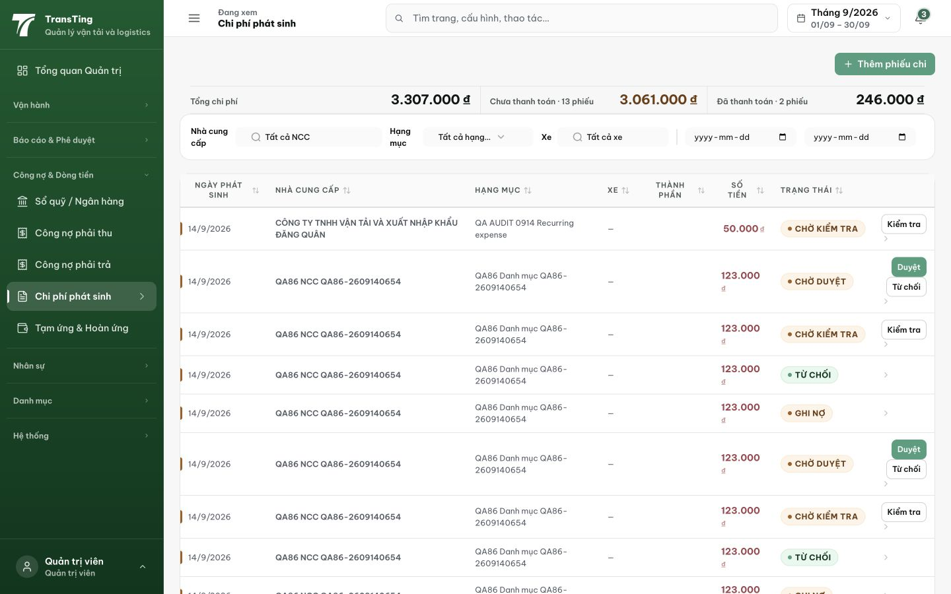
Figure 3. Desktop list: current records expose Chờ kiểm tra and Chờ duyệt states with review, approve and reject actions.

