Remove internal ePOD approval gates from accounting and billing
  - QA-116 | P2 | Enhancement | TODO
Environment: Staging https://vantai.tingting.vip
Reviewed: 14 September 2026
Role: Accountant; current desktop and tablet captures.
Page: https://vantai.tingting.vip/accounting and /debt/1/billing/new

Existing behaviour
The accounting queue blocks trips with “Thiếu POD đã chấp nhận”. Long Minh’s September debit-note dialog excludes four trips: one has “Chưa có e-POD đã duyệt” and three have “e-POD đang chờ duyệt”. It returns zero eligible lines and disables export.

Target behaviour
Use saved, complete delivery evidence directly, without an internal approver or approved-state prerequisite. Keep ordinary evidence and accounting validation. Keep external customer acknowledgement separate; the queue already identifies an unanswered customer response as non-blocking.

Impact
Staff cannot prepare accounting documents while records wait on an internal approval workflow the user has removed from the product scope.

Cause and investigation
Visible readiness and billing rules retain approved or accepted e-POD prerequisites. Inspect shared rules and labels in the UI and services. Implementation details were not inspected; no billing document was submitted.

Steps to reproduce
1. As Accountant, open Công việc at /accounting and inspect the blocked rows and “Thiếu POD đã chấp nhận” links.
2. Open Long Minh at /debt/1, choose Giấy báo nợ and create a document for 1–30 September 2026. Observe four exclusions naming e-POD approval and zero eligible lines.

Acceptance criteria
1. Remove internal e-POD approval requirements and related approval actions/status queues from accounting readiness and debit-note eligibility, including service-side checks.
2. A complete, valid saved e-POD is usable without an approver action or a fabricated approval record. Migrate pending records without losing evidence or history.
3. Continue to explain actual missing evidence or invalid data. Do not automatically include every captured trip if another independent valid condition is unmet.
4. Keep external customer acknowledgement separate. Verify direct evidence save, readiness refresh and billing generation at phone, tablet and desktop widths with accurate compact status text.

Requirement reference
User decision: remove internal approval flows; implement any future approval workflow only after the customer defines it.

Evidence 1
  - Remove internal ePOD approval gates from accounting and billing
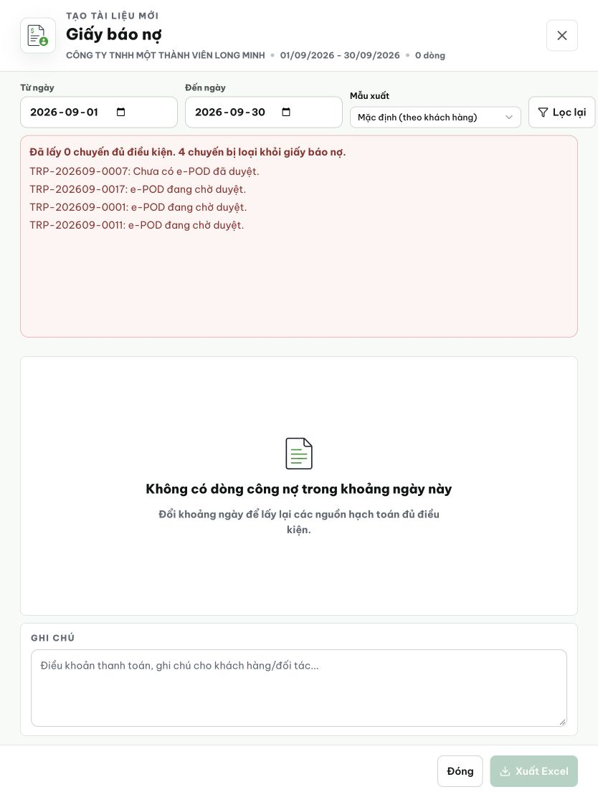
Figure 1. Tablet 834 × 1112: all four excluded trips cite absent or pending approved e-POD; the document has zero eligible lines and export is disabled.

Evidence 2
  - Remove internal ePOD approval gates from accounting and billing
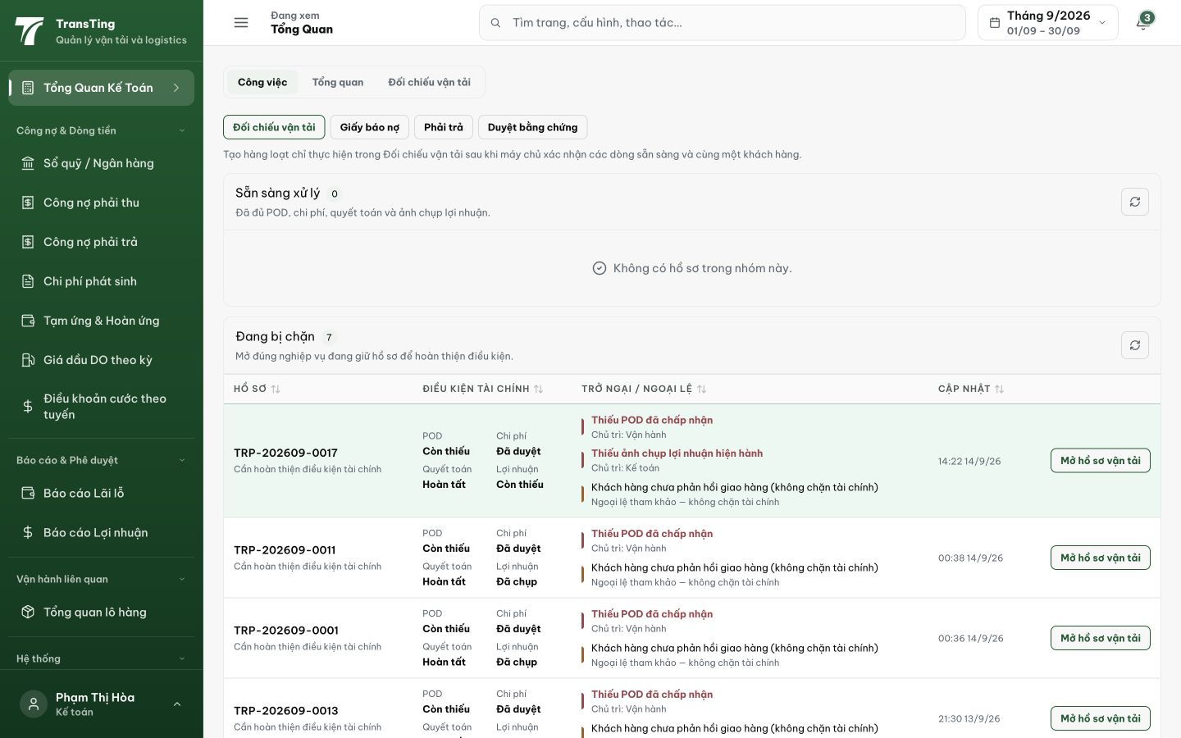
Figure 2. Desktop 1440 × 900: the accounting queue lists missing accepted POD as a blocker. Customer non-response is separately described as not blocking finance.

