Remove internal fuel invoice approval and approved expense prerequisites
  - QA-117 | P2 | Enhancement | TODO
Environment: Staging https://vantai.tingting.vip
Reviewed: 14 September 2026
Role: Admin invoice creation; Accountant related workspace. Desktop, tablet and phone captures.
Page: https://vantai.tingting.vip/payables; related /accounting/fuel-evidence and accounting navigation

Existing behaviour
The invoice workspace has a “Chờ duyệt” counter. Creation copy says approval requires allocated litres to match the invoice. An allocation field is “Chi phí nhiên liệu đã duyệt”; the only save action is “Lưu bản nháp”. Related OCR copy describes confirming or rejecting images. No invoice was submitted.

Target behaviour
Save valid invoices and allocations directly. Remove internal approval queues and approved-expense prerequisites; link valid recorded expenses. OCR checking and correction can remain part of accurate data entry with a direct save result.

Impact
The flow depends on approval steps and source-record statuses that the user has removed from the product scope.

Cause and investigation
The workspace retains approval-oriented copy and dependencies. Trace invoice eligibility, expense selection and posting together; no backend state model or executed approval was verified.

Steps to reproduce
1. As Admin, open /payables and inspect the fuel-invoice “Chờ duyệt” count.
2. Open Tạo hóa đơn nhiên liệu; inspect the allocation helper, approved-expense field and draft-only save action.
3. As Accountant, inspect /accounting/fuel-evidence. Separate ordinary OCR correction from internal approval.

Acceptance criteria
1. Remove invoice approval/rejection queues, reviewer actions and approved-expense eligibility checks from UI and services. Give authorized users a direct save action.
2. Retain exact allocated-litres reconciliation, required references, valid unit prices and duplicate prevention as save validation. Never replace actual allocations with an automatic equal split.
3. Link valid recorded expenses regardless of approval status. Migrate pending/draft records without losing invoice, evidence or allocation history or inventing approval events.
4. Keep OCR suggestions editable and corrected evidence directly saveable without another approver.
5. Check create, edit, validation and reload on phone, tablet and desktop. Show the actual recorded/posting state after save with no hidden approval wait.

Requirement reference
User decision: remove internal approval flows; implement any future approval workflow only after the customer defines it.

Evidence 1
  - Remove internal fuel invoice approval and approved expense prerequisites
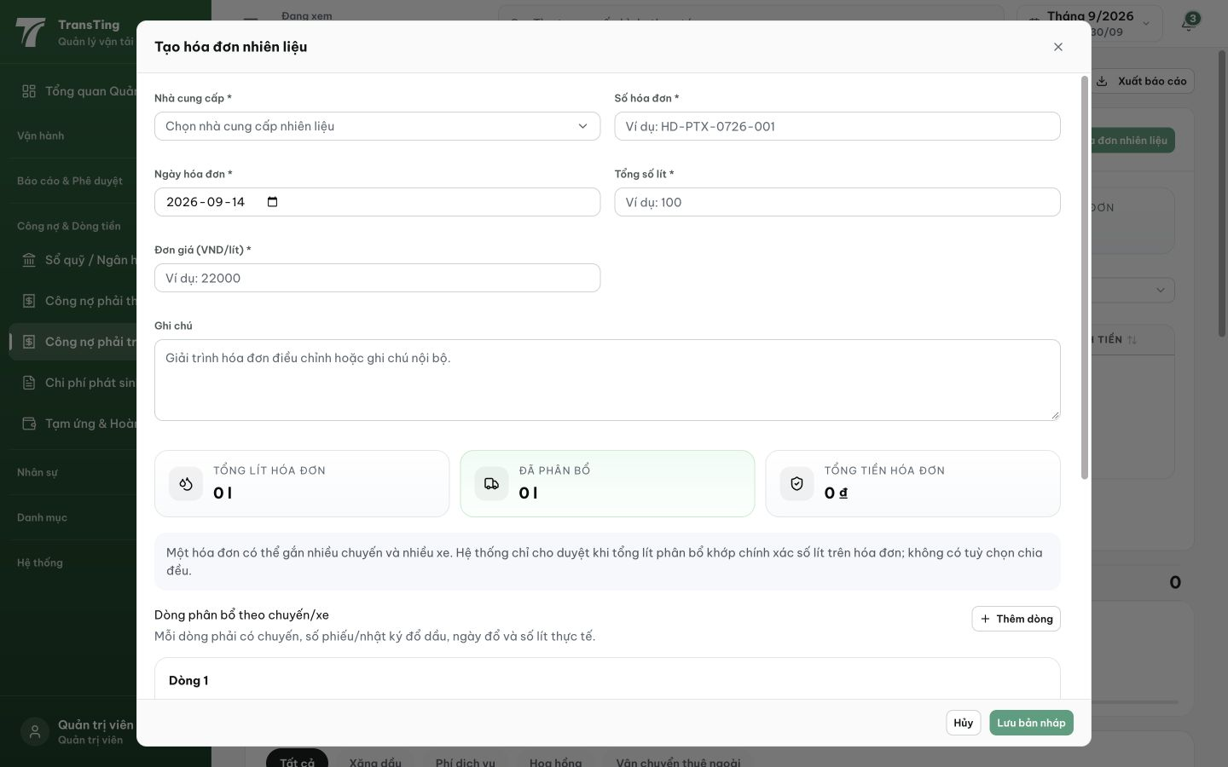
Figure 1. Desktop 1440 × 900: the invoice dialog explicitly ties approval to matching allocated litres and offers “Lưu bản nháp”. The saved page text also names “Chi phí nhiên liệu đã duyệt” in the allocation section.

