Replace profit allocation approval with direct authorized finalization
  - QA-118 | P2 | Requirement | TODO
Environment: Staging https://vantai.tingting.vip
Reviewed: 14 September 2026
Role: ADMIN; other roles with authorized profit-allocation access.
Page: /profit · Quyết toán & Chốt Quý

Existing behaviour
Quyết toán & Chốt Quý shows Xem trước and Gửi duyệt phân bổ, so official allocation still uses approval submission. The current preview also flags missing vehicle ownership; this is a separate data prerequisite.

Target behaviour
Let an authorized user preview and finalize a valid allocation directly. Remove approval submission and waiting states while retaining ownership, period and arithmetic validation.

Impact
The final action introduces an internal review handoff outside the agreed product scope.

Cause and investigation
The displayed action still reflects approval. Update its server transition and dependent statuses together; renaming the button is insufficient.

Steps to reproduce
1. As Admin, open /profit and scroll to Quyết toán & Chốt Quý.
2. Inspect the quarter, year, preview and Gửi duyệt phân bổ. No request was submitted during this check.

Acceptance criteria
1. Provide direct authorized finalization with preview, saving feedback and a persisted result; no reviewer or approver.
2. Remove approval-only queues, reasons and waiting/rejected states. Give existing pending records a logged migration path.
3. Retain ownership percentages, period consistency, arithmetic and duplicate-finalization protection. Missing data remains actionable.
4. Preserve audit history and role access. Recording allocation must not claim an actual payment or transfer occurred.
5. Rename Báo cáo & Phê duyệt to an accurate approval-free group label, retaining both report links.
6. Keep period, preview and finalization together across phone, tablet and desktop. Verify readback, duplicate attempts and validation failures.

Requirement reference
User decision, 14 September 2026: no approval workflows; live Admin profit screen.

Evidence 1
  - Replace profit allocation approval with direct authorized finalization
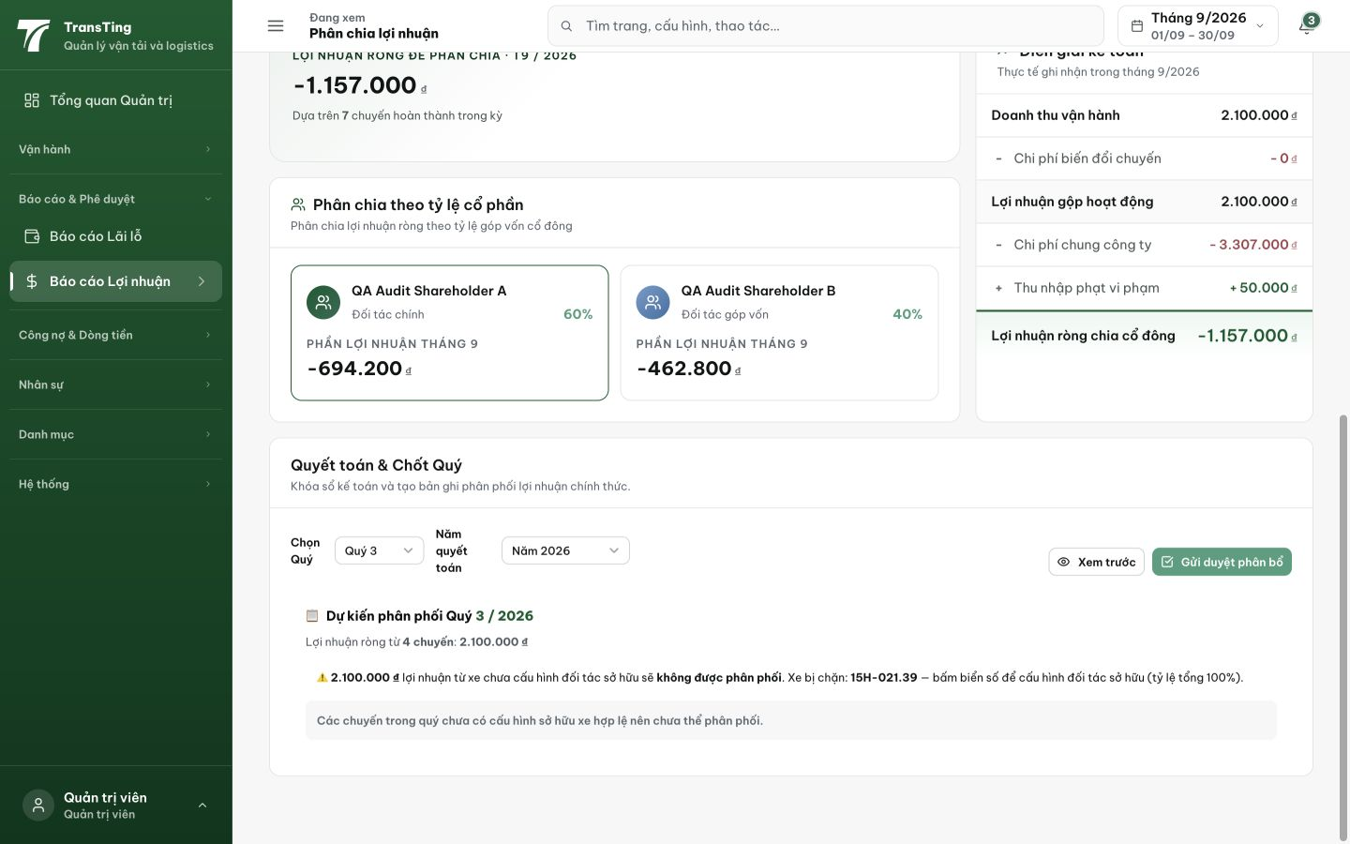
Figure 1. Live quarterly panel: Gửi duyệt phân bổ remains beside Xem trước. The ownership warning is a separate validation prerequisite.

