Remove the internal shipment deletion approval request
  - QA-119 | P2 | Enhancement | TODO
Environment: Staging https://vantai.tingting.vip
Reviewed: 14 September 2026
Role: Admin; desktop 1440 × 900 confirmed.
Page: https://vantai.tingting.vip/shipments — Yêu cầu xóa lô hàng

Existing behaviour
Rows offer “Yêu cầu xóa lô hàng”. Even for Admin, the dialog says the request goes to an administrator for approval, while also saying a shipment without operational activity may be deleted immediately. The action remains “Gửi yêu cầu xóa”. No request or deletion was submitted.

Target behaviour
Use a direct, clearly confirmed action for an authorized user when the shipment is eligible. If references prevent deletion, explain the reason and offer the supported cancellation or correction path where applicable. Do not park actions in an approval queue.

Impact
Users cannot tell whether they are deleting a record or merely asking another person to do so; the interface retains an approval workflow outside the agreed product scope.

Cause and investigation
The row action and dialog retain request-and-approve semantics. Trace deletion/cancellation eligibility and pending-request handlers together. The inspection does not establish what submitting a request would persist.

Steps to reproduce
1. Sign in as Admin and open /shipments. On an available row, click “Yêu cầu xóa lô hàng”.
2. Read the modal explanation and “Gửi yêu cầu xóa” action. It names administrator approval and a possible direct-deletion branch without a clear direct action. Close without submitting.

Acceptance criteria
1. Remove the shipment deletion approval queue, approver action and submit-for-approval lifecycle from all affected roles and services.
2. For an authorized user and an eligible shipment, show a clear delete or cancel action and a confirmation naming the shipment and consequence; report the actual result and refresh the list.
3. Keep permission checks, required reason rules and operational/financial reference protections. When deletion is invalid, show the concrete blocking references and the available supported next action.
4. Preserve existing records and request history during migration. Resolve old pending requests without inventing approvals or silently deleting shipments.
5. Verify eligible, blocked, cancelled and failed-action states with keyboard and phone/tablet/desktop layouts. One confirmed action must not create duplicate requests or mutations.

Requirement reference
User decision: remove internal approval flows; implement any future approval workflow only after the customer defines it.

Evidence 1
  - Remove the internal shipment deletion approval request
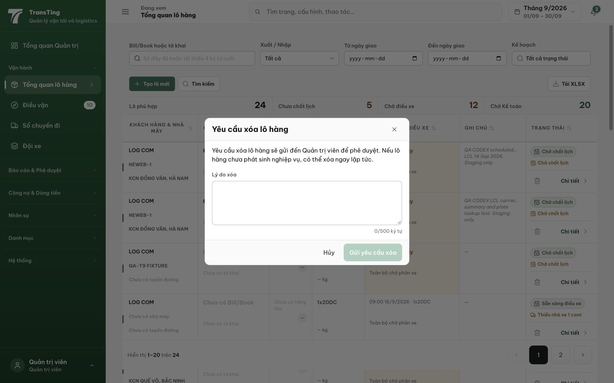
Figure 1. Admin desktop 1440 × 900: the shipment dialog states the deletion request goes to an administrator for approval. The visible action is “Gửi yêu cầu xóa”; no request was submitted.

