Remove duplicate configuration entries from the settings overview
  - QA-027 | P3 | Bug | TODO
Environment: Staging https://vantai.tingting.vip
Reviewed: 14 September 2026
Role: Administrator (admin); Chrome desktop 1728 × 873
Page: /config; /config/fuel-price-periods; /config/freight-rate-terms

Existing behaviour
The configuration overview displays Giá dầu DO theo kỳ twice, each with a 2 kỳ giá count, and Điều khoản cước theo tuyến twice, each with a 3 điều khoản count. Both fuel entries open the same fuel-price-periods page and two records. Both terms entries open the same freight-rate-terms page and three records.

Target behaviour
Show one entry for each configuration destination, with one clear title, description and current count. Remove the redundant fuel and route-terms choices while retaining the existing settings and actions.

Impact
Duplicate choices add scanning effort and uncertainty about which entry owns the setting, and consume space in a long configuration list.

Cause and investigation
Hypothesis: overlapping configuration registry entries may point to the same destinations. Inspect entry identity and route mapping; source code was not reviewed.

Steps to reproduce
1. Open Hệ thống → Cấu hình chung as admin and scroll to the pricing settings.
2. Open each Giá dầu DO theo kỳ entry, returning to the overview between visits; compare the route and two records.
3. Repeat for both Điều khoản cước theo tuyến entries; compare the route and three records.

Acceptance criteria
1. The overview contains one fuel-price-periods entry and one route-terms entry.
2. Each entry retains the correct destination, current count and existing create/edit actions.
3. Desktop, tablet and mobile present the remaining choices compactly without oversized replacement panels.

Requirement reference
Exploratory staging review, 14 September 2026.
User direction: professional, compact, data-heavy UI across desktop, tablet and mobile.

Evidence 1
  - Remove duplicate configuration entries from the settings overview
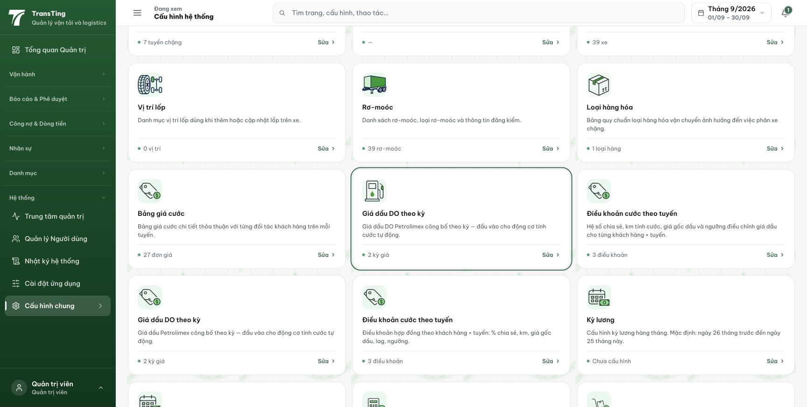
Figure 1. The overview shows two Giá dầu DO theo kỳ cards with 2 kỳ giá and two Điều khoản cước theo tuyến cards with 3 điều khoản. Click-through confirmed that each pair opens the same destination and records.

