Align payroll period summary with the current default rule
  - QA-029 | P3 | Bug | TODO
Environment: Staging https://vantai.tingting.vip
Reviewed: 14 September 2026
Role: Administrator (admin); Chrome desktop 1728 × 873
Page: /config; /config/salary-periods

Existing behaviour
The Kỳ lương card says the default runs from the 26th of the previous month to the 25th of this month and shows Chưa cấu hình. Opening it shows Cuối tháng selected, with the current configuration described as day 1 through the last day of the same month and labeled Mặc định hệ thống. The overview and detail therefore describe different defaults. No payroll calculation error was established.

Target behaviour
Make the overview description agree with the effective rule shown in payroll-period settings. Distinguish an unset override from the system default. Derive the summary from the current rule or use neutral explanatory copy; do not change payroll policy solely to match the existing card text.

Impact
Administrators receive conflicting guidance about the dates used by the default payroll period.

Cause and investigation
Hypothesis: the overview may contain a fixed description that no longer matches the effective default. Verify how both views obtain the rule; the intended payroll policy must remain authoritative.

Steps to reproduce
1. Open /config and read the Kỳ lương card description and configuration status.
2. Open Kỳ lương without editing it; compare the selected mode and Cấu hình hiện tại text with the card.

Acceptance criteria
1. With no custom override, the overview and detail describe the same effective system default.
2. With a custom period, both views consistently identify that rule and its dates after save and reload.
3. Keep the card summary short and clear; the copy fix does not silently change the effective payroll period.

Requirement reference
Exploratory staging review, 14 September 2026.
User direction: professional, compact, data-heavy UI across desktop, tablet and mobile.

Evidence 1
  - Align payroll period summary with the current default rule
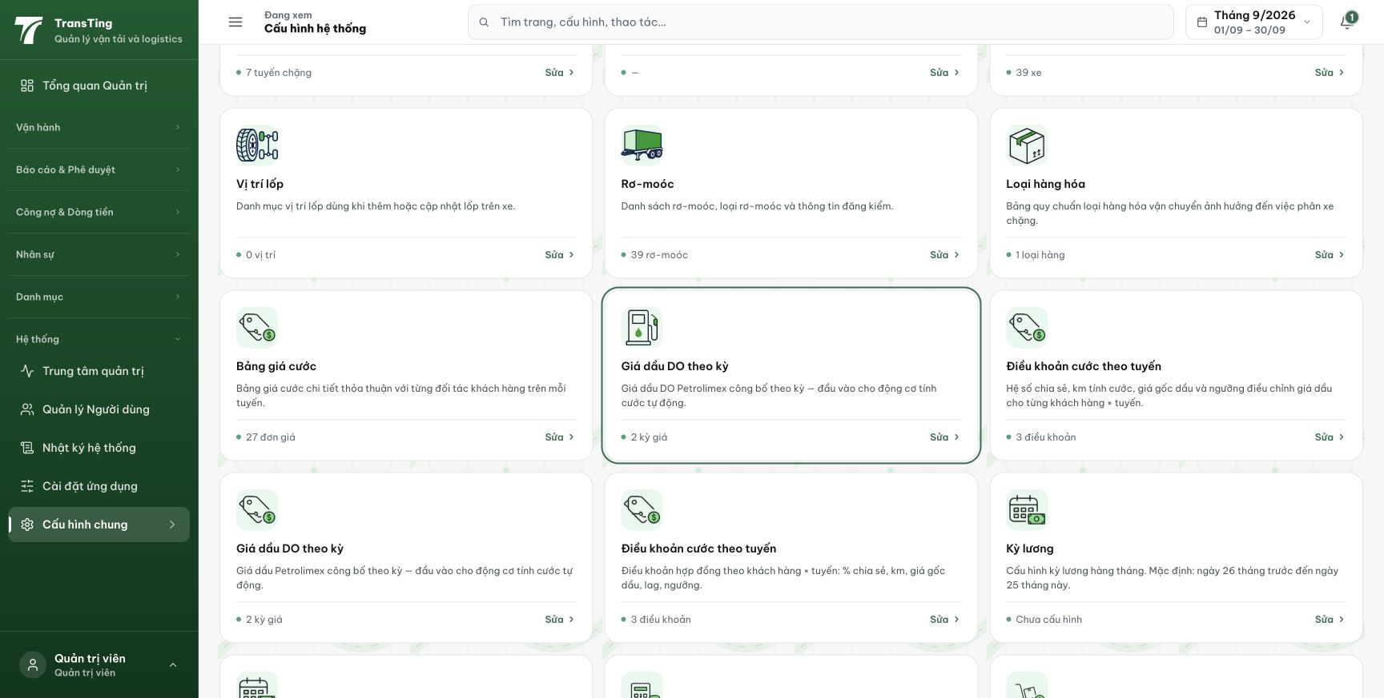
Figure 1. The Kỳ lương card at lower right describes a default from day 26 of the previous month to day 25 of this month, while its status is Chưa cấu hình.

Evidence 2
  - Align payroll period summary with the current default rule
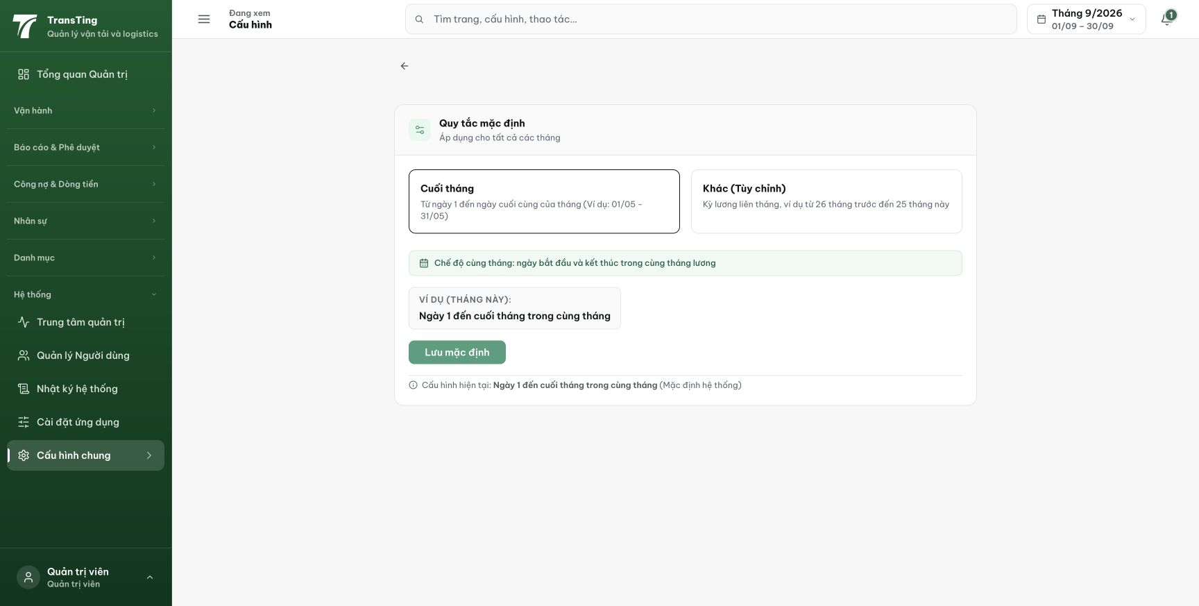
Figure 2. The detail selects Cuối tháng and states Cấu hình hiện tại: Ngày 1 đến cuối tháng trong cùng tháng (Mặc định hệ thống). This conflicts with the overview description.

