Make the mobile trip list show records sooner
  - QA-031 | P3 | Enhancement | TODO
Environment: Staging https://vantai.tingting.vip
Reviewed: 14 September 2026
Role: Administrator (admin); Chrome mobile viewport 390 × 844
Page: https://vantai.tingting.vip/trips

Existing behaviour
At 390 × 844, Sổ chuyến đi shows a total-and-status chart followed by another set of status filter chips containing the same categories and counts. The summary, spacing and filter panels occupy most of the initial viewport; the first trip starts around 635 pixels down and is only partly visible. Users must scroll through repeated summary information before reviewing complete trip records.

Target behaviour
Consolidate the repeated status summary into a compact set of useful filters, keep search readily available and move secondary filters behind a concise disclosure when appropriate. Prioritize readable trip records while retaining the available filtering and summary functions.

Impact
Repeated information delays record scanning and reduces the useful data visible on a phone.

Cause and investigation
Hypothesis: the responsive layout stacks desktop summary and filter sections without reducing duplicated information. Review their mobile hierarchy; no code cause is confirmed.

Steps to reproduce
1. As admin, open Sổ chuyến đi with records present at a 390 × 844 viewport.
2. Compare the status chart and status filters, then observe how far down the first trip begins before scrolling.

Acceptance criteria
1. At 390 × 844, the default list begins within the first half of the viewport and exposes one complete compact trip card when records exist.
2. Status counts and selected filters remain understandable without presenting the same summary twice.
3. Search, filter reset and trip creation remain easy to reach; touch controls and text remain readable.
4. Tablet and desktop preserve useful data density and do not gain oversized controls or unnecessary empty panels.

Requirement reference
Exploratory staging review, 14 September 2026.
User direction: professional, compact, data-heavy UI across desktop, tablet and mobile.

Evidence 1
  - Make the mobile trip list show records sooner
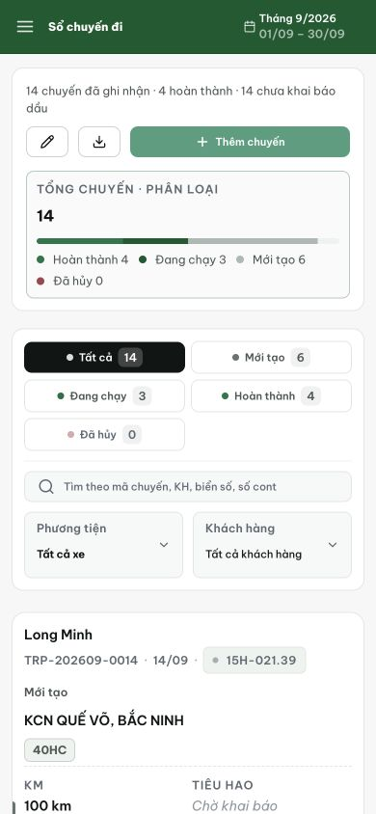
Figure 1. The total/status chart is repeated immediately by status-filter chips. The first trip begins near the bottom of the 390 × 844 viewport and its lower details are below the fold.

