Explain rejected negative amounts in discipline rule edits
  - QA-074 | P3 | Bug | TODO
Environment: Staging https://vantai.tingting.vip
Reviewed: 14 September 2026
Role: ADMIN · desktop 1440 × 900
Page: /config/penalty-reasons → Chỉnh sửa lỗi vi phạm

Existing behaviour
For QA AUDIT 0914 - staging only, entering −50000 in Mức phạt mặc định (VNĐ) leaves Lưu thay đổi enabled. Activating it by Enter and by click keeps the dialog open without a visible error or invalid-field marking. The saved row remains 50,000 VND. Correcting the amount to 60,000 VND succeeds and survives reload. No negative amount persisted.

Target behaviour
Explain the invalid amount beside its field in Vietnamese and give a clear submission state. Keep the draft available for correction, associate and announce the error, and focus the affected field. A valid correction must save normally.

Impact
Admin cannot tell why Save does nothing or which correction is required, encouraging repeated attempts.

Cause and investigation
An invalid-value guard may return without presenting feedback. Inspect validation and submit state; no backend or source-code cause is confirmed.

Steps to reproduce
1. Edit QA AUDIT 0914 - staging only, initially 50,000 VND with severity Nhẹ.
2. Enter -50000 in Mức phạt mặc định (VNĐ); activate Lưu thay đổi by Enter, then click.
3. Observe the unchanged dialog without feedback. Correct to 60000, save and reload to confirm the valid update.

Acceptance criteria
1. Reject negative amounts with a visible Vietnamese explanation beside the field; preserve the saved value.
2. Expose the invalid state and message accessibly, with focus after a rejected submission.
3. If Save is disabled for invalid input, explain why; never leave an enabled submission silently ineffective.
4. Verify Enter, click, correction and reload on desktop, tablet and phone; retain name and severity values.

Requirement reference
Observed discipline-rule editing; invalid amount produces no saved change, while a valid correction succeeds.

Evidence 1
  - Explain rejected negative amounts in discipline rule edits
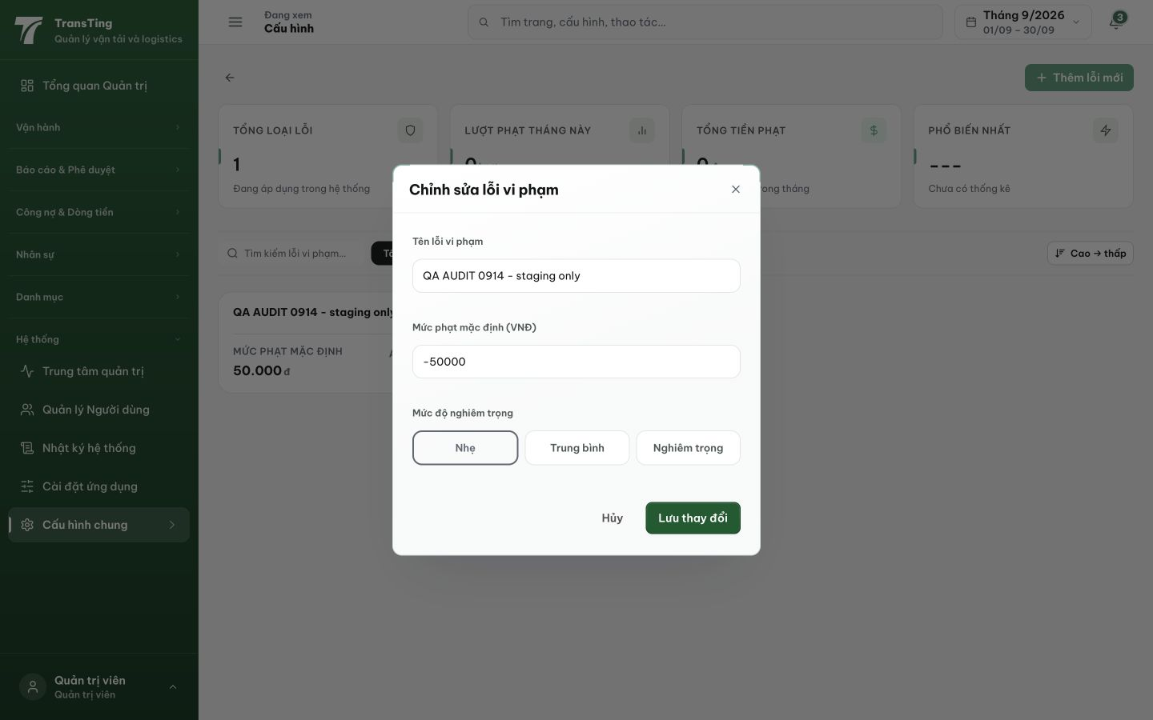
Figure 1. After Save is activated with −50000, the dialog stays open with no visible error. The saved row behind it still shows 50,000 VND.

