Remove duplicate currency units from discipline amounts
  - QA-075 | P3 | Bug | TODO
Environment: Staging https://vantai.tingting.vip
Reviewed: 14 September 2026
Role: ADMIN; Chrome desktop 1440 × 900
Page: /penalties — Phạt YTD ranking and cancellation confirmation

Existing behaviour
Dương Văn Thực’s populated ranking row shows 60.000 ₫ followed by an extra đ; its accessibility text is 60.000 ₫đ. The ledger and violation rule below show the same amount with one currency unit. Zero-value ranking rows show 0đ. Opening Hủy kỷ luật repeats 60.000 ₫đ in the confirmation’s Số tiền field.

Target behaviour
Render discipline amounts with exactly one consistent VND unit, using the shared currency formatter for zero and nonzero values in the ranking and confirmation.

Impact
The duplicated unit makes the financial column look unfinished and inconsistent with nearby amounts. No arithmetic error was established.

Cause and investigation
Hypothesis: an already formatted currency value receives an additional manual suffix. Inspect the ranking renderer and use one formatting path; no implementation cause is confirmed.

Steps to reproduce
1. As Admin, open /penalties with the September 2026 staging data.
2. Scroll to Dương Văn Thực in the ranking (rank 39 in the captured fixture), with Phạt YTD of 60,000 VND.
3. Compare its duplicated currency unit with the ledger and violation-rule amounts below.
4. Open Hủy kỷ luật on that record and compare Số tiền in the confirmation; it repeats the duplicate unit. No cancellation is needed to observe this.

Acceptance criteria
1. The 60,000 VND ranking and confirmation amounts display one unit, such as 60.000 ₫, without an added đ.
2. Zero and nonzero amounts use the same formatting convention; preserve underlying values, sorting and compact column alignment.
3. Check visible and accessibility text on desktop, tablet and phone; ledger and rule amounts remain consistently formatted.

Requirement reference
Observed staging discipline ranking and paired accessibility capture on 14 September 2026.

Evidence 1
  - Remove duplicate currency units from discipline amounts
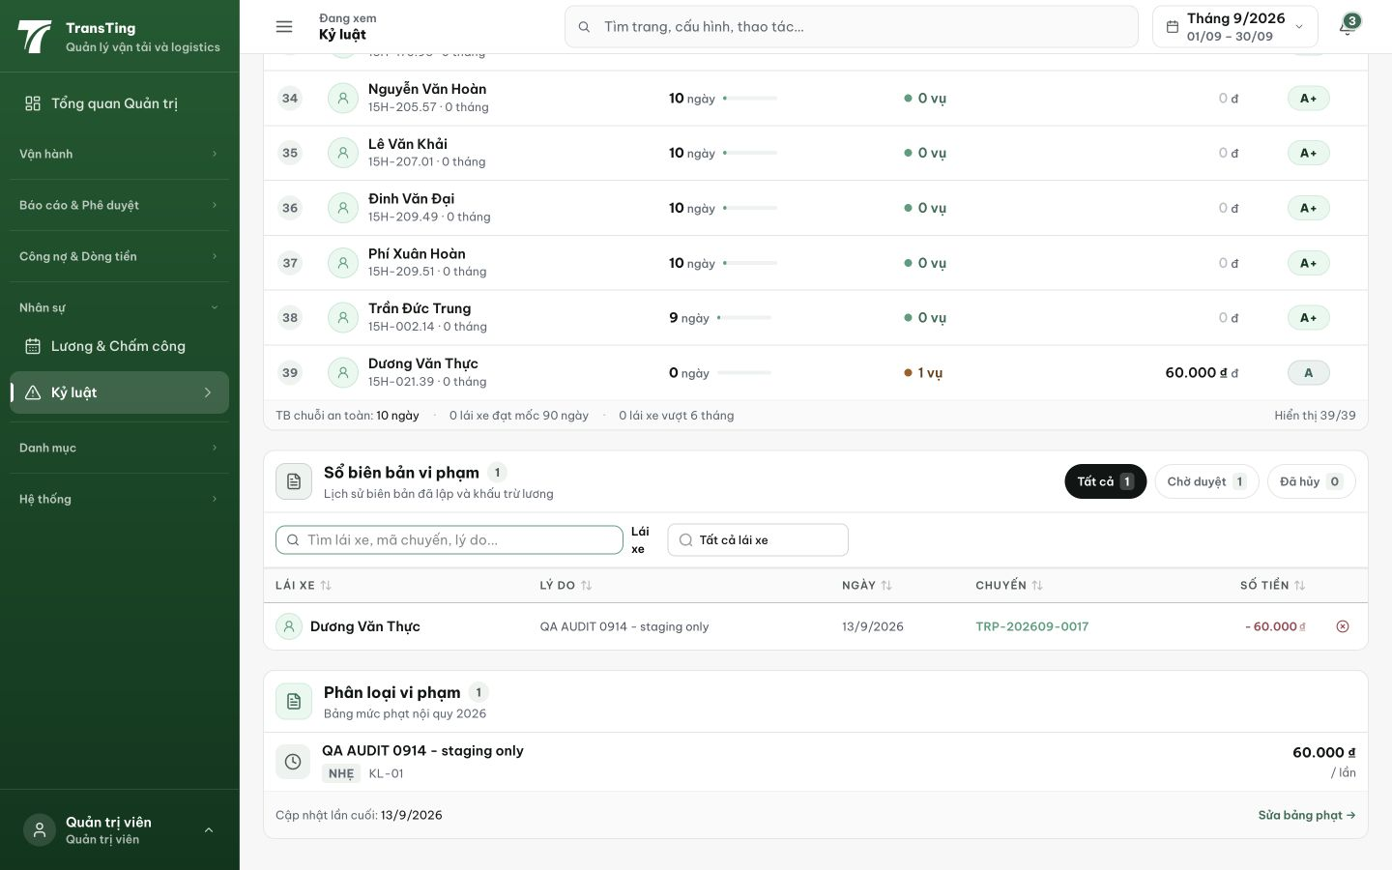
Figure 1. Rank 39, Dương Văn Thực: 60.000 ₫ has an extra đ at the right. The ledger and rule below each display a single currency unit. The paired accessibility capture reads 60.000 ₫đ.

Evidence 2
  - Remove duplicate currency units from discipline amounts
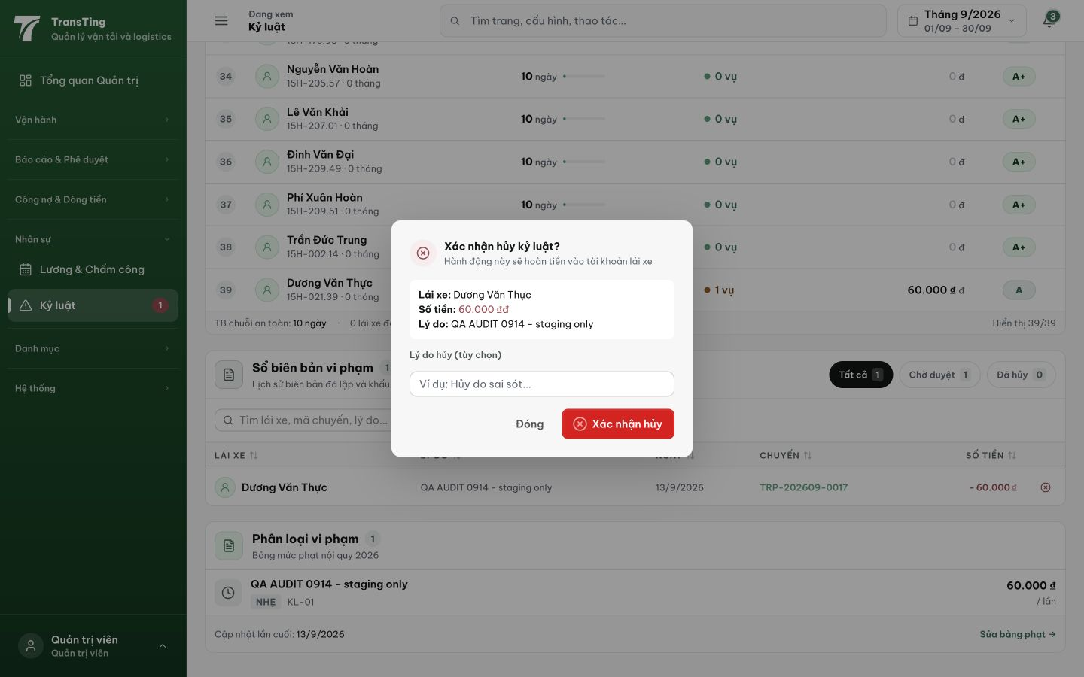
Figure 2. The same 60.000 ₫đ formatting appears in Số tiền inside the cancellation confirmation. This is the same currency-rendering symptom; dialog focus management is tracked separately in QA-082.

