Align and compact the expense entry form
  - QA-088 | P3 | Enhancement | TODO
Environment: Staging https://vantai.tingting.vip
Reviewed: 14 September 2026
Role: Admin; desktop 1440×900. Lower form also inspected at tablet 834×1112 and phone 390×844.
Page: https://vantai.tingting.vip/expenses/new; https://vantai.tingting.vip/expenses/1/edit

Existing behaviour
Desktop payment/supplier and category/cost-type controls have staggered baselines. Hiệu lực từ and Hiệu lực đến sit diagonally across rows. The invoice/actions column leaves substantial empty space while the required reason continues below the viewport. Smaller captures cover only the lower form; its full top layout was not reviewed at those widths.

Target behaviour
Use a compact, aligned grid with adjacent effective dates, concise read-only metadata and a proportionate receipt/action area. Reduce avoidable scrolling while preserving readable labels and touch access.

Impact
Related fields take more effort to scan when rows and date pairs do not align.

Cause and investigation
Hypothesis: differing label/action heights and sidebar sizing cause the staggered rows and unused space. Source code was not inspected.

Steps to reproduce
1. As Admin, open the recurring expense form or /expenses/1/edit for QA-EXP-0914-01 at 1440×900.
2. Compare payment/supplier and category/cost-type rows, then locate both effective dates.
3. Scroll to the required reason and compare the long left form with the largely empty lower-right column.

Acceptance criteria
1. Align labels, inline Thêm mới actions and controls on consistent row baselines. Keep both effective dates together in reading and keyboard order.
2. Present the automatic entry date as compact read-only metadata; size receipt and action areas to their content without removing upload, cancel or submission controls.
3. At desktop/tablet/phone widths, retain logical field order, readable long values and visible validation. Avoid horizontal overflow and oversized headings or fields; provide at least 44px phone touch hit areas.
4. Check recurring and non-recurring forms, empty/populated receipts and validation states. Preserve values, permissions and submission semantics; approval posting and broken receipts remain QA-086/087.

Requirement reference
Staging screenshots, 14 September 2026; user requirement for compact, data-heavy UI.

Evidence 1
  - Align and compact the expense entry form
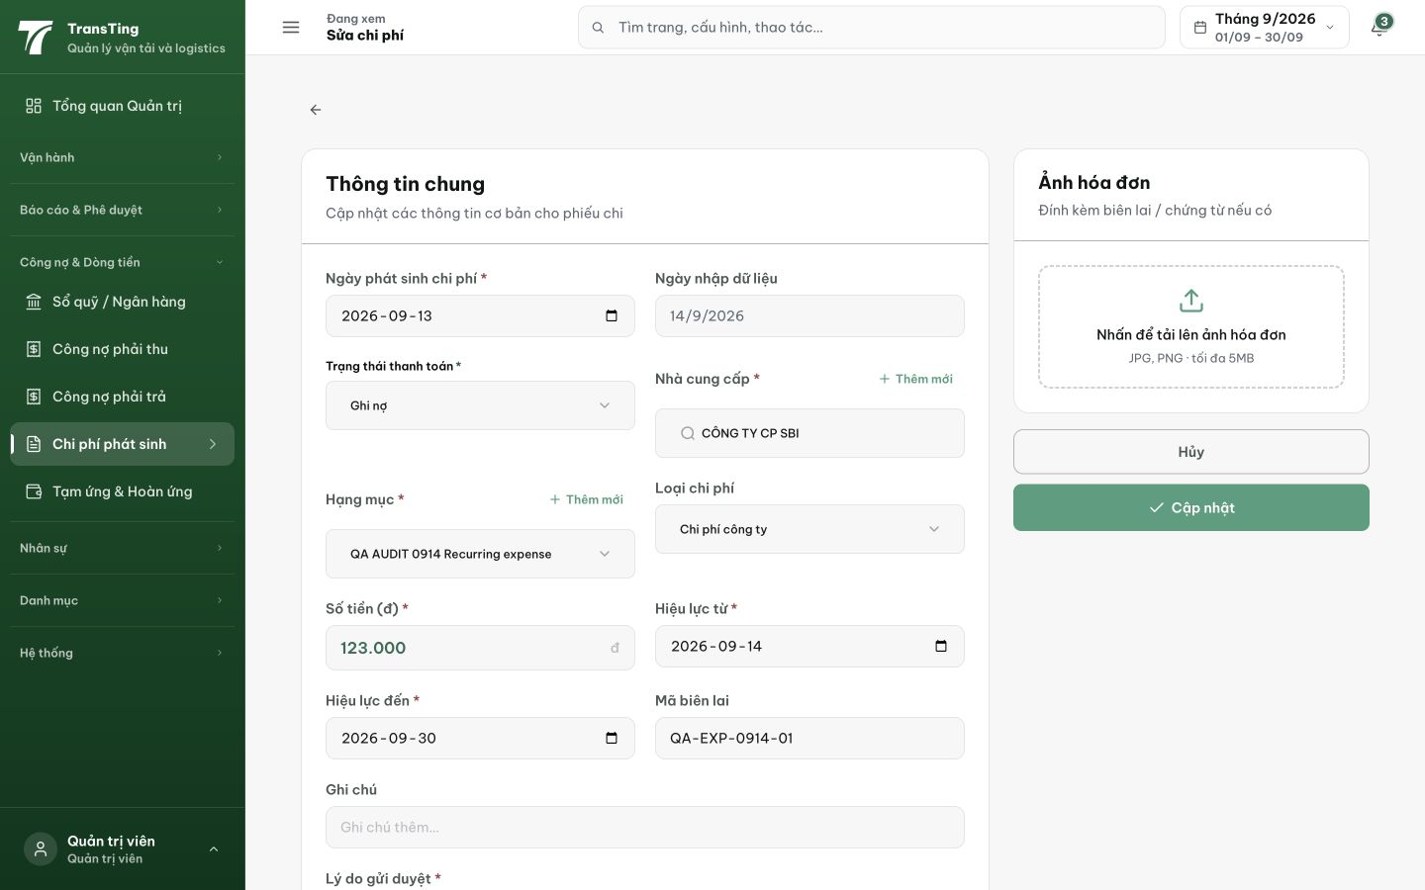
Figure 1. Desktop edit form: payment/supplier and category/cost-type controls are staggered; effective dates occupy different rows. Receipt/actions use a separate wide column while the required reason continues below the viewport.

Evidence 2
  - Align and compact the expense entry form
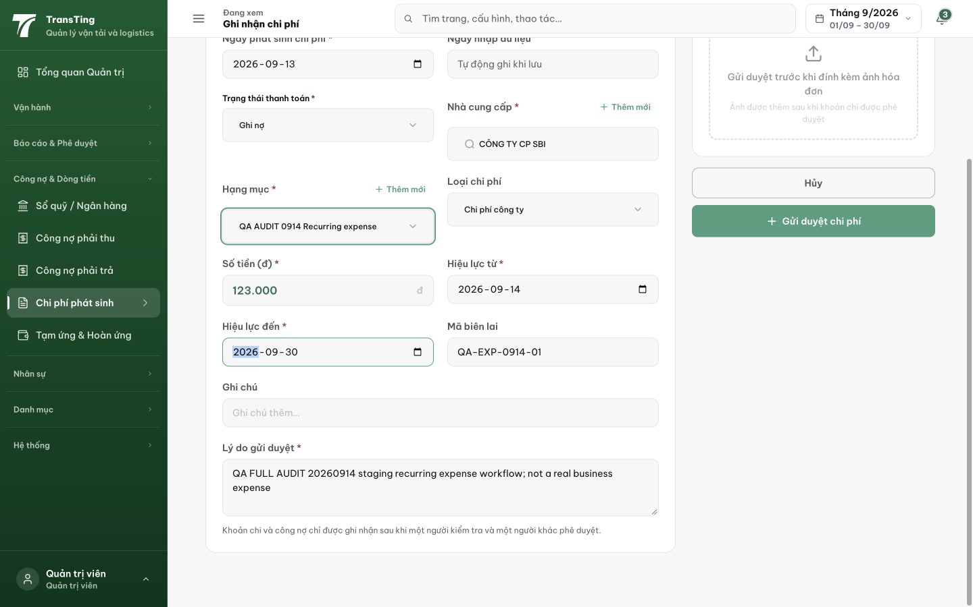
Figure 2. Desktop creation form scrolled to its lower fields: the reason and policy text occupy the left column beside substantial unused space under the right-side actions. Scrolled content under the fixed header is not itself reported as a defect.

