Make customer and factory directories easier to scan
  - QA-090 | P3 | Enhancement | TODO
Environment: Staging https://vantai.tingting.vip
Reviewed: 14 September 2026
Role: Admin — 1440 × 900 desktop, 834 × 1112 tablet and 390 × 844 phone
Page: https://vantai.tingting.vip/config/customers; /config/factories

Existing behaviour
Customer tables fragment names and identifiers even on desktop; phone records start halfway down and expand each attribute into a row. Factory routes wrap into five or six desktop lines; tablet/phone cards add ordinal/edit rows, reaching approximately 355/473 pixels. The secondary directories listed below repeat full-field phone cards, most also on tablet, despite compact desktop tables.

Target behaviour
Prioritize identity, identifiers, route/contact and status in compact summaries and appropriately sized columns. Use separators instead of decorative nested cards, reduce cumulative phone insets, and expose full secondary details on demand.

Impact
Scrolling and reconstructing fragmented values slows routine lookup, comparison and editing.

Cause and investigation
Hypothesis: low-priority columns and full attribute inventories displace useful summaries. Shared implementation has not been verified.

Steps to reproduce
1. Open Customers as Admin at all three widths; compare the first two records and phone starting position.
2. Open Factories; inspect NEWEB-1 route wrapping and its ordinal, contact and edit rows.

Acceptance criteria
1. Keep codes, MST and phones unbroken; give identity/route useful width. Use deliberate column selection or scrolling instead of smaller text.
2. Show a complete phone customer summary sooner by reducing summary-panel height. Preserve search, filters, export and creation.
3. Factory summaries retain code, customer, name, route and status. Group ordinal/edit with identity; materially reduce phone/tablet card height.
4. Keep full names, addresses, contacts, terms, missing-value meaning and editing accessible through explicit touch/keyboard details.
5. Check long/empty values, readability, focus and touch targets at all widths. Regress /config directories: trucks, trailers, tire-positions, cargo-types, pricing-tables, fuel-price-periods, freight-rate-terms and routes. Preserve compact desktop tables and the route tablet view.

Requirement reference
Current staging Chrome captures; user request for compact data-heavy UI across desktop, tablet and phone.

Evidence 1
  - Make customer and factory directories easier to scan
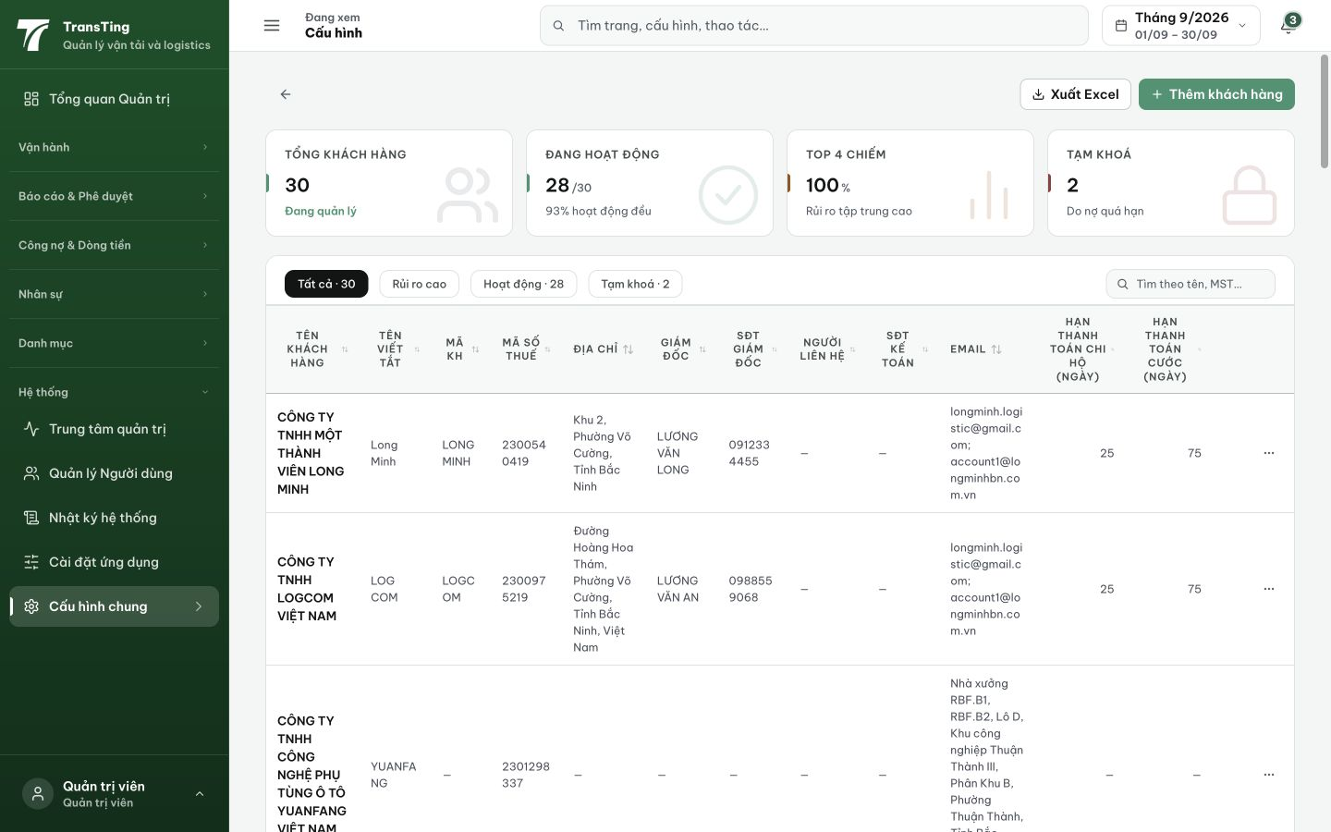
Figure 1. Customer directory, 1440 × 900: narrow columns split identifiers and names; only two complete rows fit beneath the header.

Evidence 2
  - Make customer and factory directories easier to scan
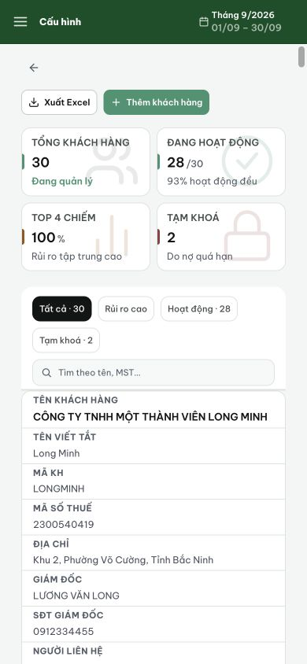
Figure 2. Settled customer directory, 390 × 844: the first record begins halfway down the screen and remains incomplete at the bottom.

Evidence 3
  - Make customer and factory directories easier to scan
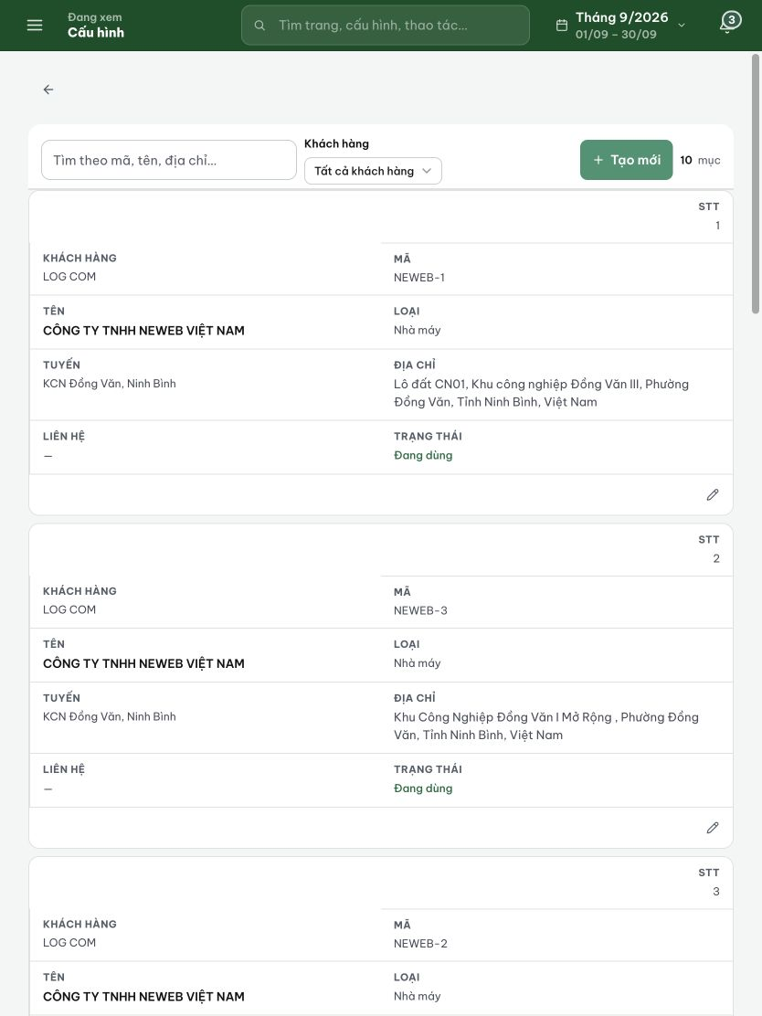
Figure 3. Factory directory, 834 × 1112: repeated attribute grids include dedicated ordinal and edit rows, making each card tall.

Evidence 4
  - Make customer and factory directories easier to scan

Figure 4. Factory directory, 390 × 844: one complete record occupies roughly 473 pixels, including a separate empty-contact row.

