Use space efficiently in the customer dialog
  - QA-091 | P3 | Enhancement | TODO
Environment: Staging https://vantai.tingting.vip
Reviewed: 14 September 2026
Role: Admin — 1440 × 900 desktop, 834 × 1112 tablet and 390 × 844 phone
Page: https://vantai.tingting.vip/config/customers — Thêm khách hàng

Existing behaviour
At 390 pixels, creation combines roughly 24-pixel outer and 20-pixel inner insets with approximately 134-pixel input columns. Placeholders clip, wrapped labels offset controls, and large gaps separate rows. Desktop/tablet retain generous spacing; the final selector/actions require scrolling at 900-pixel desktop height. Dimensions are visual estimates; scrolling itself is not a failure.

Target behaviour
Reduce cumulative phone insets and repeated vertical gaps. Give long-value fields enough width, pair short fields only when labels and values fit, and align related controls. Preserve readable labels and the complete customer workflow.

Impact
Narrow fields hinder review while empty space increases scrolling to final options and actions.

Cause and investigation
Hypothesis: combined insets, two columns and row spacing constrain input area. Source styles and edit-form reuse are unverified.

Steps to reproduce
1. As Admin, open Customers → Thêm khách hàng at all three stated widths.
2. Compare phone input widths/wrapped labels and desktop row gaps/final action position.

Acceptance criteria
1. Use more of the phone width: target about 12–16 pixels of content inset within the surface, while respecting safe areas and close controls.
2. Give long customer/contact fields full row width where needed. Pair short fields only when labels and expected values remain usable; do not force one grid at every size.
3. Reduce repeated blank row gaps and align paired inputs when labels wrap. At 1440 × 900, expose final fields/actions sooner without shrinking readable text.
4. Keep all fields, defaults, carrier option, debt-template selection and create/cancel actions. Maintain logical focus order, visible validation and at least 44-pixel phone touch hit areas.
5. Check creation and populated editing at all three widths, including long names and invalid inputs. No overlap, lost values or horizontal clipping; actions remain reachable while scrolling.

Requirement reference
Current staging Chrome captures; user request for compact data-heavy UI. Creation inspected; editing is a required regression check.

Evidence 1
  - Use space efficiently in the customer dialog

Figure 1. Customer creation, 390 × 844: cumulative side insets constrain paired inputs; wrapped labels and large row gaps are visible together.

Evidence 2
  - Use space efficiently in the customer dialog
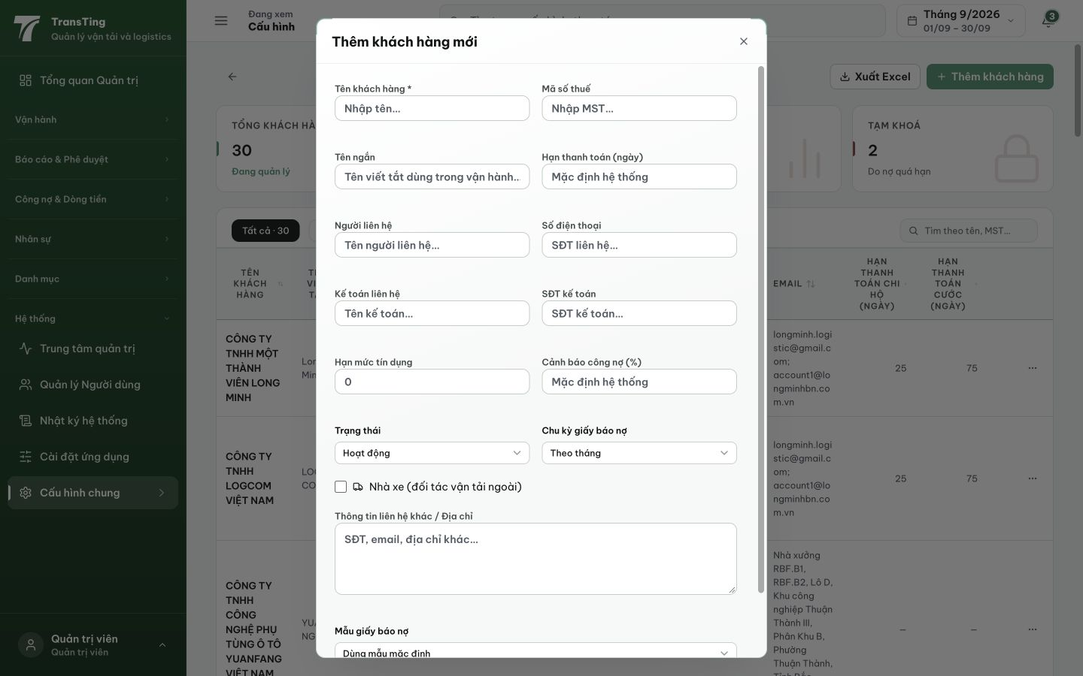
Figure 2. Customer creation, 1440 × 900: repeated vertical gaps push the final selector and actions below the initial dialog view.

Evidence 3
  - Use space efficiently in the customer dialog
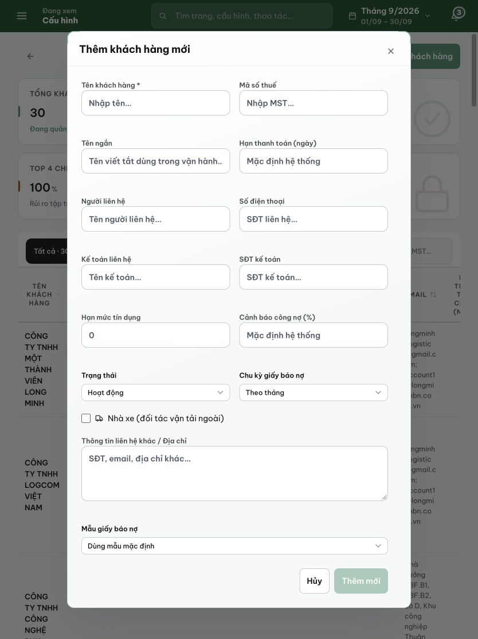
Figure 3. Customer creation, 834 × 1112: the taller viewport shows the full form and the repeated spacing throughout it.

