Keep template column properties close to selection
  - QA-092 | P3 | Enhancement | TODO
Environment: Staging https://vantai.tingting.vip
Reviewed: 14 September 2026
Role: Admin — 390 × 844 phone, 834 × 1112 tablet and 1440 × 900 desktop
Page: https://vantai.tingting.vip/config/debit-note-templates/1 — Cột Excel

Existing behaviour
On phone, selecting TÊN NHÀ MÁY changes its pressed state but leaves properties around y=1630, below all 20 selectors and the 844-pixel viewport. Scrolling or keyboard focus reaches them, while the selected column moves offscreen. Larger captures show properties after the grid within the initial view. No template was saved.

Target behaviour
Keep the selected column and its properties together using compact navigation, optional search and adjacent or inline controls. Make phone properties immediately reachable.

Impact
Repeated scrolling and remembering the offscreen selection make column editing harder.

Cause and investigation
Hypothesis: the full selector list separates selection from editing. Source implementation is unverified.

Steps to reproduce
1. Open MẪU DEBIT LONG MINH → Cột Excel as Admin at 390 × 844.
2. Select TÊN NHÀ MÁY; its state changes while properties remain below all 20 selectors.
3. Scroll or move keyboard focus to properties; the selected early column is now offscreen.

Acceptance criteria
1. Selecting a phone column exposes its properties without traversing the full list; return preserves the list position.
2. Identify the selected column beside its property controls.
3. Keep navigation compact and properties adjacent or inline where space allows. Search is optional; traversing the full grid must not be required.
4. Preserve column identity, order, visibility, alignment, total settings, preview, saving and navigation with unsaved changes.
5. Check first/middle/last, hidden and long-name columns at all three widths. Preserve readable text, focus continuity and adequate touch targets.
6. Edited values and preview remain tied to the intended column. Do not silently save or discard changes.

Requirement reference
Current staging Chrome evidence; user request for compact data-heavy editing across screen sizes.

Evidence 1
  - Keep template column properties close to selection
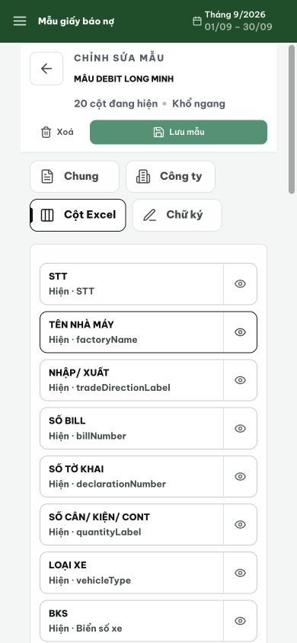
Figure 1. After selecting TÊN NHÀ MÁY at 390 × 844, its outline changes but the properties remain outside the viewport beneath the full selector list.

Evidence 2
  - Keep template column properties close to selection
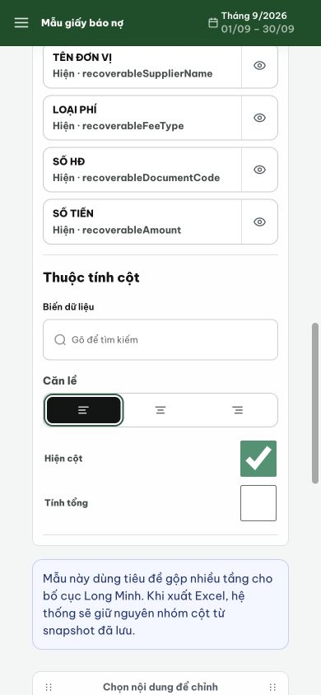
Figure 2. After moving down to the properties, the selected early column is offscreen; the property section begins only after the final column selectors.

Evidence 3
  - Keep template column properties close to selection
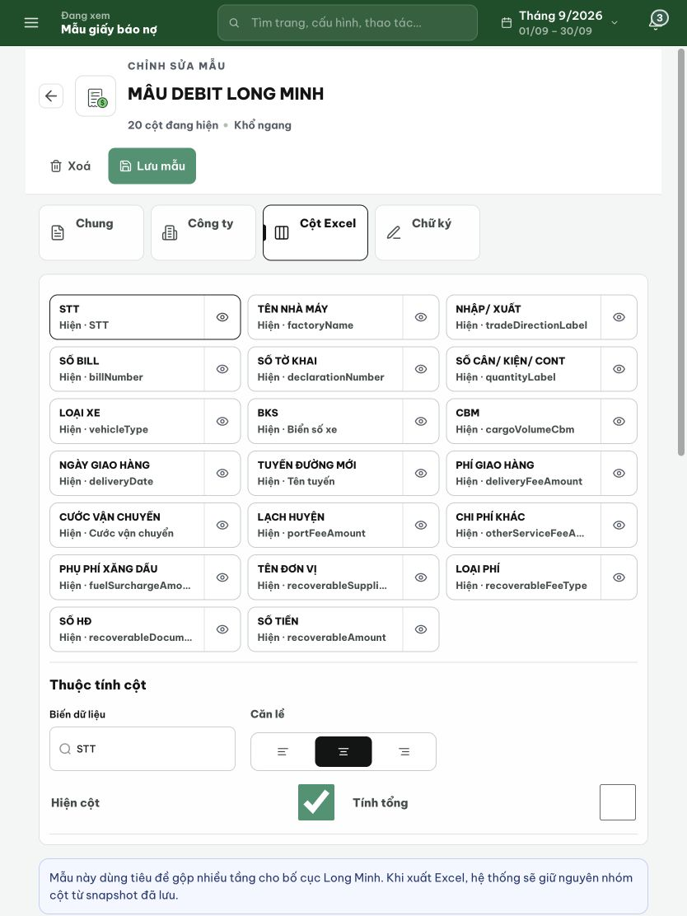
Figure 3. Tablet at 834 × 1112: the properties are visible after the three-column grid. Preserve this visibility while improving the phone selection workflow.

