Prioritize supplier debt lookup on the payables page
  - QA-095 | P3 | Enhancement | TODO
Environment: Staging https://vantai.tingting.vip
Reviewed: 14 September 2026
Role: Manager — 1440 × 900 desktop and 834 × 1112 tablet
Page: https://vantai.tingting.vip/payables

Existing behaviour
The empty Hóa đơn nhiên liệu nhiều xe workspace precedes the supplier debt summary and queue. It occupies about 520 pixels on desktop and 489 on tablet, with four zero-value tiles, search and filters. Desktop repeats the empty message inside and below its table. The 1,496,000 VND balance for four suppliers appears beneath this workspace; no supplier record is visible in either initial viewport.

Target behaviour
Make supplier balances, search and the payable queue the primary entry view. Present fuel-invoice capture and lookup as a compact secondary section or clearly accessible tab.

Impact
Users scroll past an empty secondary workspace before finding suppliers and outstanding balances.

Cause and investigation
Hypothesis: the invoice workspace is always expanded ahead of the main debt workflow. Source implementation is unverified.

Steps to reproduce
1. Open Công nợ phải trả as Manager for September 2026 at 1440 × 900.
2. Observe the empty fuel-invoice workspace above the four-supplier debt summary; scroll to reach supplier records.
3. Repeat at 834 × 1112; the same workspace precedes the debt queue.

Acceptance criteria
1. At desktop, tablet and phone widths, the initial view prioritizes debt totals, supplier search and available supplier records.
2. Keep invoice capture and lookup easy to open, with concise invoice counts when useful. Do not preserve or introduce internal approval queues or gates.
3. Use one concise empty message. Reduce repeated tiles, nested containers and excess spacing without enlarging components or shrinking readable text.
4. Preserve supplier filters, relevant invoice search, balances, aging categories, ordinary role access and navigation to invoice and supplier detail views.
5. Verify empty and populated invoice states with a populated supplier queue; preserve keyboard navigation, visible focus and adequate phone touch targets.

Requirement reference
Current staging Chrome evidence; user request for compact data-heavy UI.

Evidence 1
  - Prioritize supplier debt lookup on the payables page
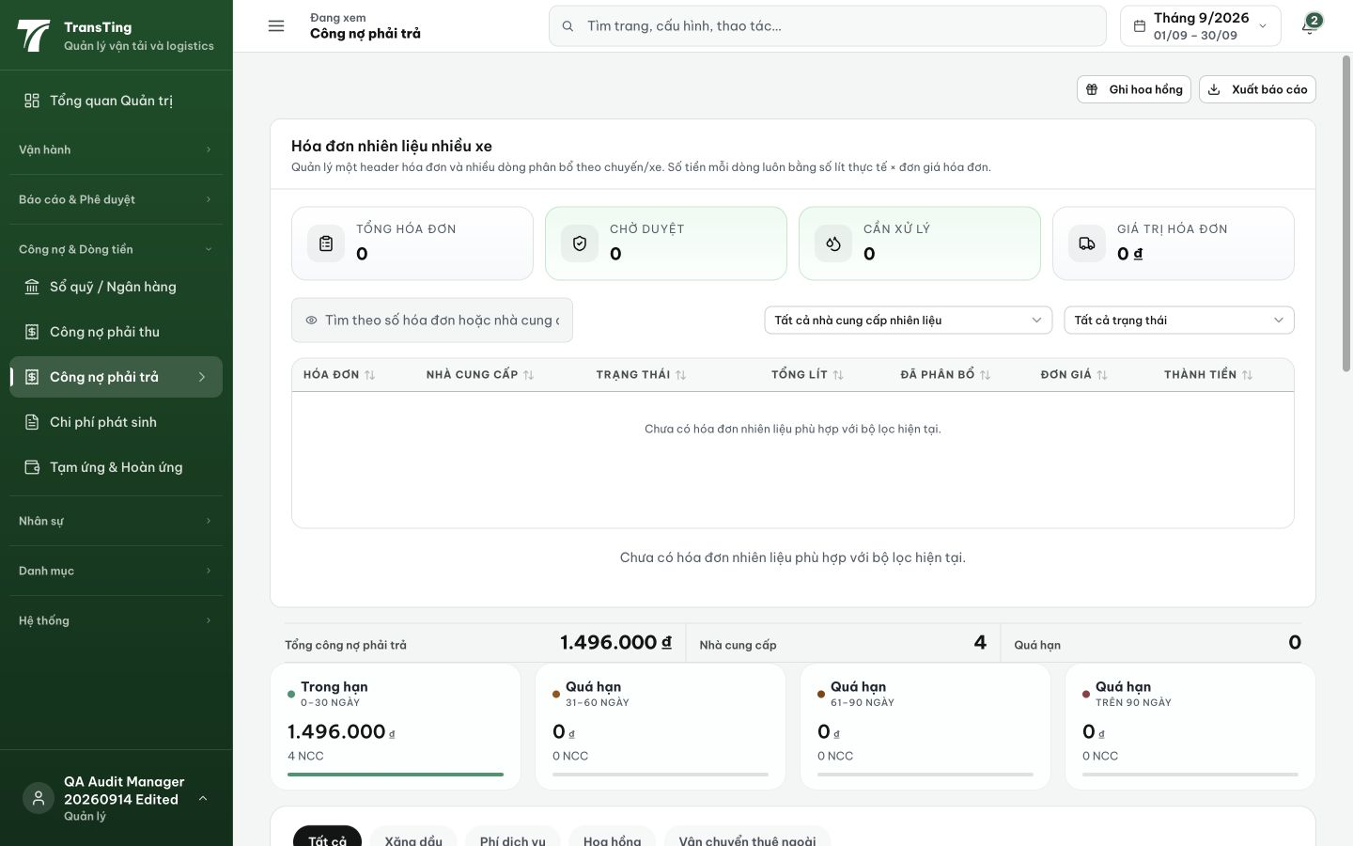
Figure 1. Desktop at 1440 × 900: the empty fuel-invoice workspace spans approximately y126–646. The supplier debt summary appears beneath it; supplier records are below the viewport.

Evidence 2
  - Prioritize supplier debt lookup on the payables page
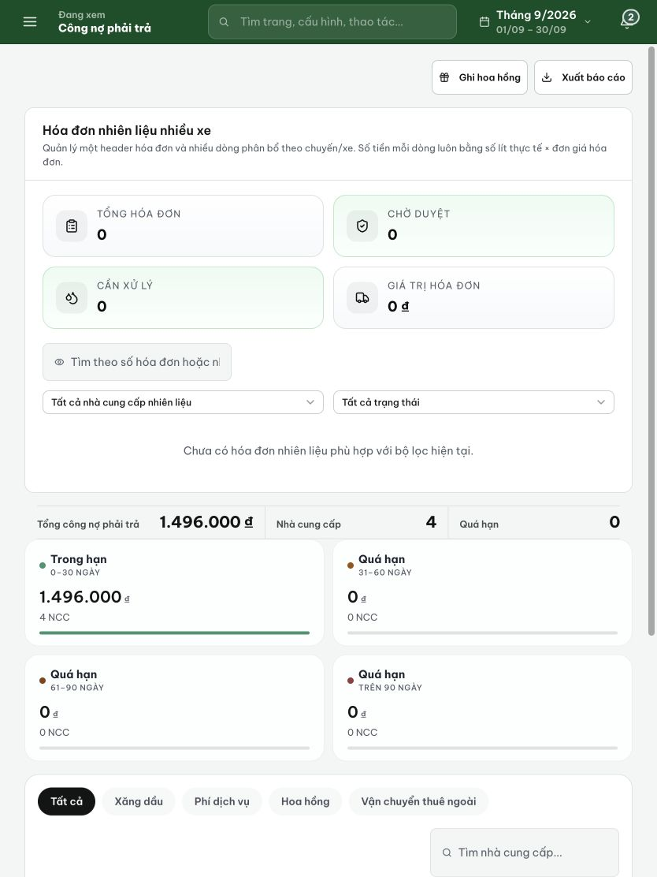
Figure 2. Tablet at 834 × 1112: zero-value invoice tiles and filters precede the debt summary and aging cards. Supplier tabs begin near the bottom; no supplier record is initially visible.

