Show CUS shipment records sooner with compact filters
  - QA-098 | P3 | Enhancement | TODO
Environment: Staging https://vantai.tingting.vip
Reviewed: 14 September 2026
Role: CUS — 1440 × 900 desktop, 834 × 1112 tablet and 390 × 844 phone
Page: https://vantai.tingting.vip/shipments; https://vantai.tingting.vip/shipments-detail?dateScope=all

Existing behaviour
Both lists expand every filter and action row with blank dates and all selection values. Phone records start around y590 on the overview and y651 on the detail list; neither first record fits completely. Tablet records start around y436 and y516. This concerns controls above records, not filtering correctness.

Target behaviour
Keep search and primary actions compact. Put secondary criteria behind a labeled control with visible active-filter counts and values. Use desktop width without nested filter cards.

Impact
Expanded criteria leave less of the shipment and container working lists visible.

Cause and investigation
Hypothesis: all criteria remain expanded before records. Shared implementation is unverified.

Steps to reproduce
1. Open Tổng quan lô hàng as CUS with blank query/delivery dates and all type/plan values.
2. At phone and tablet widths, note the expanded controls and first-record position.
3. Repeat on Chi tiết lô hàng with dateScope=all, blank query/transport dates and all customer/type/status values; compare desktop.

Acceptance criteria
1. Reduce space above phone/tablet records while keeping search and primary actions reachable. Secondary filters use a named, discoverable control.
2. When collapsed, show active-filter counts and selected values. Reopening preserves selections; users can identify and remove active criteria.
3. Preserve delivery/transport date meanings, ranges and Hôm nay/Hôm sau/Tất cả behavior. Keep all-dates and reset state clear, distinct from the global reporting month.
4. Preserve search/apply behavior, options, creation/export, summaries and pagination. Rearranging controls must not silently apply or discard criteria.
5. Use compact aligned desktop controls and a single filter surface, without nested cards or oversized text. Preserve readable labels and adequate touch targets.
6. Verify active filters, long labels, empty results and expanded controls at all widths, with keyboard focus, disclosure state and logical navigation.

Requirement reference
Current staging Chrome evidence; user request for compact data-heavy UI.

Evidence 1
  - Show CUS shipment records sooner with compact filters

Figure 1. Overview at 390 × 844: expanded query, date/type/plan fields and action rows precede the summaries; the first record starts around y590 and is incomplete at the bottom.

Evidence 2
  - Show CUS shipment records sooner with compact filters
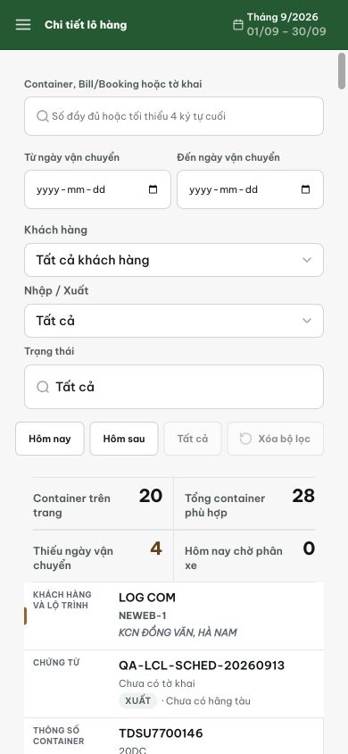
Figure 2. Detail list at 390 × 844, all dates: search, five secondary criteria and date/reset actions remain expanded. The first container record starts around y651.

Evidence 3
  - Show CUS shipment records sooner with compact filters
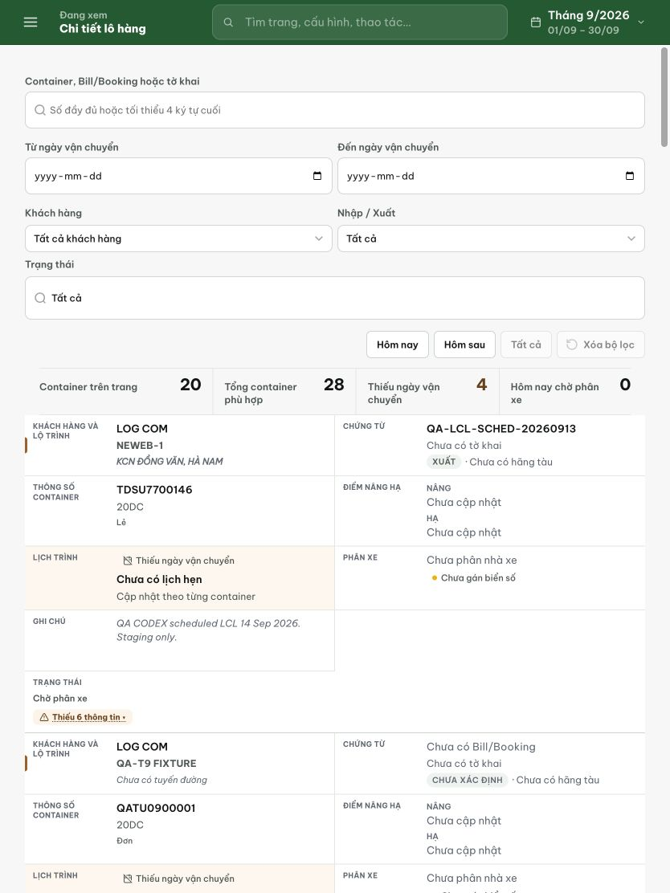
Figure 3. Detail list at 834 × 1112, all dates: several filter rows, date/reset actions and counts precede the first record at approximately y516.

