Show nonempty accounting queues before large empty sections
  - QA-101 | P3 | Enhancement | TODO
Environment: Staging https://vantai.tingting.vip
Reviewed: 14 September 2026
Role: ACCOUNTANT · 390 × 844, 834 × 1112, 1440 × 900
Page: /accounting · Công việc

Existing behaviour
The work page shows Sẵn sàng xử lý 0 as a large empty panel above Đang bị chặn 7. It occupies about 180 px on the phone and 165 px on tablet and desktop. On the phone, the first blocked record begins around y537; its action is below the initial viewport. The panel repeats the zero count with a centered empty-state message.

Target behaviour
Represent an empty work state as a compact status row with its count and refresh control. Give nonempty work the main visible area. Use relevant data completeness and processing blockers in the simplified workflow; do not require or reintroduce internal approval steps.

Impact
Accountants scroll past an empty bucket before reviewing records that need follow-up.

Cause and investigation
Review the empty queue layout and section hierarchy. This is a presentation enhancement; no queue classification or navigation failure is claimed.

Steps to reproduce
1. As Accountant, open Công việc with zero ready records and seven blocked records.
2. Inspect the initial viewport at 390 × 844, 834 × 1112 and 1440 × 900. Compare the empty panel height with the start of the blocked list.

Acceptance criteria
1. Use a compact empty state so the first nonempty queue and more of its first record appear sooner; avoid a large empty card or duplicate message.
2. Retain relevant counts, refresh controls, record identities, data or processing blockers and valid direct actions. Distinguish actionable records from records missing required information.
3. Handle both queues populated, both empty, loading and errors without hiding status or causing disruptive focus or scroll jumps.
4. At all three widths, keep text readable, controls easy to touch and keyboard accessible, and desktop rows compact. The layout must support the workflow without internal reviewer or approver queues.

Requirement reference
Fresh Accountant work queue captures and the requested compact interface.

Evidence 1
  - Show nonempty accounting queues before large empty sections
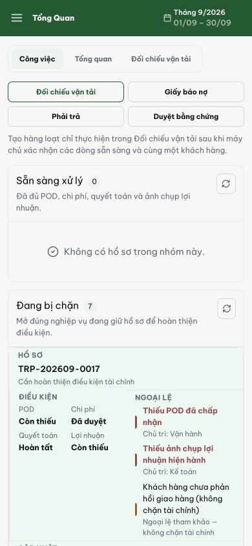
Figure 1. Phone 390 px: the empty ready panel occupies about 180 px; the first blocked record begins around y537 and its action is below this viewport.

Evidence 2
  - Show nonempty accounting queues before large empty sections
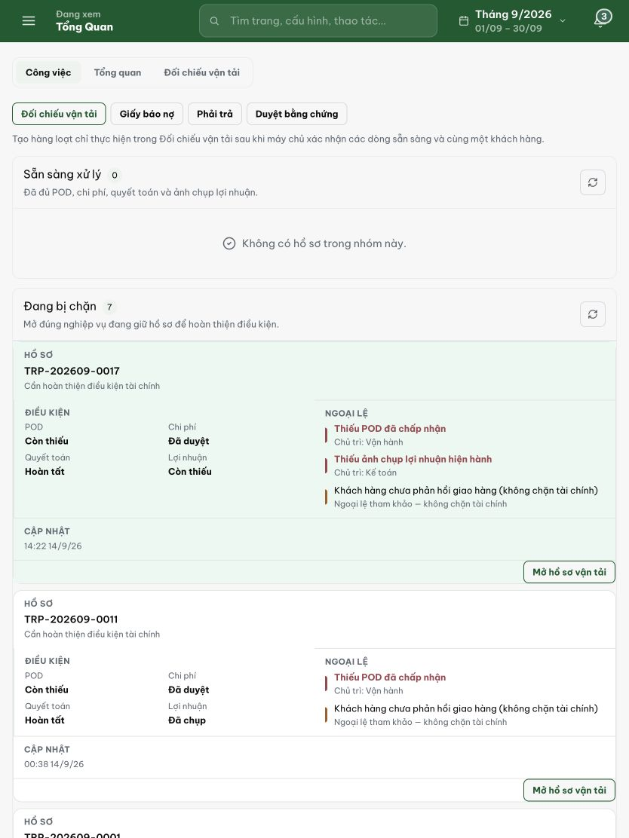
Figure 2. Tablet 834 px: a large empty ready panel precedes seven blocked records, reducing the records visible at once.

Evidence 3
  - Show nonempty accounting queues before large empty sections
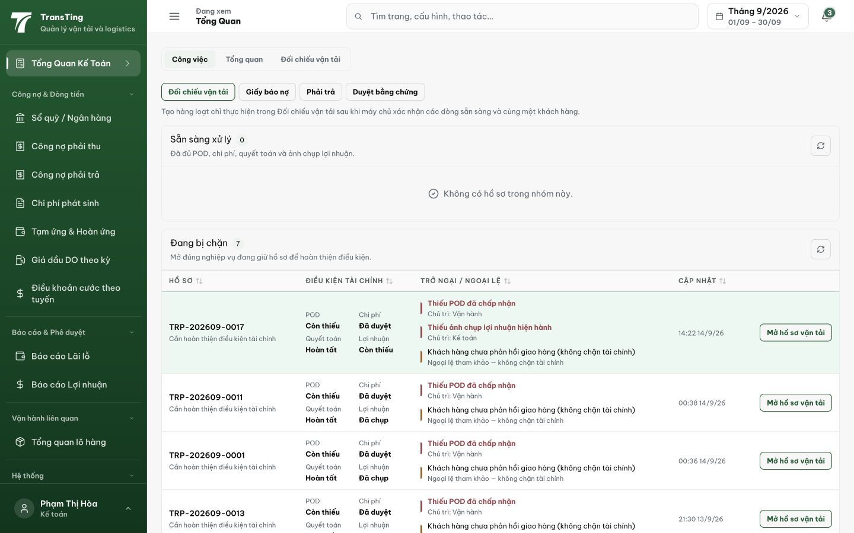
Figure 3. Desktop 1440 px: the empty ready panel spans the work area above the compact blocked-record table.

