Prioritize account ledgers with compact debt summaries
  - QA-102 | P3 | Enhancement | TODO
Environment: Staging https://vantai.tingting.vip
Reviewed: 14 September 2026
Role: Accountant — desktop 1440 × 900, tablet 834 × 1112 and phone 390 × 844
Page: https://vantai.tingting.vip/debt/1 and https://vantai.tingting.vip/payables/2

Existing behaviour
Receivable details stack four summary cards above a second expanded aging panel. On phone, the four cards occupy about 414 pixels; aging begins near the bottom of the first screen. On tablet, repeated balances, a bar and four aging tiles put record navigation near pixel 938. Payable details likewise place a large aging panel and layered period controls ahead of transactions. Three empty aging buckets receive substantial space in both observed accounts.

Target behaviour
Prioritize the account ledger beneath a compact identity, balance and risk summary. Present aging in a concise strip or disclosure while keeping every bucket, amount and drilldown available.

Impact
Users scroll through repeated account summaries before reaching routine ledger review and filtering.

Cause and investigation
Hypothesis: summary and aging components repeat information without a shared compact account-detail hierarchy. Implementation is unverified.

Steps to reproduce
1. Open the customer account from Công nợ phải thu as Accountant; inspect the initial phone and tablet views.
2. Compare summary cards, aging detail and the position of record navigation. Open a supplier account from Công nợ phải trả and compare the same hierarchy.

Acceptance criteria
1. Combine repeated summary values and risk information into a compact region. Show meaningful warnings immediately; make all aging buckets and explanatory details easy to expand.
2. In the observed fixtures, expose ledger navigation and core filters within the initial phone and tablet viewport. Avoid nested summary cards and dedicated tall cards for empty aging buckets.
3. Keep period selection and transaction filters in a compact coherent toolbar. Preserve current versus period balances, dates, account context and active filter values.
4. Retain aging drilldowns, payment and statement actions, permissions and transaction content. This change must not alter financial calculations or hide overdue balances.
5. Verify empty, single-bucket and mixed-aging accounts at all three widths. Maintain readable figures, visible focus and approximately 44-pixel phone touch targets without oversized headings or fields.

Requirement reference
Current staging Chrome captures and viewport metadata.

Evidence 1
  - Prioritize account ledgers with compact debt summaries

Figure 1. Receivable account at 390 × 844: four full-width summary cards precede the expanded aging panel, with record navigation below the initial view.

Evidence 2
  - Prioritize account ledgers with compact debt summaries
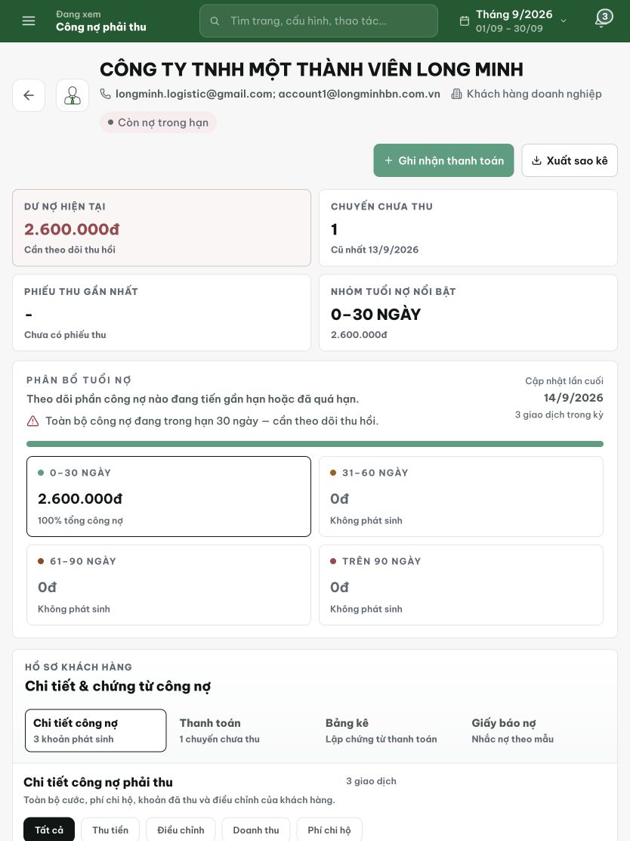
Figure 2. Receivable account at 834 × 1112: summary cards and the expanded aging panel repeat the balance before record navigation near the bottom.

Evidence 3
  - Prioritize account ledgers with compact debt summaries
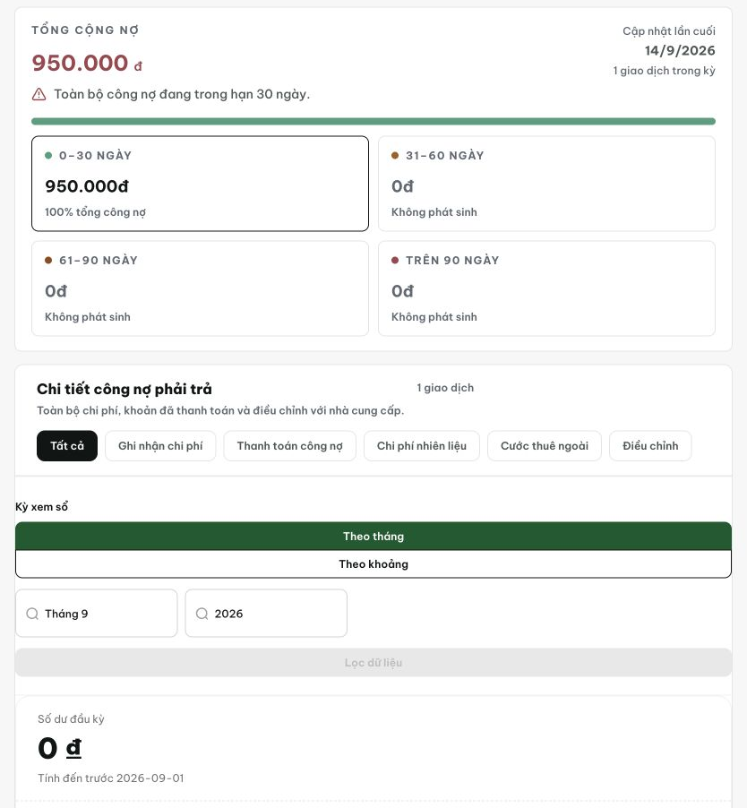
Figure 3. Supplier account at 834 × 1112, cropped below contact details: the expanded aging panel and stacked period controls precede transaction content. The crop preserves the original pixels.

