Make Ops work queue records easier to scan
  - QA-103 | P3 | Enhancement | TODO
Environment: Staging https://vantai.tingting.vip
Reviewed: 14 September 2026
Role: OPS · 390 × 844, 834 × 1112, 1440 × 900
Page: /my-orders · Lệnh giao nhận

Existing behaviour
At 390 px, the first record occupies about 410 px; at 834 px it occupies about 430 px. Each card repeats container and driver identity, then separates information, milestones, status, blockers, update time and action into full rows. Only one complete record fits on the phone below the controls. The desktop table is more compact.

Target behaviour
Use a compact operational card with clear shipment identity, assigned vehicle and driver, current blocker and next action. Group related metadata, combine completed milestones and remove repeated identity text while preserving details and terminal-state guidance.

Impact
Ops staff must scan and scroll through repeated information to compare jobs and find the next action.

Cause and investigation
Review responsive record grouping and spacing. This is a layout enhancement; the captured action outcomes and permissions were not tested.

Steps to reproduce
1. As Ops, open /my-orders with the two current Cần làm records, SHP-2609-00020 and SHP-2609-00023.
2. Compare the first record at 390 × 844 and 834 × 1112 with the compact desktop table at 1440 × 900.

Acceptance criteria
1. Materially reduce the captured 410–430 px card height without shrinking readable text or touch controls; show more of the work list in the same viewport.
2. Keep shipment and container identity, driver, vehicle, meaningful milestones, blocker ownership, update time and valid next action available and clearly related.
3. Avoid repeating the same identity in the header and information area; group secondary details without obscuring blockers or the primary action.
4. Verify active, waiting and terminal records, long names and multiple containers at all three widths. Preserve keyboard access, permissions and the compact desktop table.

Requirement reference
Fresh Ops work queue captures and the requested compact data-heavy interface.

Evidence 1
  - Make Ops work queue records easier to scan
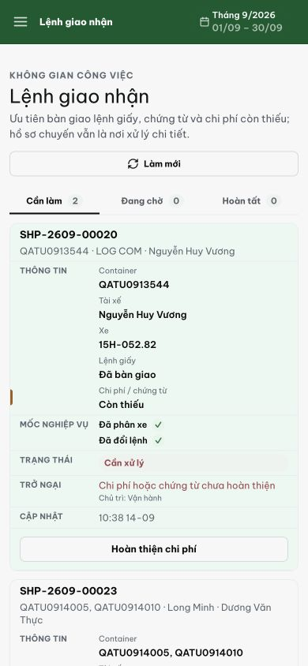
Figure 1. Phone 390 px: the first record spans approximately y314–724, leaving only the next record header and initial fields visible.

Evidence 2
  - Make Ops work queue records easier to scan
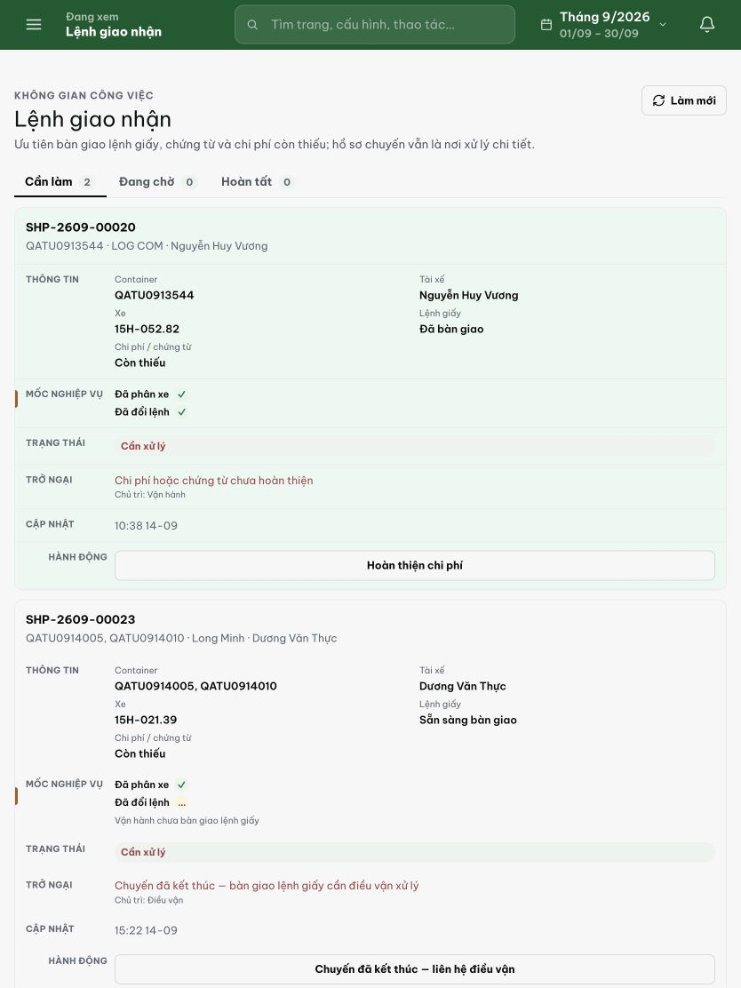
Figure 2. Tablet 834 px: the first record still spans approximately 430 px despite the wider content area.

Evidence 3
  - Make Ops work queue records easier to scan
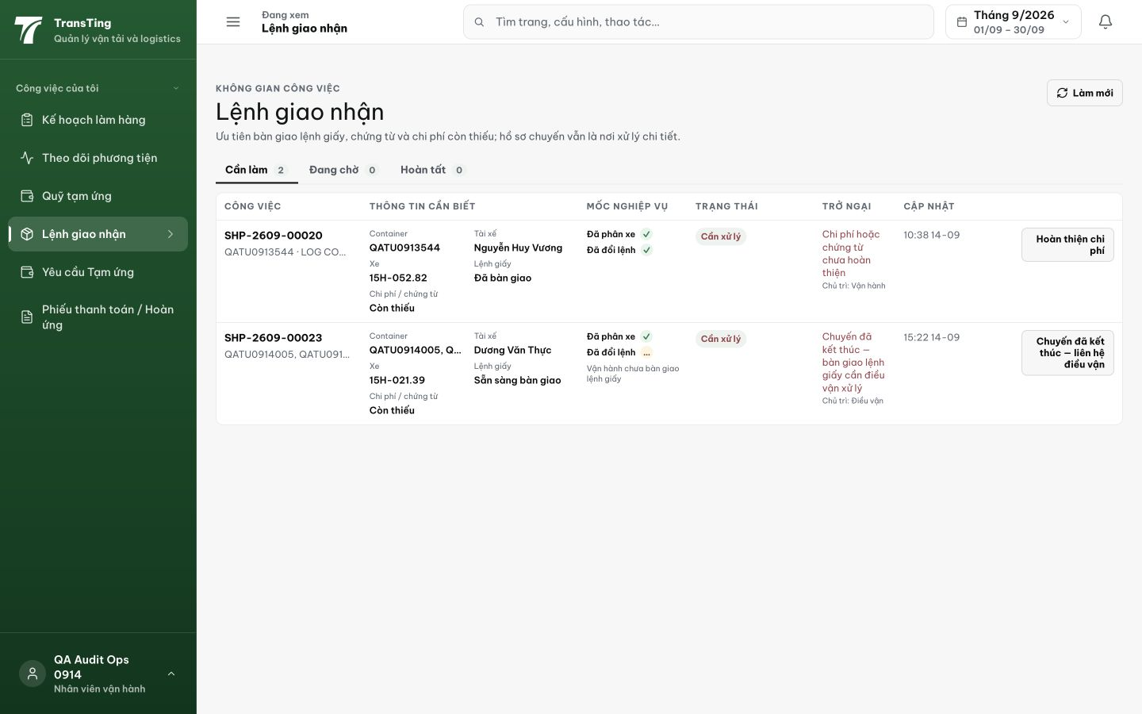
Figure 3. Desktop 1440 px: the same two records use a compact table. Preserve this comparison density while improving narrower layouts.

