Keep empty ancillary services below core trip information
  - QA-109 | P3 | Enhancement | TODO
Environment: Staging https://vantai.tingting.vip
Reviewed: 14 September 2026
Role: Admin — desktop 1440 × 900, tablet 834 × 1112 and phone 390 × 844
Page: https://vantai.tingting.vip/trips/21

Existing behaviour
For TRP-202609-0019, Dịch vụ đi kèm contains no services but occupies an approximately 280-pixel illustration panel before Thông tin cơ bản on desktop and tablet. The core vehicle, driver, trailer and date facts start below that empty section. The phone view already presents basic trip information first. Header actions are visible; this finding does not claim that starting or editing a trip is blocked.

Target behaviour
Place core trip information before optional empty services. Represent the empty ancillary section with a concise row or disclosure below the operational facts, retaining access to add and inspect services.

Impact
A large empty section consumes the most useful screen area before users can scan basic trip facts.

Cause and investigation
Hypothesis: the optional service section uses the same prominent placement and spacious empty state regardless of whether services exist. Source implementation is unverified.

Steps to reproduce
1. As Admin, open the trip list and open TRP-202609-0019 at /trips/21.
2. Compare the empty Dịch vụ đi kèm panel and the position of Thông tin cơ bản on desktop and tablet, then compare the phone ordering.

Acceptance criteria
1. At desktop and tablet widths, core trip facts precede the empty ancillary-services section. Preserve the phone view’s useful basic-information-first order.
2. Replace the large empty illustration panel with a compact descriptive row or disclosure. Avoid a fixed tall blank section when no services exist.
3. Keep existing service entry points easy to find. Populated services must retain their descriptions, amounts, editing access and relevant billing links.
4. Keep trip identity, status and primary actions prominent. Preserve vehicle, driver, trailer, dates, container information and financial figures.
5. Verify trips with zero, one and several services at all three widths. Use readable type, compact spacing, keyboard access and appropriate phone touch targets; do not change service calculations or introduce approval steps.

Requirement reference
Current staging trip-detail captures across three viewport sizes.

Evidence 1
  - Keep empty ancillary services below core trip information
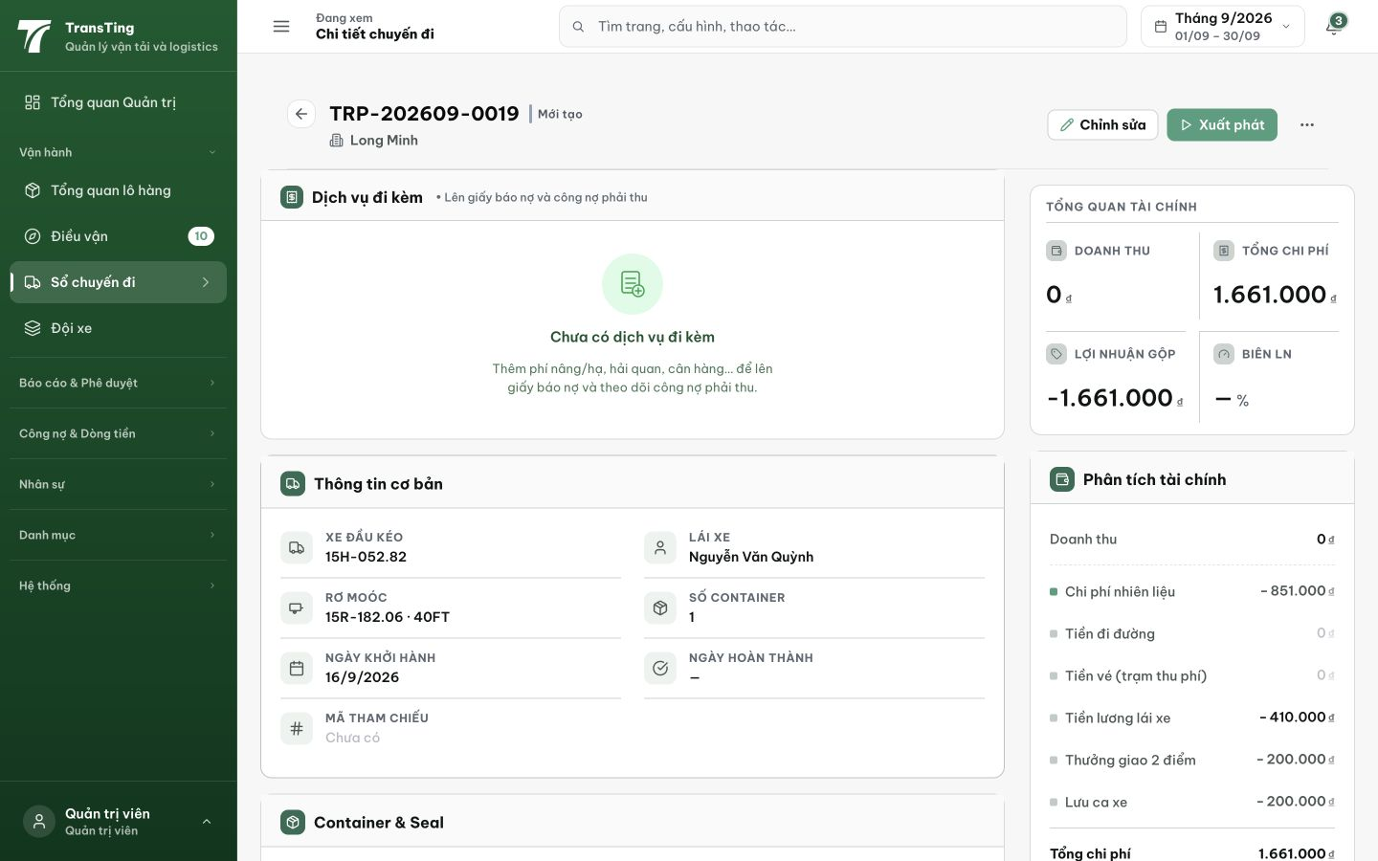
Figure 1. Desktop 1440 × 900: the empty ancillary-services panel spans approximately y178–459, with basic trip information starting beneath it.

Evidence 2
  - Keep empty ancillary services below core trip information
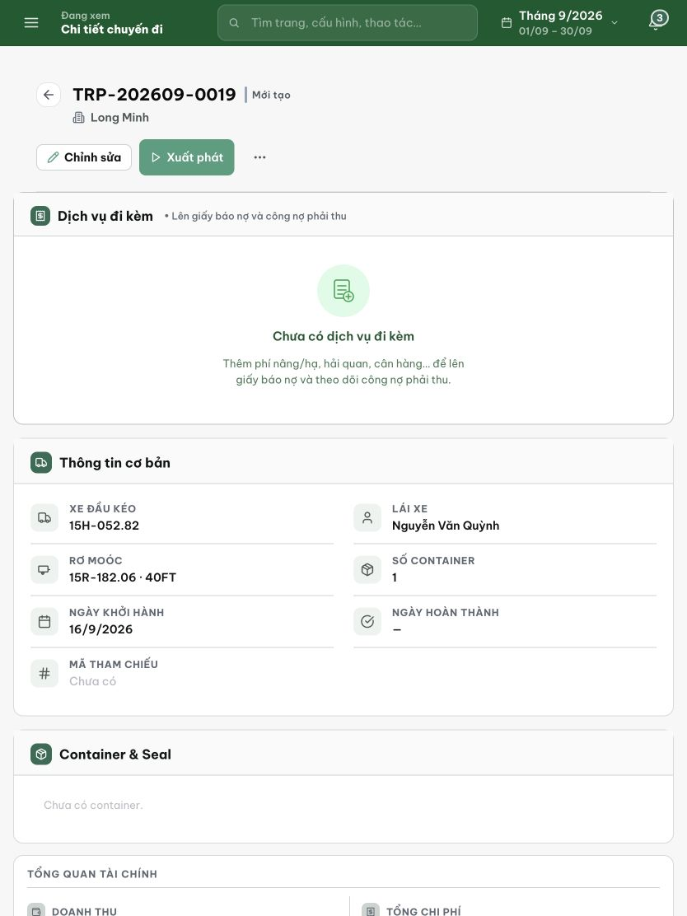
Figure 2. Tablet 834 × 1112: the same large empty panel precedes vehicle, driver and other operational facts.

Evidence 3
  - Keep empty ancillary services below core trip information
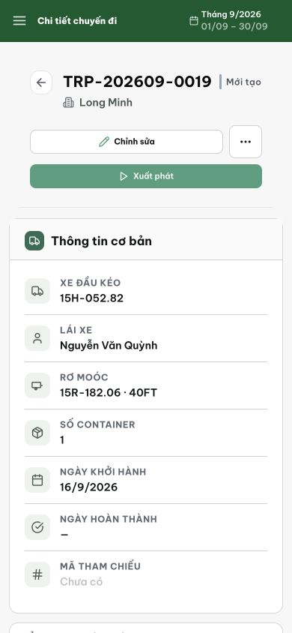
Figure 3. Phone 390 × 844 comparison: basic trip information is already the first content section below the header actions. Preserve this ordering.

