Keep fleet trailer identifiers intact at tablet widths
  - QA-111 | P3 | Bug | TODO
Environment: Staging https://vantai.tingting.vip
Reviewed: 14 September 2026
Role: Admin — tablet 834 × 1112, with desktop and phone comparisons
Page: https://vantai.tingting.vip/fleet

Existing behaviour
The tablet truck table fragments short trailer identifiers inside nested badges. RM becomes R above M, 40FT becomes 40F above T or 40 above FT, and the first trailer plate wraps as 15R- above 182.06. This repeats across multiple rows in a fresh settled capture. Desktop keeps the same tokens together. The phone card shows the trailer plate on one line. Data values are not claimed to be wrong.

Target behaviour
Keep each trailer plate, type and short prefix readable as an intact unit. Allocate space to operational identifiers and use a compact grouping that does not fragment tokens inside padded badge containers.

Impact
Operators must reconstruct familiar trailer codes across lines, slowing vehicle-to-trailer comparison.

Cause and investigation
Hypothesis: shrinkable nested badge elements allow internal word breaking before the table allocates enough space to the identifier group. Implementation is unverified.

Steps to reproduce
1. Open Đội xe as Admin at 834 × 1112.
2. Inspect the Rơ-moóc column for the first several trucks, including trailer 15R-182.06. Compare its prefix, plate and type with the desktop view.

Acceptance criteria
1. RM, 40FT and equivalent short type labels do not split character by character. Trailer plates remain intact and easy to compare.
2. When space requires multiple lines, wrap between complete identifier and type units. Avoid a miniature card or excessive padding inside the table cell.
3. Keep the relationship between truck, trailer, assigned driver and tire action clear. Preserve stored values and existing navigation.
4. Verify common and longer plate formats, missing trailer/type data and narrow tablet breakpoints, plus desktop and phone. Preserve compact rows, readable typography and visible keyboard focus.
5. Do not solve the issue by hiding meaningful type information, reducing text to an unreadable size or making the whole table unnecessarily wide.

Requirement reference
Fresh settled staging screenshot and cross-width comparison.

Evidence 1
  - Keep fleet trailer identifiers intact at tablet widths
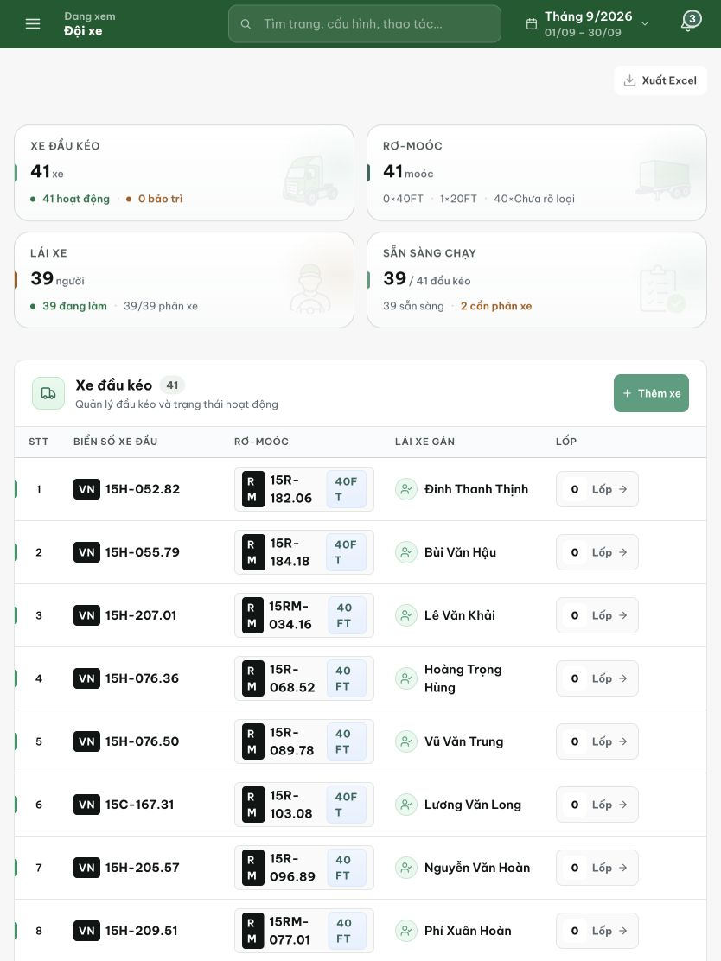
Figure 1. Fresh tablet capture at 834 × 1112: RM, trailer plates and 40FT split across lines inside the Rơ-moóc cells, including the first row.

