Prioritize required trip fields with compact estimate and progress summaries
  - QA-120 | P3 | Enhancement | TODO
Environment: Staging https://vantai.tingting.vip
Reviewed: 14 September 2026
Role: Admin — desktop 1440 × 900, tablet 834 × 1112 and phone 390 × 844
Page: https://vantai.tingting.vip/trips/new

Existing behaviour
Large estimate and completion cards precede required fields on desktop and tablet. The fresh desktop panel spans approximately y92–470; fields start at y493. Zero estimates and incomplete progress occupy much of the initial view. Phone already presents fields first. The fixed footer usefully identifies missing fields.

Target behaviour
Put essential trip entry first. Use a compact estimate/progress summary or adjacent desktop area, retaining the full breakdown, phone field-first ordering and validation footer.

Impact
Large secondary panels reduce useful space for entering the information needed to create a trip.

Cause and investigation
Hypothesis: prominent secondary summaries displace primary entry fields. Source implementation is unverified.

Steps to reproduce
1. As Admin, open Tạo chuyến đi at /trips/new without entering data.
2. Compare the estimate/completion panels and first required fields at desktop, tablet and phone widths.

Acceptance criteria
1. Place the first required fields close to the form introduction on desktop and tablet; avoid a large stacked summary block before data entry.
2. Use a concise estimate and progress treatment with access to complete costs, revenue and completion details. Preserve all values and calculation behavior.
3. Keep required-field feedback and the create/cancel actions easy to find. Retain a logical keyboard order and visible focus.
4. Preserve the phone’s field-first ordering. Use readable type, compact spacing and suitable touch targets without enlarging headings or adding nested decorative cards.
5. Verify empty, partially completed and completed forms at all three widths. Summary updates and validation must remain understandable without covering fields or hiding errors.

Requirement reference
Current staging captures and user request for compact, data-heavy UI.

Evidence 1
  - Prioritize required trip fields with compact estimate and progress summaries
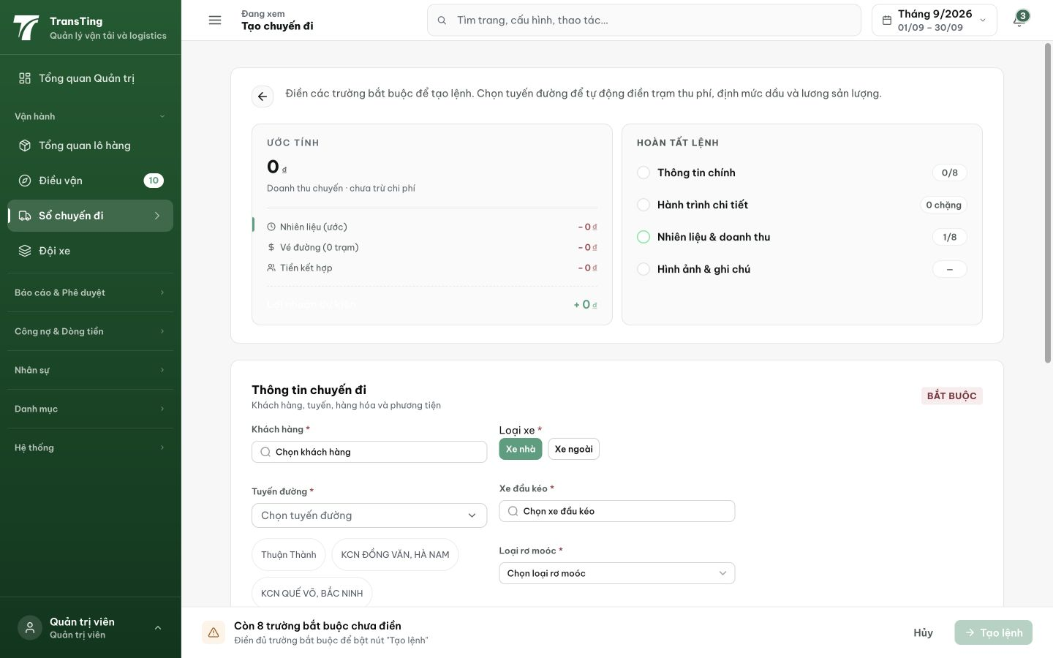
Figure 1. Fresh desktop 1440 × 900: the large estimate/progress panel occupies y92–470 before the required-field section at y493.

Evidence 2
  - Prioritize required trip fields with compact estimate and progress summaries
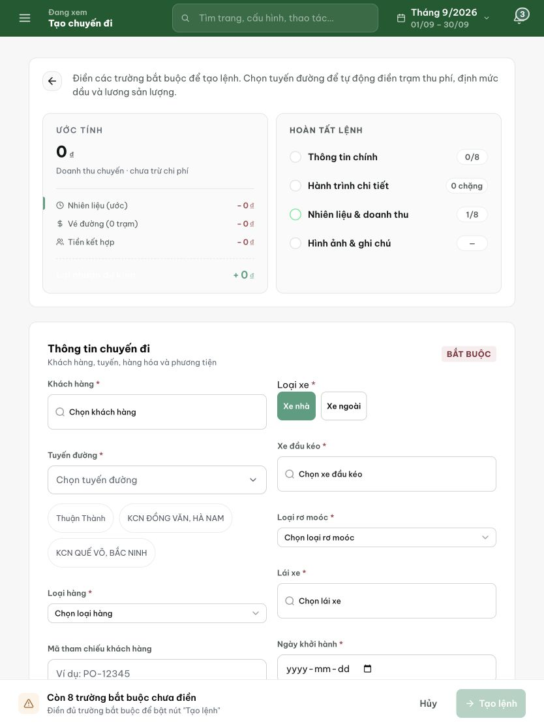
Figure 2. Tablet 834 × 1112: the two summary cards still precede the primary trip fields.

Evidence 3
  - Prioritize required trip fields with compact estimate and progress summaries

Figure 3. Phone 390 × 844 comparison: required fields appear directly below the introduction, with missing-field feedback in the footer. Preserve this useful ordering.

