# **Google Cloud API – OCR Service Activation and Configuration**

**OPEN “Google Cloud SDK Shell”**

**Ein Bild, das Screenshot, Text, Multimedia-Software, Software enthält.
**

**LOGIN**

gcloud auth login

* Login in Browser

You are now logged in as [v.brazhnik@web.de].

Your current project is [candoimage-521377].

**CREATE NEW CONFIGURATION**

gcloud init

Choose “[1] Re-initialize this configuration [default] with new settings”

Login with Account “[3] [vlabra.development@gmail.com](mailto:vlabra.development@gmail.com)”

Create Project, if not already existing

Welcome! This command will take you through the configuration of gcloud.

Your Google Cloud SDK is configured and ready to use!

**ENABLE OCR SERVICE**

gcloud services enable vision.googleapis.com

**LOGIN TO SAVE CREDENTIALS**

DefaultCredentialsError: Your default credentials were not found. .com/docs/authentication/external/set-up-adc for more information.

gcloud auth application-default login

Credentials saved to file: [C:\Users\vbraz\AppData\Roaming\gcloud\application_default_credentials.json]

These credentials will be used by any library that requests Application Default Credentials (ADC).

Quota project "toolbox-scanner-ocr" was added to ADC which can be used by Google client libraries for billing and quota. Note that some services may still bill the project owning the resource.

**ENABLE BILLING IN PROJECT DASHBOARD**

PermissionDenied: 403 This API method requires billing…

https://console.developers.google.com/billing/enable?project=709683009801 then retry.

*Make sure to register a payment method:*

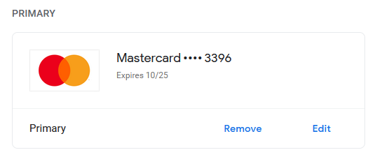

*Check if project has payment method registered:*

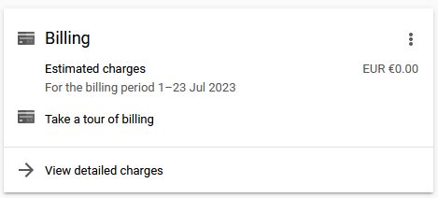

*Check if Billing Account is assigned to the right project:*

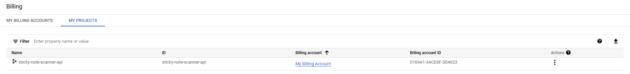

_____________________________________________________

**CMD Commands**

gcloud

Login:

gcloud auth login

Show Projects:

gcloud projects list

Select Project:

gcloud config set project 192638466873