Add your own robot to the library
…a step by step guide…
The ARTE library has been designed to let the students add freely more robots to the library. The following example presents how to do so:

0 Summary: Add your own robot to the library
In the reference you can find more information on the steps needed to add a robot to your library. Please read them. The ARTE library has been designed to let the students add freely more robots to the library. In order to do so, the student should be able to:
- Obtain 3D CAD files to represent the robot. Robot manufacturers provide 3D CAD files for their robots.
- Normally, you can either download separate files for each of the links or the whole robot arm in a single file. You will find different CAD formats available. You should choose the STL format preferably, in particular ASCII STL format. In case you have downloaded the arm as a whole, divide it in their independent links. Link0_base is the base, link1_base, link2_base … etc. Each of these links should be exported to STL (STereoLithography) format This is a common format for many CAD software. You can find more information under http://en.wikipedia.org/wiki/STL_(file_format)
- Add a directory to robots/manufacturer. For example, if you want to add the KUKA KR_1000_L750_TITAN, create the directory robots/kuka/KR_1000_L750_TITAN. You may copy a parameters.m file for a similar robot in this directory. Copy link1_base.stl, link2_base.stl… etc to this directory.
- Modify the parameters.m file to adapt it to your robot. In this first practical session you should concentrate on modifying the robot.DH table.
- Each stl file is stored at each of the robot directories. For example, the stl files corresponding to the KUKA KR_1000_L750_TITAN robot arm are stored at robots/kuka/KR_1000_L750_TITAN. Each stl file stores the 3D position of a set of points belonging to the link in coordinates of its own DH reference system. For example link0.stl has the position of the base points in coordinates of DH system 0. Link1.stl stores the position of the points belonging to link1 in coordinates of system 1, etc. The function transform_to_own will help you transform each stl file for each of the reference systems. Before executing transform_to_own, you should create the robot.DH table. Read the transform_to_own help for more details.
>> help transform_to_own
- Test everything. During the next practical sessions you will modify the parameters.m file to add more functionality to your robot, solving the inversekinematic problem, adding dynamics… etc.

1 Obtain 3D CAD files to represent the robot
Robot manufacturers provide 3D CAD files for their robots. They are in different formats. Normally, you can either download separate files for each of the links or the whole robot arm in a single file. You will find different CAD formats available. You should choose the STL format preferably, in particular ASCII STL format. In case you have downloaded the arm as a whole, divide it in their independent links. Link0_base is the base, link1_base, link2_base … etc. Each of these links should be exported to STL (STereoLithography) format This is a common format for many CAD software. You can find more information under http://en.wikipedia.org/wiki/STL_(file_format)
For example, download the files for the ABB IRB6650S 90 390. Go into: http://www.abb.com/product/us/9AAC910011.aspx
Or navigate to www.abb.com→ products→ robotics.
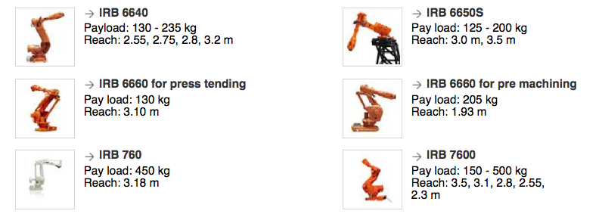
Download the CAD files. Beware of the robot version you are downloading. You can either download the compl (whole arm), or joint (separate links). In this example we will download the joint version. Extract the files and save them under robot/abb/IRB6650S_90_390
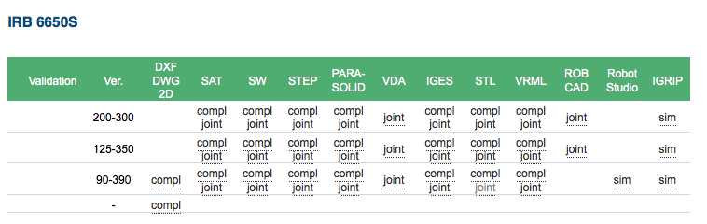

2 Copy the files to the directory of your robot
You may place all the CAD files in the following directory:
arte/robots/abb/IRB6650S_90_390, if we have a look at it:
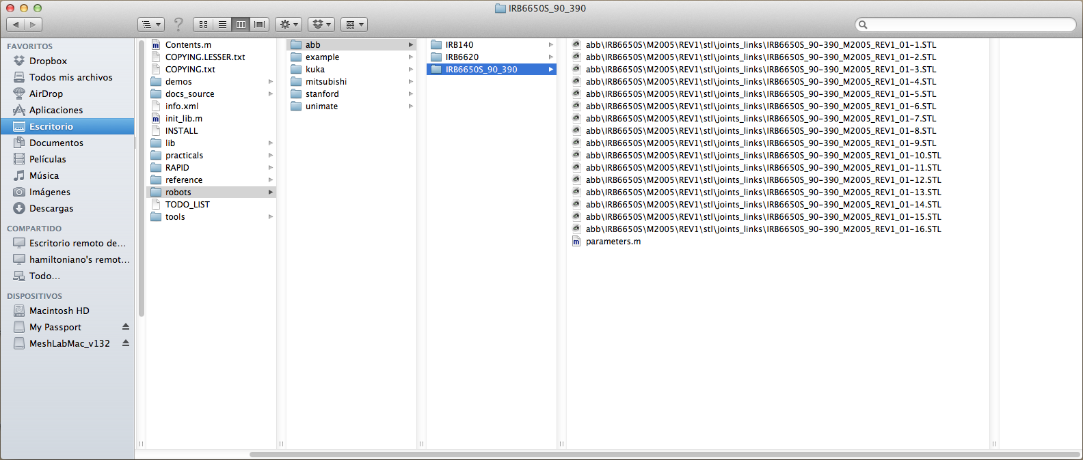
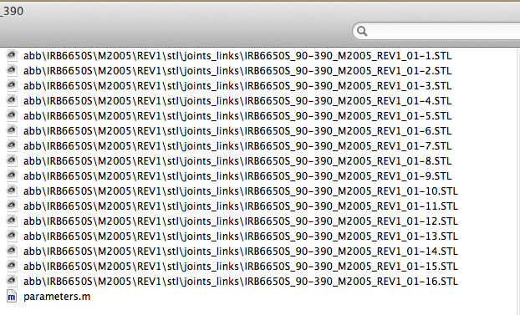
You should also copy a parameters.m file belonging to other robot and place it in the same directory.
Most CAD programs will read the STL files. For example, download and install Meshlab: meshlab.sourceforge.net, for Windows, Mac or Linux. You should now have a look at the files. In Meshlab, open each of the files to view them. If you open the first file, you should find something like:
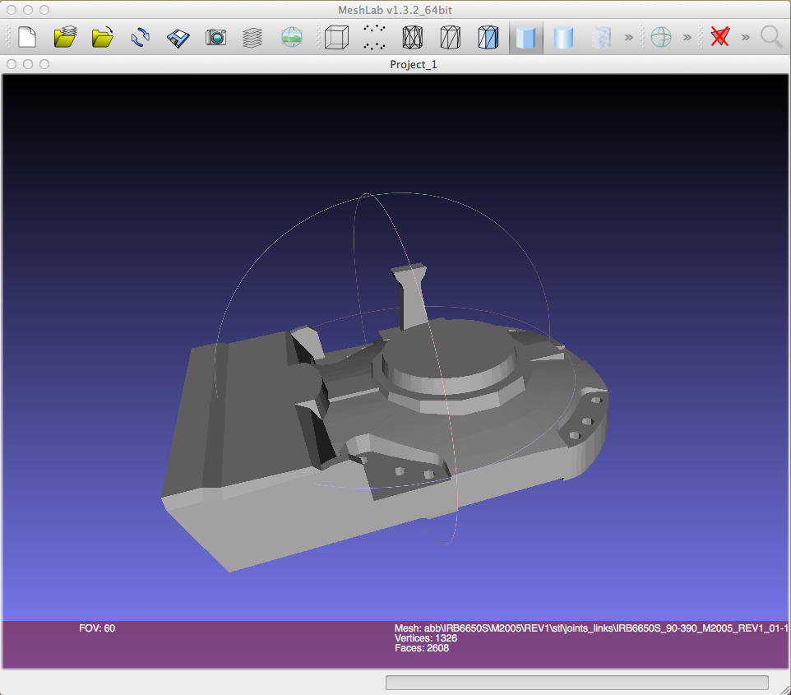
Or, the second file:
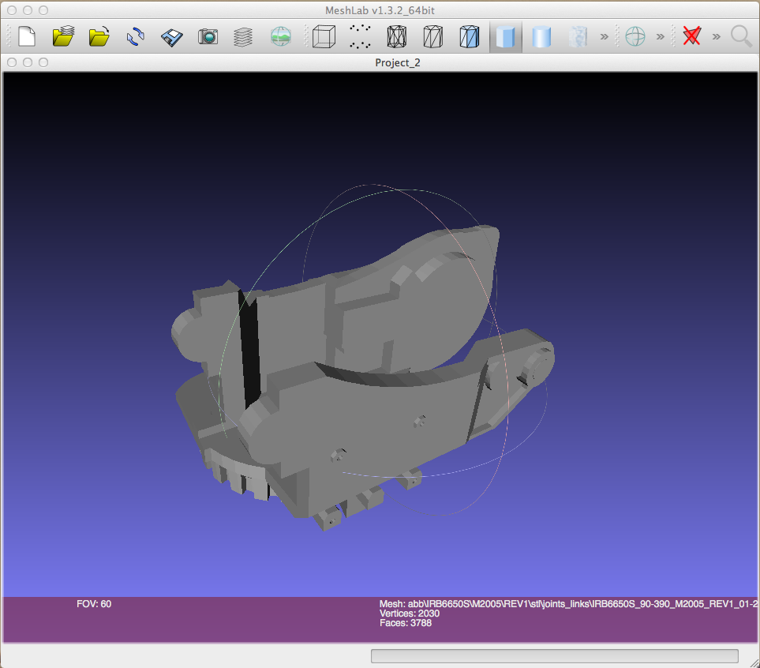
Third file:
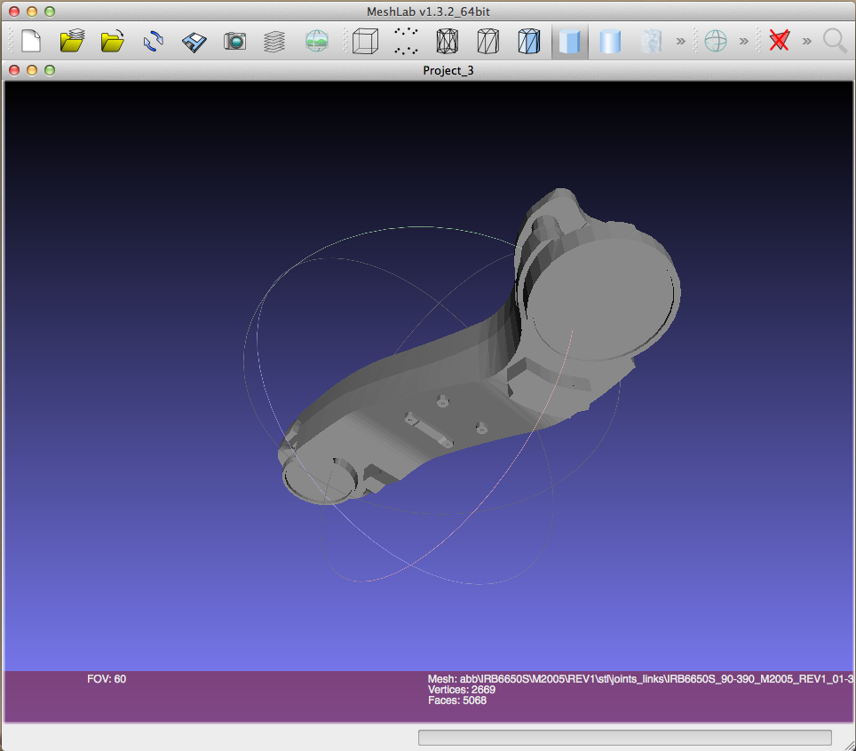

The reader should observe that some of the files constitute the basic shape of some of the robot links, whereas other files are details. You can merge some files into a single file to obtain a more detailed view of any of the links. To do so, you should have a look at the complete robot:
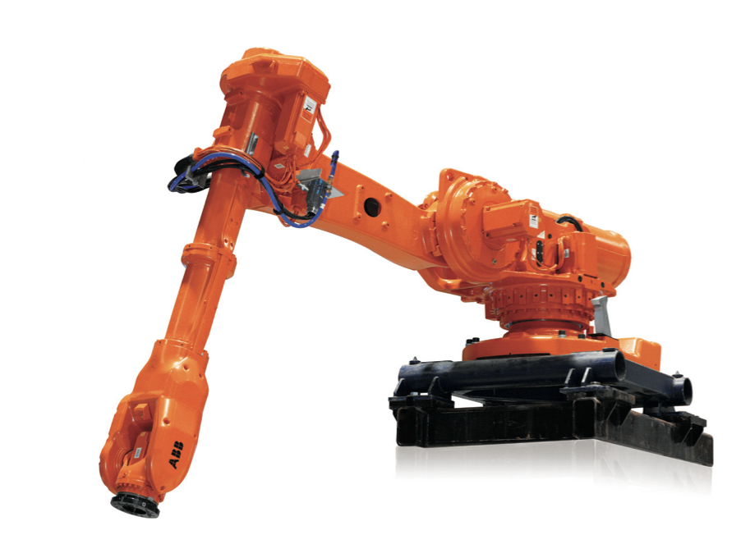
For example, start by opening the files with indexes 2, 8, 11, 12, 16. To do so, click on File→ Import Mesh
Select several files by clicking on Ctrl or cmd button.
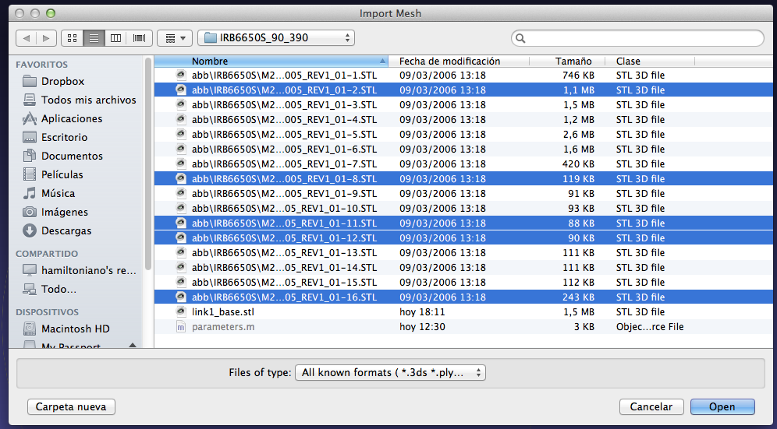
For example, after opening the files with index 2, 8, 11, 12, 16, you should have the following view of link 1.
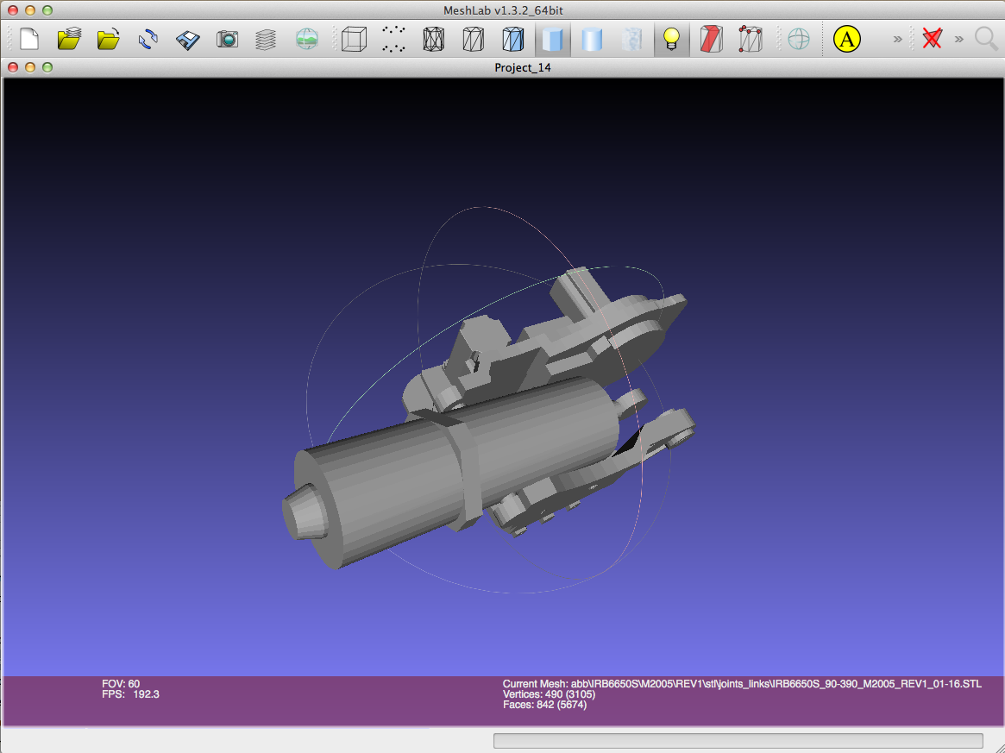
Next, open files 2, 8, 11, 12 and 16. Additionally, you should go to Filters→Layers→ Flatten visible layers
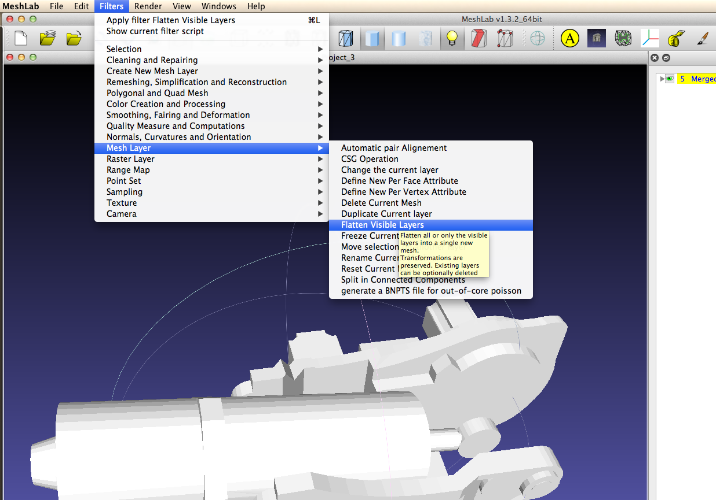
Next, click on Apply to combine the meshes.
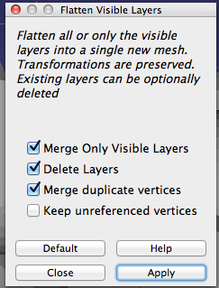

Finally, save the file by selecting File→Export Mesh As. Select STL as format. And name the file as link1_base.stl. The suffix base means that the points in the STL file are referred to the base reference system.
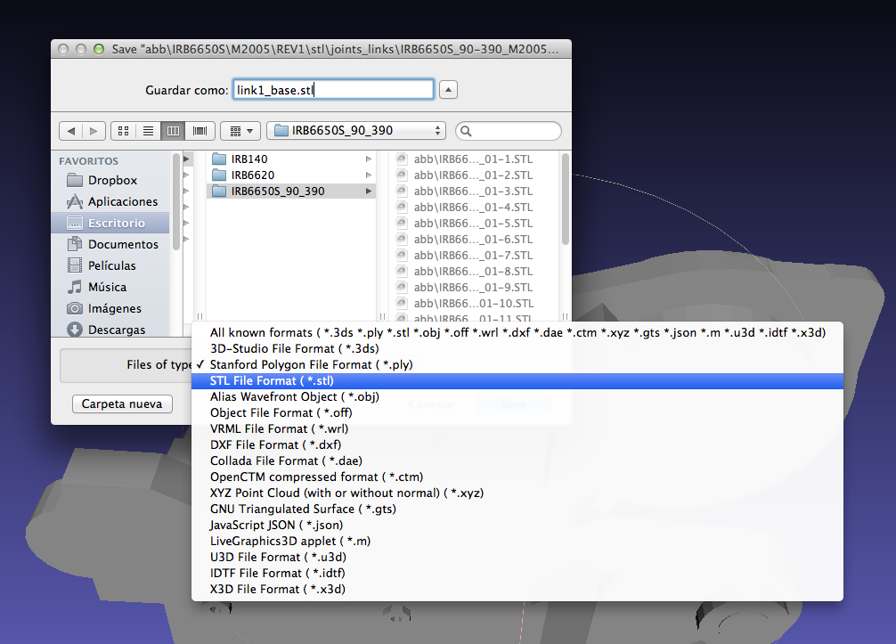

Next, de-select the Binary encoding option, which stores the file in ASCII format, that can be later read by Matlab.
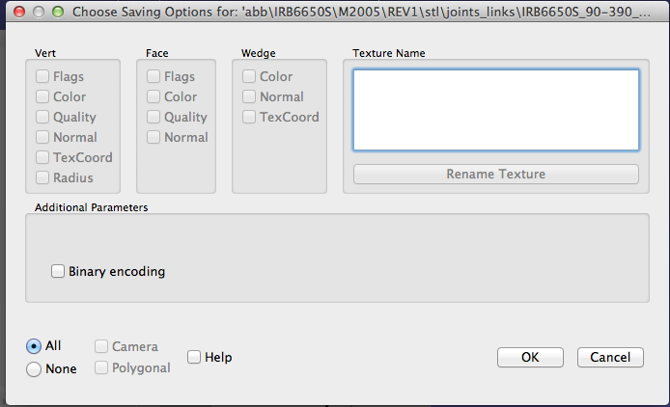
Repeat the process for the rest of the files. The table shows the file indices that should be merged (flattenned) together.

Robot ARTE file | Robot file index
link0_base.stl  Base, system 0 | 1
link1_base.stl  Link 1, system 1. | 2, 8, 11, 12, 16
link2_base.stl  Link 2, system 2. | 3, 9
link3_base.stl  Link 3, system 3. | 4, 10, 13
link4_base.stl  link 4, system 4. | 5, 14, 15
link5_base.stl  link 5, system 5. | 6
link6_base.stl  link 6, system 6. | 7
You can now try to visualize the files in Matlab. To do so, place the current folder in arte_libX.X/robots/IRB6650S_90_390 and type the following commands:
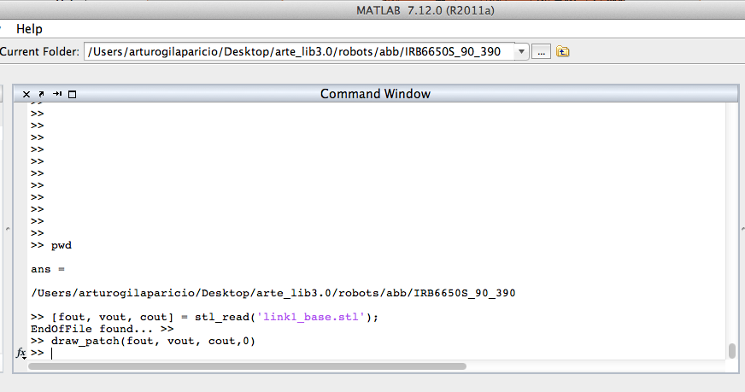

>>[fout, vout, cout] = stl_read('link0_base.stl');
>>draw_patch(fout, vout, [204 51 0]./255,0)
After calling the draw_patch function, the following figure appears:
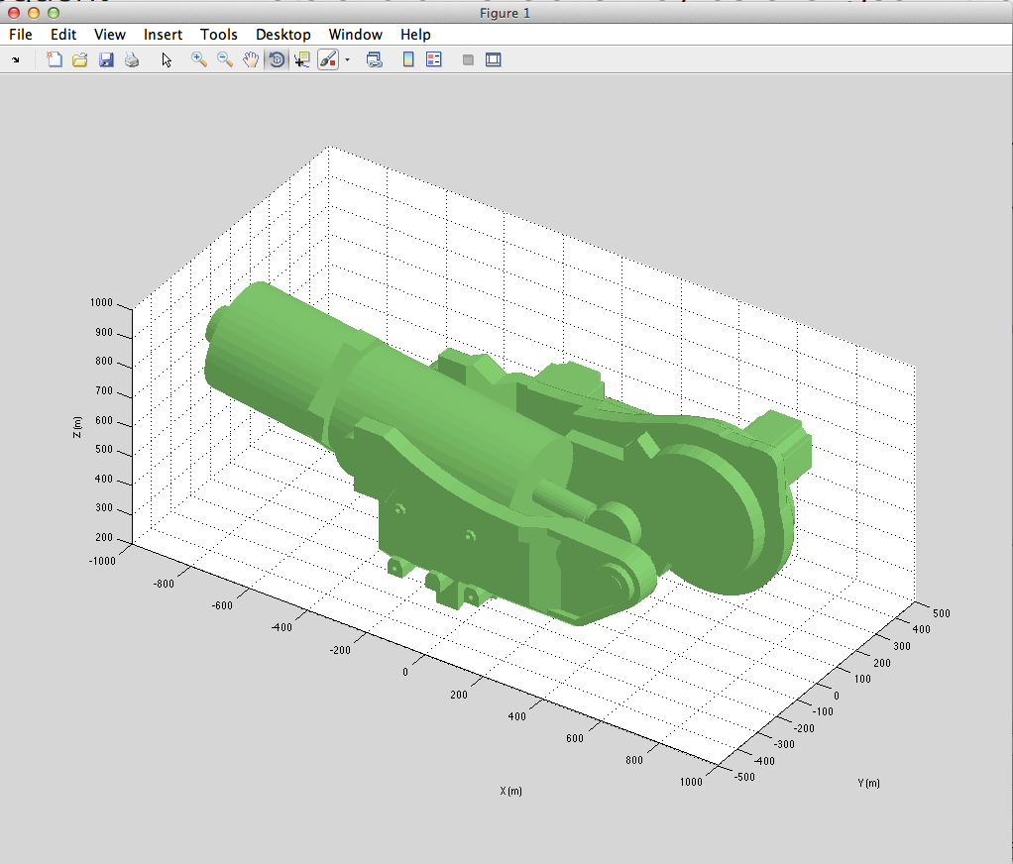
Please, note the scale (mm) and that the origin of the figure is not placed inside the link (points are referred to the base reference system).
>>[fout, vout, cout] = stl_read('link0_base.stl');
>>draw_patch(fout, vout, [204 51 0]./255,0)
>>[fout, vout, cout] = stl_read('link1_base.stl');
>>draw_patch(fout, vout, [204 51 0]./255,0)
>>[fout, vout, cout] = stl_read('link2_base.stl');
>>draw_patch(fout, vout, [204 51 0]./255,0)
>>[fout, vout, cout] = stl_read('link3_base.stl');
>>draw_patch(fout, vout, [204 51 0]./255,0)
>>[fout, vout, cout] = stl_read('link4_base.stl');
>>draw_patch(fout, vout, [204 51 0]./255,0)
>>[fout, vout, cout] = stl_read('link5_base.stl');
>>draw_patch(fout, vout, [204 51 0]./255,0)
>>[fout, vout, cout] = stl_read('link6_base.stl');
>>draw_patch(fout, vout, [204 51 0]./255,0)

We should obtain something like that. Beware that the units are meters.
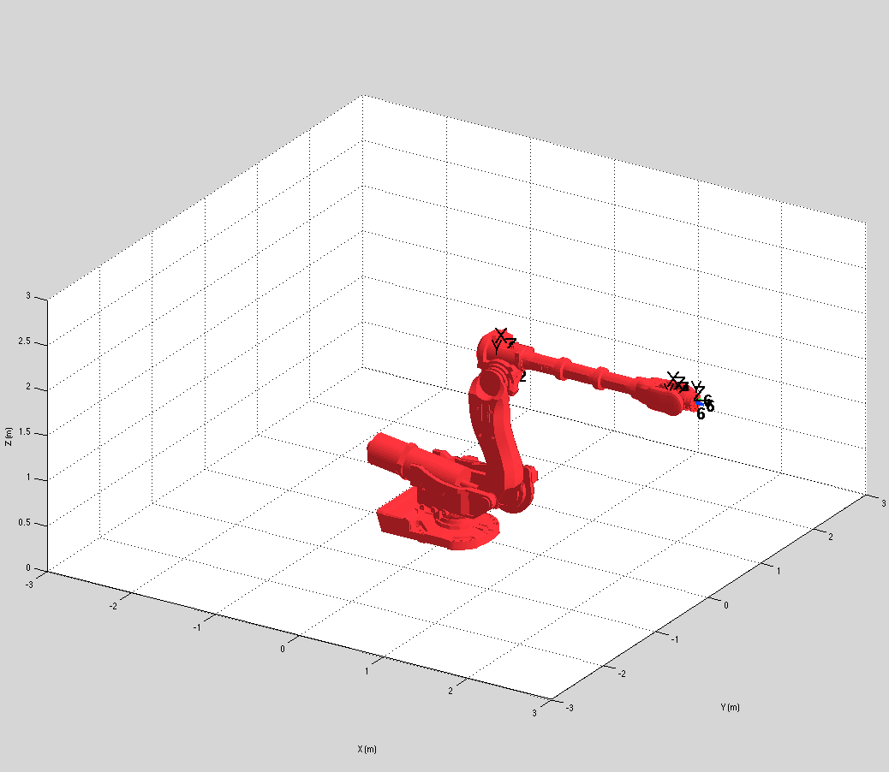
Caution!: Please beware that now every point in the stl file (the vout in the previous commands) are referred to a common base reference system. In order to paint them properly we will be changing them to their own DH reference system. YOU SHOULD USE THE FIGURE ABOVE IN ORDER TO OBTAIN YOUR DH PARAMETERS FOR YOUR ROBOT.

3 Transform the files to a different reference system
Now, you should edit the parameters.m file to include the basic parameters of the arm, namely the D-H parameters, axes ranges, etc. In order to do so, copy a parameters.m file from a different robot and edit it. You should read the datasheet of the robot to obtain the main data.
From the datasheet, we observe the positive turn direction for each joint and the main dimensions.
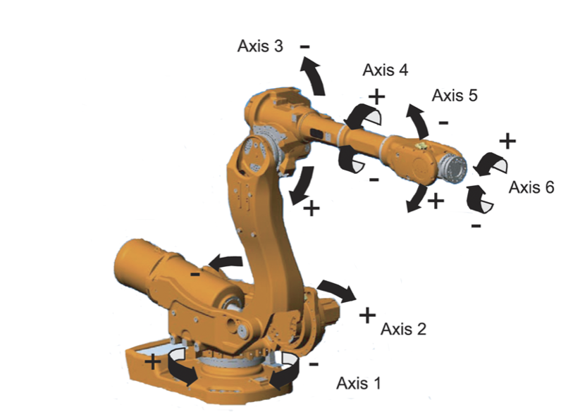
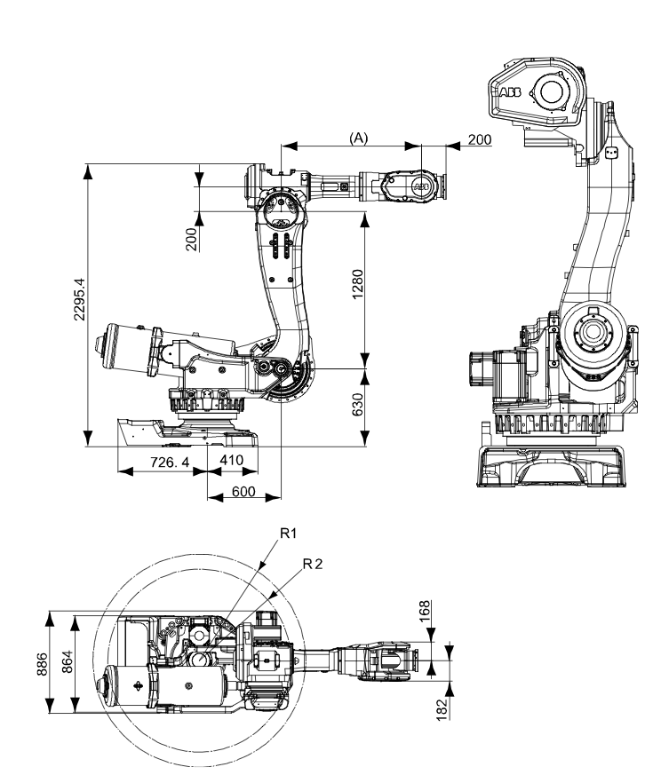
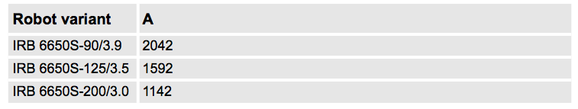
In our case, A=2.042 meters. According to the version of the arm. Using the drawing above, place the D-H systems and write a D-H table. A possible placement for the standard D-H systems is shown next.
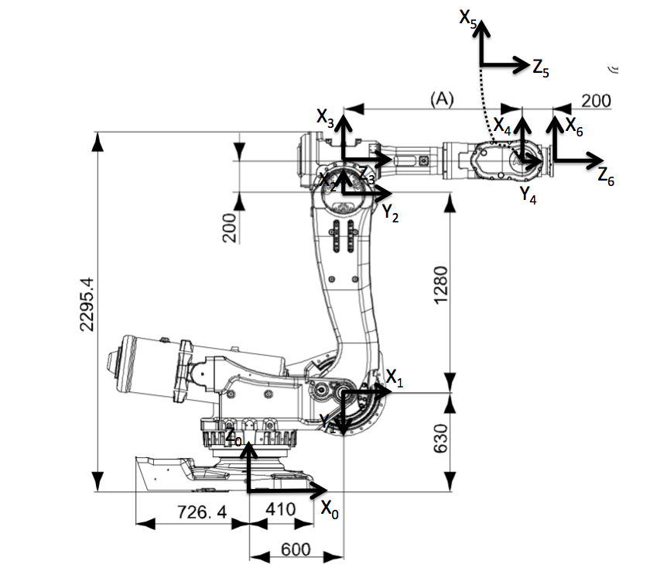

Which has the following D-H table associated:

θ | d | a | α
θ₁ | 0.630 | 0.600 | -π/2
θ₂-π/2 | 0 | 1.280 | 0
θ₃ | 0 | 0.200 | -π/2
θ₄ | 2.042 | 0 | π/2
θ₅ | 0 | 0 | -π/2
θ₆ | 0.200 | 0 | 0

Edit the parameters.m file to indicate the previous table. Note the variables, robot.DH.theta, robot.DH.d, etc.:
function robot = parameters()

robot.name= 'ABB_IRB6650S_90_390';

%Path where everything is stored for this robot
robot.path = 'robots/abb/IRB6650S_90_390';

robot.DH.theta= '[q(1) q(2)-pi/2 q(3) q(4) q(5) q(6)]';
robot.DH.d='[0.630 0 0 2.042 0 0.2]';
robot.DH.a='[0.600 1.280 0.2 0 0 0]';
robot.DH.alpha= '[-pi/2 0 -pi/2 pi/2 -pi/2 0]';

robot.J=[];

robot.inversekinematic_fn = 'inversekinematic_irb6650S_90_390(robot, T)';

%number of degrees of freedom
robot.DOF = 6;

%rotational: 0, translational: 1
robot.kind=['R' 'R' 'R' 'R' 'R' 'R'];

%minimum and maximum rotation angle in rad
robot.maxangle =[deg2rad(-180) deg2rad(180); %Axis 1, minimum, maximum
deg2rad(-40) deg2rad(160); %Axis 2, minimum, maximum
deg2rad(-180) deg2rad(70); %Axis 3
deg2rad(-300) deg2rad(300); %Axis 4:
deg2rad(-120) deg2rad(120); %Axis 5
deg2rad(-360) deg2rad(360)]; %Axis 6:

%maximum absolute speed of each joint rad/s or m/s
robot.velmax = [deg2rad(100); %Axis 1, rad/s
deg2rad(90); %Axis 2, rad/s
deg2rad(90); %Axis 3, rad/s
deg2rad(150); %Axis 4, rad/s
deg2rad(120); %Axis 5, rad/s
deg2rad(235)];%Axis 6, rad/s
% end effectors maximum velocity
robot.linear_velmax = 0.0; %m/s, unavailable from datasheet

%base reference system
robot.T0 = eye(4);

Each STL file stores the 3D position of a set of points belonging to the link in coordinates of its own DH reference system. For example link0.stl has the position of the base points in coordinates of DH system 0. Link1.stl stores the position of the points belonging to link1 in coordinates of system 1, etc. However, the files, link1_base.stl, link2_base.stl… etc store the points in the base reference system. In addition, the units in this files are millimeters. The function transform_to_own will help you transform each stl file for each of the reference systems, and at the same time, transform the scale to meters. Before executing transform_to_own, you should have created the robot.DH table before. The function reads the files link0_base.stl, link1_base.stl… and transforms each link to its own D-H reference system. Finally, the links are wrote to the same directory as link0.stl, link1.stl, etc. Read the transform_to_own help for more details.
>> help transform_to_own
Now, execute transform_to_own for the robot. You should obtain the following
>> transform_to_own('abb','IRB6650S_90_390', 1000)

ans =

/Users/arturogilaparicio/Desktop/arte_lib3.0/robots/abb/IRB6650S_90_390

Reading link0_base.stlEndOfFile found... Wrote 2608 facets
Reading link1_base.stlEndOfFile found... Wrote 5674 facets
Reading link2_base.stlEndOfFile found... Wrote 5388 facets
Reading link3_base.stlEndOfFile found... Wrote 4764 facets
Reading link4_base.stlEndOfFile found... Wrote 9759 facets
Reading link5_base.stlEndOfFile found... Wrote 5522 facets
Reading link6_base.stlEndOfFile found... Wrote 1476 facets

4 Test everything
Test everything! First, load the robot:
>> robot=load_robot('abb', 'IRB6650S_90_390');
ans =

/Users/arturogilaparicio/Desktop/arte_lib3.0/robots/abb/IRB6650S_90_390

Reading link 0
EndOfFile found...
Reading link 1
EndOfFile found...
Reading link 2
EndOfFile found...
Reading link 3
EndOfFile found...
Reading link 4
EndOfFile found...
Reading link 5
EndOfFile found...
Reading link 6
EndOfFile found...

Now, you can use the teach GUI to test your robot. Use the sliders to move the joints and test that everything is correct.
>> teach

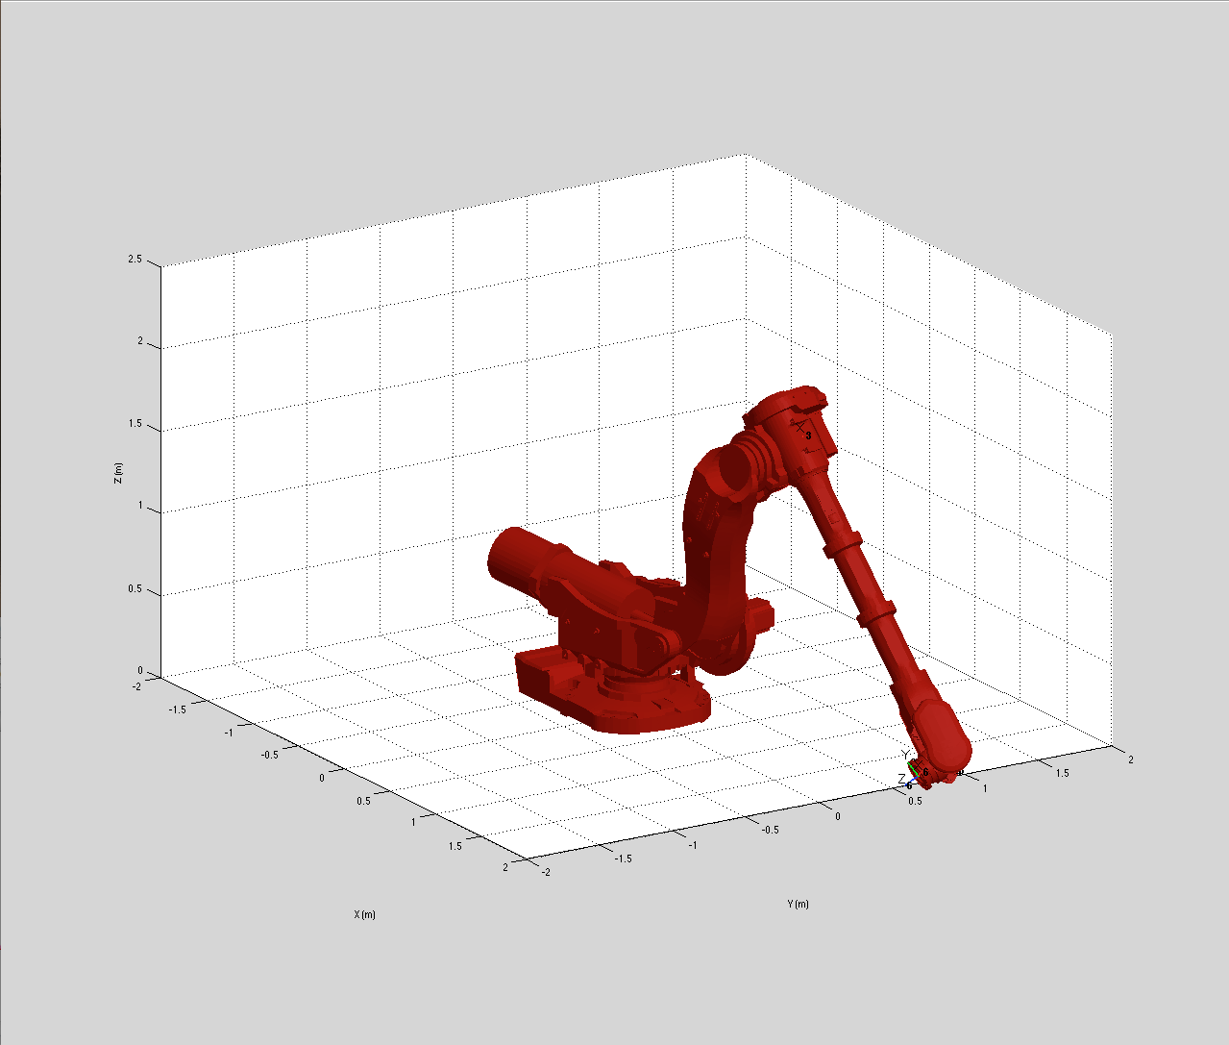

Large robots may require that you modify the axis in the matlab figure. Edit the parameters.m file and modify the robot.axis variable:
robot.axis=[-3 3 -3 3 0 3];

Set robot.graphical.draw_transparent=1 if you prefer to observe the D-H systems and a transparent representation of the robot.
>> robot.graphical.draw_transparent=1

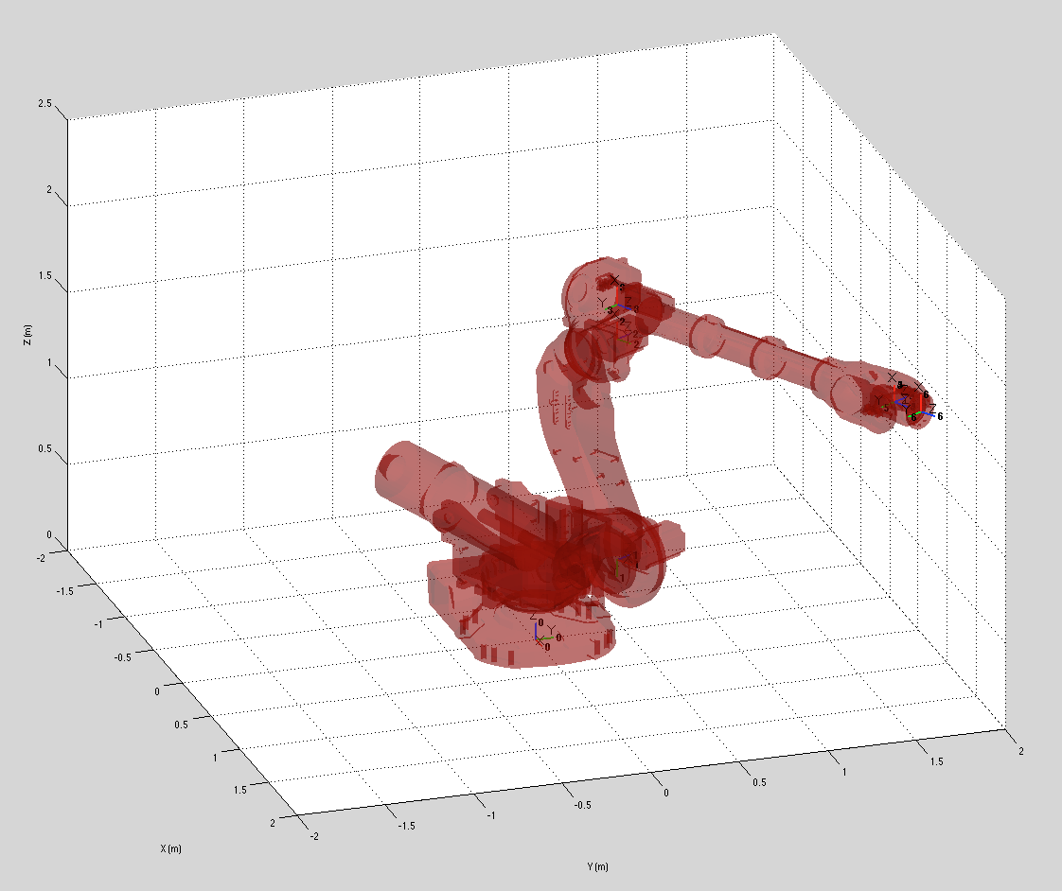

5 What’s next?
During the rest of the practical sessions you will be shown how to modify the parameters.m file to add more functionality to your robot, solving the inversekinematic problem, adding dynamics and programming the robot.
Exercise 1:
Add a commercial robot to the library. The CAD files and the necessary information can be found in the web pages of:
- ABB.
- Stäubli.
- FANUC.
- KUKA robotics.
- Mitsubishi electric.
- Motoman.
- Adept.
You will find more information to do this in the videos under the Summary section.
6 Direct and inverse kinematic problem
In a serial manipulator, the direct kinematic problem is totally defined by the DH table of parameters. Next, in ARTE, the inverse kinematic problem is solved specifically for any robot. Practice 2: inverse kinematics deals with this problema. In order to do this, you should create a function named inversekinematic_robot_name(robot, T). In the parameters.m file, edit the robot.inversekinematic_fn to suit this fact.
Lets asume that your added a robot to the library named PA-10, manufactured by Mitsubishi. Try the following code. You should obtain a constant matrix Ti for any solution in qinv.

q = [0.5 0.2 0.3 0.5 0.2 -0.8]
robot=load_robot('mitsubishi', 'pa-10'); n_solutions = 8;

%adjust 3D view as desired
adjust_view(robot)

%draw the robot
drawrobot3d(robot, q)

%Now compute direct kinematics for this position q
T = directkinematic(robot, q)

%Set to zero if you want to see the robot transparent
robot.graphical.draw_transparent=1;

%Call the inversekinematic for this robot
% all the possible solutions are stored at qinv
% at least, one of the possible solutions should be coincident with q
qinv = inversekinematic(robot, T);

%check that all of them are possible solutions!
for i=1:size(qinv,2),
%Ti is constant for the different solutions
Ti = directkinematic(robot, qinv(:,i))

% Note that all the solutions may not be feasible. Some of the joints may
% be out of range. You can test this situation with test_joints
test_joints(robot, qinv(:,i))

%now draw the robot to see the solution
drawrobot3d(robot, qinv(:,i))

pause(1)
end

Exercise 2:
Implement the inverse kinematic problem for the robot that you are adding to the library. Test the previous code and load the robot that you have just added. In this way you can verify that everything is correct. You should change the variable q to test the code under different situations.
Please note that the robots have some physical restrictions. For example, any joint of the robot cannot turn freely a whole turn. Generally, each joint (rotational or translational) has a particular range of motion. Figure 4 shows an extract of the datasheet corresponding to the KUKA KR5 arc welding robot. Next, the code in its parameters.m file reflects this data.
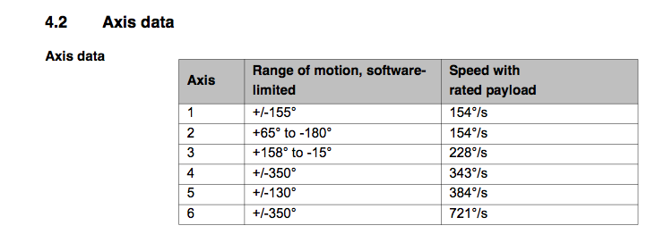
Figure 1
%rotational: 0, translational: 1
robot.kind=['R' 'R' 'R' 'R' 'R' 'R'];

%minimum and maximum rotation angle in rad
robot.maxangle =[deg2rad(-155) deg2rad(155); %Axis 1, minimum, maximum
deg2rad(-180) deg2rad(65); %Axis 2, minimum, maximum
deg2rad(-15) deg2rad(158); %Axis 3
deg2rad(-350) deg2rad(350); %Axis 4: Unlimited (400∫ default)
deg2rad(-130) deg2rad(130); %Axis 5
deg2rad(-350) deg2rad(350)]; %Axis 6: Unlimited (800∫ default)

%maximum absolute speed of each joint rad/s or m/s
robot.velmax = [deg2rad(154); %Axis 1, rad/s
deg2rad(154); %Axis 2, rad/s
deg2rad(228); %Axis 3, rad/s
deg2rad(343); %Axis 4, rad/s
deg2rad(384); %Axis 5, rad/s
deg2rad(721)];%Axis 6, rad/s

The function
test_joints(robot, qinv(:,i))
checks that any joint is inside its motion range and issues an alert if any of them. For example, a solution of the inverse kinematic problem could be mathematically feasible but may not be physically achievable due to the joint restrictions.

Exercise 3:
Modify the range of motion of your robot according to its datasheet.

