Hogwarts Arena
History: Remote Wizarding Education
“It’s 2025, and the magical world has been shaken up by an unexpected announcement. The Headmaster of Hogwarts, tired of the chaos caused by students running around casting spells, has decided that remote education is the way to go. No more wandering the corridors, no more wild broomstick races in the halls – everything will be managed online. In the middle of the Wizarding World’s digital transformation, the Headmaster has called upon you, an aspiring wizarding web developer, to implement the Wizarding Arena platform. This web application will allow Hogwarts students to log in, learn spells virtually, track their magical power, and see how they stack up against their housemates.
Your task? To bring Hogwarts Arena to life! A platform where students can enter their accounts, hone their magical skills, and engage in some good old digital wizardry – all from the comfort of their own home.
Are you ready to bring the magic to the web?”

Entities and Enums
There are two main entities in the system:

Wizard
This represents the user who is registered on the platform. Wizards will log in, learn spells, and track other wizards, edit their profile data and alignment.
- id: Unique identifier for each wizard (UUID)
- username: The wizard's username (String, unique, not null)
- password: The wizard's password (String, not null) - must be hashed
- avatarUrl: URL of the wizard's avatar (String, not null)
- alignment: The wizard’s alignment (WizardAlignment, not null)
- house: The wizard’s house (House, not null)
- spells: List of spells the wizard has learned (List<Spell>)
- createdOn: When the wizard registered (LocalDateTime, not null)
- updatedOn: When the wizard's information was last updated (LocalDateTime, not null)

Spell
This represents a spell that a wizard has learned. Each spell has various attributes:.
- id: Unique identifier for each spell (UUID)
- code: The code of the spell (e.g., "LUMOS", "EXPELLIARMUS") (String, not null)
- name: The name of the spell (String, not null)
- description: A brief description of the spell (String, not null)
- wizard: The wizard who learned the spell (Wizard, not null)
- category: The category of the spell (SpellCategory, not null)
- alignment: The alignment of the spell (SpellAlignment, not null)
- image: The image of the spell (String, not null)
- power: The power of the spell (int)
- createdOn: Date when the spell was learned by the wizard (LocalDateTime, not null)

SpellCategory: OFFENSE, DEFENSE, UTILITY

SpellAlignment: LIGHT, NEUTRAL, DARK

WizardAlignment: LIGHT, DARK

House: GRYFFINDOR, SLYTHERIN, RAVENCLAW, HUFFLEPUFF
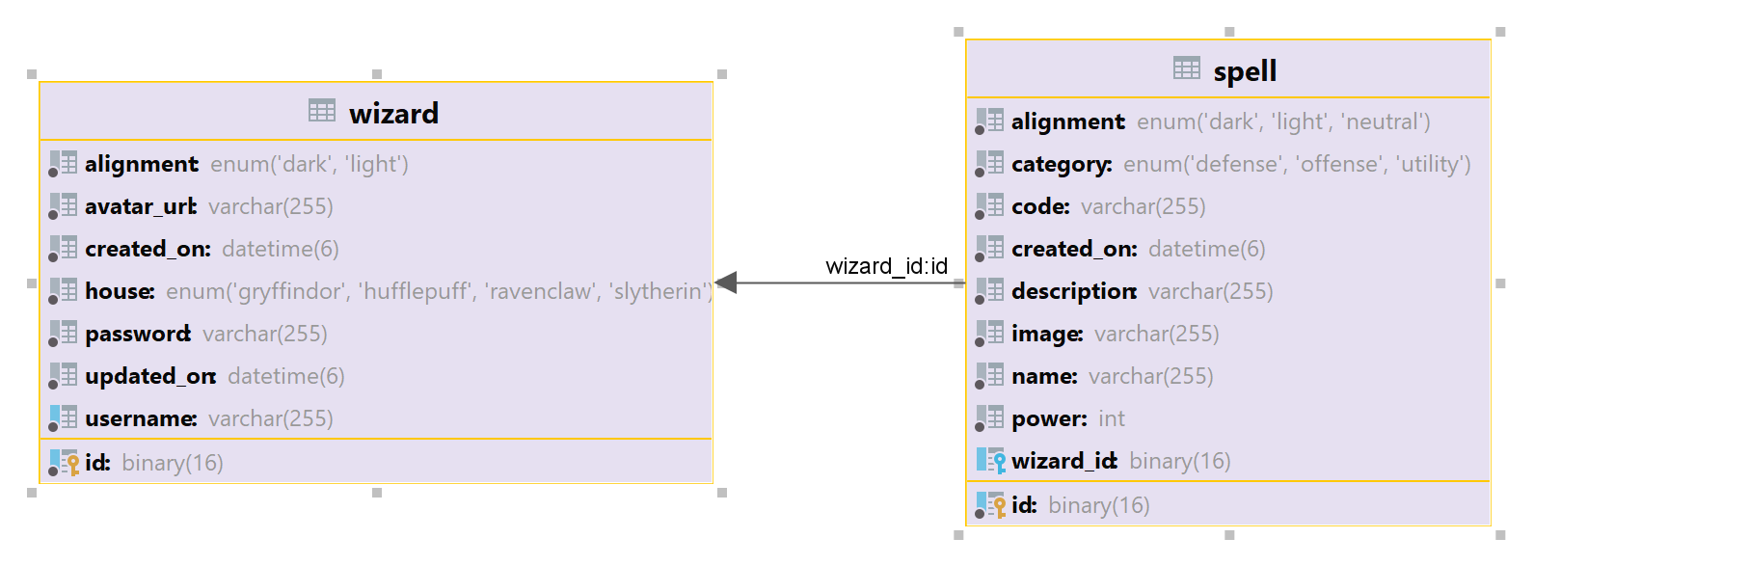

Configuration Properties
In the project skeleton, you are provided with a spells.yaml file containing the details of all available spells. This file will be used by the application to display spells to the wizard and manage which spells they can learn.
Each spell in the YAML contains the following fields:
- code - unique spell code (e.g. LUMOS)
- name - name of the spell
- image - spell’s image (e.g. /images/spells/lumos.png)
- category - one of OFFENSE, DEFENSE, or UTILITY
- alignment - one of LIGHT, NEUTRAL, or DARK
- minLearned - how many spells a wizard must already know (have learned) before being allowed to learn this one
- power - numeric value representing the magical power for this spell
- description - description of the spell
Additionally, you are given an empty SpellsProperties.java class. Your task is to complete this class to read the spells.yaml file at application startup and map its content. The loaded data must be accessible across the application in runtime, allowing wizards to learn spells.

Business Constraints & Error Handling
You must enforce every business rule described in this document. If a user attempts an action that violates a business constraint, throw a custom Java runtime exception (e.g., only unique usernames, not learning the same spell twice, not learning a spell before meeting its minLearned requirement). The WhiteLabel Error Page is acceptable for the exam.
For pages with form validation - Register and Edit Profile forms, you must validate user input according to the listed constraints in the description. If invalid input is given upon form submit, you should re-render the same form and display the field error messages in the provided HTML. Do not use custom error messages, just use the message that is already provided in the HTML file.

Functionalities

Index Page
View: index.html
Mandatory endpoint: “/”
Requirements:
- Implement a GET handler that serves the index.html view as the application’s landing page (See Figure 1 below).
- On this view, there are two main navigation links/buttons:
  - Create Account - navigates the user to the Register page
  - Login - navigates the user to the Login page
Figure 1: Default index view, landing page.
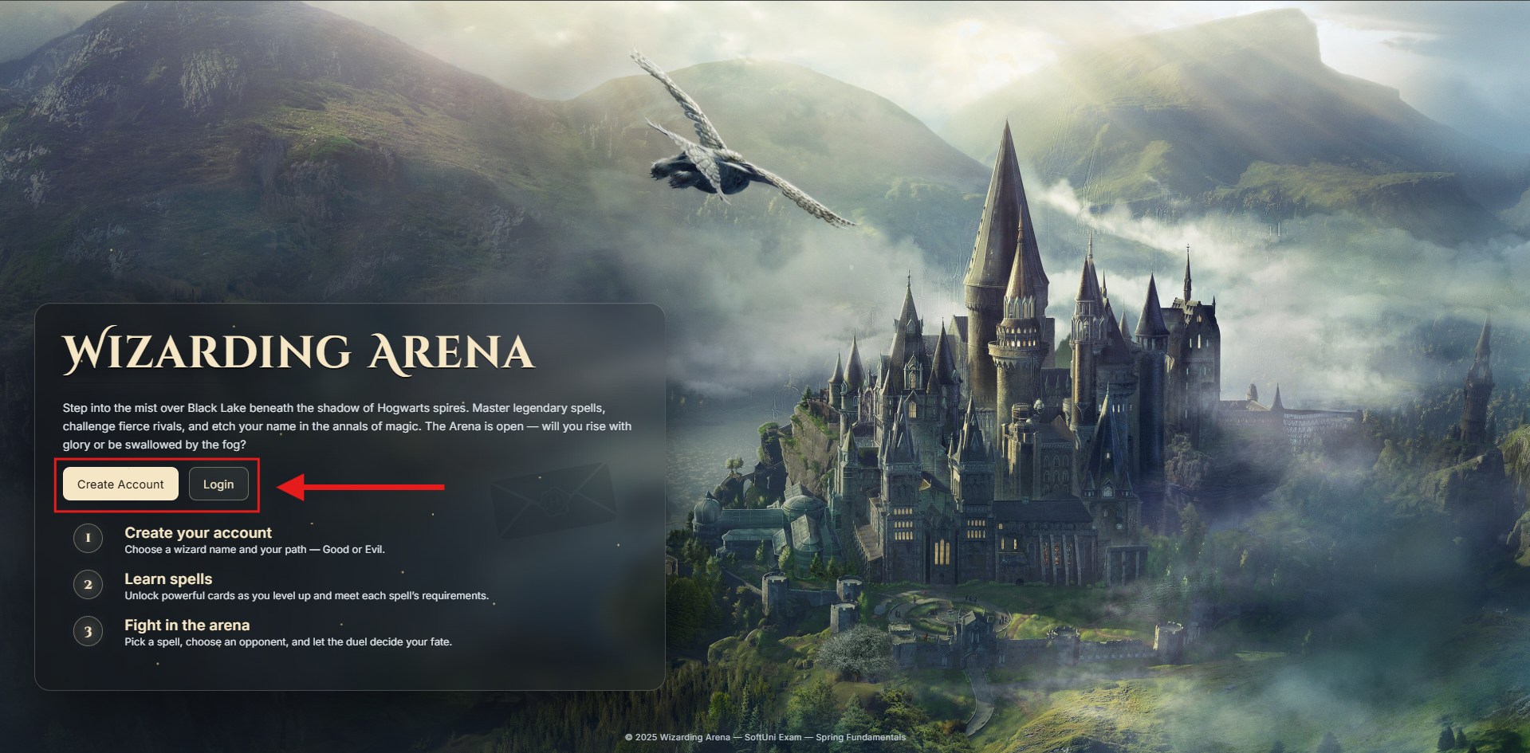

Register Page
View: register.html
Mandatory endpoint: “/register”
Requirements:
- Implement a GET handler that serves the register.html view (See Figure 1 below).
- Implement a POST handler that creates a new Wizard profile with the submitted form data.
  - Store the password hashed
  - Upon successful registration, the wizard must automatically learn 1 random spell from the spells list, but only from those that have minLearned = 0.
- Validate the form input, on DTO field validation error, show the same page with the error message provided in the HTML file - the small red messages, above the form input field (See Figure 2 below).
- You are given an avatars.txt file, where you can find existing avatar urls for your convenience to use, when you test your solution.
- Form validation constraints:
  - Username - length [6 - 12] characters, not empty/blank text
  - Password - exactly 6 characters, must include only digits, not empty/blank text
  - Avatar URL - must be a valid URL, not empty/blank text
  - House - must be valid House enum value, not null
  - Alignment - must be valid WizardAlignment enum value, not null
- On successful registration: navigates the user to the Login page.
Figure 1: Registration page, default view
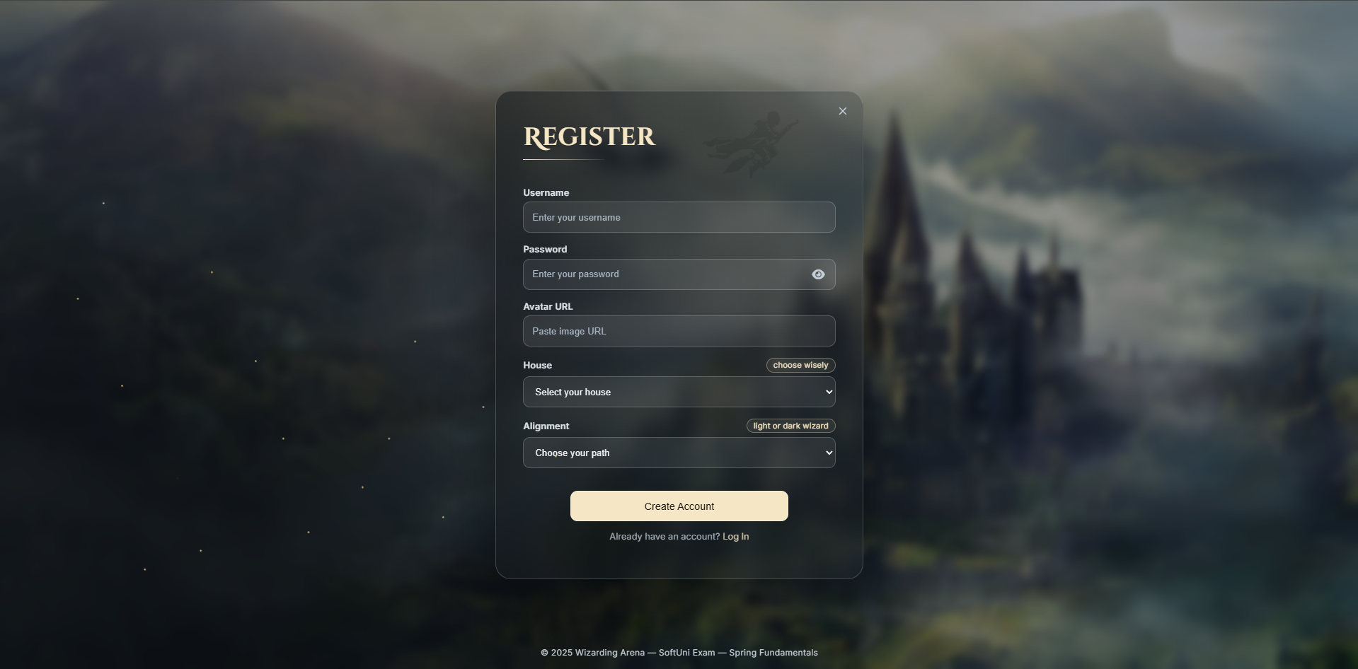
Figure 2: Registration page filled with invalid data, shows error message above the input field
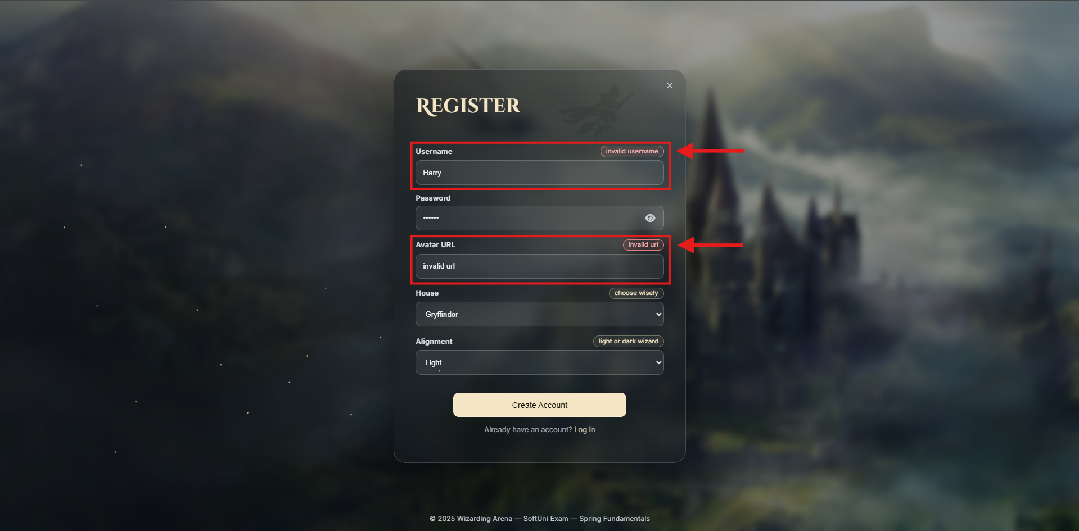

Login Page
View: login.html
Mandatory endpoint: “/login”
Requirements:
- Implement a GET handler that serves the login.html view (See Figure 1 below).
- Implement a POST handler that authenticates a wizard using username and password.
- On successful authentication: create a session and store the wizard’s ID in a session attribute named user_id, then navigate the user to the Home page.
- On incorrect credentials (wizard not found or password mismatch): throw a custom Java exception.
Figure 1: Login page, default view
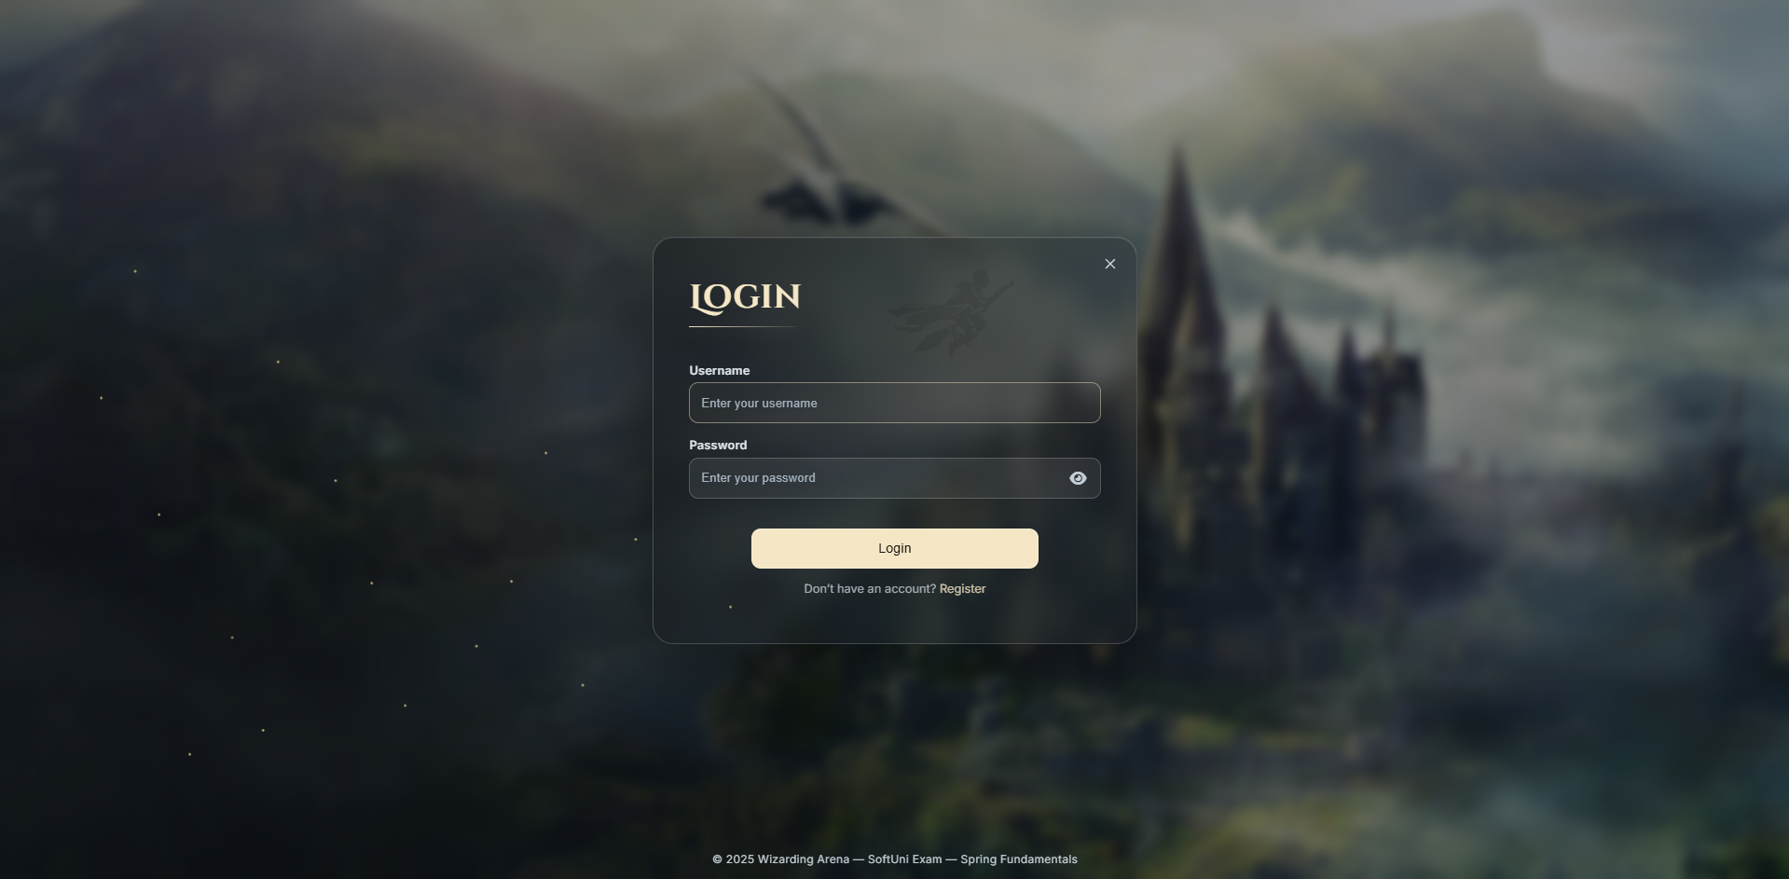

Logout
View: Redirect to index page
Mandatory endpoint: “/logout”
Requirements:
- Implement a GET handler that logs out the user and redirects them to the index page. The logout must happen upon clicking the “Logout” button in any page it exists. Upon successful logout, the user’s session has to be invalidated! (See Figure 1 below)
Figure 1: Logout button
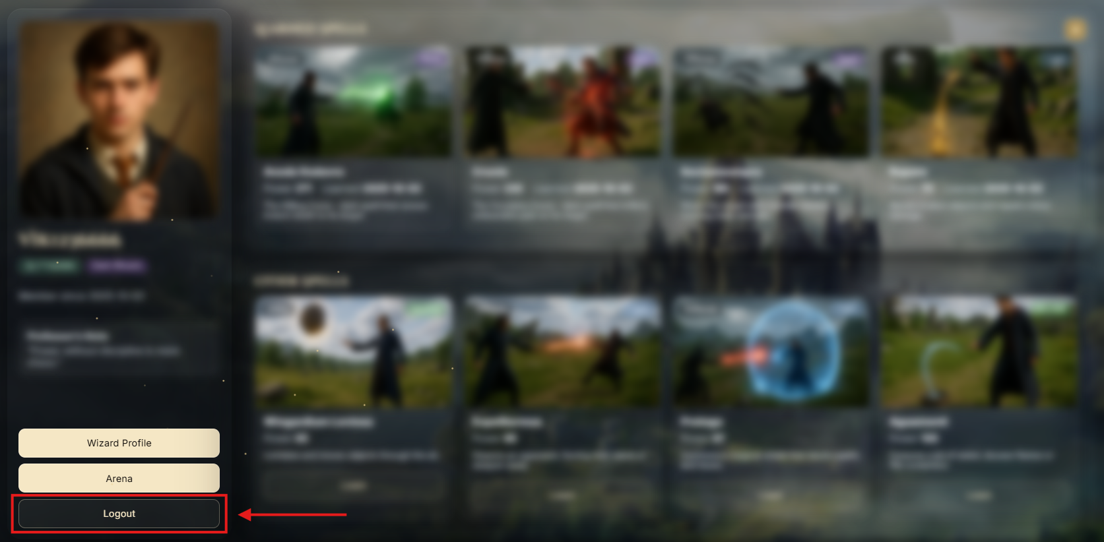

Home Page
View: home.html
Mandatory endpoint: “/home”
Requirements:
Implement a GET handler that serves the home.html view.
The home page contains three main sections you need to implement carefully:
- Wizard Profile Section
- Learned Spells Section
- Other Spells Section
Wizard Profile Section (See Figure 1 below)
- Displays wizard details: avatar, username, house, alignment, “Member since {createdOn}”
- On this section, there are three main navigation links/buttons:
  - Wizard Profile - navigates the user to the Profile page.
  - Arena - navigates the user to the Arena page.
  - Logout - directly logouts the user, invalidates their session and redirects them to the Index page.
- The house badge reflects the wizard’s house. Show one of these possible options:
- The alignment badge reflects the wizard’s alignment. Show one of these possible options:
Figure 1: Wizard profile section
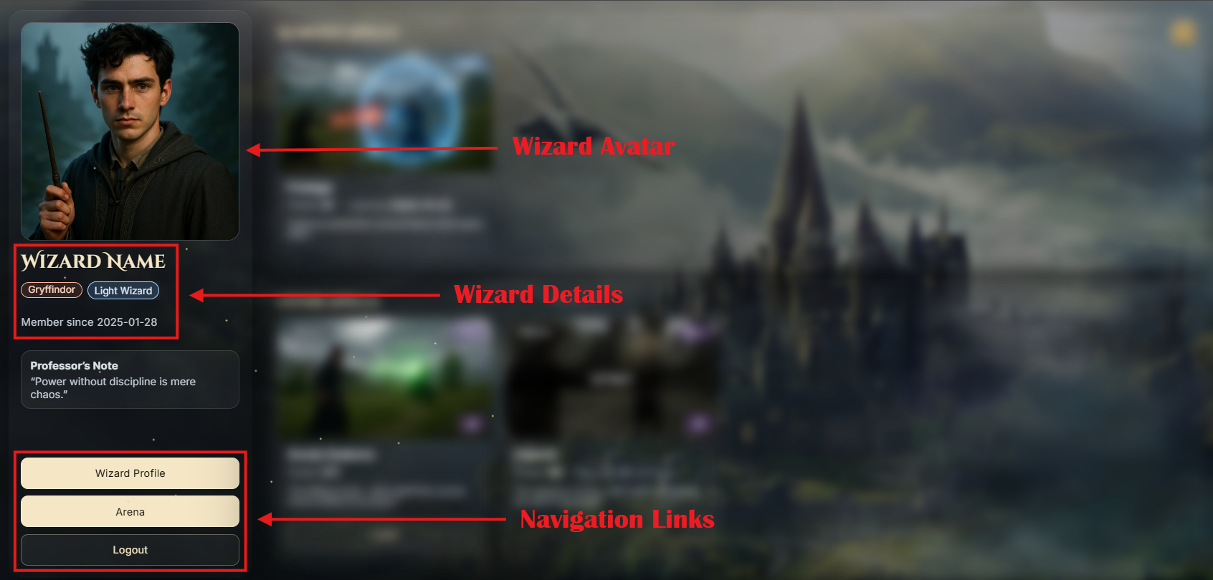
Learned Spells Section (See Figure 2 below)
- Header: Learned Spells with a counter for you to show how many spells the wizard has learned.
- Displays all spells the wizard has already learned and for each learned spell show - image, category, alignment, name, power, "Learned {createdOn}", description
- The spells must be ordered by power descending.
- The spell alignment batch reflects the spell’s alignment. Show one of these possible options:
- The spell category badge must be displayed with the first letter capitalized only (e.g., Offense, Defense, Utility). There are no different styles for that badge.
Figure 2: Learned spells section
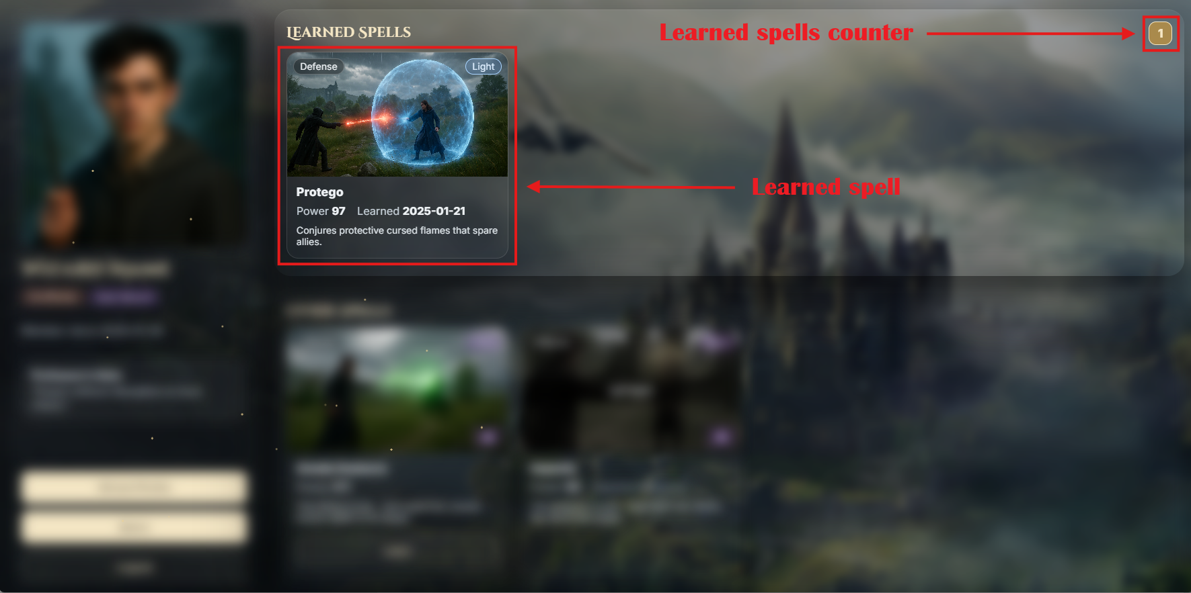
Other Spells Section (See Figure 3 below)
- Load all spells from the spells.yaml file that the wizard has not learned yet. Show their details - image, category, alignment, name, power, description, and warning badge (read below for this badge).
- Spells in this section are separated into two groups
  - Available to Learn - spells where the wizard meets the minLearned requirement. Each of these spells will be available for the wizard to learn.
  - Locked - spells where the wizard does not meet the minLearned requirement (they haven’t learned the required number of spells yet).
- No specific ordering is required in this section.
- The spell alignment batch reflects the spell’s alignment. Show one of these possible options:
- The spell category badge must be displayed with the first letter capitalized only (e.g., Offense, Defense, Utility). There are no different styles for this badge.
- If the logged-in user is Light wizard and the spell in the section is a Dark spell, display the warning badge 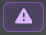, otherwise this badge must not be displayed!
- Learn spell functionality - when a wizard clicks on the “Learn” button a POST handler must be implemented to handle the user’s request (e.g, /spells?spell-code=LUMOS). A new learned Spell must be created for the wizard based on the selected spell from spells.yaml. Do not allow learning the same spell twice, already learned spells should ideally not appear in this section anymore. A wizard cannot learn a spell if the minLearned requirement is not satisfied! Every wizard can learn any spell, regardless of the spell/wizard alignment, but if a Light wizard learns a Dark spell, the wizard’s alignment instantly changes to Dark, while if a Dark wizard learns a Light spell, there are no consequences (their alignment stays Dark). After a spell successfully learned, redirect the user to the Home page again, they should be able to see the newly learned spell in the Learned Spells Section.
- About minLearned - every spell in the spells.yaml file has a field called minLearned. This number tells how many spells a wizard must have already learned before they can be able to learn this spell.
Figure 3: Other spells section
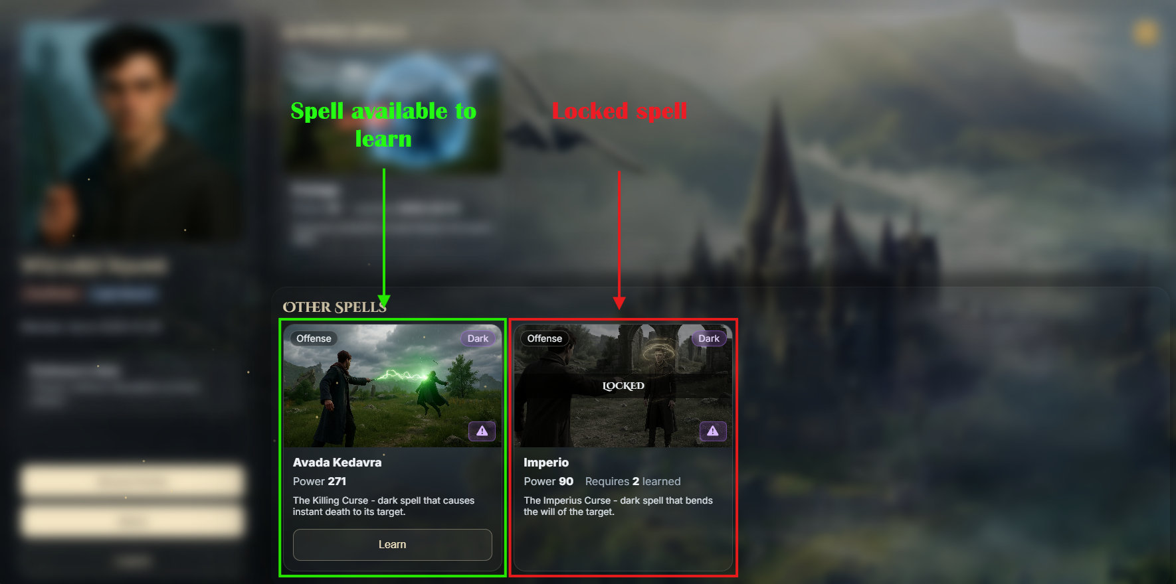

Profile Page
View: profile.html
Requirements:
Implement a GET handler that serves the profile.html view.
On the page there is a Back to Home button that you should make to navigate the user to the Home page.
The page also shows two panels you need to implement:
Edit Profile (See Figure 1 below)
- Implement a PUT handler that allows the wizard to edit their username and avatar url.
- On page load, the form fields must be pre-filled with the wizard’s current data (username and avatar URL)
  - Hint: Instead of passing an empty object DTO for the form (as you normally would), set the DTO fields with the wizard’s details and then pass it.
- Validate the form input, on DTO field validation error, show the same page with the error message provided in the HTML file - the small red messages, above the form input field.
- Form validation constraints:
  - Username - length [6 - 12] characters, not empty/blank text
  - Avatar URL - must be a valid URL, not empty/blank text
- On submit: update the user’s data with the incoming username and avatar, set updatedOn to now and persist the changes.
Alignment Change (See Figure 2 below)
- Implement a PATCH handler that changes the wizard’s alignment from Light to Dark.
- If the wizard is already Dark: don’t show a button/form element, but display the static paragraph provided in the HTML document - “You have chosen the Dark path. This choice is permanent.”

Figure 1: Profile page, edit profile panel
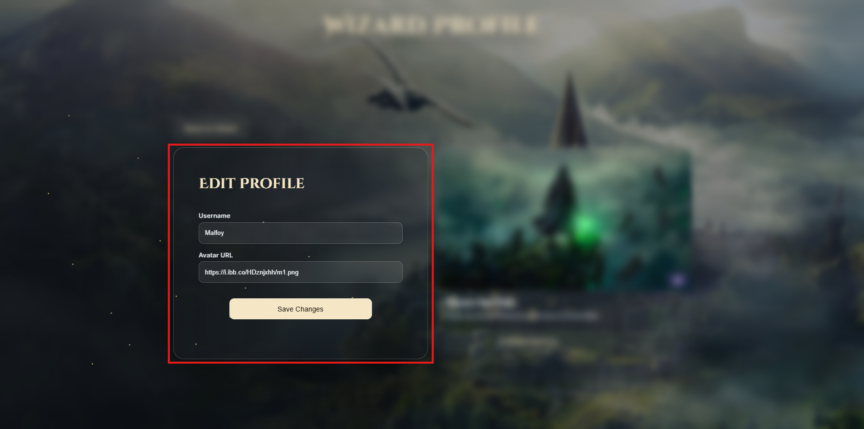
Figure 2: Profile page, change alignment panel
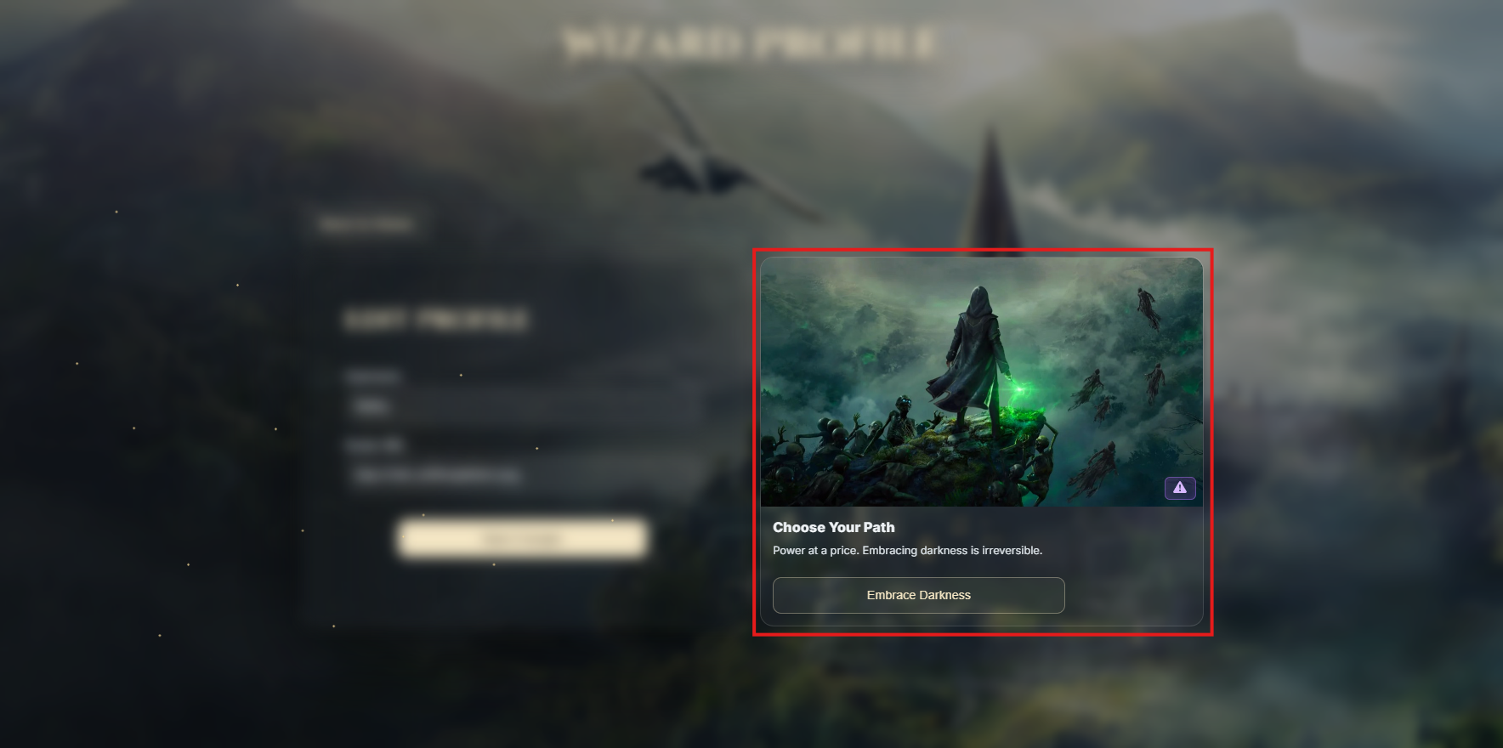

Security
The security is based on an active session. Upon login, you must store the user’s unique identifier (id) in a session attribute named user_id.
A SessionInterceptor class is provided in the project skeleton - do not modify it.
Access control already enforced as part of the SessionInterceptor class:
Public: Index Page, Register Page, Login Page, Logout
Restricted (only logged-in users): Home, Arena, Profile, and all related functionalities

Project Upload
When uploading your solution, you must create an archive containing the src folder and the pom.xml file.
Go to the Regular Exam topic, click 'ИЗБОР НА ФАЙЛ', select the archived file, and click Upload/ КАЧИ.
Please note that only your last uploaded file will be saved.
Important Note: Projects will be tested for functionality. Any project that does not run successfully will receive 0 points.

Optional functionality
Important Note: The Arena page is optional. You can achieve the full score for this exam without implementing this page. However, if implemented, it may serve as compensation for missing parts in other sections!

Arena Page
View: arena.html
Requirements:
- Implement a GET handler that serves the arena.html view (See Figure 1 below).
- The page shows four fixed rows, one per house: Gryffindor, Slytherin, Ravenclaw, Hufflepuff
- Each house row lists the wizards belonging to that house as horizontal cards. For each wizard card show:
  - Avatar, username, alignment badge.
  - Spells N (number of learned spells)
  - Power Σ (sum of the wizard’s learned spells’ power)
- The alignment badge reflects the wizard’s alignment. Show one of these possible options:
- Each house must display the count of wizards in that house.
- Sorting inside each house row: by total power descending, then by username ascending. (See Figure 1 below for an example)
- If a house has no wizards, show the empty state “No students yet.”, that is provided in the HTML document and count of wizards 0 (See Figure 2 below)
- There is a Back to Home button placed above the Gryffindor row (top-left corner) that you should make to navigate the user to the Home page.
Figure 1: Arena page, default view
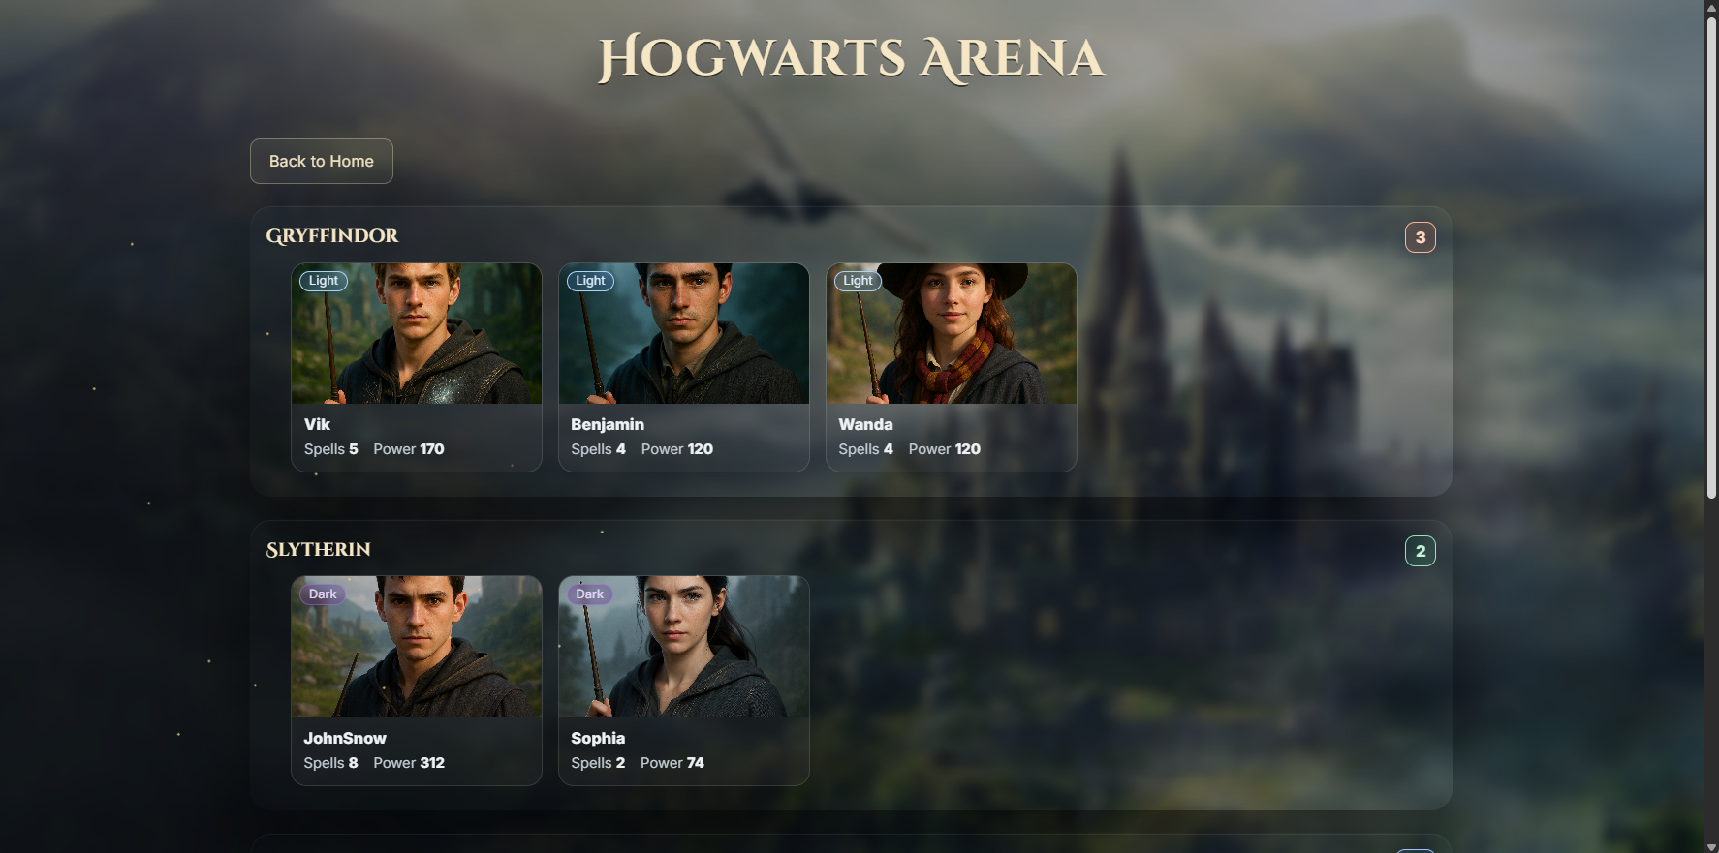
Figure 2: Arena page with a house with no students
