Activity Session Three

**Watch the** [**video**](https://www.youtube.com/watch?v=C9FlbhRVYdc) **and answer the questions**

1. What is programming?

Giving instructions to a computer, clearly and specifically, in a language it understands

1. What components do computers use and what is the main language of computers?
2. Los componentes que usan los computadores son los transistores y el lenguaje principal es el lenguaje de maquina o lenguaje binario.
3. What does Assembly do?

Assembly language tells the computer what to do using simple commands like "move," "add," or "compare." It's like giving direct orders to the computer's brain. According to its level of classification it allows us several levels of abstraction

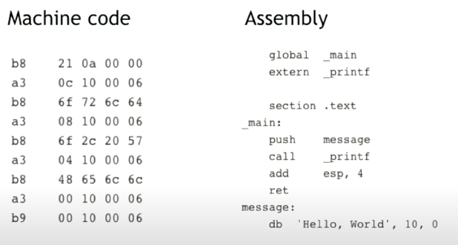

1. What is Scratch?

Scratch is a visual programming language designed for beginners, especially children, so that everyone can get started in programming. To learn programming concepts through a simple and intuitive interface.

1. What are some examples of high-level programming languages mentioned in the video, and why are they preferred over low-level languages

Java, Python, Javascript y Scratch. They are preferable because they allow versatility in programming, as well as ease of writing and understanding the program.

1. Is HTML a programming language? What is it used for?

Not a programming language. Describes the content of a web page.

* **Programming language =** *Lenguaje de programación.*
* **Sequence of instructions =** *Secuencia de instrucciones.*
* **Application domain =** *Dominio de aplicación.*
* **Coding basics =** *Códigos básicos*
* **Syntax =** *Sintaxis*
* **Machine Code =** *Código máquina.*
* **Statements =** *Sentencias*
* **Client-server application =** *Aplicación Cliente-Servidor*
* **Script =** *Script.*
* **Time-consuming =** *Consumo de tiempo.*