Statement of the problem
A 2.5-kg homogeneous disk of 80 mm radius is free to rotate with respect to arm ABC, which is welded to a shaft DCE supported by bearings at D and E. Both the arm and the shaft have negligible mass.
At time t = 0, a couple $M_{0}=(0.5N∙m\text{) }k$is applied to shaft DCE. It is known that at t = 0 the angular velocity of the disk is $ω_{1}=(60\text{ rad/s}) j,$ and that friction in the bearing at A causes the magnitude of $ω_{1}$to decrease at a rate of $15{\text{rad/s}}^{2}.$
Determine the dynamic reactions exerted on the shaft by the bearings at D and E at any time t. Resolve these reactions into components directed along the x and y axes rotating with the shaft.
Using computational software:
(a) calculate the components of the reactions for 0 ≤ t ≤ 4 s;
(b) determine the times t₁ and t₂ at which the x and y components of the reaction at E are respectively equal to zero.

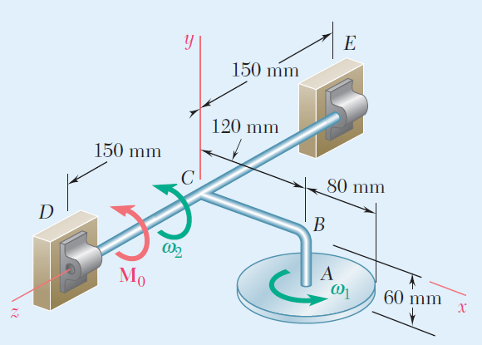
Beer, F. P.; Johnston Jr., E. R.; Mazurek, D. F.; Cornwell, P. J.; Self, B. P.
Vector Mechanics for Engineers: Statics and Dynamics.
McGraw-Hill Education, 11th Edition, 2016.
Problems 18.C4 (Dynamics, 9th Edition) and 18.C5 (Dynamics, 7th Edition).

Analytical solution
To find the reactions at points D and E, one must first establish an equivalence between the forces at D and E and the forces and moments at the center of mass of the body.

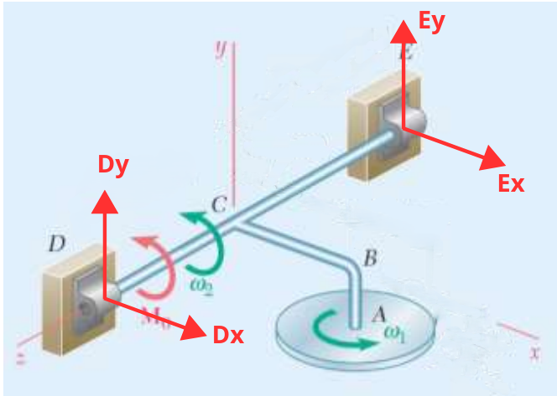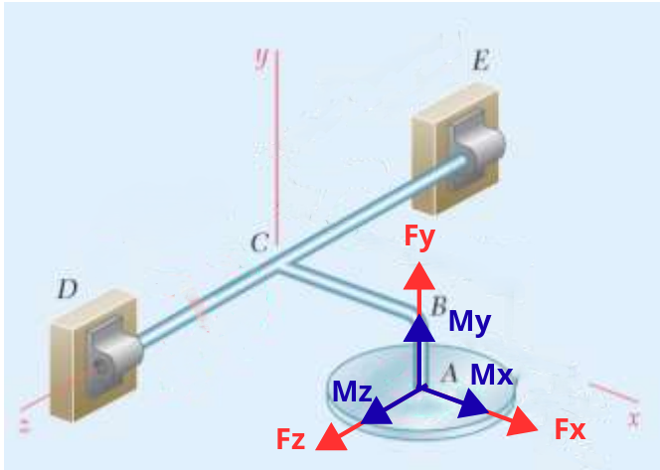

- Angular Momentum at A
Angular Momentum Equation in a Rotating Reference Frame
$$\sum{\vec{M_{A}}}=\vec{(\dot{H_{A}})_{xyz}}+\vec{Ω}×\vec{H_{A}}$$
Angular momentum expression
$$\vec{H_{A}}=H_{x}i+H_{y}j+H_{z}k$$
$$\vec{H_{A}}=I_{x}ω_{x}i+I_{y}ω_{y}j+I_{z}ω_{z}k$$
Moments of inertia of the disk
$$I_{x}=\frac{1}{4}mR^{2}→Moment of the disk around the x-axis.$$
$$I_{y}=\frac{1}{2}mR^{2}→Moment of the disk around the y-axis.$$
$$I_{z}=\frac{1}{4}mR^{2}→Moment of the disk around the z-axis.$$
Angular velocity components
$$ω_{x}=0$$
$$ω_{y}=ω_{1}$$
$$ω_{z}=ω_{2}$$

$$\vec{H_{A}}=\frac{1}{4}mR^{2}0i+\frac{1}{2}mR^{2}ω_{1}j+\frac{1}{4}mR^{2}ω_{2}k$$
$$\vec{H_{A}}=\frac{1}{2}mR^{2}ω_{1}j+\frac{1}{4}mR^{2}ω_{2}k$$
$$\vec{{\dot{H}}_{A}}=\frac{1}{2}mR^{2}{\dot{ω}}_{1}j+\frac{1}{4}mR^{2}{\dot{ω}}_{2}k$$
Angular velocity of the rotating reference frame
$$\vec{Ω}=ω_{2}k$$
Final moment equation

$$\vec{M_{A}}=\left(\frac{1}{2}mR^{2}{\dot{ω}}_{1}j+\frac{1}{4}mR^{2}{\dot{ω}}_{2}k\right)+\left(ω_{2}k\right)×\left(\frac{1}{2}mR^{2}ω_{1}j+\frac{1}{4}mR^{2}ω_{2}k\right)$$
$$\vec{M_{A}}=-\frac{1}{2}mR^{2}ω_{1}ω_{2}i+\frac{1}{2}mR^{2}{\dot{ω}}_{1}j+\frac{1}{4}mR^{2}{\dot{ω}}_{2}k$$
- Forces in A
$$m\vec{a_{a}}=m\left(\vec{a_{c}}+\vec{a_{a/c}}\right)$$
Since point C is fixed,
$$a_{c}=0$$

$$m\vec{a_{a}}=m\vec{a_{a/c}}$$
$$m\vec{a_{a}}=m(\vec{{\dot{ω}}_{2}}×\vec{r_{a/c}}-ω_{2}^{2}\vec{r_{a/c}})$$

$$\vec{r_{a/c}}=-d_{AB}j+d_{BC}i$$

$$m\vec{a_{a}}=m({\dot{ω}}_{2}k×(-d_{AB}j+d_{BC}i)-ω_{2}^{2}(-d_{AB}j+d_{BC}i))$$
$$m\vec{a_{a}}=m({\dot{ω}}_{2}k×(-d_{AB}j+d_{BC}i)-ω_{2}^{2}(-d_{AB}j+d_{BC}i))$$
$$m\vec{a_{a}}=m{\dot{ω}}_{2}d_{AB}i+m{\dot{ω}}_{2}d_{BC}j+mω_{2}^{2}d_{AB}j-mω_{2}^{2}d_{BC}i$$
$$\vec{F_{A}}=(m{\dot{ω}}_{2}d_{AB}-mω_{2}^{2}d_{BC})i+(m{\dot{ω}}_{2}d_{BC}+mω_{2}^{2}d_{AB})j$$

- Moment in D
Note: Here, it is also possible to calculate the moments at point E with the aim of nullifying the moments generated by the forces Ex and Ey, but it has been opted to do this at point D, nullifying the moments generated by the forces Dx and Dy. Thus:
$$\vec{r_{d/e}}×\vec{F_{E}}+\vec{M_{0}}=\vec{r_{d/a}}×\vec{F_{A}}+\vec{M_{A}}$$

$$\vec{r_{d/e}}=-d_{ED}k$$
$$\vec{F_{E}}=E_{y}j+E_{x}i$$
$$\vec{M_{0}}=M_{0}j$$
$$\vec{r_{d/a}}=d_{BC}i+d_{AB}j+d_{CD}k$$
$$\vec{F_{A}}=(m{\dot{ω}}_{2}d_{AB}-mω_{2}^{2}d_{BC})i+(m{\dot{ω}}_{2}d_{BC}+mω_{2}^{2}d_{AB})j$$
$$\vec{M_{A}}=-\frac{1}{2}mR^{2}ω_{1}ω_{2}i+\frac{1}{2}mR^{2}{\dot{ω}}_{1}j+\frac{1}{4}mR^{2}{\dot{ω}}_{2}k$$

Determination of $\vec{r_{d/e}}×\vec{F_{E}}+\vec{M_{0}}$
$$\vec{r_{d/e}}×\vec{F_{E}}+\vec{M_{0}}$$
$$-d_{ED}k×(E_{y}j+E_{x}i)+M_{0}k$$
$$d_{ED}E_{y}i-d_{ED}E_{x}j+M_{0}k$$
$$d_{ED}E_{y}i-d_{ED}E_{x}j+M_{0}k$$
Determination of $\vec{r_{d/a}}×\vec{F_{A}}+\vec{M_{A}}$
$$\vec{r_{d/a}}×\vec{F_{A}}+\vec{M_{A}}$$
$$\left(d_{BC}i-d_{AB}j-d_{CD}k\right)×\left(\left(m{\dot{ω}}_{2}d_{AB}-mω_{2}^{2}d_{BC}\right)i+\left(m{\dot{ω}}_{2}d_{BC}+mω_{2}^{2}d_{AB}\right)j\right)+\vec{M_{A}}$$

$$md_{CD}\left({\dot{ω}}_{2}d_{BC}+ω_{2}^{2}d_{AB}\right)i-\frac{1}{2}mR^{2}ω_{1}ω_{2}i$$
$$-md_{CD}\left({\dot{ω}}_{2}d_{AB}-ω_{2}^{2}d_{BC}\right)j+\frac{1}{2}mR^{2}{\dot{ω}}_{1}j$$
$$m{\dot{ω}}_{2}\left(d_{BC}^{2}+d_{AB}^{2}\right)k+\frac{1}{4}mR^{2}{\dot{ω}}_{2}k$$
By equating each component of k
$$M_{0}=m{\dot{ω}}_{2}\left(d_{BC}^{2}+d_{AB}^{2}\right)+\frac{1}{4}mR^{2}{\dot{ω}}_{2}$$
$$M_{0}={\dot{ω}}_{2}m\left(\left(d_{BC}^{2}+d_{AB}^{2}\right)+\frac{1}{4}R^{2})\right)$$
$${\dot{ω}}_{2}=\frac{M_{0}}{\left(\left(d_{BC}^{2}+d_{AB}^{2}\right)+\frac{1}{4}R^{2}\right)}$$
By equating each component of j
$$-d_{ED}E_{x}=-md_{CD}\left({\dot{ω}}_{2}d_{AB}-ω_{2}^{2}d_{BC}\right)+\frac{1}{2}mR^{2}{\dot{ω}}_{1}$$
$$E_{x}=\frac{-md_{CD}\left({\dot{ω}}_{2}d_{AB}-ω_{2}^{2}d_{BC}\right)+\frac{1}{2}mR^{2}{\dot{ω}}_{1}}{-d_{ED}}$$

By equating each component of i
$$d_{ED}E_{y}=md_{CD}\left({\dot{ω}}_{2}d_{BC}+ω_{2}^{2}d_{AB}\right)-\frac{1}{2}mR^{2}ω_{1}ω_{2}$$
$$E_{y}=\frac{md_{CD}\left({\dot{ω}}_{2}d_{BC}+ω_{2}^{2}d_{AB}\right)-\frac{1}{2}mR^{2}ω_{1}ω_{2}}{d_{ED}}$$
- $\sum{F}=ma_{A}$

Note: Similarly to what was done in the previous item, the moments could also be taken about point E to determine the reactions at D. However, once the reactions at point E are known, it is simpler to compute the sum of forces; therefore, this approach was adopted.
$$\sum{F}=ma_{A}$$
$$E_{x}i+D_{x}i+E_{y}j+D_{y}j=(m{\dot{ω}}_{2}d_{AB}-mω_{2}^{2}d_{BC})i+(m{\dot{ω}}_{2}d_{BC}+mω_{2}^{2}d_{AB})j$$
By equating each component of i
$$E_{x}+D_{x}=m{\dot{ω}}_{2}d_{AB}-mω_{2}^{2}d_{BC}$$
$$D_{x}=m{\dot{ω}}_{2}d_{AB}-mω_{2}^{2}d_{BC}-E_{x}$$
By equating each component of j
$$E_{y}+D_{y}=m{\dot{ω}}_{2}d_{BC}+mω_{2}^{2}d_{AB}$$
$$D_{y}=m{\dot{ω}}_{2}d_{BC}+mω_{2}^{2}d_{AB}-E_{y}$$
  - Reactions as Functions of Time
To obtain the reactions as functions of time, it is sufficient to express the angular velocities as functions of time, that is, by replacing $ω_{2}$with ${\dot{ω}}_{2} t$ and $ω_{1}$with $ω_{1,\text{initial}}+{\dot{ω}}_{1} t$.

Computational Implementation
- Matlab Graphs
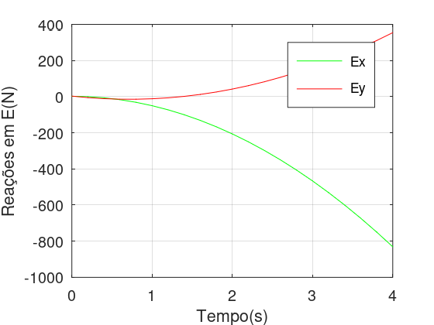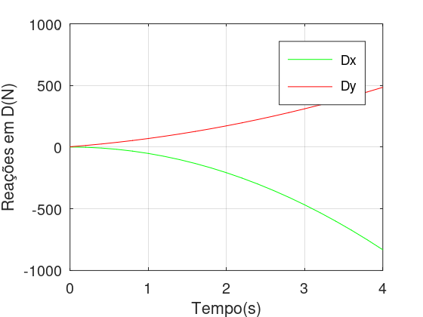
- Python Graphs
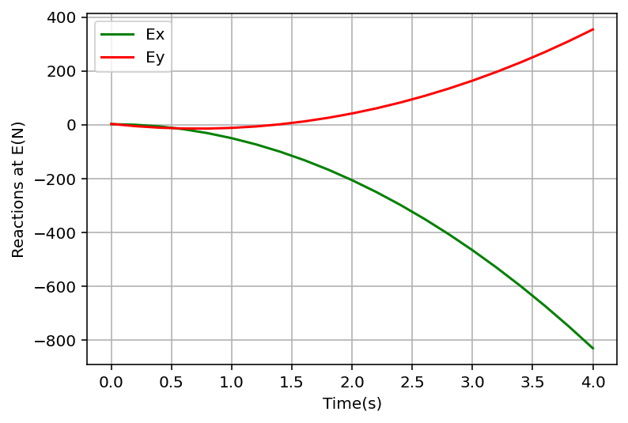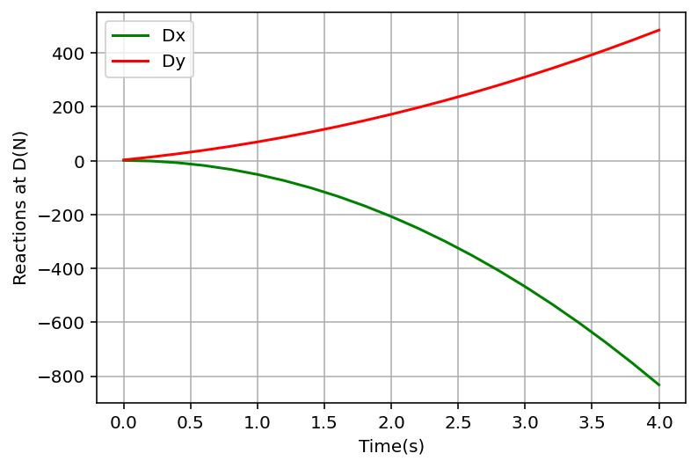

- Time at Which the Reactions at Point E Are Equal to Zero
Having the equations $E_{x}(t)$and $E_{y}(t)$, computational numerical methods can be used to determine the points at which $E_{x}(t)$and $E_{y}(t)$are equal to zero. In this case, the bisection method was employed to find the roots of the equations, leading to the following times.

Equation | Time (from 0s to 4s)
E_{x}(t) | 0.19651931s
E_{y}(t) | 0.06549466s
E_{y}(t) | 1.36690485s

Simulation
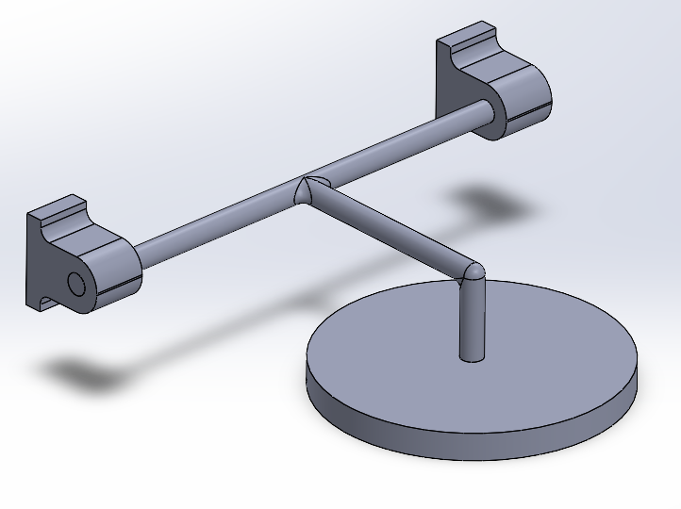
Illustration of the component modeled in SolidWorks
The plots generated using SolidWorks are shown below.
Ex | Ey
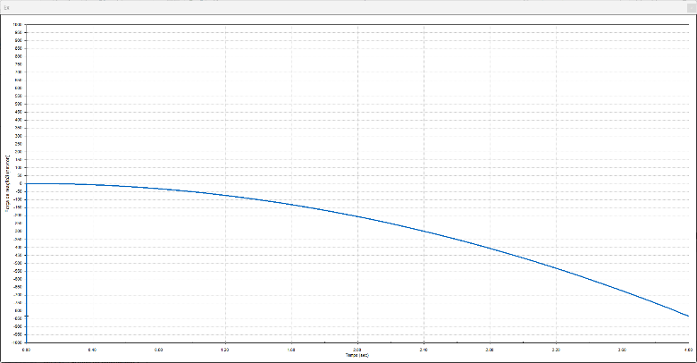 | 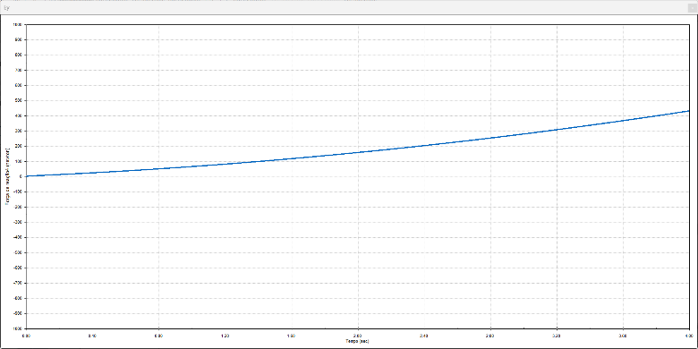
Dx | Dy
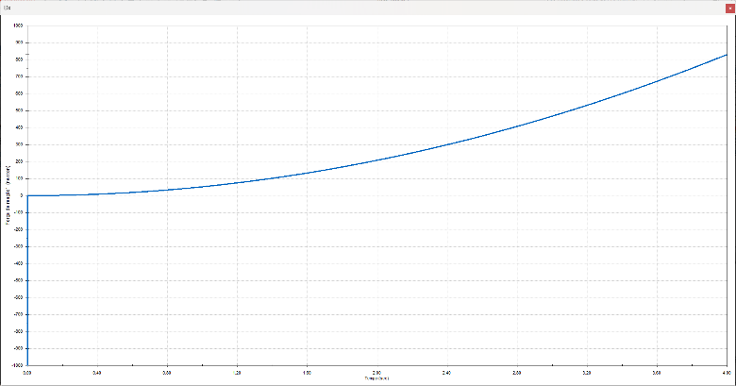 | 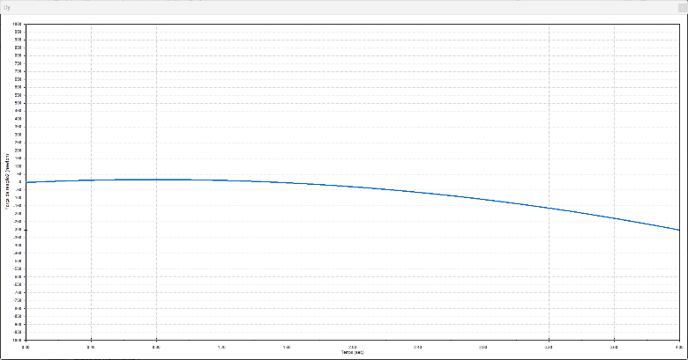

Results
The results obtained from the analytical/programming approach and from the simulation are consistent with each other. This can be observed by comparing the graphs from both approaches. It is worth noting that, due to a convention adopted by the software, the Dx and Dy values in the SolidWorks graphs have the opposite sign compared to those adopted in the MATLAB and Python graphs.

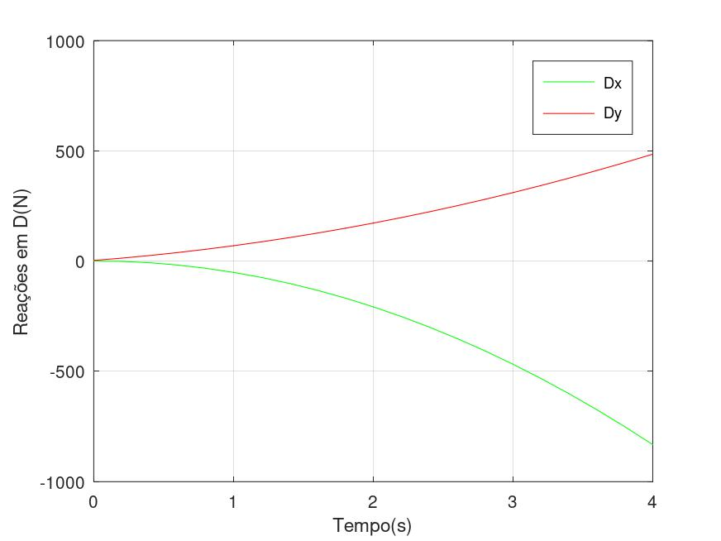
- Reaction of D
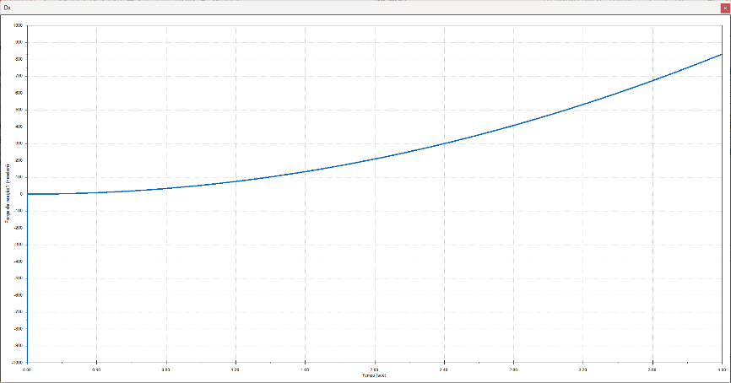
Graph of the reaction force at D in the x-direction (SolidWorks)
Graphs of the reaction force at D (MATLAB)
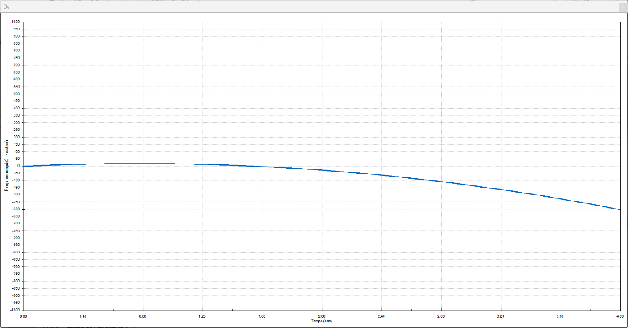
Graph of the reaction force at D in the y-direction (SolidWorks)
Graphs of the reaction force at D (Python)

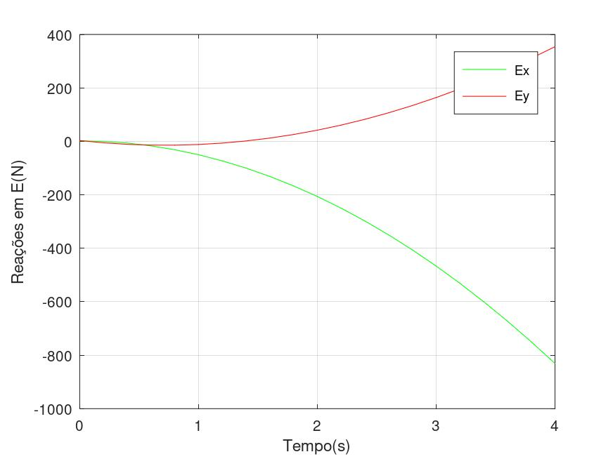
- Reaction of E
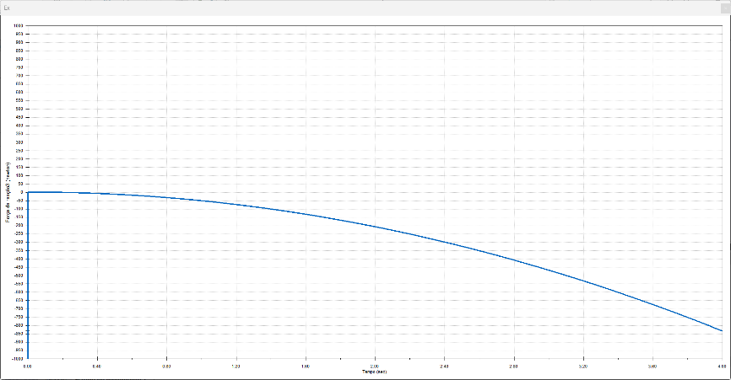
Graph of the reaction force at E in the x-direction (SolidWorks)
Graphs of the reaction force at D (MATLAB)

Graphs of the reaction force at E (Python)

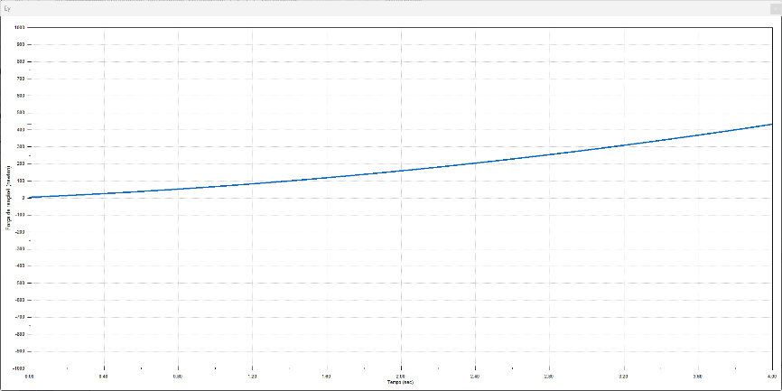
Graph of the reaction force at E in the y-direction (SolidWorks)

