**INFORME DE HITO 4**

**Link de GitHub**

**https://github.com/4teamsoft/CoinsoftWeb**

**https://github.com/4teamsoft/CoinsoftDocuments**

**Link de LucidChart**

[**https://www.lucidchart.com/invitations/accept/852601eb-d756-447b-b687-fe44508cd140**](https://www.lucidchart.com/invitations/accept/852601eb-d756-447b-b687-fe44508cd140)

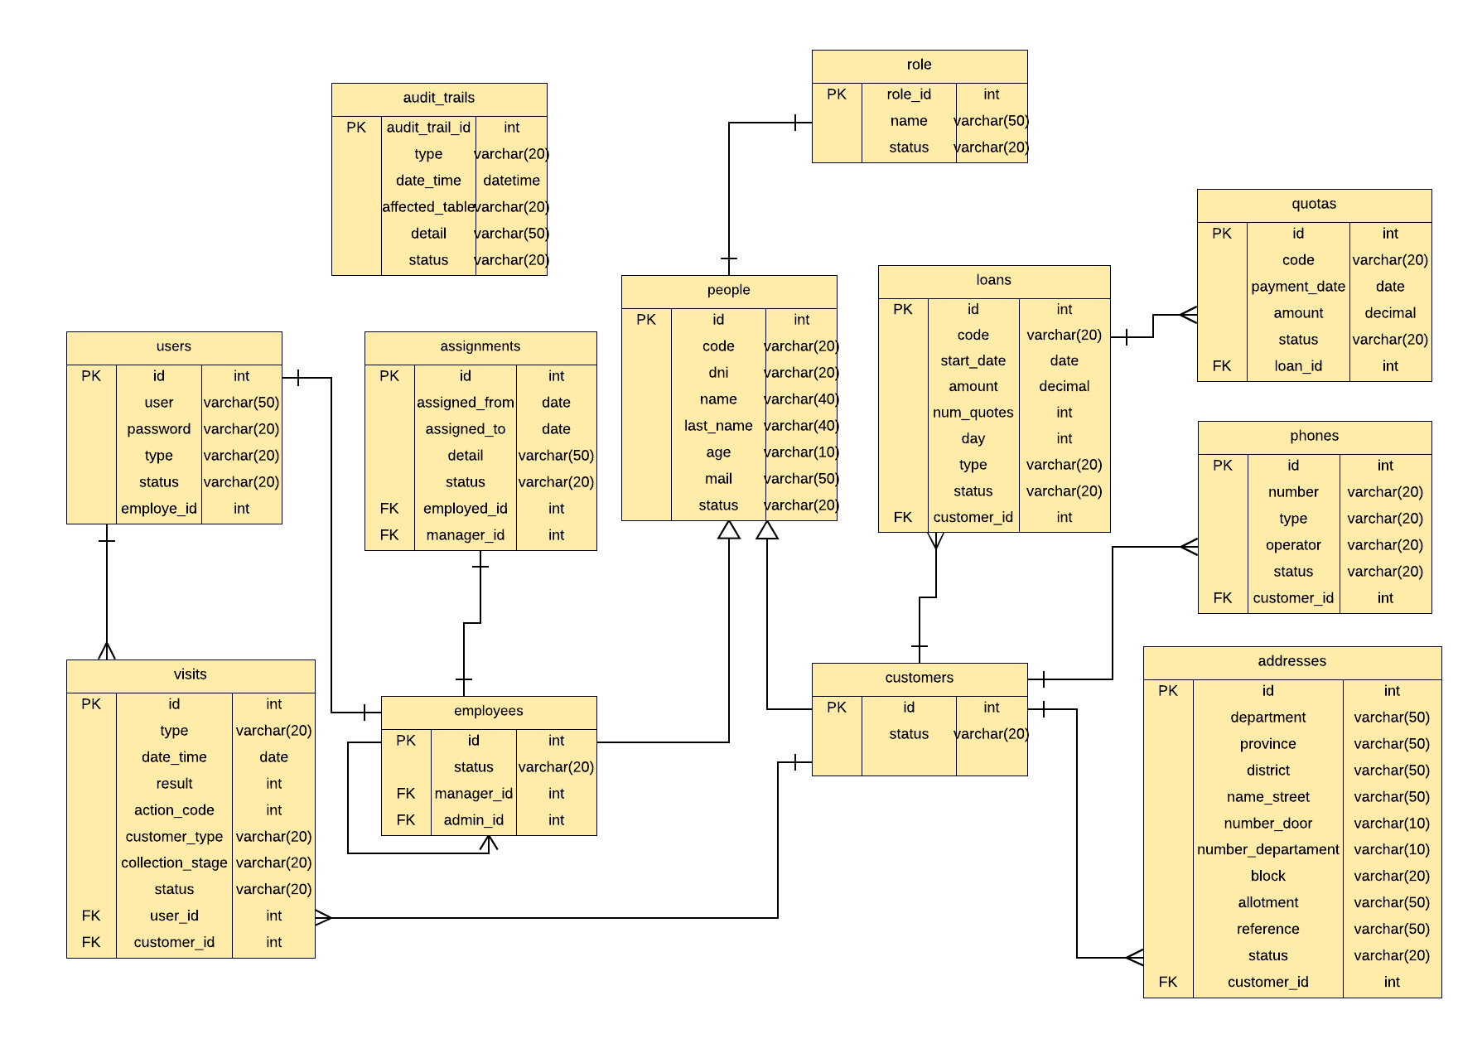

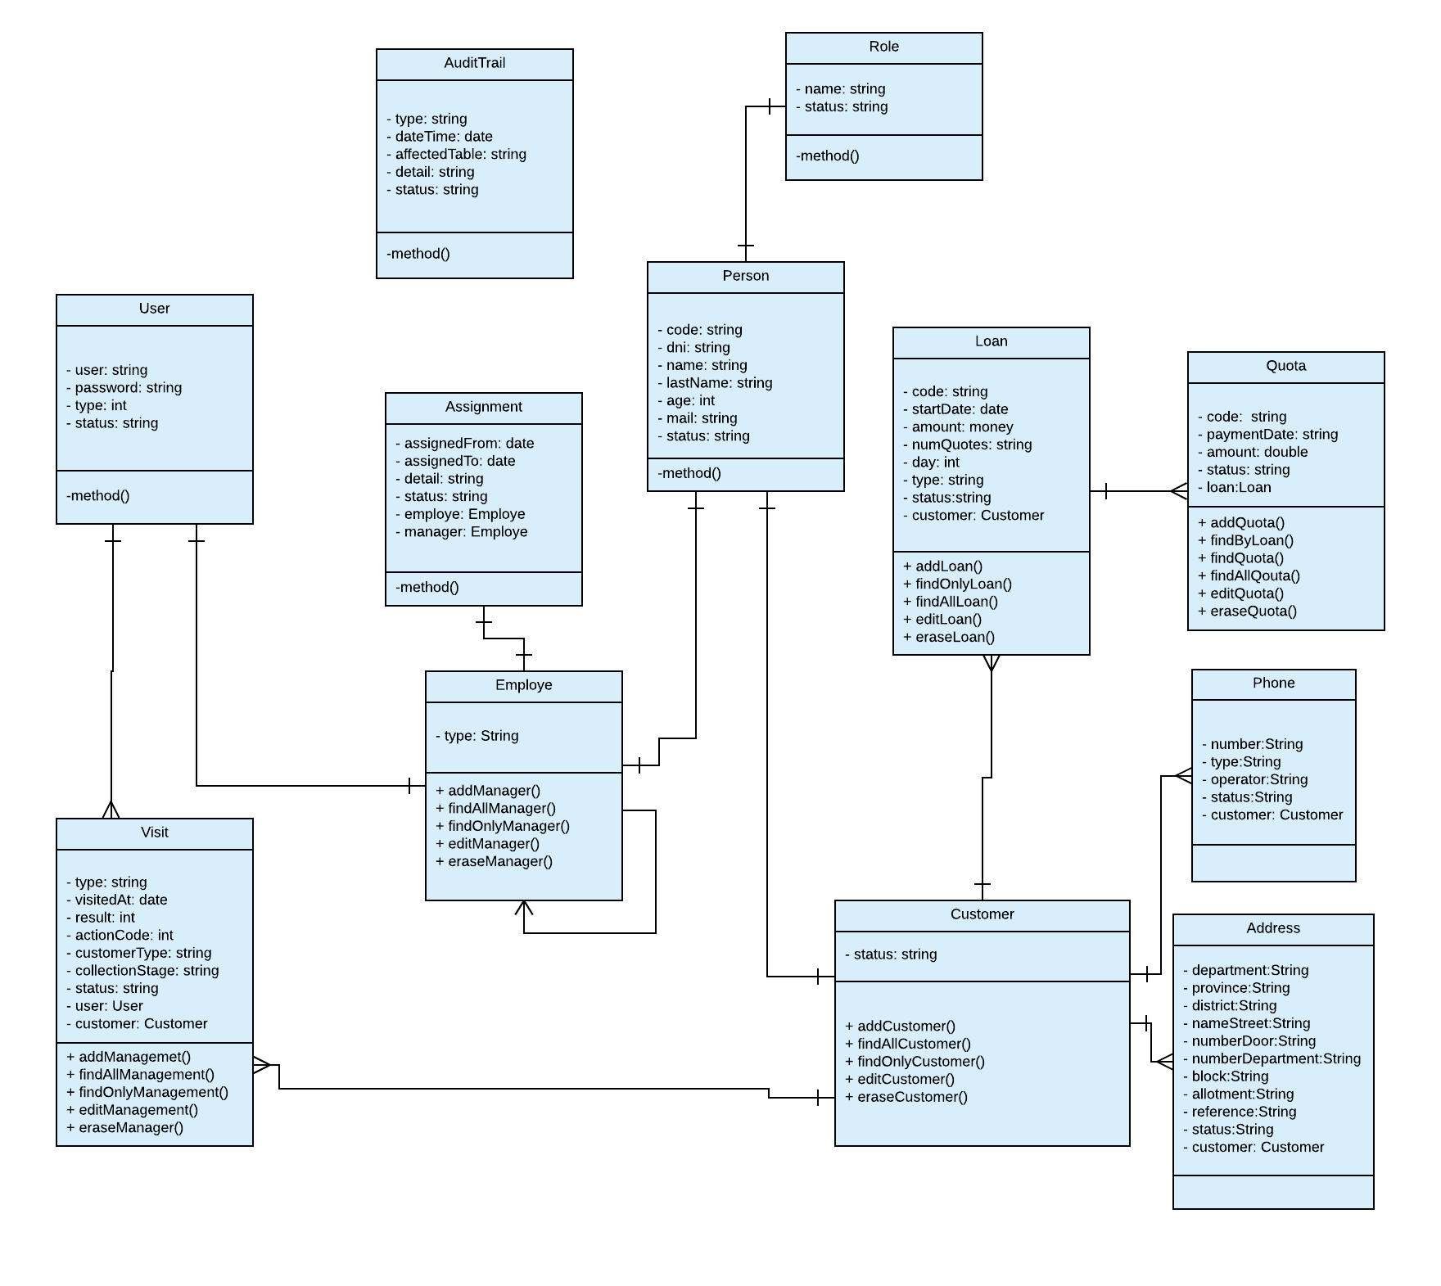

**Controllers:**

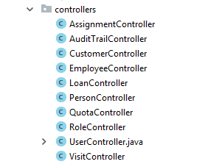

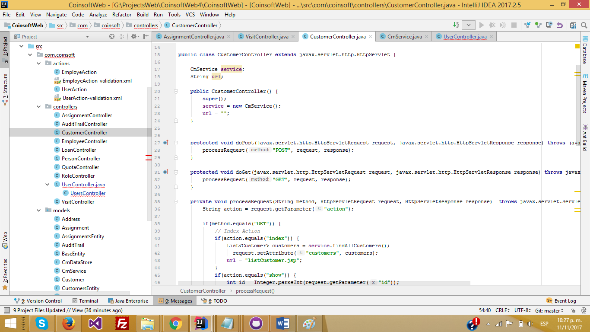

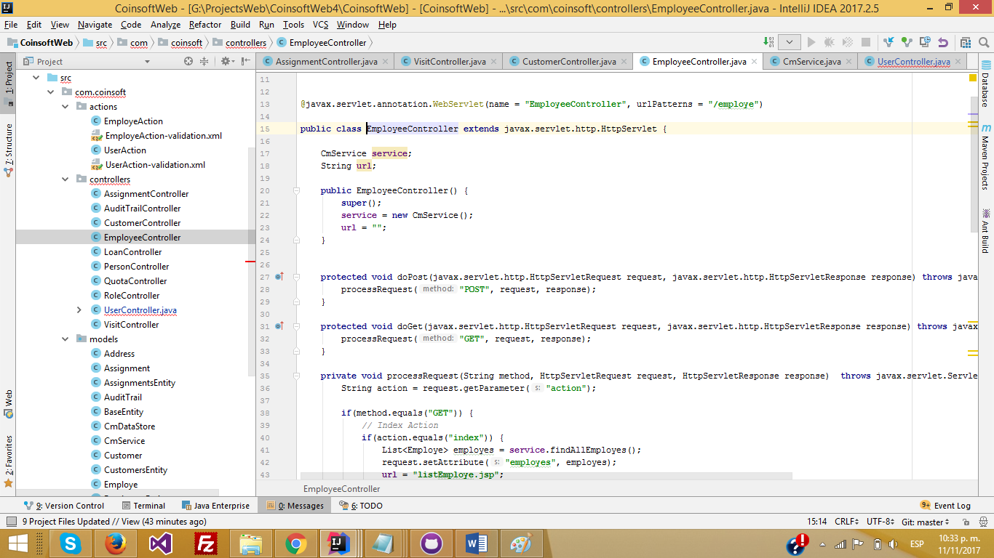

**Actions:**

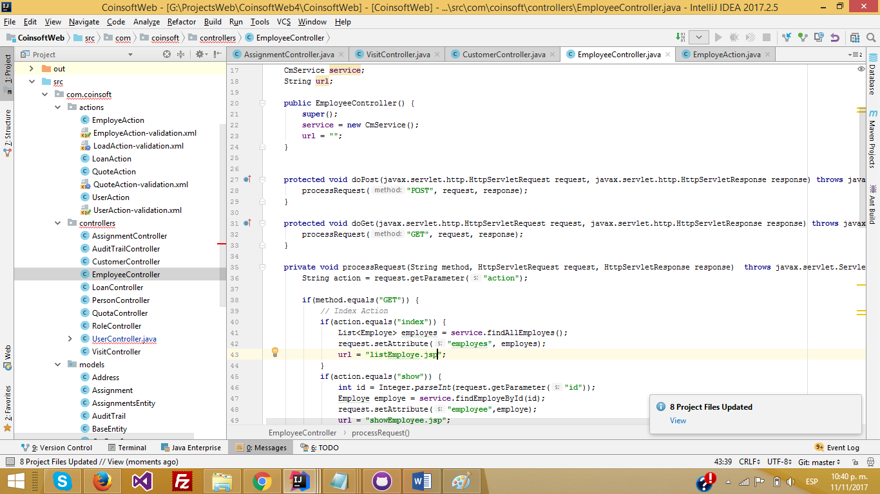

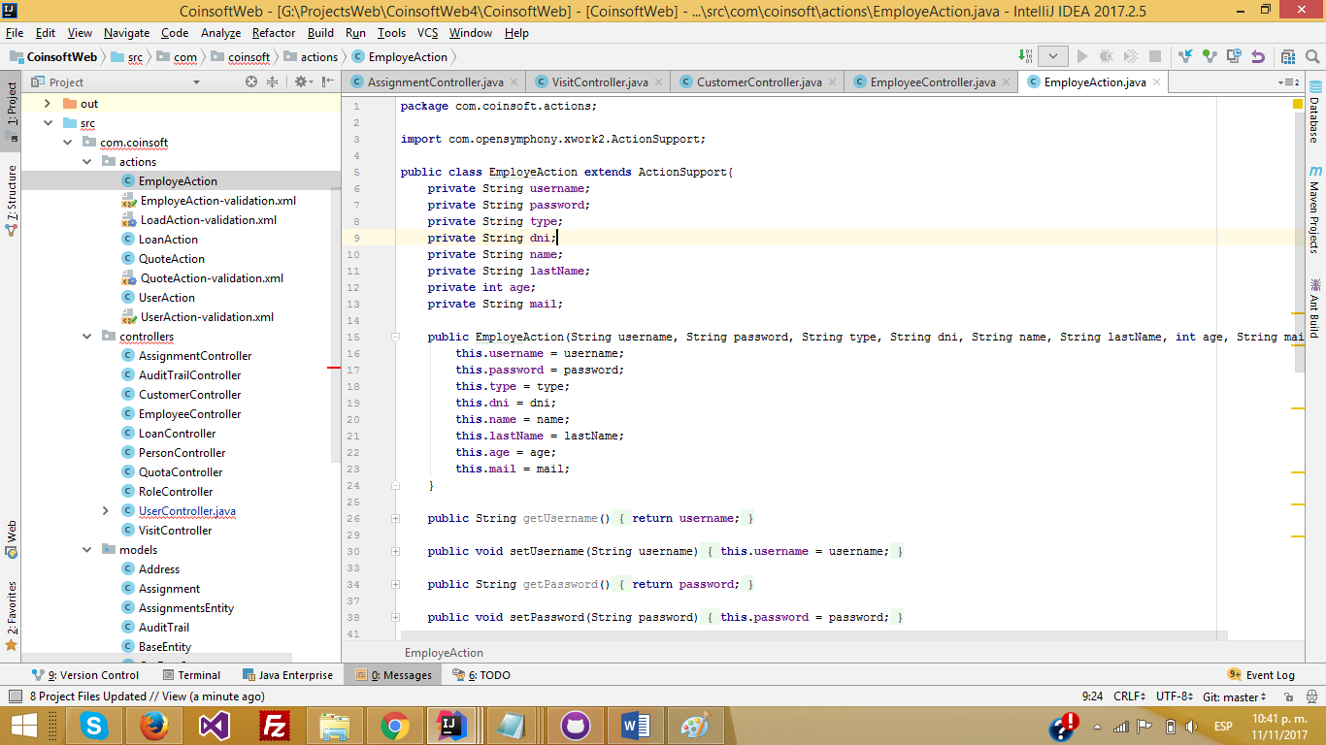

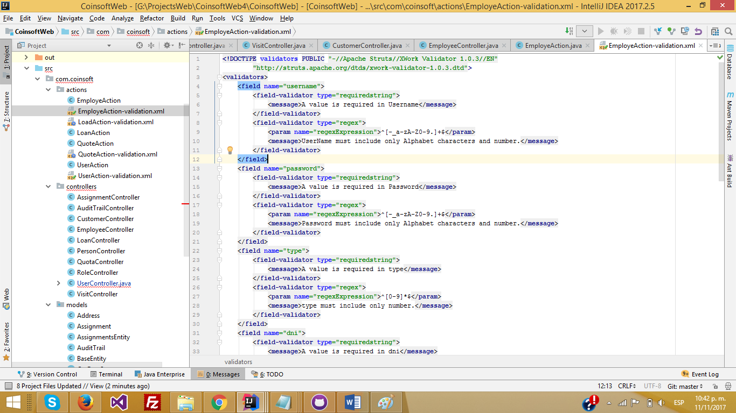

**EL EQUIPO EN GITHUB**

**El proyecto**

