# Overpass_2_KML

## Version and Licence

* Version 02/2024  
  Written by Hans Strassguetl - [https://gravelmaps.de](https://gravelmaps.de/)  
  Licenced under <https://creativecommons.org/licenses/by-sa/4.0/>
* Icons are licensed under  
  Map Icons Collection  
  Creative Commons 3.0 BY-SA  
  Author: Nicolas Mollet  
  [https://mapicons.mapsmarker.com](https://mapicons.mapsmarker.com/)
* The last download of icons placed on motorradtouren.de is version 12/2023.
* Certain icons used are from OpenStreetMap licenced under <https://creativecommons.org/publicdomain/zero/1.0/deed.en>
* Map data is provided by Openstreetmap  
  © OpenStreetMap contributors <http://www.openstreetmap.org/copyright>  
  This map data is made available under the Open Database License: <https://opendatacommons.org/licenses/odbl/>   
  Any rights in individual contents of the database are licensed under the Database Contents License: <https://opendatacommons.org/licenses/dbcl/1-0/>

## About

This program pulls data from OpenStreetMap using the Overpass Turbo API. Pulled data is then converted to Waypoints in a KML format that Oruxmaps preferers. As an alternative, you can setup the query in a way the output can be used with Organic.maps.

For Organic.Maps with Android: There seems to be no need to change your query for Oruxmaps, as long as you accept red pins only.

**18.02.2024: Beside all your configuration, by now the Organic.Maps icons are shown as a red pins only. Will be changed in my coding season 2024/2025. Now spring / summer starts and my life has different priorities.**

## **Use**

GPX_2_KML_4_Orux has no user interface. All parameters are set via command line parameters and a JSON file.

As a result, you receive

* converted KML(s) with the name {clear_name}-{country}
* all KML of a region are packed in one ZIP named {clear_name}-{region}
* all ZIP of a query will be packed into one ZIP named {clear_name}-ALL.zip

If there are any errors, you will be informed.

### Using the JSON file

folder If set to “true” all files will be stored in a folder structure on top to the ZIP files.

in_scope Set which Geos you want to pull data from.

In_scope1 just to easily park another working in_scope. Will be ignored by code.

remark Write some remarks. Will be ignored by code.

maps_geo Define the Geographies and their countries you want to pull data. *Make sure you write everything in small letter, and have an appropriate ISO code defined!*

iso_code Make sure all countries you define are reflected in this section. *Use uppercase letters!*

icon_path see more in section “Queried Waypoints”

7z to get everything packed 7z is used. 3. Make sure you have 7z installed and set the path to the executable.

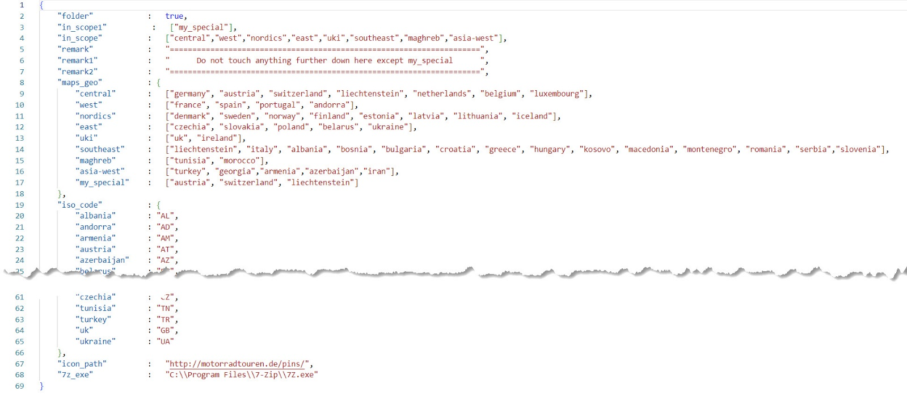

### Using the command line parameters

The command line parameters follow the python directory syntax. All key and tags need to follow the [OpenStreetMap syntax](https://wiki.openstreetmap.org/wiki/Map_features#Tourism). Everything will be queried using the Overpass Turbo API.

Example 1:

overpass_2_kml.exe --dictionary "{'key':'amenity', 'tag':'fuel', 'clear_name':'Gas_Station', 'icon':'placemark-yellow', 'brand':'false', 'brand_name':'', 'second_key':'', 'second_tag':''}"

In this example we use key = amenity and its tag=fuel. So we query [gas-stations](https://wiki.openstreetmap.org/wiki/Tag:amenity%3Dfuel).

The placemark icon is an icon used to handle the POIs for Organic.maps. The differences will be described later in this document.

We do not query a brand nor do we use a secondary key.

As a result you will receive ALL gas-station in the area you defined.

Example 2:

overpass_2_kml.exe --dictionary "{'key':'amenity', 'tag':'fuel', 'clear_name':'LPG_Gas_Station', 'icon':'placemark-yellow', 'brand':'false', 'brand_name':'', 'second_key':'fuel:lpg', 'second_tag':'yes' }"

In this example we use key = amenity and its tag=fuel. So, we query [gas-stations](https://wiki.openstreetmap.org/wiki/Tag:amenity%3Dfuel). BUT now we use a secondary key that filters the gas-stations to the ones who sell lpg gas.

Example 3:

overpass_2_kml.exe --dictionary "{'key':'shop', 'tag':'motorcycle', 'clear_name':'BMW-Dealer', 'icon':'placemark-deeporange', 'brand':'true', 'brand_name':'BMW', 'second_key':'', 'second_tag':''}"

In this example we use key=shop and tag=motorcycle. This means we search for motorcycle dealer (or someone selling motorcycle equipment, gear…). Next, we filter with brand=true, so we want to find a specific brand, in this case BMW. Second key and tag will not be used.

As a readable name on our smartphone, we want to identify these waypoints with the name BMW-Dealer. The result will be all BMW dealer per your region defined as a KML file with the name “area”-BMW-Dealer (e.g., Germany-BMW-Dealer).

More examples take from the example batch files applied to the ZIP file.

## Dependencies

Make sure you have [7z](https://7-zip.org/) installed and set the path to the executable.

## Queried Waypoints (Points of Interest)

Waypoints (POI) will be shown as icons. Based on how KML works, the icons need to come from somewhere in the web. By default, defined in the JSON, all icons used are addressed to my server <http://motorradtouren.de/pics> so they can be pulled from there.  
If you want to change that, change the JSON. It’s easy to find.  
If you decide to setup your own icon host, here is where you can download the icons:

<https://mapicons.mapsmarker.com/wp-content/uploads/zip/mapiconscollection-markers.zip>

If you want to define icons and need more information: Download the package via the link above. Find the icon you want and check if it works.

## Differences Oruxmaps / Organic.Maps

For POI, the major difference is the presentation of the icons. While Oruxmaps is able to show real icons, OrganicMaps use their own “Pins”. This means you need to change two things for your query:

1. The path to your server. For Oruxmaps I use the motorradtouren icon server, for Organic.Maps it MUST be:   
   "icon_path" : "https://omaps.app/placemarks/",
2. The icons. While for Oruxmaps you can use a variety of icons, Organic.Maps supports a defined range of Pins and colours.
3. The pathes. While OruxMaps can handle POI in pathes, OrganicMaps for Apple doesn’t like that. One needs to take all KML files in a flat structure in a folder named bookmarks.

## Folder structure

If you choose to set “folder” to true in the JSON, the output will be organised in folders that you can immediately copy to your mobile. The structure makes sure you find what you need at the place where you are. So, all points for e.g. Albania, are stored under \POI\albania. See more:

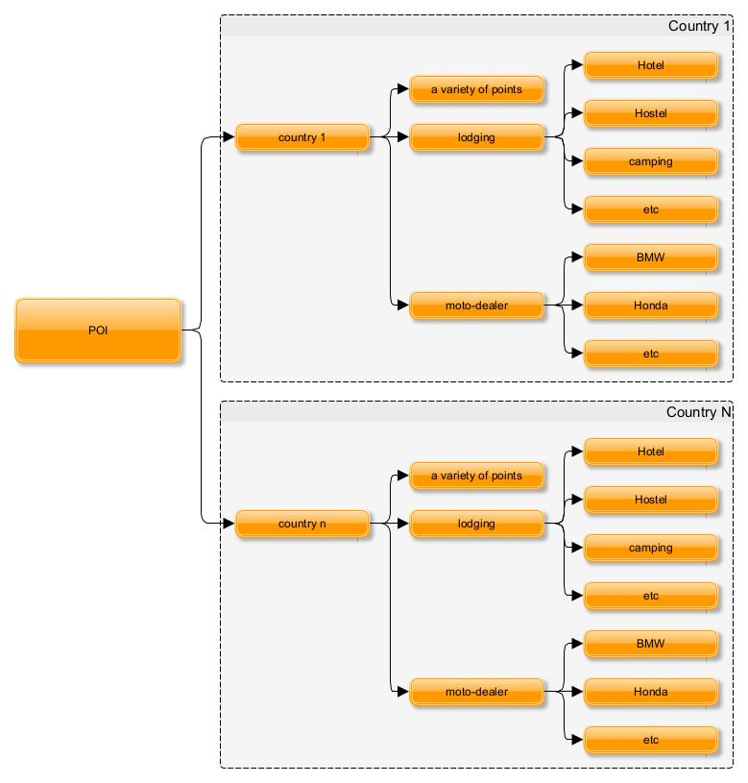

To maintain easy finding, moto-dealer are organized in their own subfolder as its true for all lodging options   
(OSM “tag = motorcycle” and “tag= hotel” and others”.

## Setting Examples

Simply copy & paste these sections to the JSON (change the existing lines)

Guesthouses:

    "key"               :   "tourism",

    "tag"               :   "guest_house",

    "clear_name"        :   "Guesthouse",

    "icon"              :   "guest_house.svg",

Apartment:

    "key"               :   "tourism",

    "tag"               :   "apartment",

    "clear_name"        :   "Apartment",

    "icon"              :   "Apartment.svg",

Hostel:

    "key"               :   "tourism",

    "tag"               :   "hostel",

    "clear_name"        :   "Hostel",

    "icon"              :   "Hostel-16.svg",

Hotels:

    "key"               :   "tourism",

    "tag"               :   "hotel",

    "clear_name"        :   "Hotel",

    "icon"              :   "Hotel-16.svg",

Motel:

    "key"               :   "tourism",

    "tag"               :   "motel",

    "clear_name"        :   "Motel",

    "icon"              :   "Motel-16.svg",

Camping:

    "key"               :   "tourism",

    "tag"               :   "camp_site",

    "clear_name"        :   "Camping",

    "icon"              :   "Camping-16.svg",

Alpine Hut:

    "key"               :   "tourism",

    "tag"               :   "alpine_hut",

    "clear_name"        :   "Alpine_Hut",

    "icon"              :   "Alpinehut.svg",

Gas Stations:

    "key"               :   "amenity",

    "tag"               :   "fuel",

    "clear_name"        :   "Gas-Station",

    "icon"              :   "Fuel.svg",

More:

<https://wiki.openstreetmap.org/wiki/DE:Tourismus>

## Credits

* To build a running EXE from python source, I'm using the pyinstaller from <https://pyinstaller.org/en/stable/>
* Icons used are licensed under  
  Map Icons Collection  
  Creative Commons 3.0 BY-SA  
  Author: Nicolas Mollet  
  [https://mapicons.mapsmarker.com](https://mapicons.mapsmarker.com/)

## Data privacy

* By design XML structures as KML reach out for external servers.
* Using icons make the KML interpreter (as Oruxmaps) reaching out to my server via <http://motorradtouren.de/pics> (or wherever you decided to host the icons!)
* No access data is collected or stored for this service by this program or on the server motorradtouren.de.

## Most common icons I use for Oruxmaps

Here some common Waypoints as they are used by Basecamp (left column) and a possible conversion to KML.

"points": {

        "remark"    : "----- Section has no function other than acting as a reference -----",

        "Default": "pin-export.png",

        "Airport": "airport.png",

        "ATV": "atv.png",

        "Bar": "bar.png",

        "Beach": "beach_icon.png",

        "Big Game": "deer.png",

        "Bike Trail": "cycling.png",

        "Building": "house.png",

        "Bunker": "bunker.png",

        "Campground": "campground.png",

        "Church": "church.png",

        "Circle, Green": "grass.png",

        "Circle with X": "comment-map-icon.png",

        "City (Small)": "star-3.png",

        "Controlled Area": "accesdenied.png",

        "Crossing": "junction.png",

        "Danger Area": "attention.png",

        "Department Store": "departmentstore.png",

        "Drinking Water": "drinkingwater.png",

        "Fast Food": "coffee.png",

        "Ferry": "cruiseship.png",

        "Flag, Blue": "flag-export.png",

        "Gas Station": "gas-station.png",

        "Heliport": "helicopter.png",

        "Information": "information.png",

        "Live Theater": "theater.png",

        "Lodge": "hotel_0star.png",

        "Lodging": "lodging.png",

        "Military": "military.png",

        "Museum": "museum_archeological.png",

        "Navaid, Black": "letter_n.png",

        "Navaid, Green": "grass.png",

        "Navaid, Orange": "symbol_excla.png",

        "Parking Area": "parkinggarage.png",

        "Police Station": "police.png",

        "Private Field": "world.png",

        "Puzzle Cache": "orienteering.png",

        "Railway": "train.png",

        "Residence": "home.png",

        "Restaurant": "restaurant.png",

        "RV Park": "campingcar.png",

        "Scenic Area": "panoramicview.png",

        "Shopping Center": "conveniencestore.png",

        "Skull and Crossbones": "skull.png",

        "Soft Field": "smiley_happy.png",

        "Summit": "hill.png",

        "Swimming Area": "swimming.png",

        "Toll Booth": "tollstation.png",

        "TracBack Point": "footprint.png",

        "Trail Head": "hiking.png",

        "Tree Stand": "kanzeldach.png",

        "Truck": "truck.png",

        "Ultralight Area": "aircraftsmall.png",

        "Wreck": "shipwreck.png"

    }

More icons placed on motorradtouren.de

Lodging:

Apartment.svg

Camping-16.svg

Hostel-16.svg

Hotel-16.svg

Motel-16.svg

guest_house.svg

Caravan-16.svg

Alpinehut.svg

Others:

Fuel.svg

## Points / Pins for OrganicMaps

The Organic.Maps implementation of KML does not use graphics as available in Garmin. The following icons are the ones I am aware of:

Standards from Organic.Maps / Maps.Me:

placemark-red  
placemark-blue  
placemark-purple  
placemark-yellow  
placemark-pink  
placemark-brown  
placemark-green  
placemark-orange  
placemark-deeppurple  
placemark-lightblue  
placemark-cyan  
placemark-teal  
placemark-lime  
placemark-deeporange  
placemark-gray  
placemark-bluegray

**Garmin Waypoints**

This are the waypoints I’m aware so far:

Airport

Alert

Amusement Park

Anchor

Animal Tracks

ATV

Ball Park

Bank

Bar

Beach

Bell

Big Game

Bike Trail

Binoculars

Blind

Block, Blue

Block, Green

Block, Red

Blood Trail

Boat Ramp

Bowling

Bridge

Building

Buoy, White

Campground

Camp Fire

Canoe

Car

Car Rental

Car Repair

Cemetery

Church

Circle with X

Circle, Blue

Circle, Green

Circle, Red

City (Large)

City (Medium)

City (Small)

Civil

Contact, Afro

Contact, Alien

Contact, Ball Cap

Contact, Big Ears

Contact, Biker

Contact, Bug

Contact, Cat

Contact, Dog

Contact, Dreadlocks

Contact, Female1

Contact, Female2

Contact, Female3

Contact, Goatee

Contact, Kung-Fu

Contact, Pig

Contact, Pirate

Contact, Ranger

Contact, Smiley

Contact, Spike

Contact, Sumo

Contact, Female3

Controlled Area

Convenience Store

Cover

Covey

Crossing

Dam

Danger Area

Department Store

Diver Down Flag

Drinking Water

Fast Food

Fishing Area

Fishing Hot Spot Facility

Fitness Center

Flag, Blue

Flag, Green

Flag, Red

Food Source

Forest

Furbearer

Gas Station

Glider Area

Golf Course

Horse Trail

Hunting

Kayak

Letter A, Red

Letter B, Red

Letter C, Red

Letter D, Red

Lighthouse

Marina

Man Overboard

Medical Facility

Mine

Movie Theater

Museum

Navaid, Amber

Navaid, Black

Navaid, Blue

Navaid, Green

Navaid, Orange

Navaid, Red

Navaid, Violet

Navaid, White

Number 1, Blue

Number, Blue

Number, Blue

Number 4, Blue

Oil Field

Parachute Area

Park

Parking Area

Pharmacy

Picnic Area

Pin, Blue

Pin, Green

Pin, Red

Pin, Yellow

Pizza

Police Station

Post Office

Private Field

Radio Beacon

Residence

Restaurant

Restricted Area

Restroom

RV Park

Scales

Scenic Area

School

Shelter

Shipwreck

Shopping Center

Short Tower

Shower

Ski Resort

Skiing Area

Skull and Crossbones

Small Game

Snowmobile

Square, Yellow

Stadium

Stop Sign

Street Intersection

Summit

Swimming Area

Tall Tower

Telephone

Toll Booth

Trail Head

Tree

Tree Stand

Treed Quarry

Triangle, Blue

Triangle, Green

Triangle, Red

Triangle, Yellow

Truck

Truck Stop

Tunnel

Ultralight Area

Upland Game

Waterfowl

Water Source

Wind Turbine

Wrecker

XSki   
Zoo

Airport

Alert

Amusement Park

Anchor

Animal Tracks

ATV

Ball Park

Bank

Bar

Beach

Bell

Big Game

Bike Trail

Binoculars

Blind

Block, Blue

Block, Green

Block, Red

Blood Trail

Boat Ramp

Bowling

Bridge

Building

Buoy, White

Campground

Camp Fire

Canoe

Car

Car Rental

Car Repair

Cemetery

Church

Circle with X

Circle, Blue

Circle, Green

Circle, Red

City (Large)

City (Medium)

City (Small)

Civil

Contact, Afro

Contact, Alien

Contact, Ball Cap

Contact, Big Ears

Contact, Biker

Contact, Bug

Contact, Cat

Contact, Dog

Contact, Dreadlocks

Contact, Female1

Contact, Female2

Contact, Female3

Contact, Goatee

Contact, Kung-Fu

Contact, Pig

Contact, Pirate

Contact, Ranger

Contact, Smiley

Contact, Spike

Contact, Sumo

Contact, Female3

Controlled Area

Convenience Store

Cover

Covey

Crossing

Dam

Danger Area

Department Store

Diver Down Flag

Drinking Water

Fast Food

Fishing Area

Fishing Hot Spot Facility

Fitness Center

Flag, Blue

Flag, Green

Flag, Red

Food Source

Forest

Furbearer

Gas Station

Glider Area

Golf Course

Horse Trail

Hunting

Kayak

Letter A, Red

Letter B, Red

Letter C, Red

Letter D, Red

Lighthouse

Marina

Man Overboard

Medical Facility

Mine

Movie Theater

Museum

Navaid, Amber

Navaid, Black

Navaid, Blue

Navaid, Green

Navaid, Orange

Navaid, Red

Navaid, Violet

Navaid, White

Number 1, Blue

Number, Blue

Number, Blue

Number 4, Blue

Oil Field

Parachute Area

Park

Parking Area

Pharmacy

Picnic Area

Pin, Blue

Pin, Green

Pin, Red

Pin, Yellow

Pizza

Police Station

Post Office

Private Field

Radio Beacon

Residence

Restaurant

Restricted Area

Restroom

RV Park

Scales

Scenic Area

School

Shelter

Shipwreck

Shopping Center

Short Tower

Shower

Ski Resort

Skiing Area

Skull and Crossbones

Small Game

Snowmobile

Square, Yellow

Stadium

Stop Sign

Street Intersection

Summit

Swimming Area

Tall Tower

Telephone

Toll Booth

Trail Head

Tree

Tree Stand

Treed Quarry

Triangle, Blue

Triangle, Green

Triangle, Red

Triangle, Yellow

Truck

Truck Stop

Tunnel

Ultralight Area

Upland Game

Waterfowl

Water Source

Wind Turbine

Wrecker

XSki   
Zoo