CSE340: Computer Architecture

Handout_Chapter - 3: Arithmetic for Computers



Prepared by: Partha Bhoumik (PBK)
Course Coordinator, CSE340

Integer Addition-Subtraction

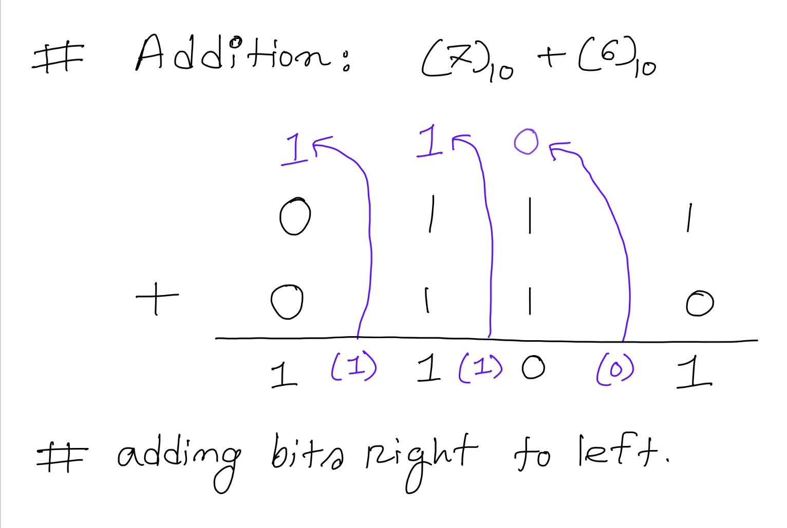

# Bits with this color represent carry-forward

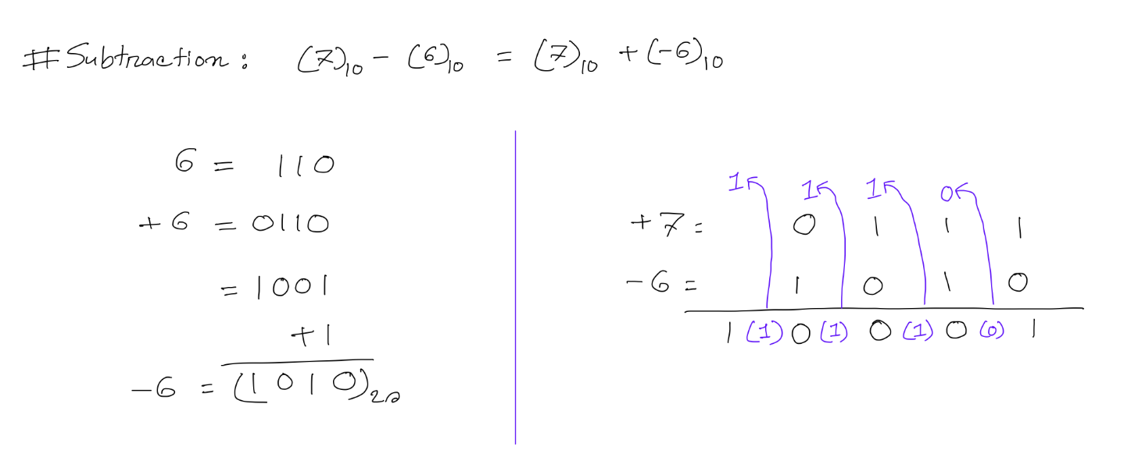

Overflow Detection (integer)

#Addition:
Case-1: Add two same signed numbers:
if (answer also has same sign):
No overflow
else:
Overflow
Case-2: Add two different signed numbers:
Never Overflow

#Subtraction:
Case-3: Sub two same signed numbers:
Never Overflow
Case-4: Sub two different signed numbers:
+A - (-B) = +A +B => Case-1
-A - (+B) = -A +(-B) => Case-1

Long Multiplication
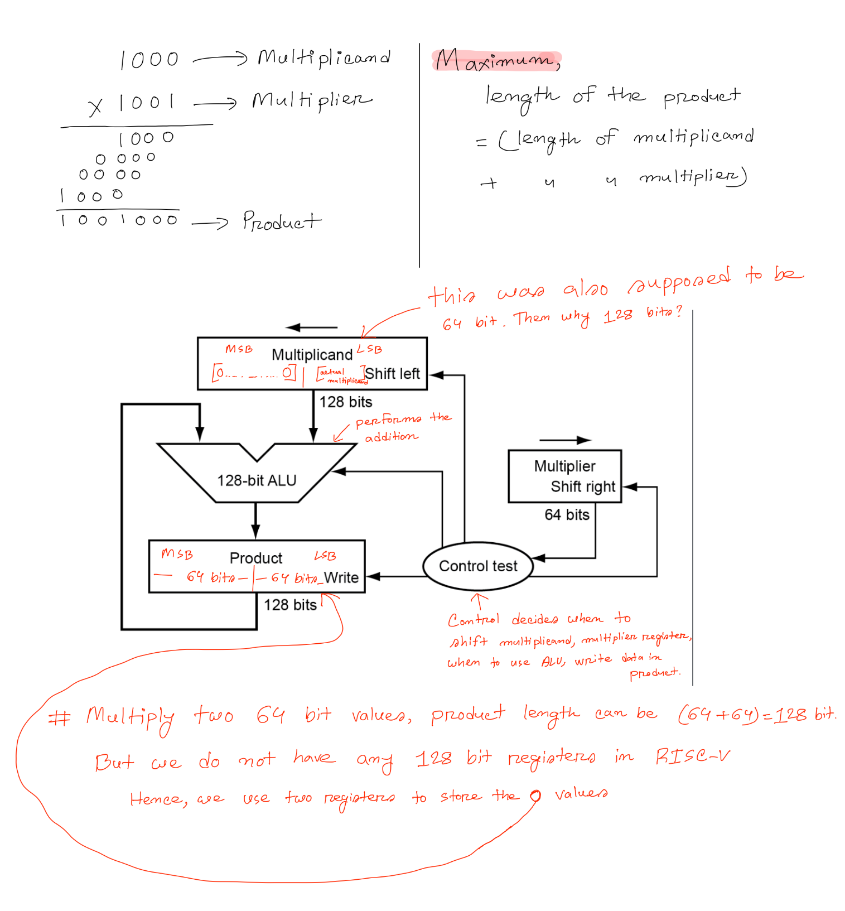

System:

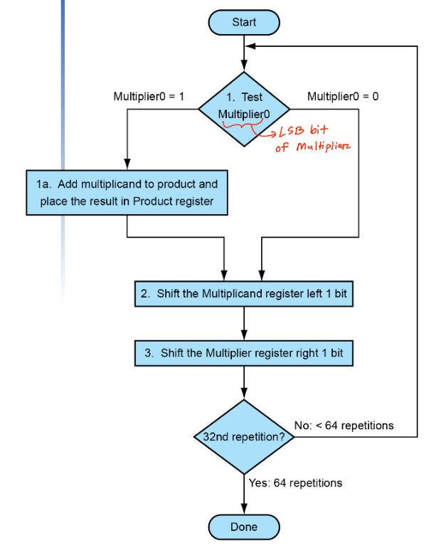

Flowchart:

Example:
Multiply 8 and 9 using the long multiplication method:
Solution:
You can choose any of the operands as multiplier or multiplicand.
Number of iterations = Number of bits in Multiplier

Iteration Multiplier Multiplicand Product
0 | 1001 | 0000 1000 | 0000 0000
1 | 1001 | 0000 1000 | 0000 1000
1 | 1001 | 0001 0000 | 0000 1000
1 | 0100 | 0001 0000 | 0000 1000
2 | 0100 | 0010 0000 | 0000 1000
2 | 0010 | 0010 0000 | 0000 1000
3 | 0010 | 0100 0000 | 0000 1000
3 | 0001 | 0100 0000 | 0000 1000
4 | 0001 | 0100 0000 | 0100 1000
4 | 0001 | 1000 0000 | 0100 1000
4 | 0000 | 1000 0000 | 0100 1000

Optimized Multiplication

System:
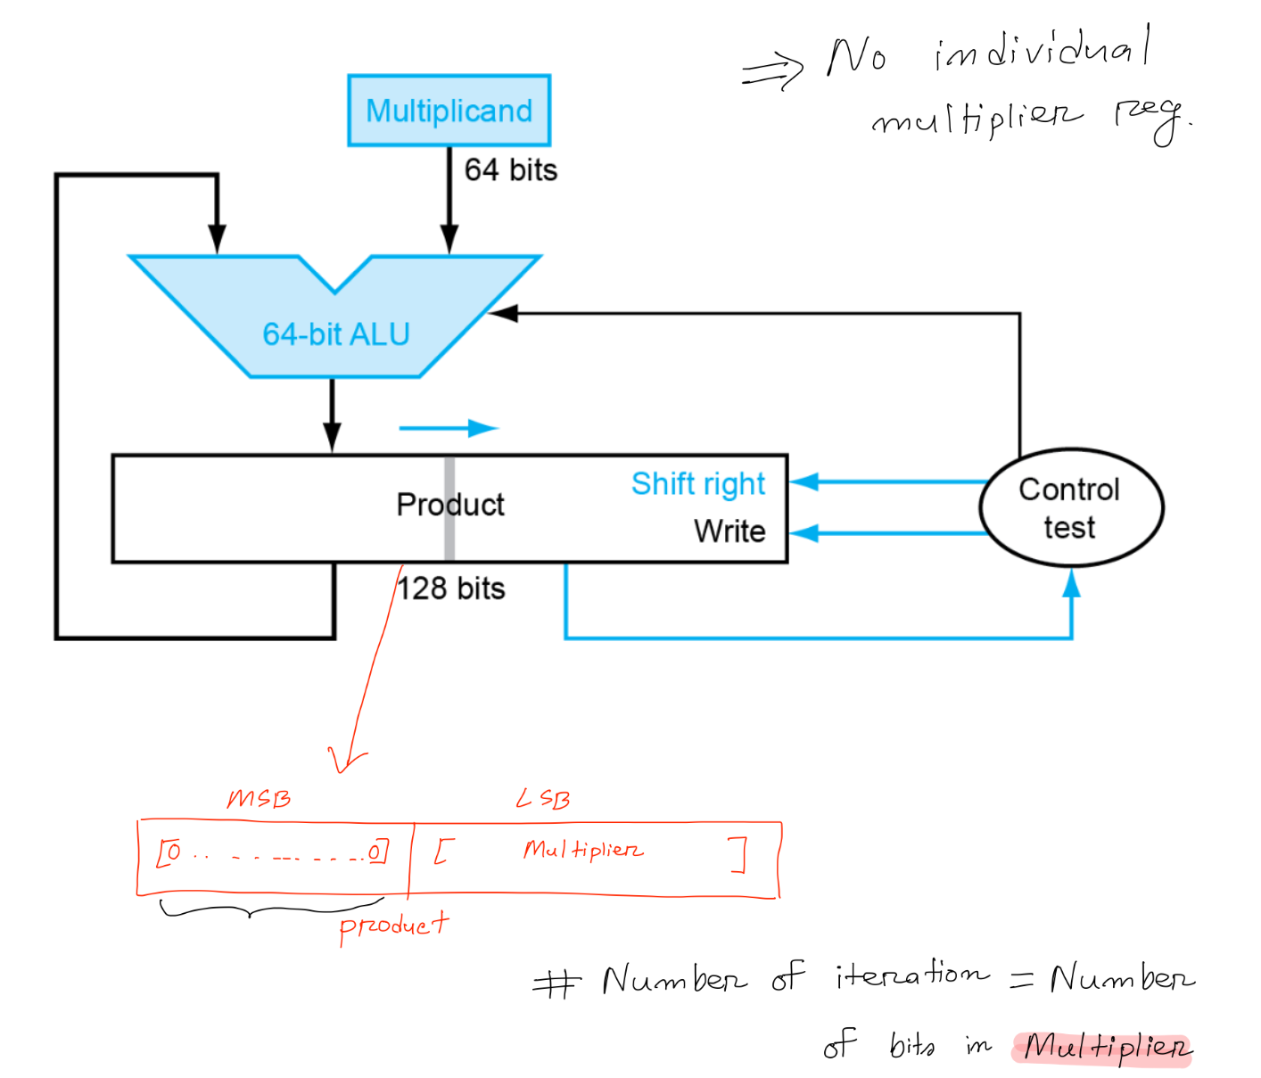

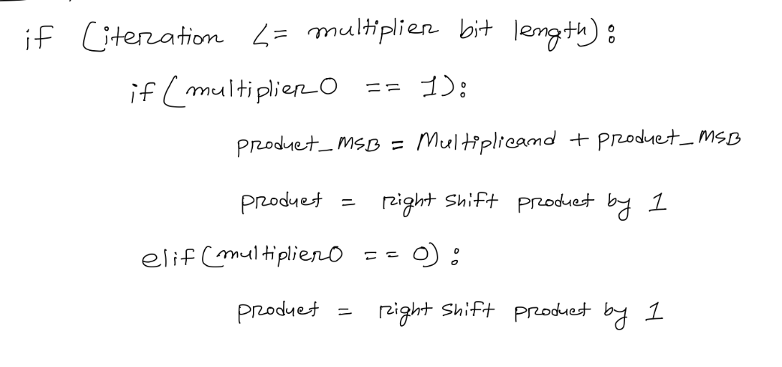
Logic:

Example:
Multiply 8 and 9 using the optimized multiplication method:
Solution:
You can choose any of the operands as multiplier or multiplicand.
Number of iterations = Number of bits in Multiplier
# This color represents the product MSB part.

Iteration Multiplicand Product
0 | 1000 | 0000 1001
1 | 1000 | 1000 1001
1 | 1000 | 0100 0100
2 | 1000 | 0010 0010
3 | 1000 | 0001 0001
4 | 1000 | 1001 0001
4 | 1000 | 0100 1000

Floating Point

How does RISC-V support numbers with fractions?
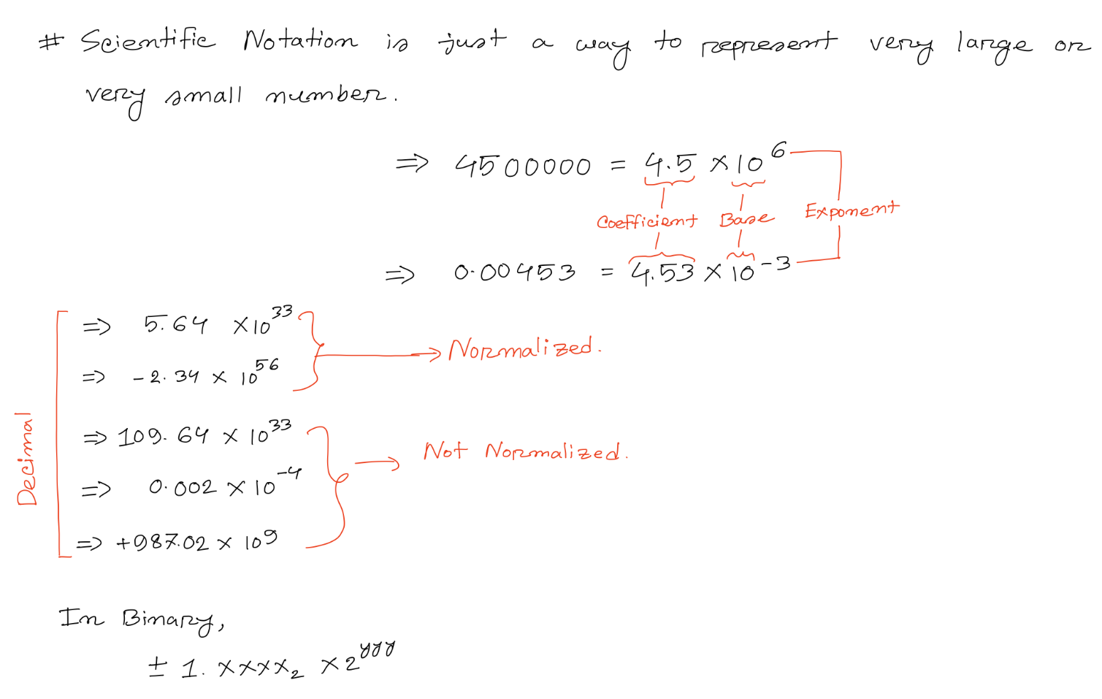
=> Using IEEE-754 floating point representation

IEEE-754 floating point representation:
i. Single Precision. (32 bits)
ii. Double Precision. (64 bits)

Using double precision, you can represent a larger or a smaller number than single precision.

Normalized Number

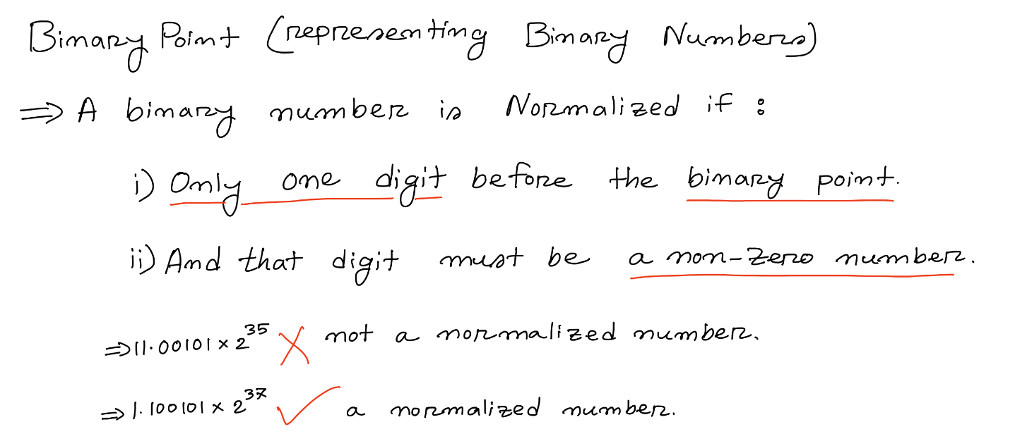
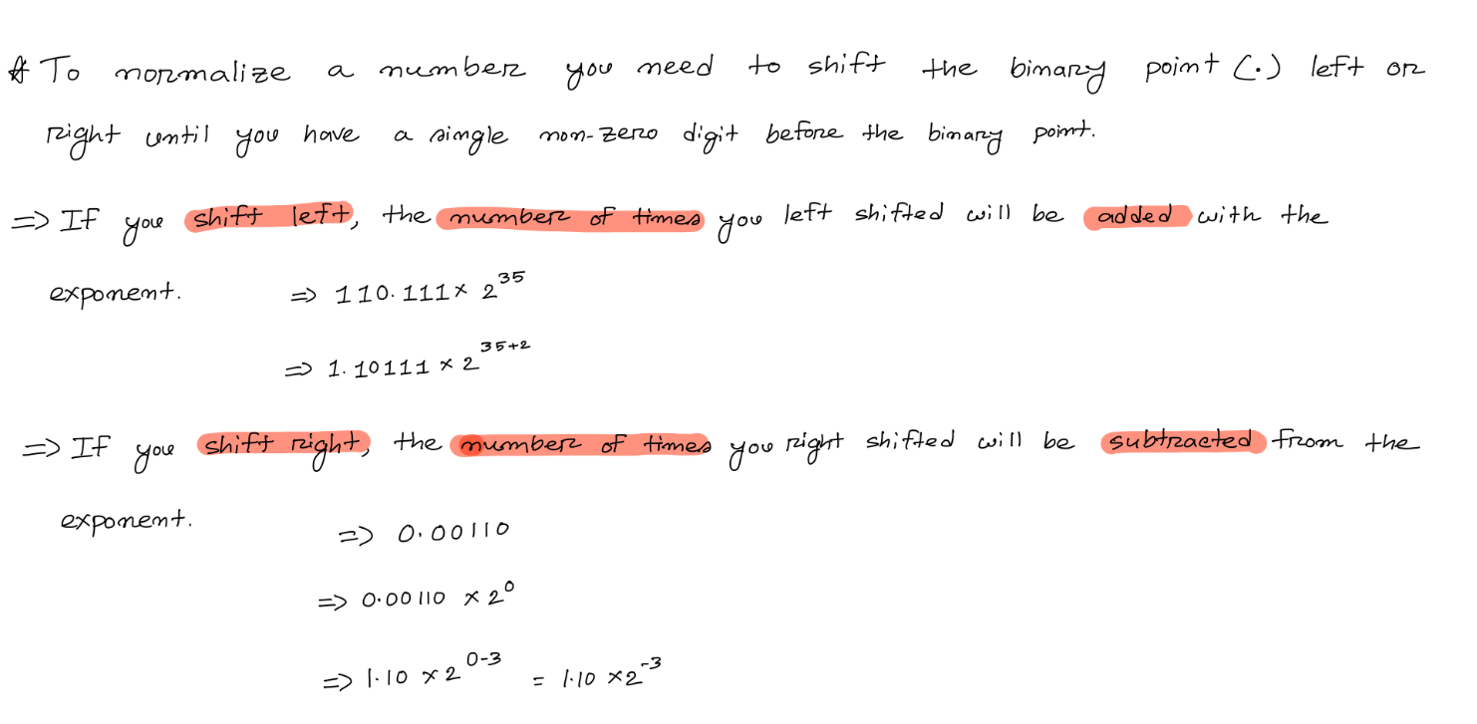

IEEE-754 Floating Point Representation

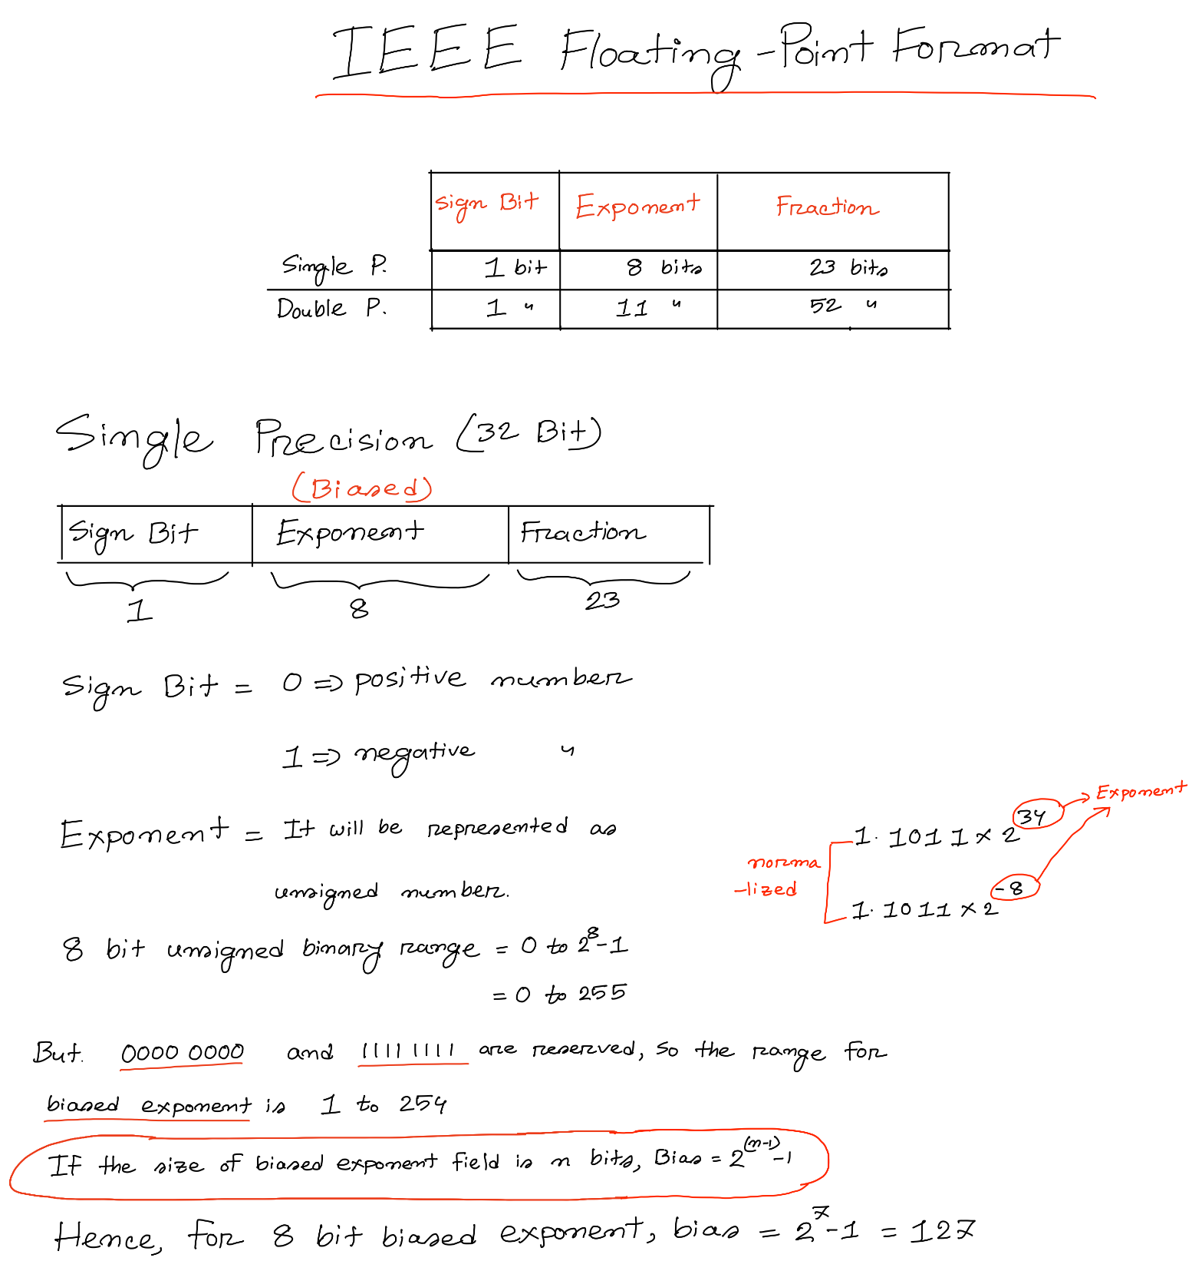
IEEE-754 Single Precision Format (32-bit)

IEEE-754 Double Precision Format (64-bit)
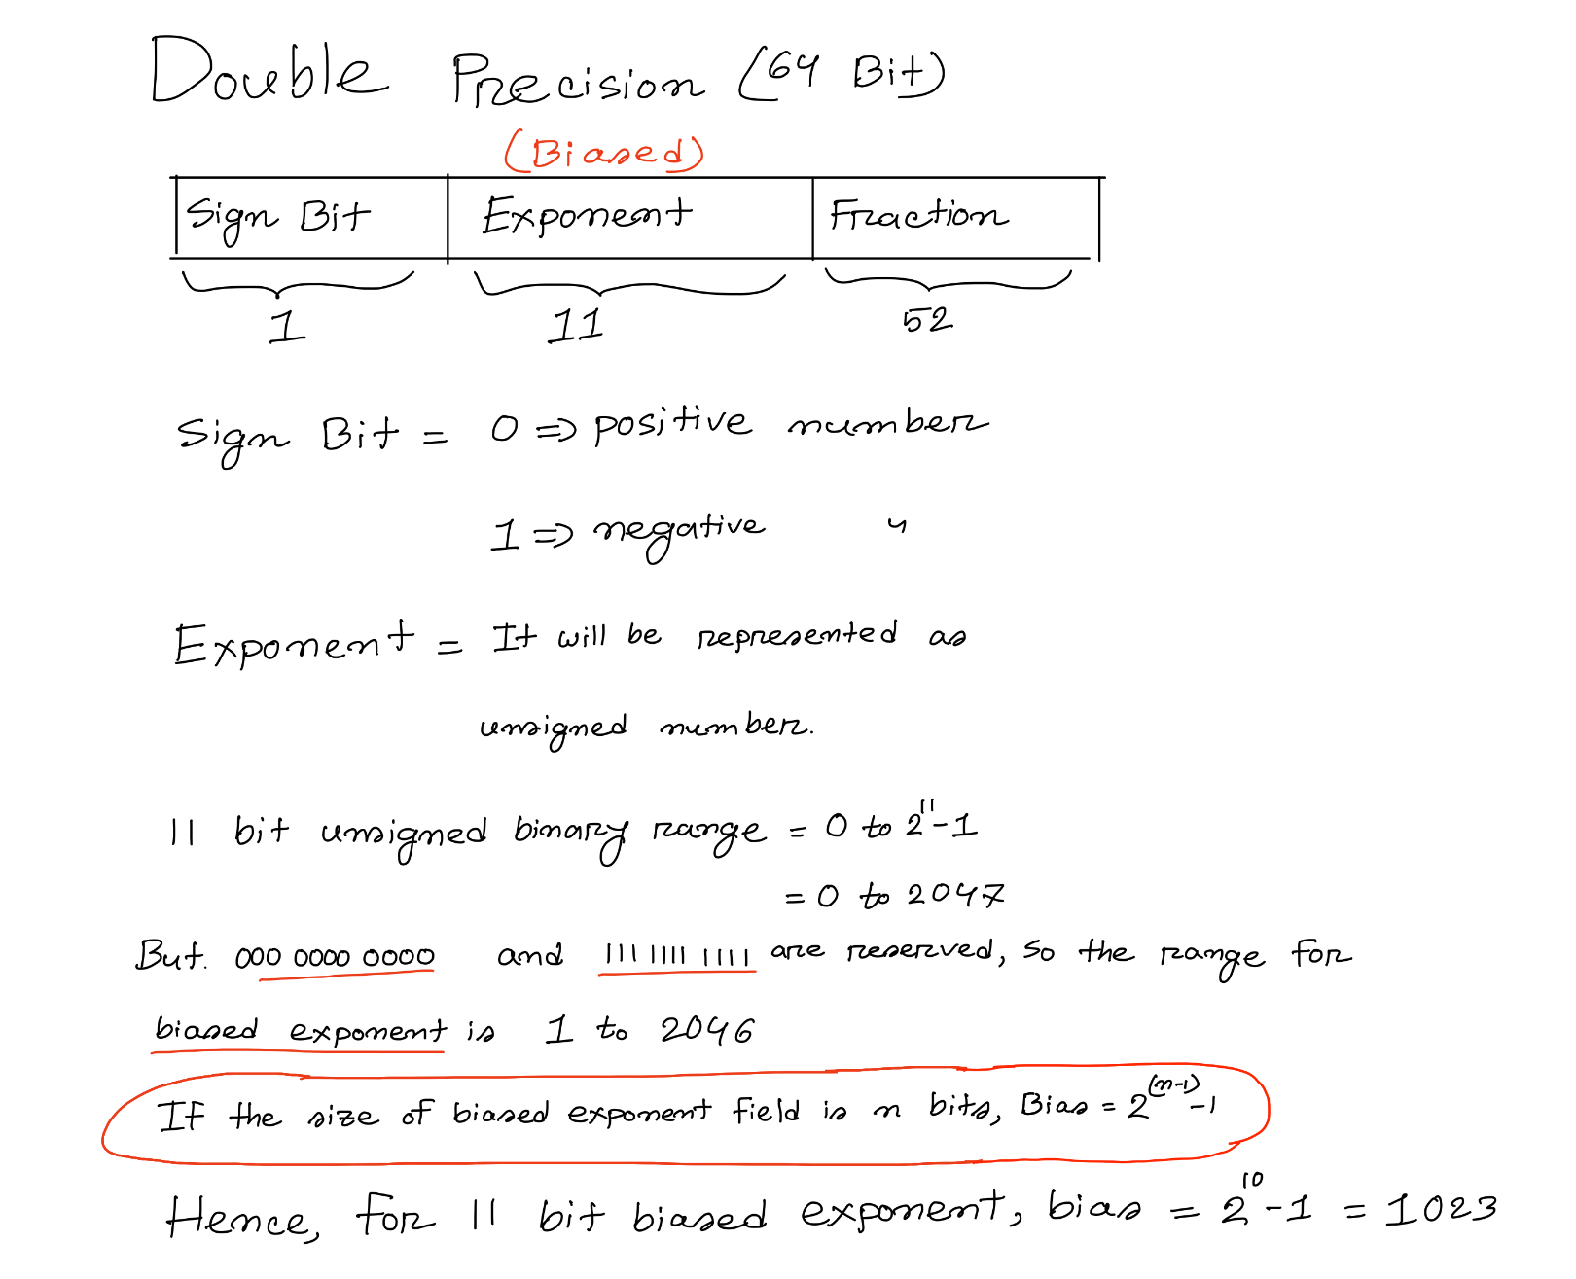

Decimal to IEEE-754 Floating Point Conversion
Steps:
1. Convert the decimal number to binary number.
2. Normalize the binary number.
3. Find the biased exponent.
4. Sign Bit.
5. Find the fraction.
6. Encode accordingly.

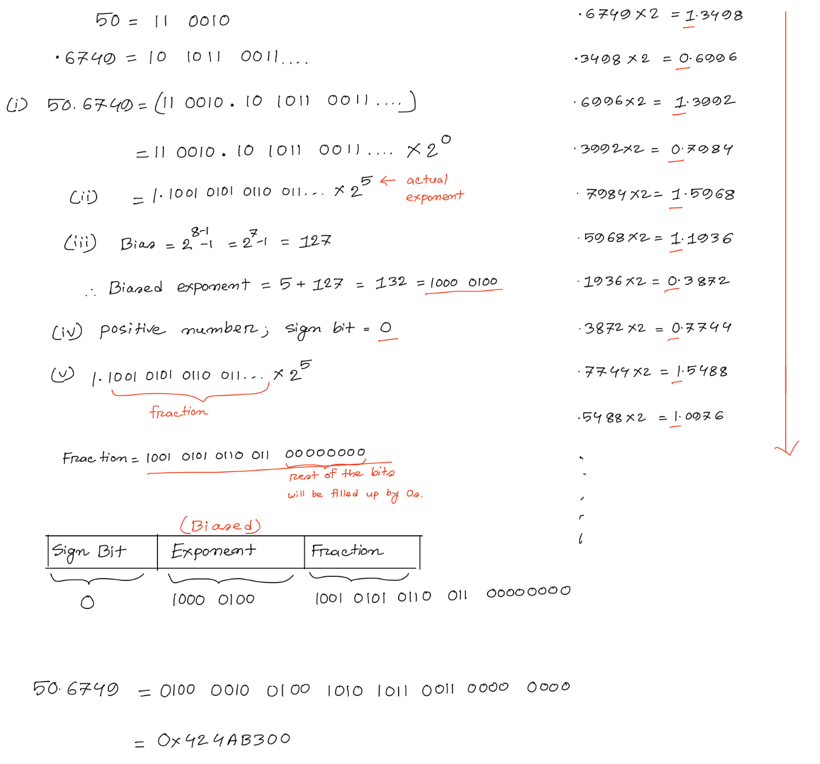
Example:
Convert 50.6749 to IEEE-754 single precision floating point representation. Show your final answer in Hex format. Consider 10 bits while converting from decimal to binary.
Solution:

Example:
Convert -0.0232 to 12-bit IEEE-754 representation where the size of the exponent field is 4 bits. Show your final answer in Hex format.

Solution:
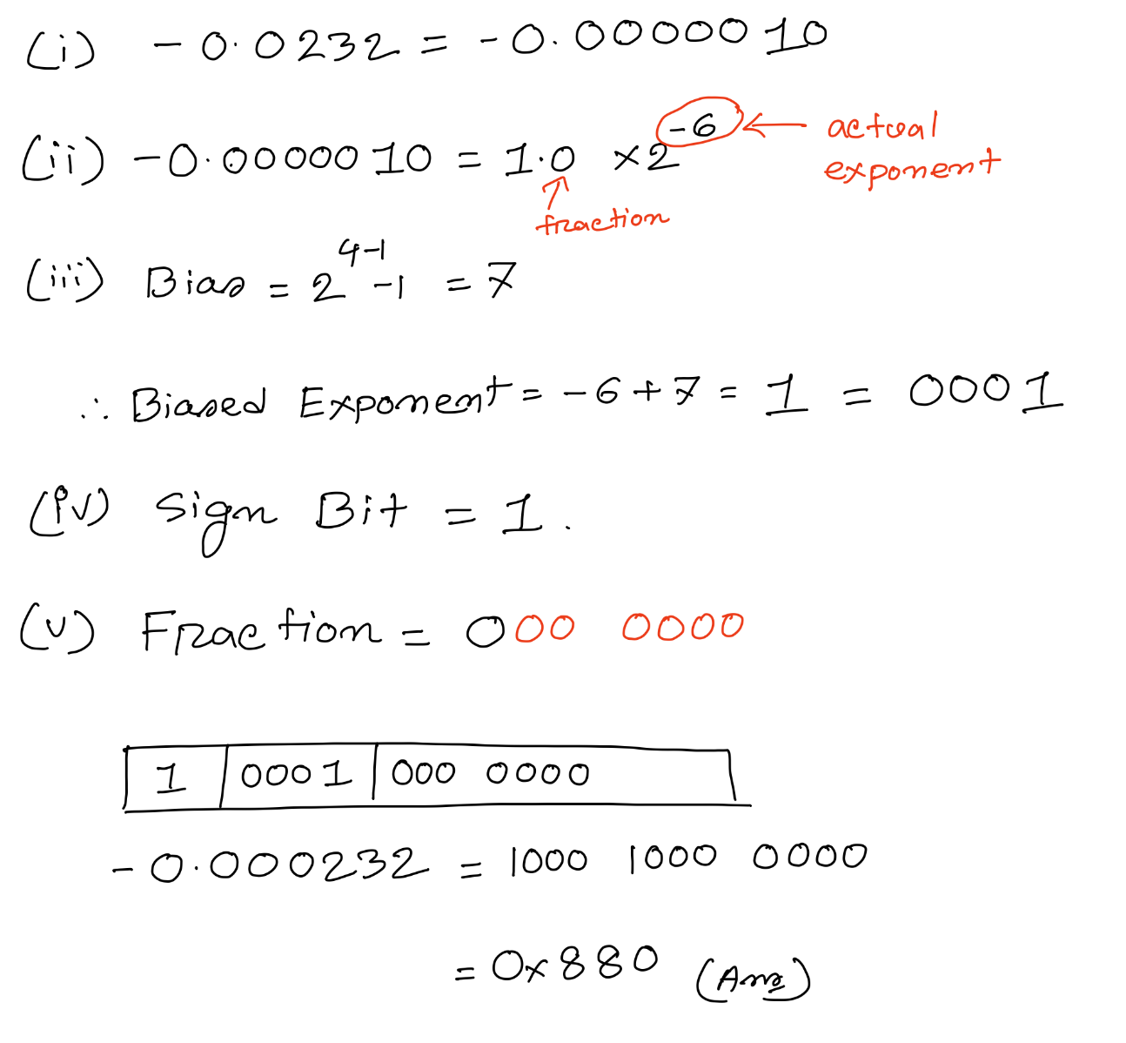
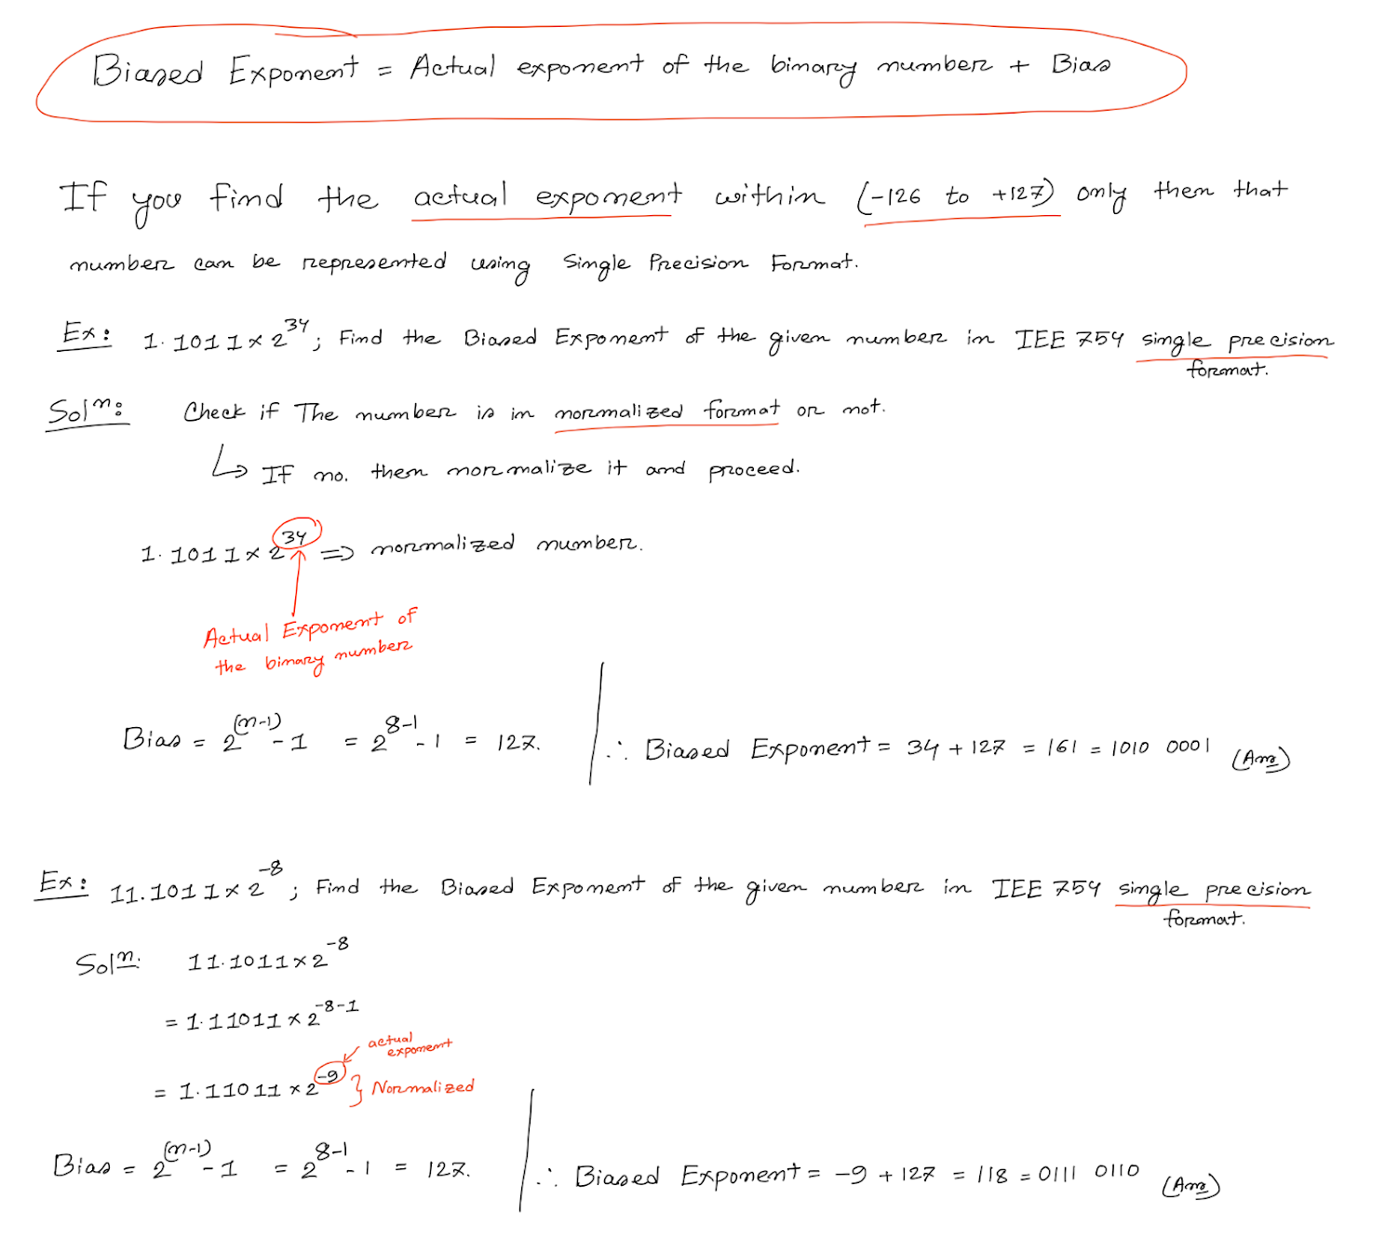

IEEE-754 Floating Point to Decimal Conversion

Steps:
1. Convert the Hex/Decimal number to binary number.
2. Arrange the binary number according to the given IEEE format.
3. Determine the sign.
4. Find out the actual exponent from the biased exponent field.
5. Convert Fraction to Decimal.
6. Final number = $(-1)^{Sign Bit}×(1+Fraction)×{2^{}}^{Actual Exponent}$.

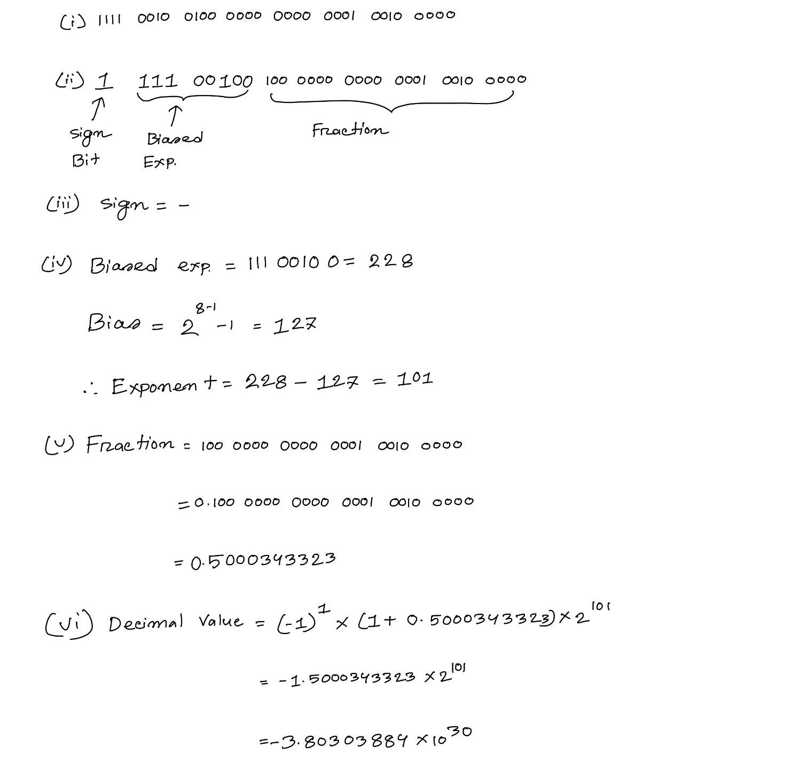
Example:
Convert the given IEEE-754 single precision floating point number 0xF2400120 to decimal.
Solution:

Floating Point Addition/Subtraction

Given A and B are both floating-point numbers.
Steps:
1. Make sure both numbers are in Binary.
2. Normalize both A and B.
3. Align the binary point so that the lower exponent matches with the higher exponent.
4. Now add or sub accordingly.
5. Normalize the result.
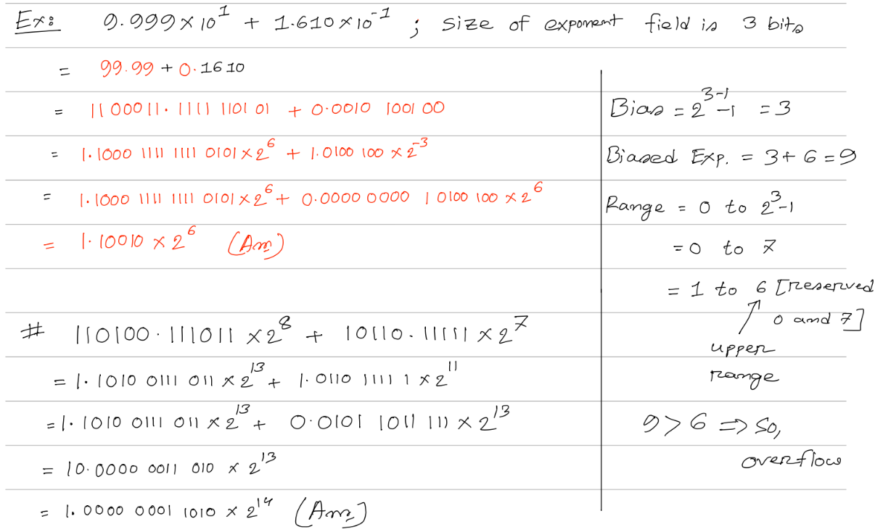

Floating Point Multiplication

Given A and B are both floating-point numbers.
Steps:
1. Make sure both numbers are in Binary.
2. Normalize both A and B.
3. Add the exponents.
4. Now multiply accordingly.
5. Normalize the result.
6. Determine the sign of the operation.

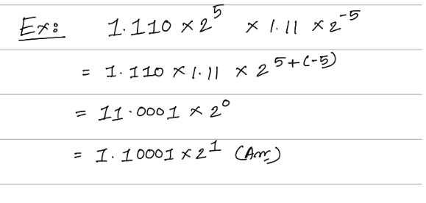

Overflow-Underflow detection for IEEE-754 format
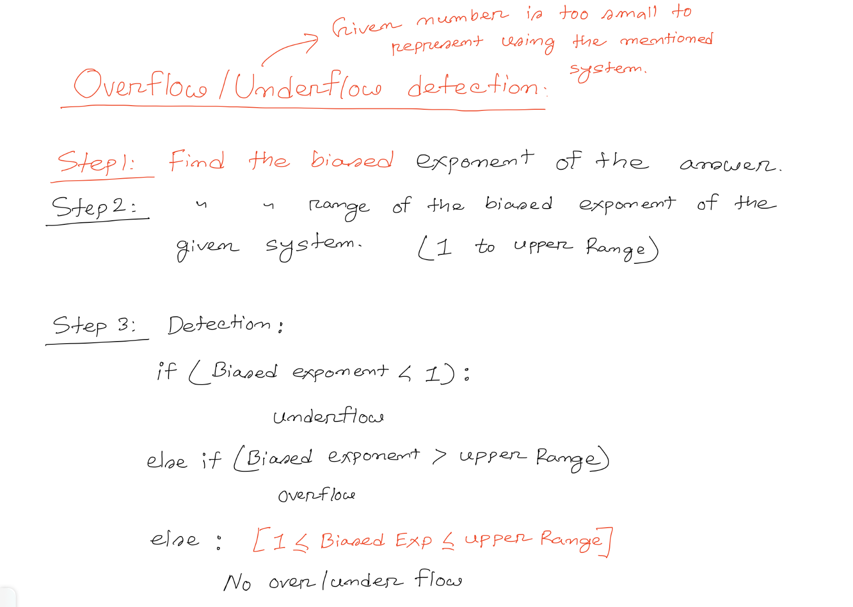

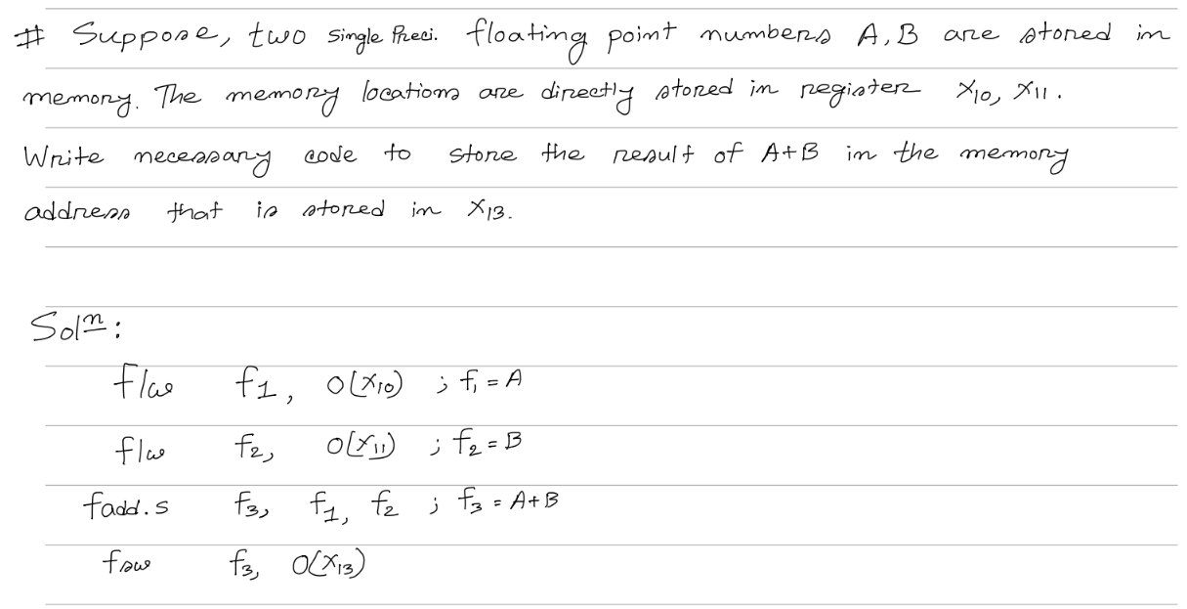
Floating Point instructions in RISC-V

Floating point instruction list:

Instruction | Syntax & Example | Operation | Note
fadd.s | fadd.s rd, rs1, rs2  Ex: fadd.s f₃, f₂, f₅ | Perform single-precision floating-point addition  rd = rs1 + rs2 | For all the red marked instructions, if the numbers are in double precision then just add “d” instead of “s”  Ex:  fadd.d rd, rs1, rs2  Perform double-  precision floating-point addition  rd = rs1 + rs2
fsub.s | fsub.s rd, rs1, rs2  Ex: fsub.s f₃, f₂, f₅ | Perform single-precision floating-point subtraction  rd = rs1 - rs2
fmul.s | fmul.s rd,rs1,rs2  Ex: fmul.s f₃, f₂, f₅ | Perform single-precision floating-point multiplication.  rd = rs1 * rs2
fdiv.s | fdiv.s rd,rs1,rs2  Ex: fdiv.s f₃, f₂, f₅ | Perform single-precision floating-point division.  rd = rs1 / rs2
fmadd.s | fmadd.s rd,rs1,rs2,rs3  Ex: fmadd.s f₃, f₂, f₅, f₆ | Perform single-precision fused multiply addition.  rd = (rs1 * rs2) + rs3
fnmadd.s | fnmadd.s rd,rs1,rs2,rs3  Ex: fnmadd.s f₃, f₂, f₅, f₆ | Perform negated single-precision fused multiply addition.  rd = -(rs1 * rs2) - rs3
fmsub.s | fmsub.s rd,rs1,rs2,rs3  Ex: fmsub.s f₃, f₂, f₅, f₆ | Perform single-precision fused multiply subtraction.  rd = (rs1 * rs2) - rs3
fnmsub.s | fnmsub.s rd,rs1,rs2,rs3  Ex: fnmsub.s f₃, f₂, f₅, f₆ | Perform negated single-precision fused multiply subtraction.  rd = -(rs1 * rs2) + rs3
fsqrt.s | fsqrt.s rd,rs1  Ex: fsqrt.s f₃, f₂ | Perform single-precision square root.  rd = sqrt(rs1)
feq.s | feq.s rd,rs1,rs2  Ex: feq.s x₃, f₂, f₅ | Performs a comparison between two floating point numbers. If both are equal stores 1 in rd else stores 0.
flt.s | flt.s rd,rs1,rs2  Ex: flt.s x₃, f₂, f₅ | Performs a comparison between two floating point numbers. If (rs1 < rs2) stores 1 in rd else stores 0.
fle.s | fle.s rd,rs1,rs2  Ex: fle.s x₃, f₂, f₅ | Performs a comparison between two floating point numbers. If (rs1 <= rs2) stores 1 in rd else stores 0.

Instruction | Syntax & Example | Operation
flw | flw rd,offset(rs1)  Ex: flw f₃, 8(x₅) | Load a single-precision floating-point value from memory into floating-point register rd.
fld | fld rd,offset(rs1)  Ex: fld f₃, 16(x₅) | Load a double-precision floating-point value from memory into floating-point register rd.
fsw | fsw rs2,offset(rs1)  Ex: fsw f₃, 8(x₅) | Store a single-precision value from floating-point register rs2 to memory.
fsd | fsd rs2,offset(rs1)  Ex: fsd f₃, 16(x₅) | Store a double-precision value from floating-point register rs2 to memory.
fcvt.s.w | fcvt.s.w rd,rs1  Ex: fcvt.s.w f₃, x₅ | Converts a 32-bit signed integer, in integer register rs1 into a floating-point number in floating-point register rd.
fcvt.w.s | fcvt.w.s rd,rs1  Ex: fcvt.w.s x₃, f₅ | Convert a floating-point number in floating-point register rs1 to a signed 32-bit in integer register rd.
fmv.w.x | fmv.w.x rd,rs1  Ex: fmv.w.x f₃, x₅ | Move the single-precision value encoded in IEEE 754 standard encoding from the lower 32 bits of integer register rs1 to the floating-point register rd.
fmv.x.w | fmv.x.w rd,rs1  Ex: fmv.x.w x₃, f₅ | Move the single-precision value in floating-point register rs1 represented in IEEE 754 encoding to the lower 32 bits of integer register rd.

Formulas
$1. Bias =2^{(n-1)}-1 ; n = Size of the exponent field$
$2. Biased Exponent = Bias + Actual Exponent$
$Actual Exponent = Biased Exponent - Bias$
$3. Biased Exponent Range = 0 to 2^{n}-1 ; [upper \& lower limit is reserved]$
$= 1 to 2^{n}-2 ; [Usable range]$
$4. Actual Exponent Range = (0 - Bias) to (2^{n}-1 - Bias)$
$=(1 -Bias) to (2^{n}-2 -Bias) ; [Usable range]$
$5. Decimal Number =(-1)^{Sign Bit}×(1+Fraction)×{2^{}}^{Actual Exponent}$

