# Lab: Models and MTV Pattern

In this exercise we are going to create a **very simple** **To-do App**. At the end, it will look something like this

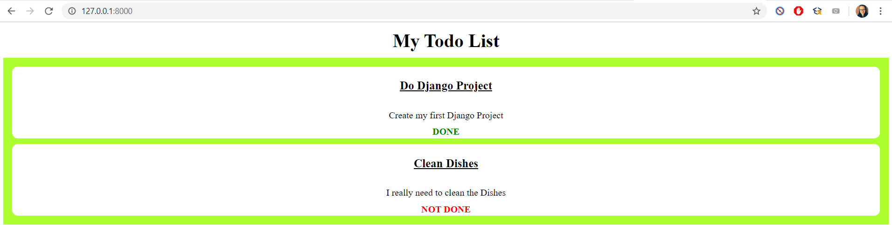

## The Basics

Let us start by creating a **new Django Project**

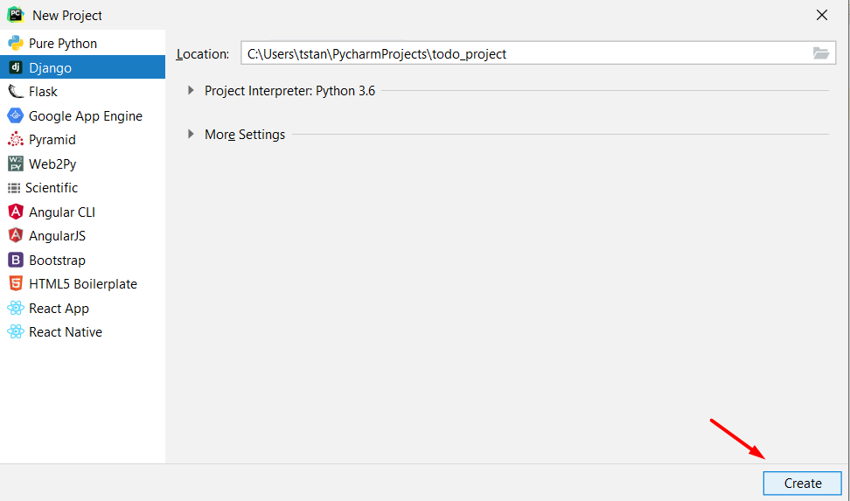

Then, we are going to **create our app**

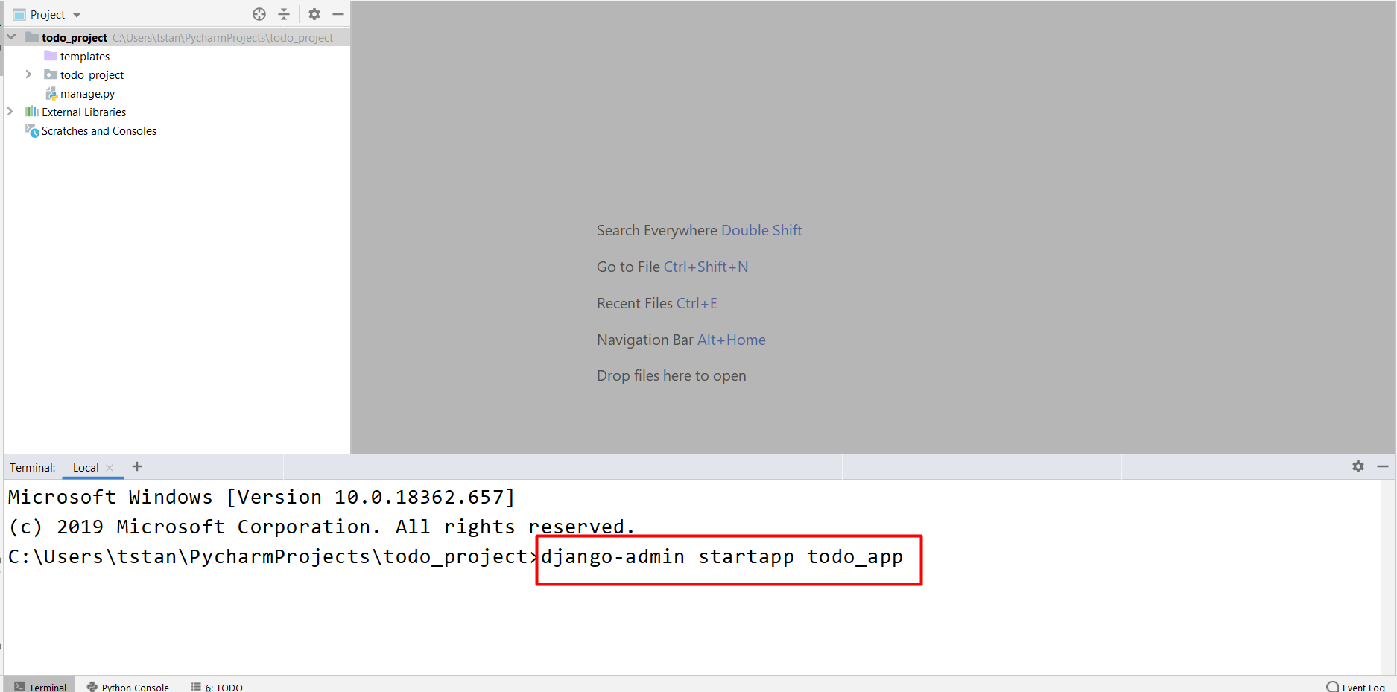

Next, we need to import our app in the **settings.py** file in the project

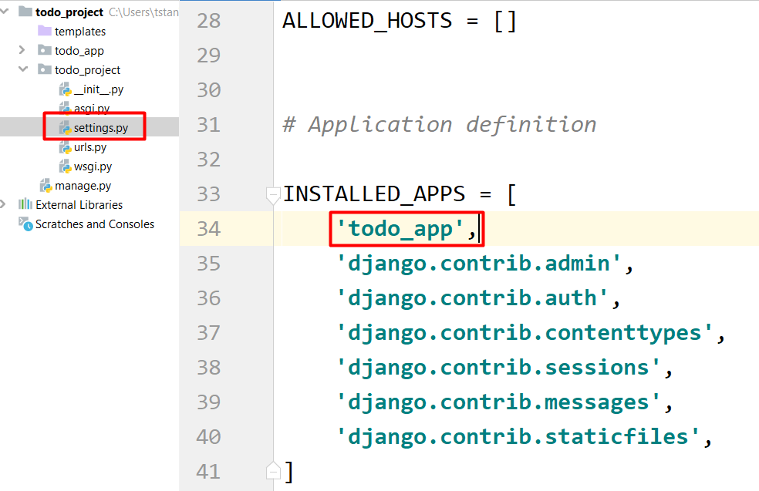

## Setting up the App

Now, let us create an **index view** in our app

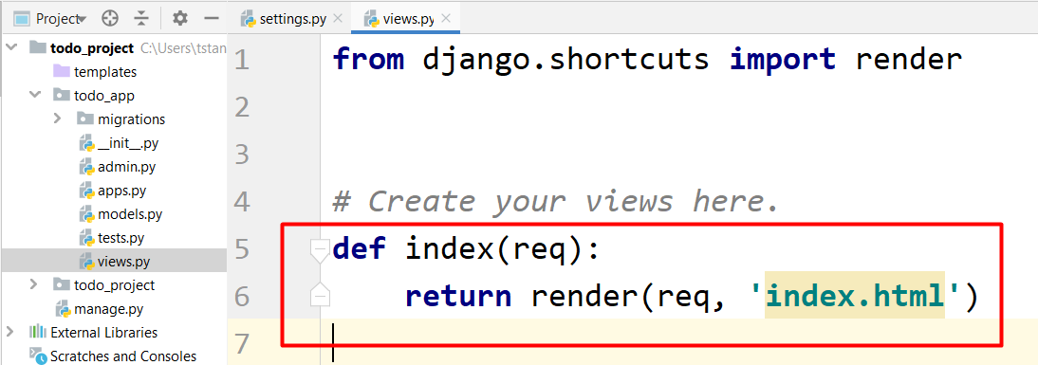

Before we create the HTML file, let us create the **urls.py** file in the **app**

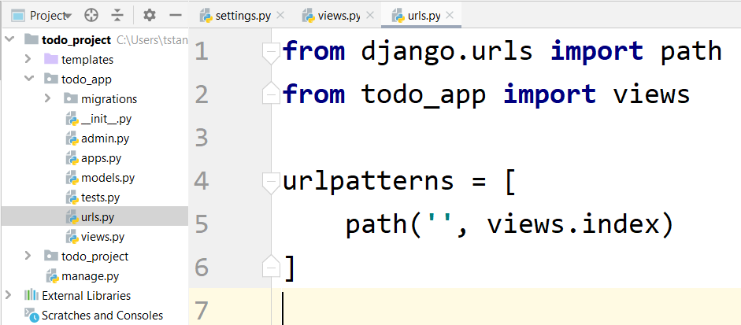

Now, since we do not yet have the **index.html** file, let us create it in the templates folder. You can copy the following HTML

<**html lang="en"**>  
<**head**>  
 <**meta charset="UTF-8"**>  
 <**meta name="viewport" content="width=device-width, initial-scale=1.0"**>  
 <**title**>Todo App</**title**>  
</**head**>  
<**style**>  
 **h1** {  
 **margin**: 5**px**;  
 **text-align**: **center**;  
 **padding**: 5**px**;  
 }  
  
 **h2** {  
 **text-align**: **center**;  
 **text-decoration**: **underline**;  
 }  
  
 **div**.**done** {  
 **color**: **green**;  
 **font-weight**: **bold**;  
 }  
  
 **div**.**open** {  
 **color**: **red**;  
 **font-weight**: **bold**;  
 }  
  
 **div**.**todo** {  
 **display**: **block**;  
 **background**: **white**;  
 **border**: 2**px solid white**;  
 **border-radius**: 10**px**;  
 **margin**: 5**px**;  
 **text-align**: **center**;  
 }  
  
 **div**.**todo p** {  
 **font-size**: 20**px**;  
 **font-weight**: **bold**;  
 **text-decoration**: **underline**;  
 }  
  
 **div**.**todo div**.**description** {  
 **padding**: 10**px**;  
 }  
  
 **div**.**container** {  
 **background**: **greenyellow**;  
 **display**: **flex**;  
 **flex-direction**: **column**;  
 **margin**: 0 **auto**;  
 **padding**: 10**px**;  
 }  
</**style**>  
<**body**>  
 <**h1**>My Todo List</**h1**>  
</**body**>  
</**html**>

**Note: It is a bad practice to write the style in the HTML file. Here we use it, because we have not yet learned about static files**

Let us include in the project the **urls** from the app

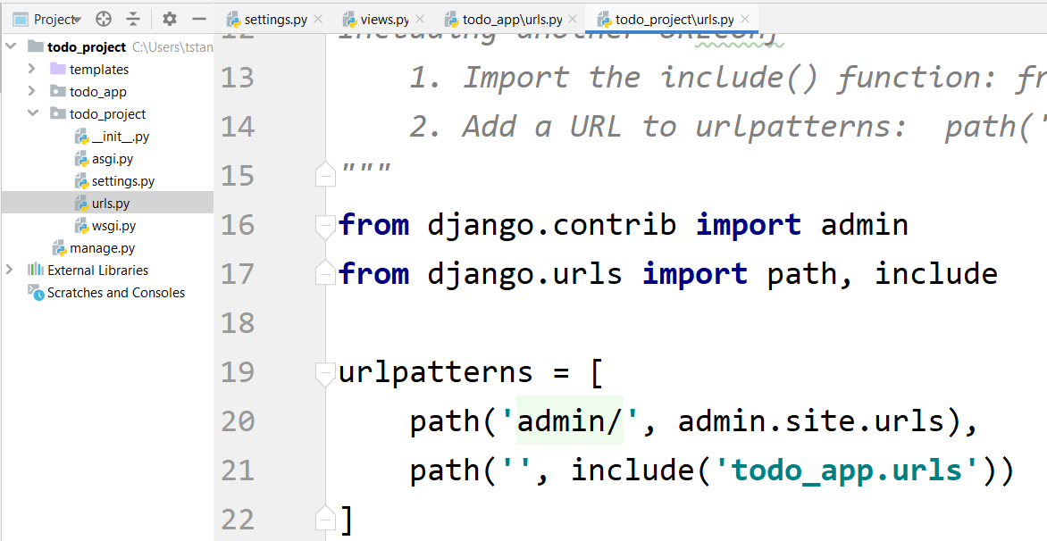

## Configuring the Database

Before we test our project, let us configure the database. First, we go to the settings.py file and write the following

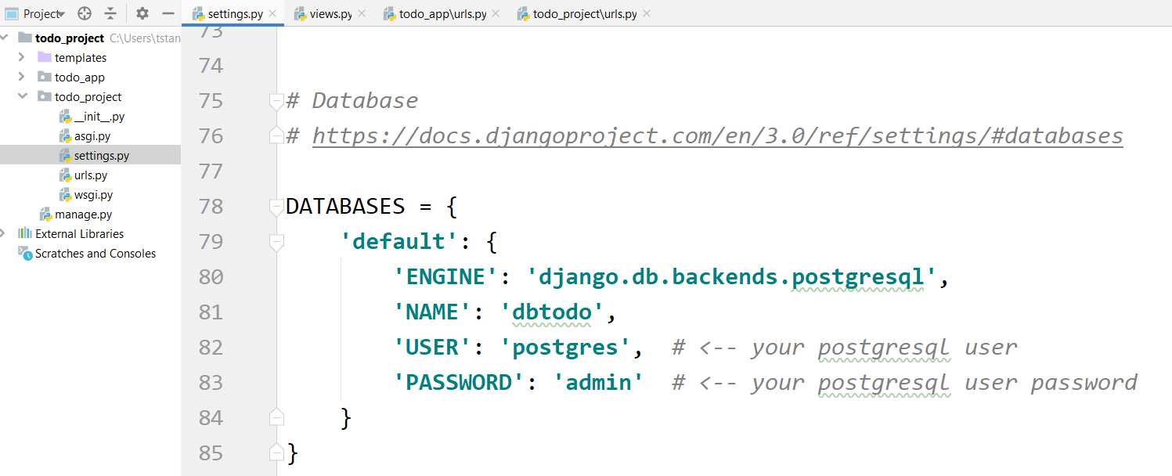

Now, let us **connect to PostgreSQL**

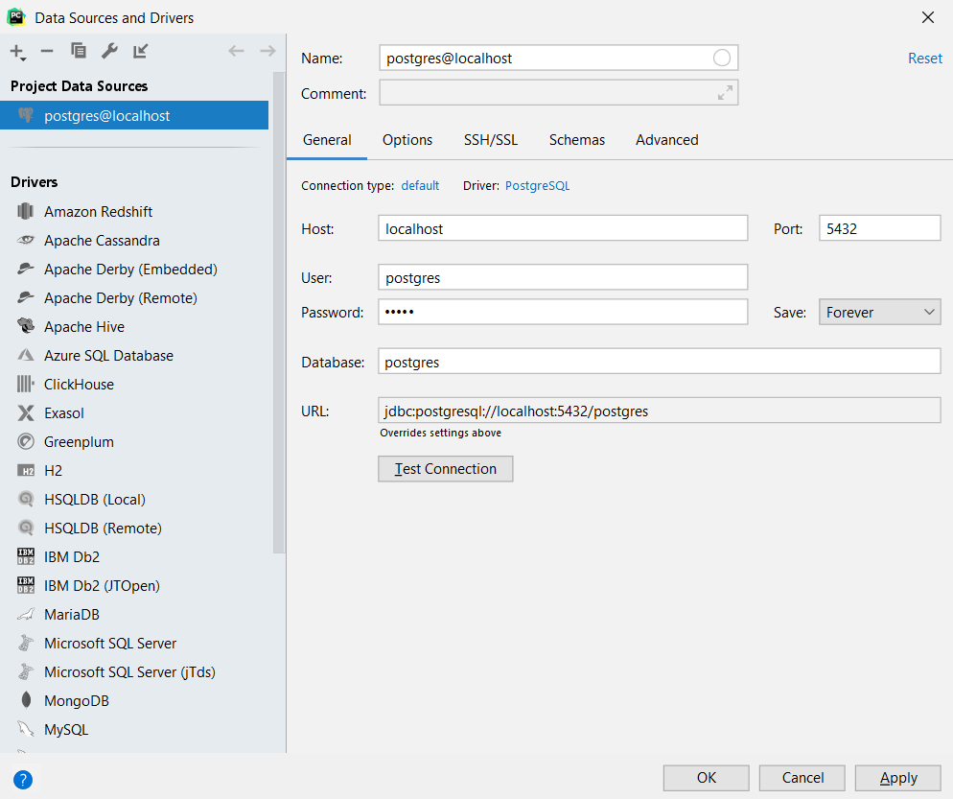

and create a new database with name **"dbtodo"**

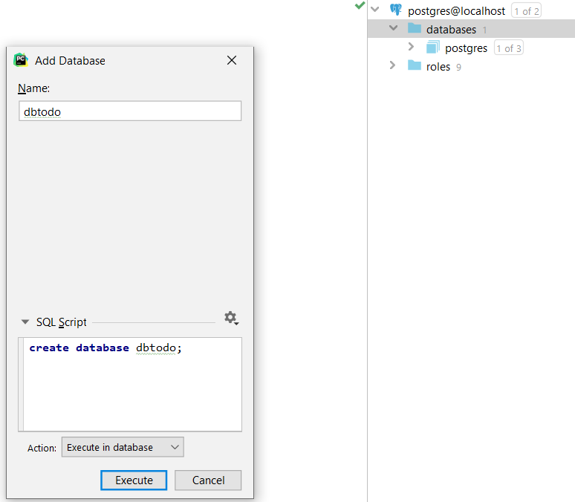

Now we are ready to test our project for the first time. Start the project and open it in the browser

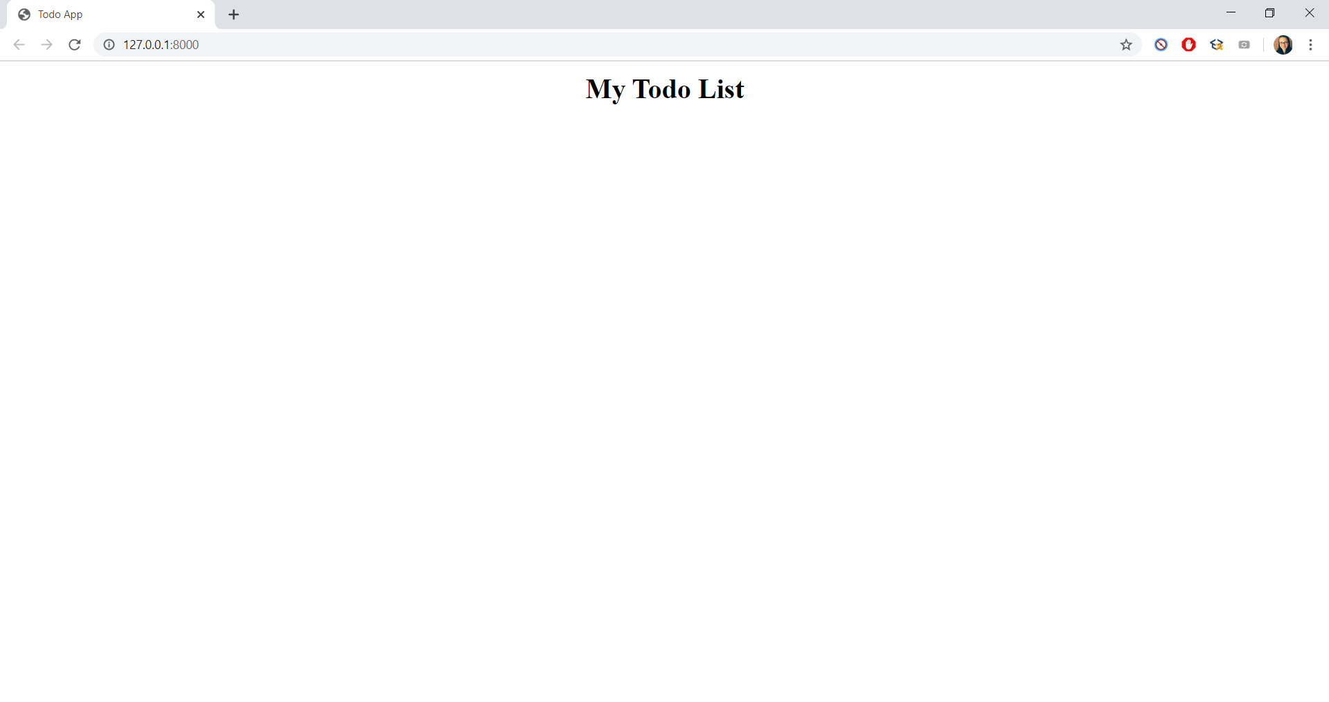

## Creating the Todo Model

Now, it is time to create our model. Go to the **models.py** file and create a **class called Todo**

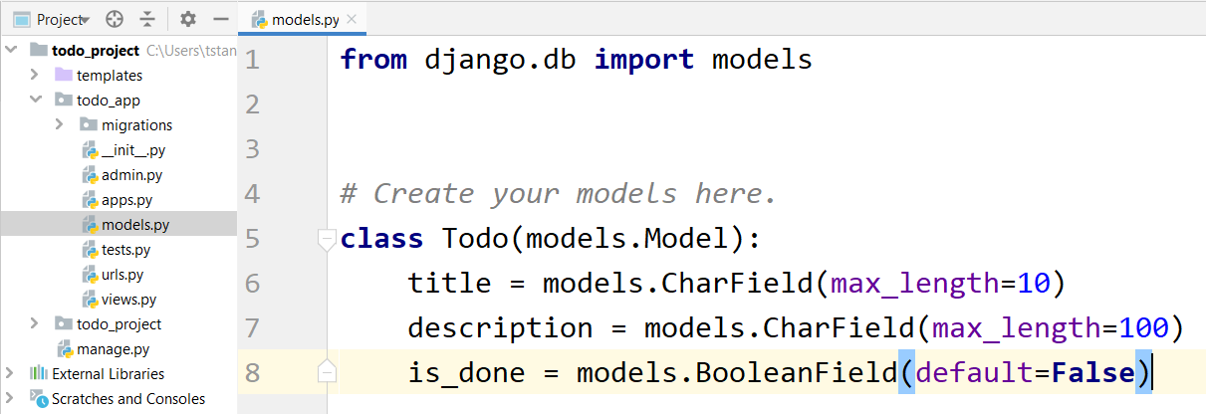

The next step is to register the model in the **admin.py** file in the app

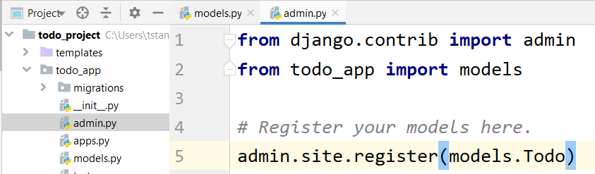

Finally, let us make the **migrations**

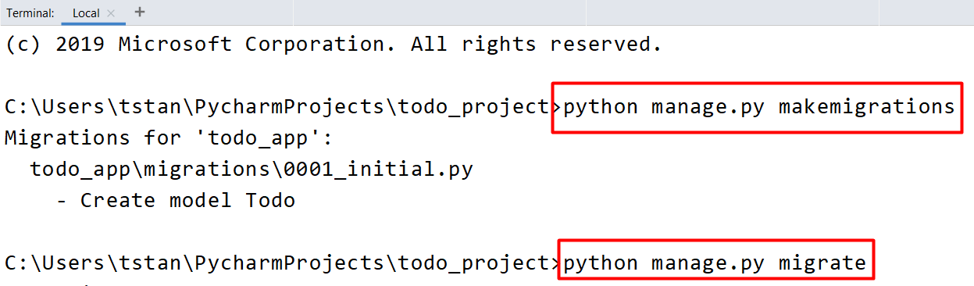

## Adding Context to the View

Now, let us go back to the **views.py** file and edit the index, so it passes a **context to the template**

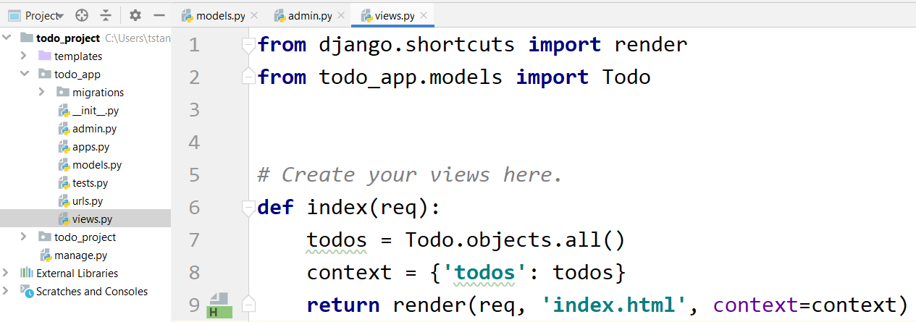

## Implement Template Logic

Before testing our project again, let us **loop** through all our **todos in the index.html** file

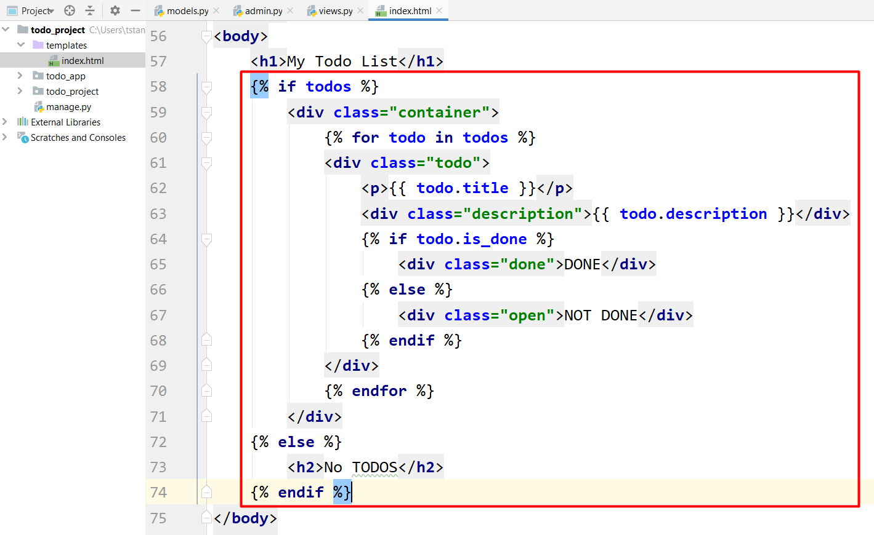

Now let us **test** the project again

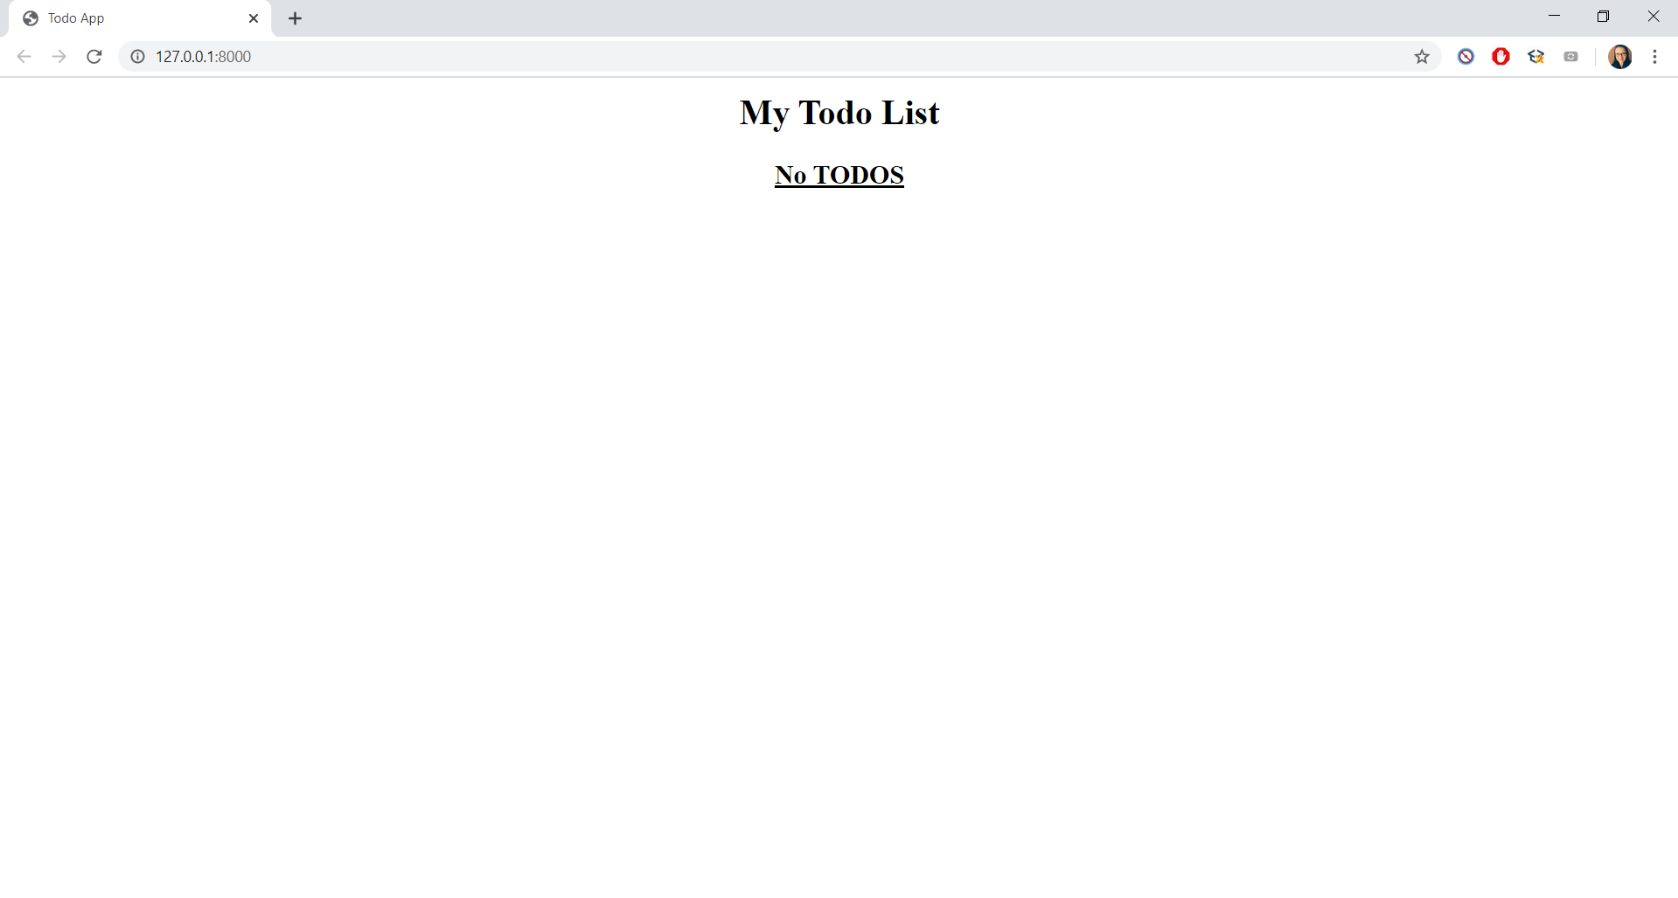

Since our **database is empty**, we do not render any todos, just the **h2** tag with the **"No TODOS"** text in it.

## Practicing Some CRUD Operations

Since we yet do not know how to use **html forms** to create objects in the database, we have **two options**:

* Use the **Django Admin** to manually create some objects (try doing it)
* Use the **shell** to create some objects using the Django Database API (what we are going to do)

Open the terminal and type the following: **python manage.py shell**

Now you should see something like this

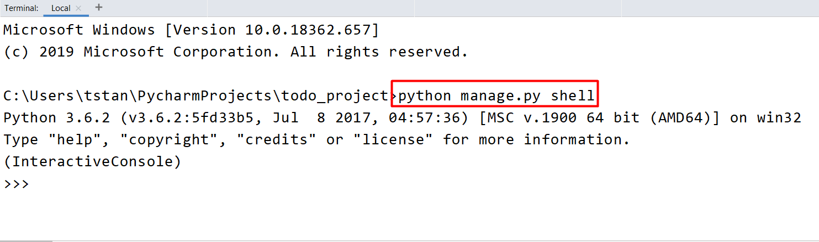

Now let us **create** a new Todo

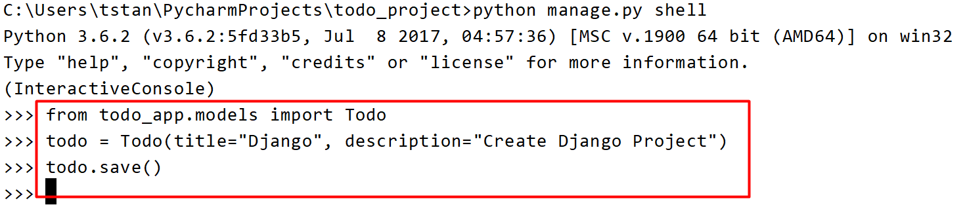

**Refresh** the page in the browser to see the new Todo

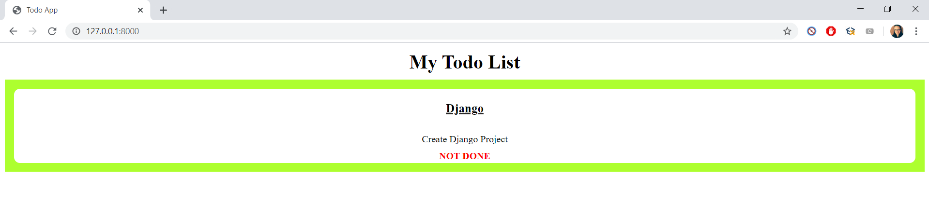

Next, let us try and **edit** the Todo

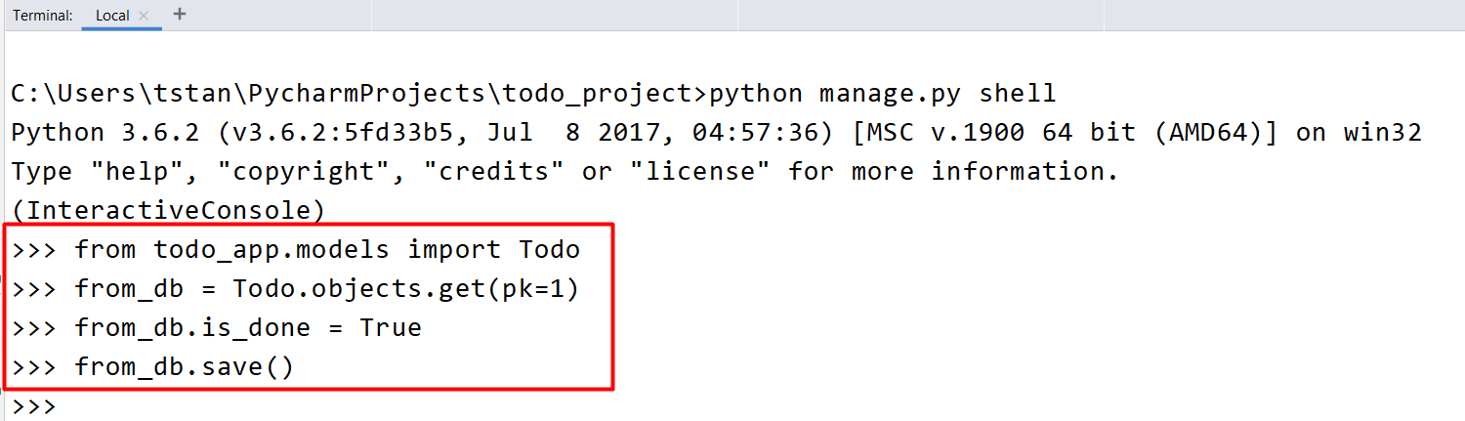

You can now see the changes in the browser.

***With that we are done with our Todo App. Try adding some more features in the app to practice what you have learned 😊***