# Lab: Unit and Integration Testing

## Create Unit and Integration Testing on Project

You will be provided with a project called "Lost and Found". You need to create tests to cover all the functionalities of the app. The following points describe how the project works

### Home Page

On the home page you should see all the posts from the database and a button with "Create" should appear on the top. URL: **"http://localhost:8000"**

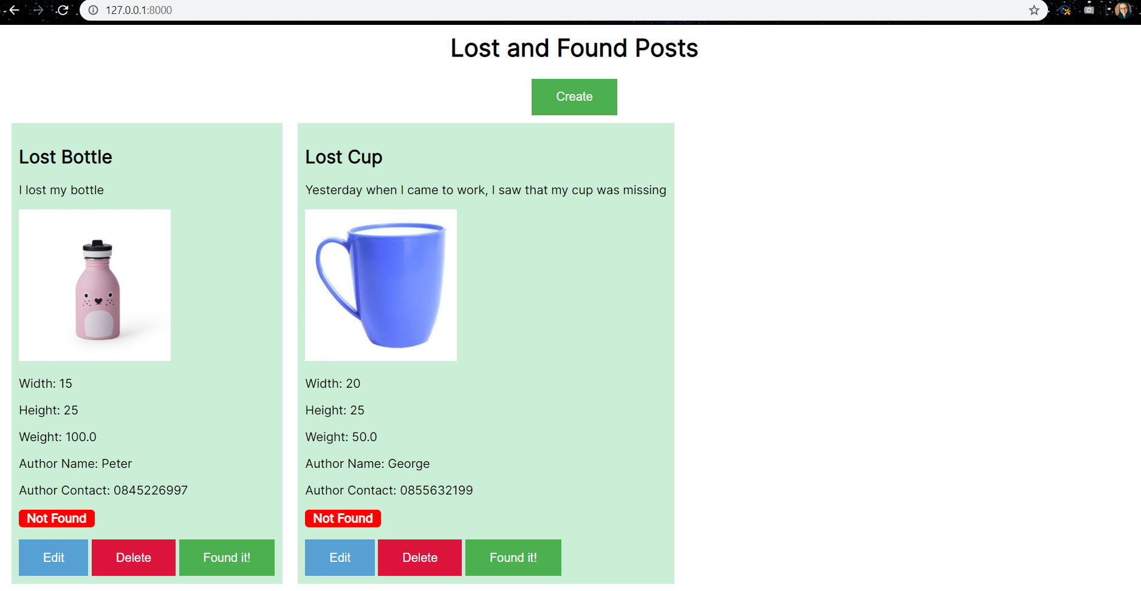

### Create

On the create page, the following form should be displayed. URL: **"http://localhost:8000/create"**

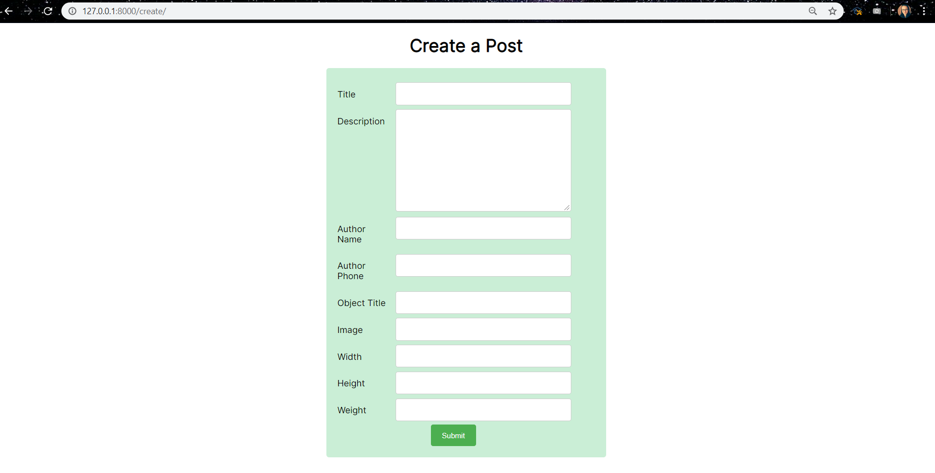

### Edit

On the edit page, the following form should be displayed. URL: **"http://localhost:8000/edit/{id}"**

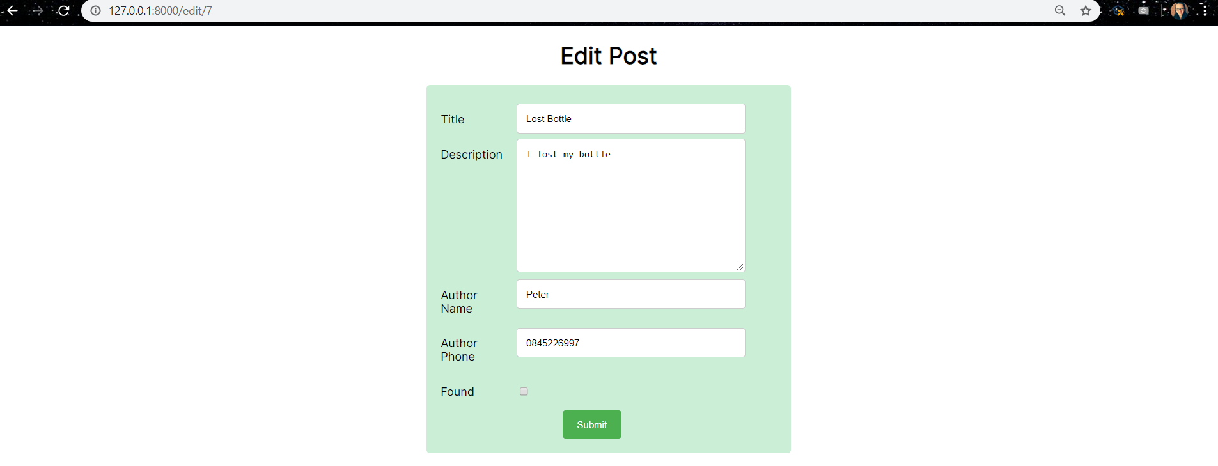

### Delete

When clicking the delete button, the post should be deleted, and the index page should be refreshed

### Found and Not Found

When an item has not yet been found, a button with content **"Found it!"** should appear in the post. If the item has been found, the button should not be there.

Also, the labels **"Not Found"** and **"Found"** should be displayed based on whether the item has been found.

For more clarification, see the picture

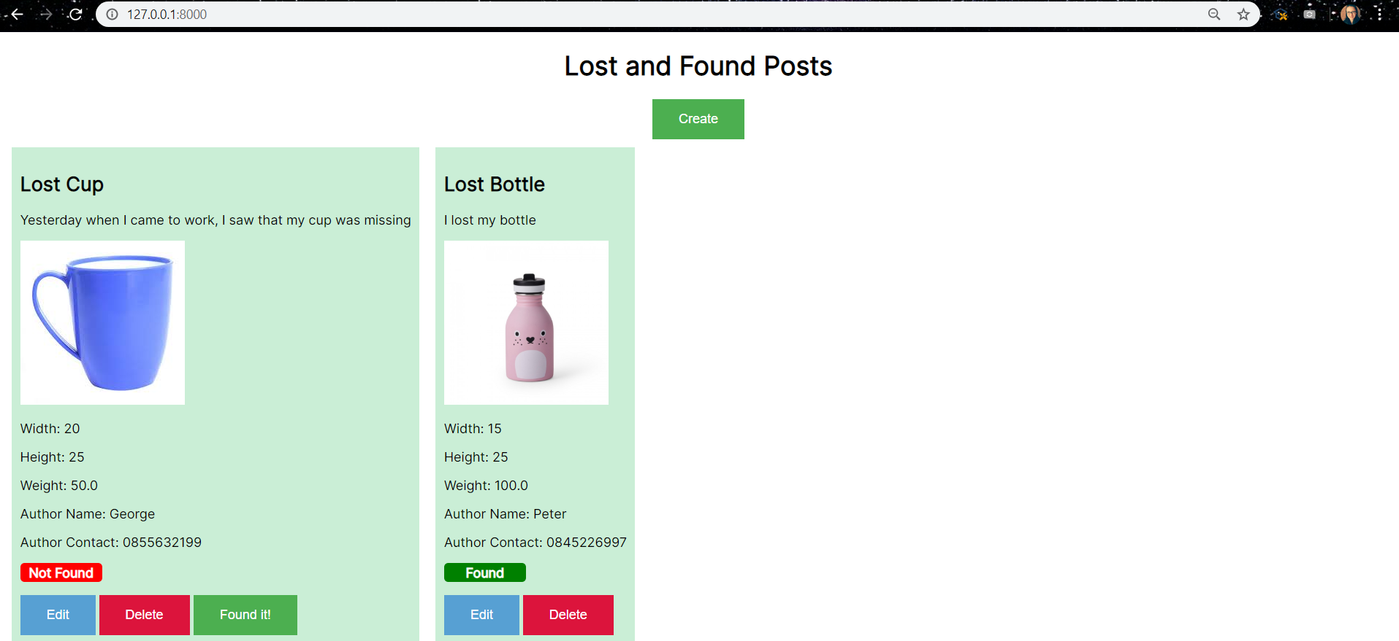

### Testing

Create tests for

* All the models
* All the forms
* All the views