# Lab: PostgreSQL

# Pet Hotel

Create a database called **pet_hotel** that has the following **tables** and **structure**

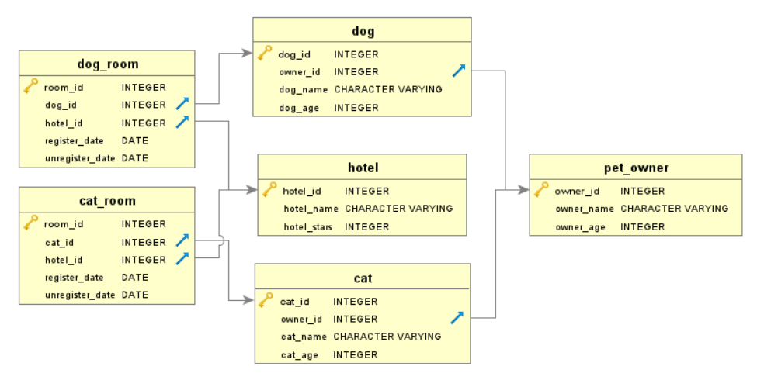

### Field Restrictions

* **owner_name** – must have a **maximum** length of **15**
* **owner_age** – must be a number **between 1** **and 110**
* **dog_name** – must have a **maximum** length of **15**
* **dog_age** – must be **between 1 and 25**
* **cat_name** – must have a **maximum** length of **15**
* **cat_age** – must be **between 1 and 25**
* **hotel_name** – must have a **maximum** length of **25**
* **hotel_stars** – must be **between 1 and 5**

### Features

* When **deleting** a **cat** or **dog**, their records from the **rooms** should also be **deleted**
* When **deleting** an **owner**, the corresponding **pets** should also be **deleted**
* When **deleting** a **hotel**, the corresponding **rooms** should also be **deleted**

## Insert

Let us **insert** some data into the tables

****Pet Owners****

|  |  |  |
| --- | --- | --- |
| **owner_id** | **name** | **owner_age** |
| 1 | 'Peter' | 26 |
| 2 | 'George' | 32 |
| 3 | 'Amy' | 67 |

****Dogs****

|  |  |  |  |
| --- | --- | --- | --- |
| **dog_id** | **owner_id** | **dog_name** | **dog_age** |
| 1 | 1 | 'Fluffy' | 2 |
| 2 | 3 | 'Bully' | 3 |
| 3 | 1 | 'Rousey' | 5 |

****Cats****

|  |  |  |  |
| --- | --- | --- | --- |
| **cat_id** | **owner_id** | **cat_name** | **cat_age** |
| 1 | 2 | 'Tommy' | 1 |
| 2 | 3 | 'Jessy' | 7 |
| 3 | 2 | 'Bubbles' | 3 |

****Hotels****

|  |  |  |
| --- | --- | --- |
| **hotel_id** | **hotel_name** | **hotel_stars** |
| 1 | 'Grand Pets Hotel' | 5 |
| 2 | 'Pets Heaven' | 2 |

****Dog Rooms****

|  |  |  |  |  |
| --- | --- | --- | --- | --- |
| **room_id** | **dog_id** | **hotel_id** | **register_date** | **unregister_date** |
| 1 | 1 | 1 | '2020-06-08' | '2020-06-10' |
| 2 | 2 | 2 | '2020-06-10' | '2020-06-15' |
| 3 | 3 | 2 | '2020-06-20' | '2020-06-23' |

****Cat Rooms****

|  |  |  |  |  |
| --- | --- | --- | --- | --- |
| **room_id** | **cat_id** | **hotel_id** | **register_date** | **unregister_date** |
| 1 | 1 | 1 | '2020-06-08' | '2020-06-10' |
| 2 | 2 | 2 | '2020-06-10' | '2020-06-15' |
| 3 | 3 | 2 | '2020-06-20' | '2020-06-23' |

## Select

Select **all** the information from the **dog_room** table

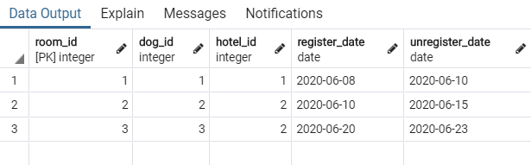

## Where

Select **only** the **ids** of the **cats** that are in **rooms** from the **hotel** with **id=2**

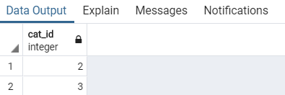

## Sort

Sort all the **pet owners** by **age** in **descending**

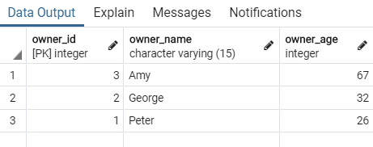

## Count

Get the **count** of all **cats** that are of **age 3 or older**

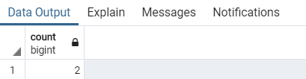

## Delete

Delete all **cats** and **dogs**, that are of **age 2 or less**

