# Lab: Authentication

# Pythons Wiki (with Authentication)

**Extend** the pythons wiki project, so it has very simple authentication.

## Create User group

Create a **group** called **'User'** with the following **permissions**

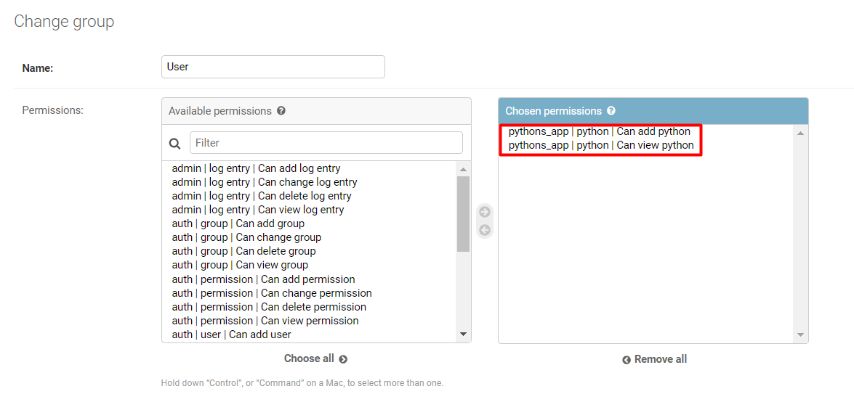

## Create User

Since we don't know how to create register forms yet, create **your own user** that is in the **'User'** group using the **django admin**

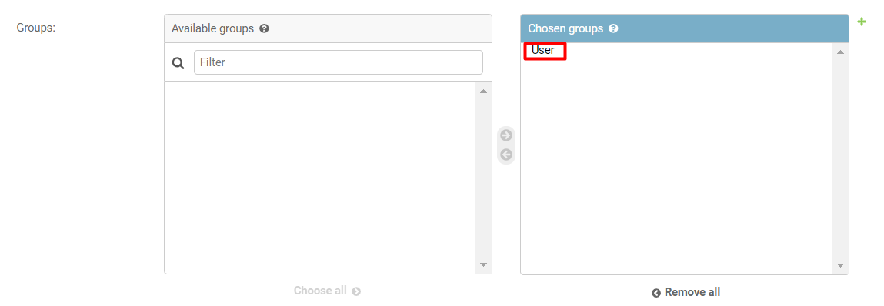

## Add Login and Logout

In the **nav bar**, implement some **logic in the template**, so when a user is **not logged** in (user is **Anonymous**), a **Login link** is displayed. Otherwise display **'Welcome {username}'** and a **Logout link**

### Not Logged In

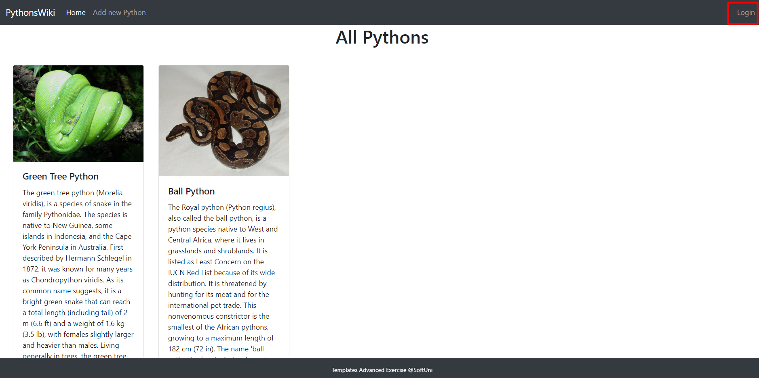

### Logged In

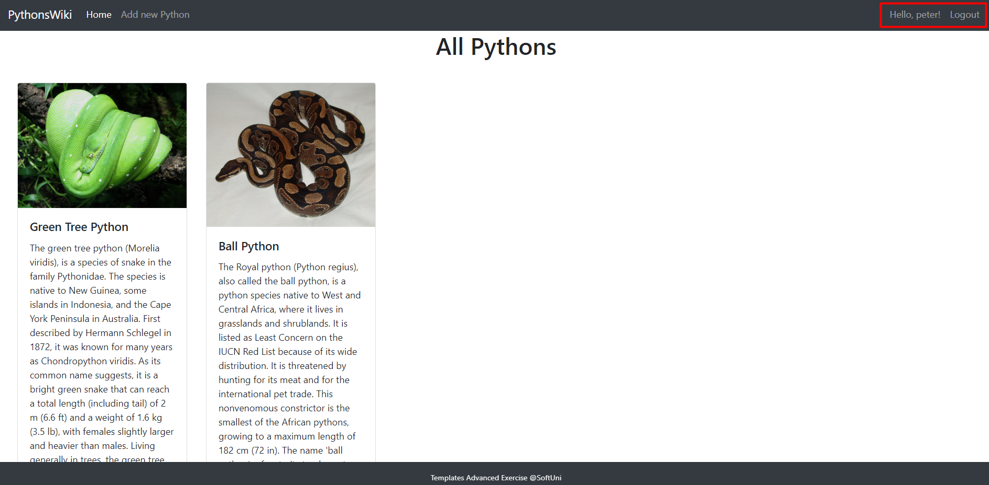

## Login and Logout View

Implement the **login view**, so the user **you created logs in** (use his credentials)

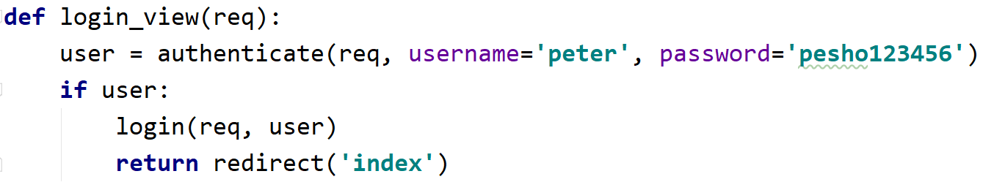

Implement the **logout logic**, so the currently logged user **logs out** and **redirect** to the **home** page

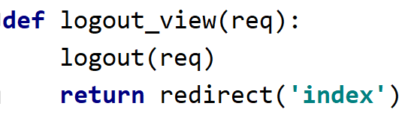

## Group Restrictions

Implement your own **decorator function** that allows only **users** from the **group** **'User'** or **superusers** to access the **create python** page. If the user does **not belong** to those groups, create your own **401 page** like in the example below

### Not Logged In



### Logged In

